The relationship between H_{S} and H_{M}
Searby and Jouventin (2004) suggested that H_{M} should be favored over H_{S} in case of modulated signals. However, they only presented the relationship between H_{M} and discrimination score and did not directly compare the performance of H_{S} and H_{M}. Moreover, their artificial dataset was limited in the number of manipulated parameters. We were therefore interested in better understanding the relationship between the H_{M} and H_{S} in our data and whether H_{M} could have advantages over H_{S}.
We first tried to replicate results of Searby and Jouventin (2004) but included the calculation of H_{S}. The process and functions necessary to replicate the data are described in the file “replicate Searby Jouventin 2004.R” within the provided R project (Linhart, 2018). We were able to replicate the results of Searby and Jouventin (2004) quite well (Figure S6.1a). H_{S} was almost identical to H_{M} * 25 (Figure S6.1b). Because the dataset comprised 25 identity variables, H_{M} could be potentially seen as the average H_{S} per identity variable. We further tested this possibility in our datasets (see below). We found no advantage of using H_{M} over H_{S} for modulated signals as the two metrics are perfectly correlated in the Searby and Jouventin (2004) replicated dataset (R² = 1.00, Figure S6.1b).
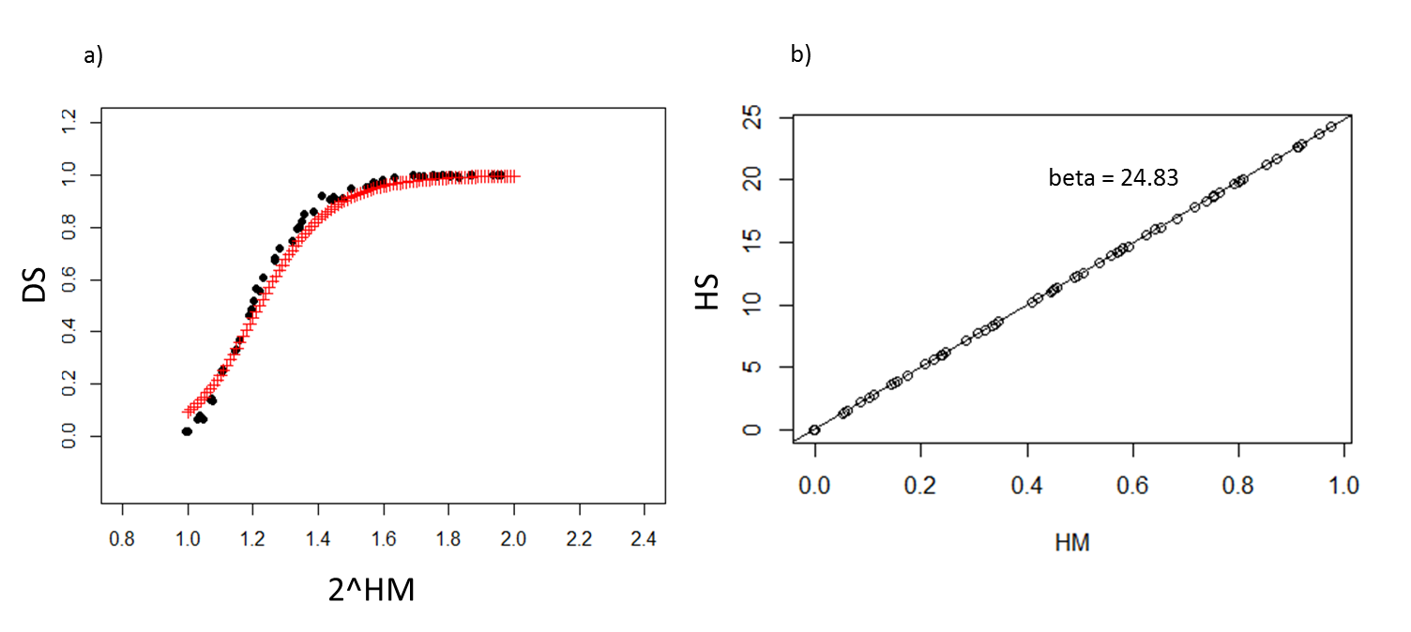
Figure S6.1. Relationship between discrimination score (DS) and 2^H_{M} as reported by Searby and Jouventin (2004) and our replication of the same data (a) – red crosses show the line predicted by Searby and Jouventin (2004, Fig 2b). Relationship between H_{S} and H_{M} in replication of data from Searby and Jouventin 2004 (b).
However, in our dataset, this perfect relationship can became blurred because of changes in covariance (H_{S} values are lower than expected from H_{M}) and insufficient sampling (in cases when there are few individuals, H_{S} is underestimated) (Figure S6.2a). When the covariance is set to zero and with sufficient sampling of individuals (full set of 40 individuals) H_{S} is again almost equivalent to H_{M} * number of variables (Figure S6.2b). We suggest that H_{S} should be preferred over H_{M} because H_{M} requires additional information about the dimensionality of the data which would need to be assessed separately for non-independent variables.
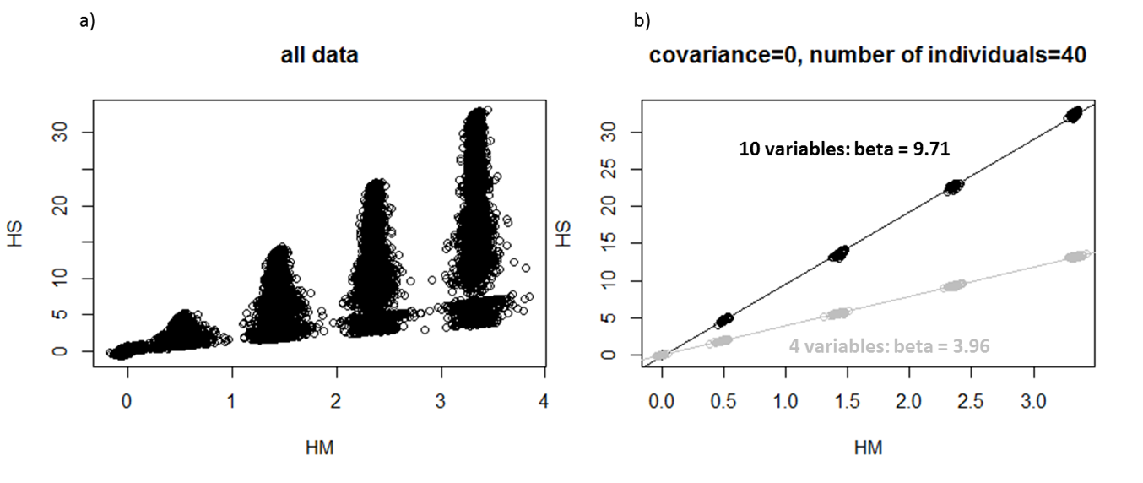
Figure S6.2. Relationship between H_{M} and H_{S} in our all simulated datasets for all data pooled (a) and for selected datasets with covariance=0 and number of individuals=40 (b).

References:
Linhart, P. (2018). pygmy83/Identity-metrics: Identity metrics. Zenodo. https://doi.org/10.5281/zenodo.1252272
Searby, A., & Jouventin, P. (2004). How to measure information carried by a modulated vocal signature? Journal of the Acoustical Society of America, 116, 3192–3198. https://doi.org/10.1121/1.1775271

