Supplementary Materials

Description | GSP field
Flanker Accuracy | Flanker_S_CORRpc
Mental Rotation Accuracy | Average of MenRot_80_CORRpc, MenRot_120_CORRpc, and MentRot_160_CORRpc
Shipley Vocabulary | Shipley_Vocab_Raw
WAIS – Matrix Reasoning | Matrix_WAIS
Speilberger Trait Anxiety | STAI_tAnxiety
Speilberger State Anxiety | STAI_sAnxiety
Total Mood Disturbance | POMS_TotMdDisturb
Barratt Impulsivity | Barratt_tot
Mind Wandering Frequency | MindWandering_Freq
NEO – Neuroticism | NEO_N
NEO – Extraversion | NEO_E
NEO – Openness to Experience | NEO_O
NEO – Agreeableness | NEO_A
NEO – Conscientiousness | NEO_C
Novelty Seeking | TCI_Novelty
Reward Dependence | TCI_RewardDependance
Harm Avoidance | TCI_HarmAvoidance
Risk Raking | DOSPERT_taking
Risk Perception | DOSPERT_perception
Behavioral Activation – Drive | BISBAS_BAS_Drive
Behavioral Activation – Fun | BISBAS_BAS_Fun
Behavioral Activation – Reward | BISBAS_BAS_Reward
Behavioral Inhibition | BISBAS_BIS

Table S1. Lookup table showing the original GSP variable names with the corresponding descriptive labels used in the manuscript.

Description | HCP field
Visual Episodic Memory | PicSeq_Unadj
Cognitive Flexibility (DCCS) | CardSort_Unadj
Inhibition (Flanker Task) | Flanker_Unadj
Fluid Intelligence (PMAT) | PMAT24_A_CR
Vocabulary (Pronunciation) | ReadEng_Unadj
Vocabulary (Picture Matching) | PicVocab_Unadj
Processing Speed | ProcSpeed_Unadj
Delay Discounting | DDic_AUC_40K
Spatial Orientation | VSPLOT_TC
Sustained Attention – Sens. | SCPT_SEN
Sustained Attention – Spec. | SCPT_SPEC
Verbal Episodic Memory | IWRD_TOT
Working Memory (List Sorting) | ListSort_Unadj
Cognitive Status (MMSE) | MMSE_Score
Sleep Quality (PSQI) | PSQI_Score
Walking Endurance | Endurance_Unadj
Walking Speed | GaitSpeed_Unadj
Manual Dexterity | Dexterity_Unadj
Grip Strength | Strength_Unadj
Odor Identification | Odor_Unadj
Pain Interference Survey | PainInterf_Tscore
Taste Intensity | Taste_Unadj
Contrast Sensitivity | Mars_Final
Emotional Face Matching | Emotion_Task_Face_Acc
Arithmetic | Language_Task_Math_Avg_Difficulty_Level
Story Comprehension | Language_Task_Story_Avg_Difficulty_Level
Relational Processing | Relational_Task_Acc
Social Cognition – Random | Social_Task_Perc_Random
Social Cognition – Interaction | Social_Task_Perc_TOM

Table S2. Lookup table showing the original HCP variable names with the corresponding descriptive labels used in the manuscript.

Description | HCP field
Working Memory (N-back) | WM_Task_Acc
Agreeableness (NEO) | NEOFAC_A
Openness (NEO) | NEOFAC_O
Conscientiousness (NEO) | NEOFAC_C
Neuroticism (NEO) | NEOFAC_N
Extraversion (NEO) | NEOFAC_E
Emot. Recog. – Total | ER40_CR
Emot. Recog. – Angry | ER40ANG
Emot. Recog. – Fear | ER40FEAR
Emot. Recog. – Happy | ER40HAP
Emot. Recog. - Neutral | ER40NOE
Emot. Recog. – Sad | ER40SAD
Anger – Affect | AngAffect_Unadj
Anger – Hostility | AngHostil_Unadj
Anger – Aggression | AngAggr_Unadj
Fear – Affect | FearAffect_Unadj
Fear – Somatic Arousal | FearSomat_Unadj
Sadness | Sadness_Unadj
Life Satisfaction | LifeSatisf_Unadj
Meaning & Purpose | MeanPurp_Unadj
Positive Affect | PosAffect_Unadj
Friendship | Friendship_Unadj
Loneliness | Loneliness_Unadj
Perceived Hostility | PercHostil_Unadj
Perceived Rejection | PercReject_Unadj
Emotional Support | EmotSupp_Unadj
Instrument Support | InstruSupp_Unadj
Perceived Stress | PercStress_Unadj
Self-Efficacy | SelfEff_Unadj

Table S2 (cont.). Lookup table showing the original HCP variable names with the corresponding descriptive labels used in the manuscript.

GSP behavior description | FD-behavior correlation | DVARS-behavior correlation
Harm Avoidance | -0.0899 | -0.0578
NEO - Neuroticism | -0.0724 | -0.0519
NEO - Agreeableness | -0.0702 | -0.0286
Behavioral Inhibition | -0.0560 | -0.0792
Flanker Accuracy | -0.0492 | -0.0662
Speilberger Trait Anxiety | -0.0356 | -0.0016
Total Mood Disturbance | -0.0302 | -0.0068
NEO - Conscientiousness | -0.0278 | -0.0999
Mind Wandering Frequency | -0.0268 | -0.0133
Risk Perception | -0.0230 | -0.0896
Speilberger State Anxiety | -0.0176 | -0.0237
NEO - Extraversion | -0.0174 | 0.0218
Behavioral Activation - Drive | -0.0137 | 0.0244
Behavioral Activation - Reward | -0.0114 | 0.0108
WAIS - Matrix Reasoning | -0.0113 | 0.0299
Reward Dependence | -0.0105 | -0.0520
Barratt Impulsivity | -0.0035 | 0.0516
NEO - Openness to Experience | 0.0063 | -0.0307
Behavioral Activation - Fun | 0.0226 | 0.0599
Shipley Vocabulary | 0.0342 | 0.0646
Novelty Seeking | 0.0383 | 0.0559
Mental Rotation Accuracy | 0.0433 | 0.0429
Risk Taking | 0.0659 | 0.0646

Table S3. Pearson’s correlation between motion (FD and DVARS) and the behavioral scores in the GSP dataset.

HCP behavior description | FD-behavior correlation | DVARS-behavior correlation
Walking Endurance | -0.2973 | 0.0685
Working Memory (N-back) | -0.2361 | 0.0151
Reading (Pronounciation) | -0.2143 | 0.0390
Fluid Intelligence (PMAT) | -0.1931 | 0.0399
Vocabulary (Picture Matching) | -0.1864 | 0.0577
Relational Processing | -0.1834 | -0.0403
Spatial Orientation | -0.1616 | 0.1028
Delay Discounting | -0.1521 | 0.0454
Cognitive Flexibility (DCCS) | -0.1461 | 0.0085
Working Memory (List Sorting) | -0.1372 | 0.0462
Openness (NEO) | -0.1283 | 0.0788
Manual Dexterity | -0.1235 | -0.0880
Story Comprehension | -0.1122 | 0.0824
Agreeableness (NEO) | -0.1071 | -0.1356
Emot. Recog. - Total | -0.1044 | -0.0721
Social Cognition - Interaction | -0.1036 | 0.0364
Visual Episodic Memory | -0.1034 | -0.0977
Inhibition (Flanker task) | -0.0990 | 0.0015
Contrast Sensitivity | -0.0955 | 0.1298
Processing Speed | -0.0875 | 0.0604
Verbal Episodic Memory | -0.0865 | -0.0387
Arithmetic | -0.0831 | 0.0020
Walking Speed | -0.0798 | -0.0949
Emot. Recog. - Sad | -0.0700 | -0.0120
Emot. Recog. - Angry | -0.0614 | -0.0352
Emotional Face Matching | -0.0584 | -0.0301
Emot. Recog. - Fear | -0.0568 | -0.0752
Sustained Attention - Spec. | -0.0457 | -0.0837
Life Satisfication | -0.0455 | -0.0146

Table S4. Pearson’s correlation between motion (FD and DVARS) and the behavioral scores in the HCP dataset.

HCP behavior description | FD-behavior correlation | DVARS-behavior correlation
Emot. Recog. - Happy | -0.0421 | 0.0119
Emot. Recog. - Neutral | -0.0380 | -0.0400
Loneliness | -0.0362 | 0.0026
Cognitive Status (MMSE) | -0.0288 | -0.0572
Odor Identificaiton | -0.0228 | -0.0958
Emotional Support | -0.0213 | -0.0260
Instrument Support | -0.0207 | 0.0058
Sadness | -0.0204 | -0.0315
Extraversion (NEO) | -0.0085 | 0.0332
Sustained Attention - Sens. | -0.0062 | 0.0567
Fear - Affect | -0.0056 | -0.0557
Conscientiousness (NEO) | -0.0046 | -0.0689
Neuroticism (NEO) | 0.0098 | -0.0382
Perceived Stress | 0.0231 | -0.0421
Grip Strength | 0.0241 | 0.3659
Pain Interference Survey | 0.0256 | 0.0273
Anger - Affect | 0.0258 | 0.0065
Anger - Hostility | 0.0354 | 0.0320
Friendship | 0.0385 | 0.0411
Self-Efficacy | 0.0424 | 0.0945
Perceived Hostility | 0.0427 | 0.0690
Social Cognition - Random | 0.0478 | 0.0093
Perceived Rejection | 0.0482 | -0.0069
Positive Affect | 0.0555 | 0.0456
Fear - Somatic Arousal | 0.0558 | 0.0093
Taste Intensity | 0.0737 | -0.0744
Anger - Aggression | 0.0760 | 0.1236
Meaning & Purpose | 0.0761 | 0.0167
Sleep Quality (PSQI) | 0.1299 | 0.0115
Table S4 (cont.). Pearson’s correlation between motion (FD and DVARS) and the behavioral scores in the HCP dataset.

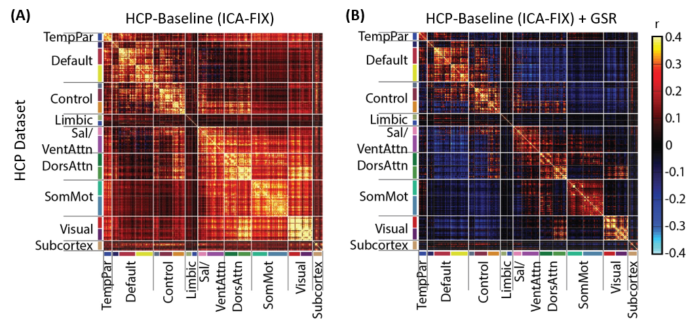

Figure S1. GSR results in a negative “shift” in RSFC in the HCP dataset. (A) RSFC matrix among the 419 ROIs using baseline processing without GSR. (B) RSFC matrix among the 419 ROIs using baseline processing with GSR. For visualization, the 419 ROIs are ordered according to the 17 networks in Figure 1A and subcortical structures listed in Figure 1B. These 17 networks are in turn divided into eight groups (TempPar, Default, Control, Limbic, Salience/Ventral Attention, Dorsal Attention, Somatomotor and Visual), roughly corresponding to major networks discussed in the literature. These eight groups and subcortical structures are separated by thick while lines. Consistent with the literature, GSR introduces a negative shift in the RSFC.

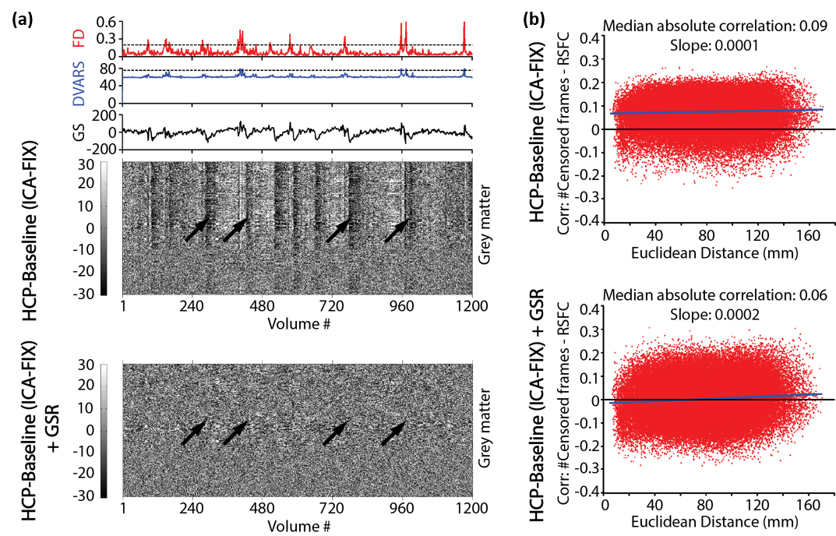

Figure S2. GSR reduces imaging artifacts, while exacerbating distance-dependent FC biases in the HCP dataset. (A) QC plot of a representative mid-motion HCP subject. FD (red), DVARS (blue), and GS (black) are shown in the top three panels. The horizontal lines in the first two panels indicate the thresholds used in the censoring step. The bottom two panels are signal intensity of gray matter voxels in two preprocessing pipelines: HCP-Baseline (upper) and HCP-Baseline+GSR (lower). Without GSR, motion-related global artifacts are visible in the gray matter timeseries, while GSR removes the global signal changes (black arrows). (B) Correlations between QC (number of censored frames) and RSFC are shown for two preprocessing pipelines: HCP-Baseline (upper) and HCP-Baseline+GSR (lower). Each red dot indicates one ROI pair. The x-axes are the Euclidean distances among pairs of ROIs. The functional connectivity between each pair of ROIs are correlated with the number of censored frames across all subjects and shown on the y-axes. The blue lines corresponded to linear fits of the red dots.

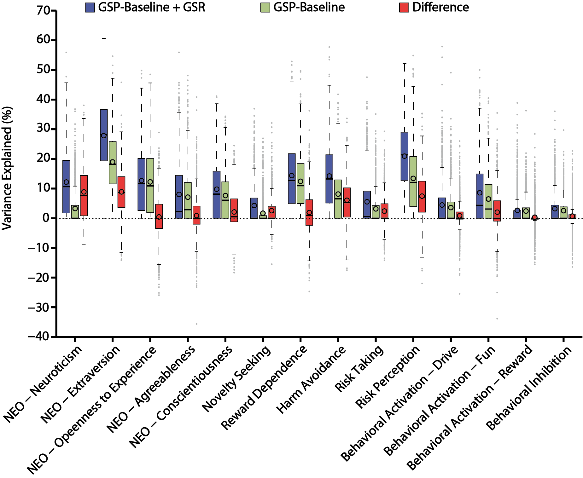

Figure S3. GSR improves behavioral variance explained by RSFC in the GSP dataset. Behavioral variance explained by RSFC for 14 remaining measures of personality and associated biosocial factors. For each behavioral measure, the explained variance by the GSP-Baseline+GSR pipeline, GSP-Baseline pipeline, and difference between the two pipelines are shown in blue, green and red respectively. The “boxes” show the median and interquartile range (IQR) of explained variance across all jackknife samples. The whisker length is 1.5 IQR. Black circles indicate mean. Outliers are shown by grey dots.

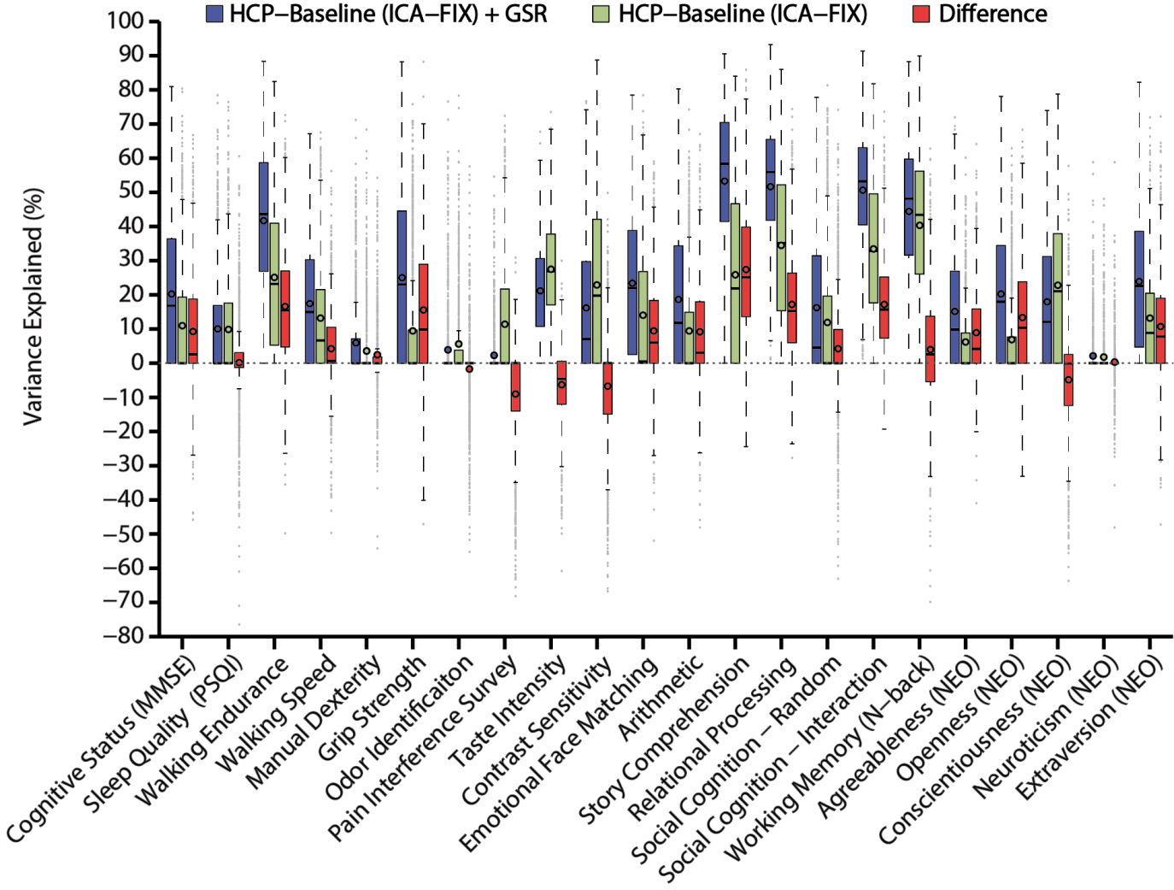

Figure S4. GSR improves behavioral variance explained by RSFC in the HCP dataset. Behavioral variance explained by RSFC for 22 measures including alertness, motor, sensory, personality, and in-scanner measures. For each behavioral measure, the explained variance by the HCP-Baseline+GSR pipeline, HCP-Baseline pipeline, and difference between the two pipelines are shown in blue, green and red respectively. The “boxes” show the median and interquartile range (IQR) of explained variance across all jackknife samples. The whisker length is 1.5 IQR. Black circles indicate mean. Outliers are shown by grey dots.

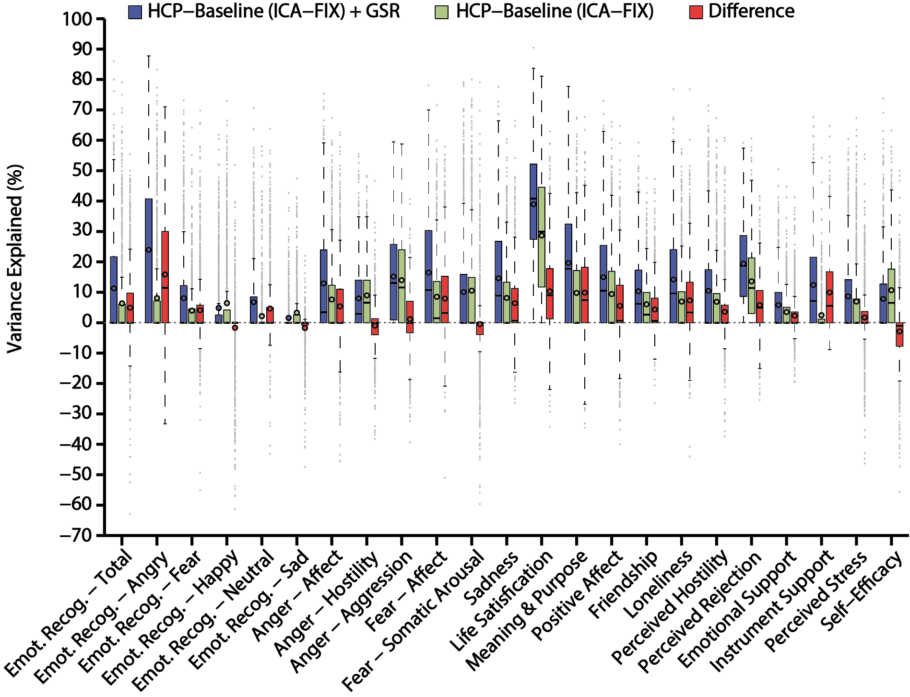

Figure S5. GSR improves behavioral variance explained by RSFC in the HCP dataset. Behavioral variance explained by RSFC for 23 social-emotional measures. For each behavioral measure, the explained variance by the HCP-Baseline+GSR pipeline, HCP-Baseline pipeline, and difference between the two pipelines are shown in blue, green and red respectively. The “boxes” show the median and interquartile range (IQR) of explained variance across all jackknife samples. The whisker length is 1.5 IQR. Black circles indicate mean.

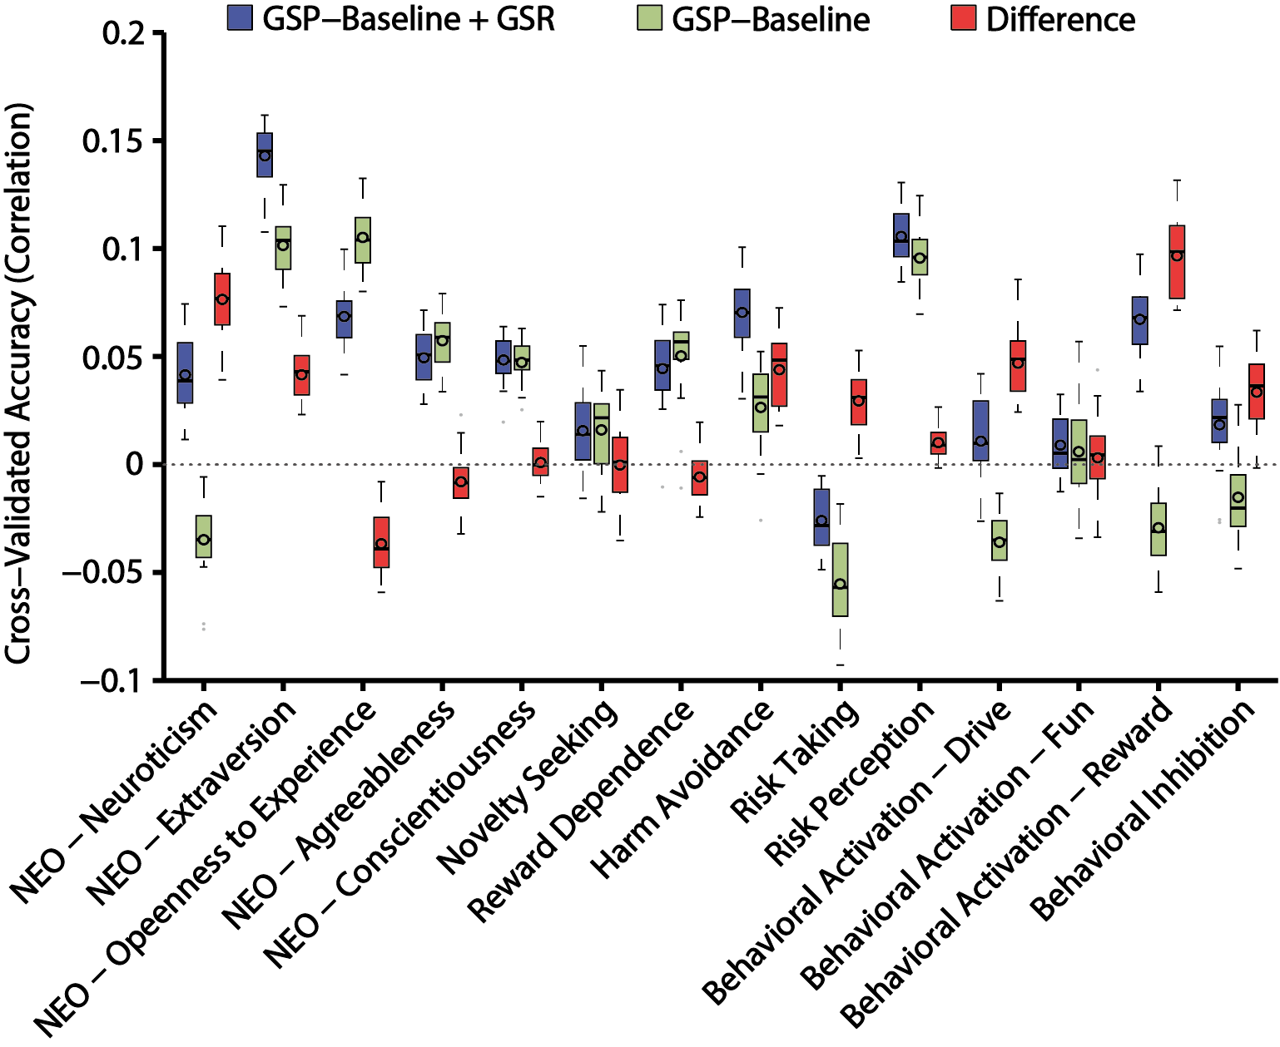

Figure S6. GSR improves RSFC-based behavioral prediction accuracies in the GSP dataset using kernel ridge regression. Test accuracies for 14 remaining measures of personality and associated biosocial factors. For each behavioral measure, the accuracies with the GSP-Baseline+GSR pipeline, GSP-Baseline pipeline, and difference between the two pipelines are shown in blue, green and red respectively. The “boxes” show the median and interquartile range (IQR) of test accuracies across 20 random cross-validation splits. The whisker length is 1.5 IQR. Black circles indicate mean. Outliers are shown by grey dots.

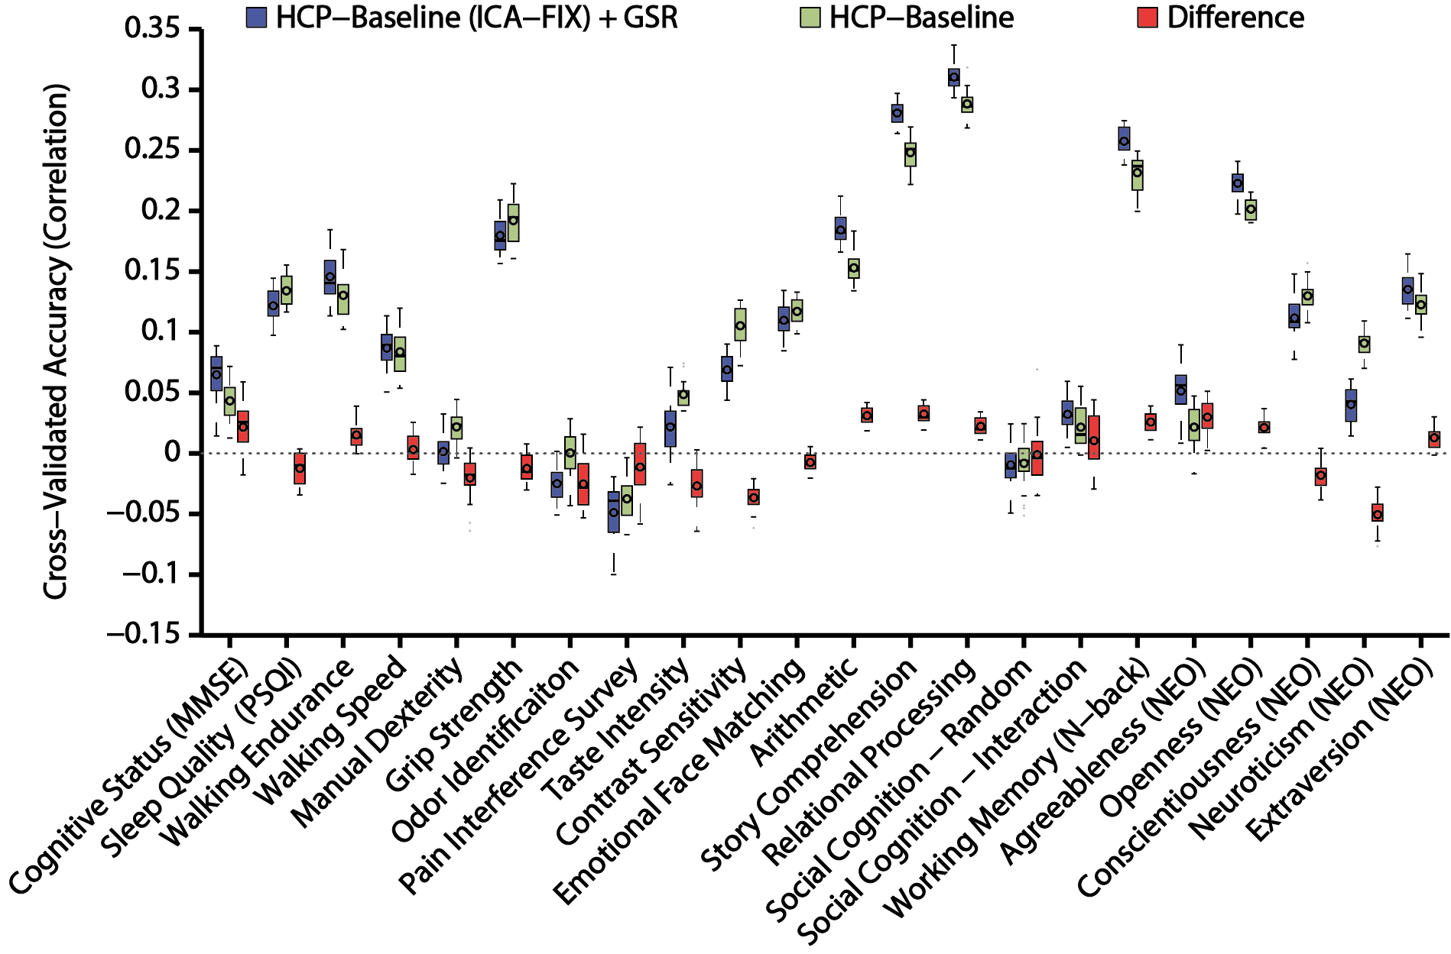

Figure S7. GSR improves RSFC-based behavioral prediction accuracies in the HCP dataset using kernel ridge regression. Test accuracies for 22 measures including alertness, motor, sensory, personality, and in-scanner measures. For each behavioral measure, the accuracies with the HCP-Baseline+GSR pipeline, HCP-Baseline pipeline, and difference between the two pipelines are shown in blue, green and red respectively. The “boxes” show the median and interquartile range (IQR) of test accuracies across 20 random cross-validation splits. The whisker length is 1.5 IQR. Black circles indicate mean. Outliers are shown by grey dots.

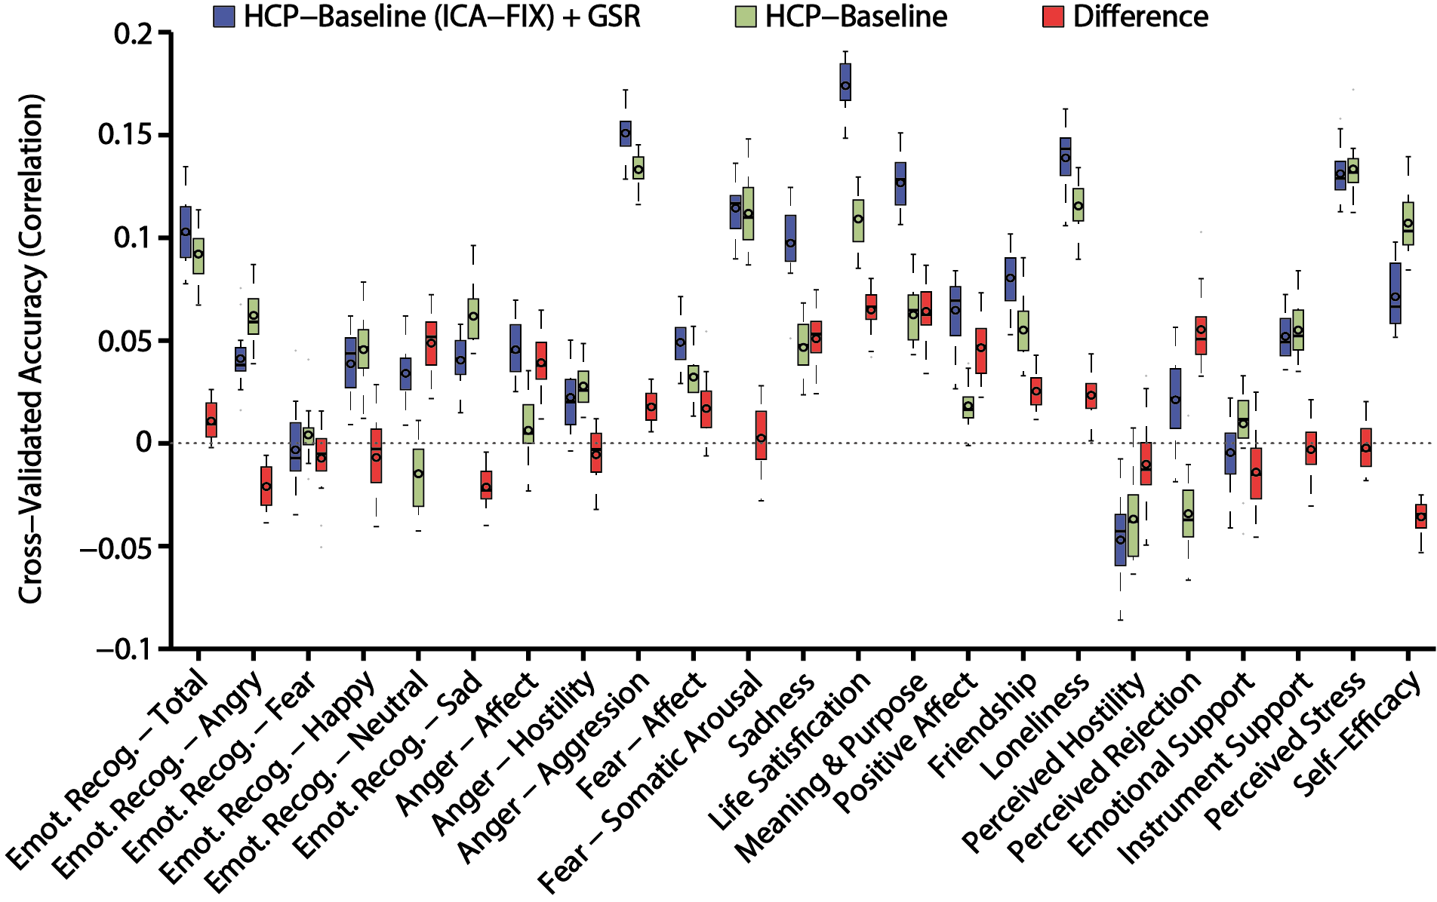

Figure S8. GSR improves RSFC-based behavioral prediction accuracies in the HCP dataset using kernel ridge regression. Test accuracies for 23 social-emotional measures. For each behavioral measure, the accuracies with the HCP-Baseline+GSR pipeline, HCP-Baseline pipeline, and difference between the two pipelines are shown in blue, green and red respectively. The “boxes” show the median and interquartile range (IQR) of test accuracies across 20 random cross-validation splits. The whisker length is 1.5 IQR. Black circles indicate mean.

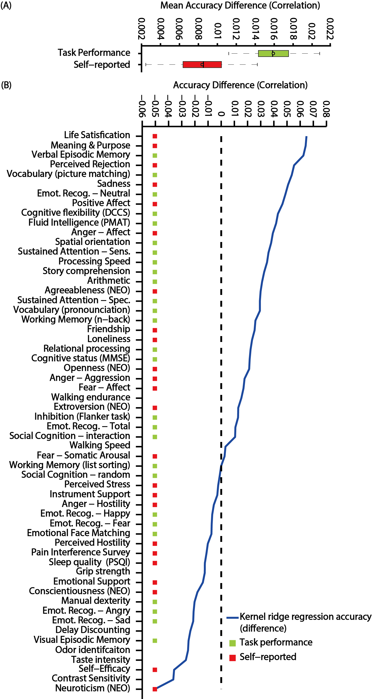

Figure S9. GSR preferentially improves behavioral prediction accuracies for task-performance measures compared with self-reported measures using kernel ridge regression. (A) Improvement in test accuracies averaged across all HCP task-performance measures (green) and across all self-reported measures (red). The “boxes” show the median and interquartile range (IQR) of test accuracies across all random data splits. The whisker length is 1.5 IQR. Black circles indicate mean. (B) Behavioral measures are ordered based on improvement in test accuracies, i.e., baseline+GSR minus baseline (blue line). Behavioral measures marked with green color are considered task-performance measures. Behavioral measures marked with red color are considered self-reported measures.

