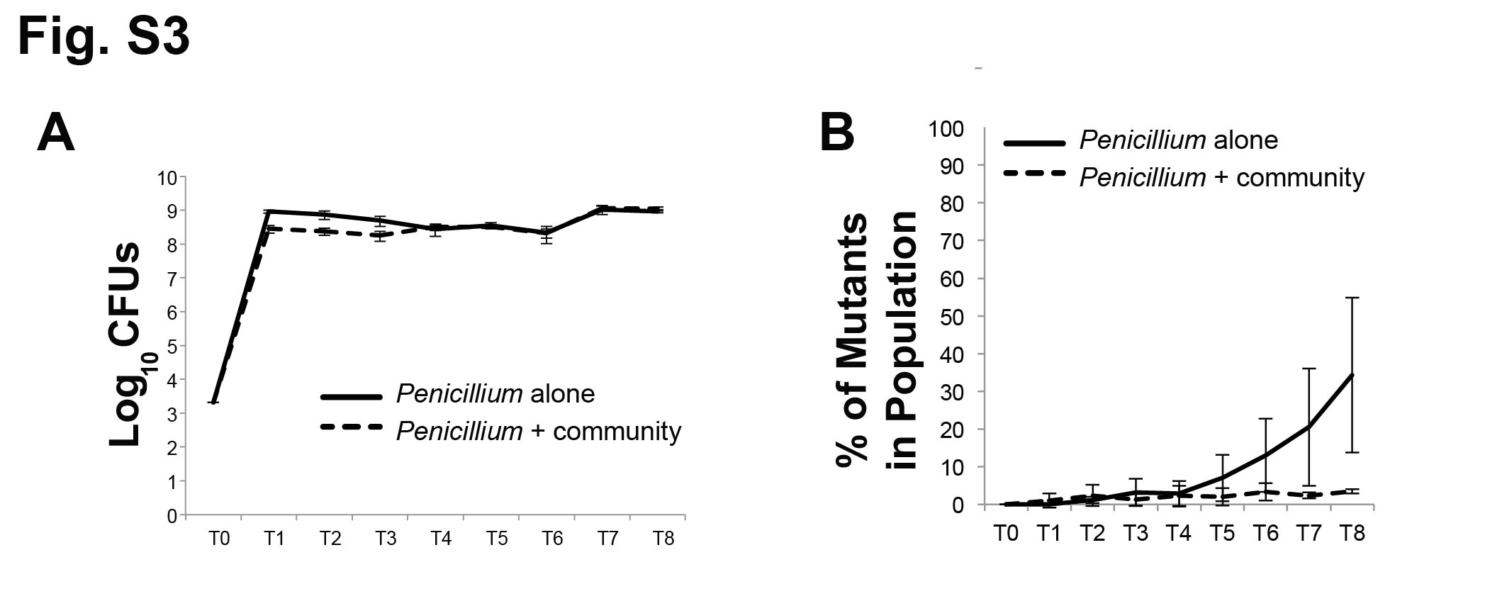
Figure S3: Experimental evolution of Penicillium sp. 12 alone and with a community of cheese rind microbes. (A) Population size of Penicillium sp. 12 when evolved alone and with a community of cheese microbes. Lines connect points representing mean mutant phenotype frequencies of four replicate populations and error bars represent one standard deviation of the mean. Total CFUs in the Penicillium + community treatment was significantly different from Penicillium alone (repeated-measures ANOVA F_{1,6}= 16.8, p =0.006). Lines connect points representing mean colony forming units (CFUs) of four replicate populations and error bars represent one standard deviation of the mean. (B) Phenotypic mutant frequency of Penicillium sp. 12 when evolved alone and with a community of cheese microbes. Lines connect points representing mean mutant phenotype frequencies of four replicate populations and error bars represent one standard deviation of the mean. Mutant frequency in the Penicillium + community treatment was significantly different from Penicillium alone (repeated-measures ANOVA F_{1,6}= 20.1, p <0.005).

