**Supplementary methods**

**Sex chromosome filtering for PSMC analysis**

We excluded the sex chromosomes for demographic analyses because their effective population size differs from that of autosomes. We identified potential sex chromosome scaffolds using three strategies: (a) The assembled tiger scaffolds were aligned to the domestic cat genome assembly (Felis_catus_9.0) using BLAST (Altschul et al. 1990). The top hits for each alignment were chosen. All tiger scaffolds that aligned with the domestic cat X chromosome scaffolds were marked as a sex chromosome; (b) The re-sequencing reads for MAL1 (also the individual used for 10x assembly) were aligned to the tiger genome assembly. All the scaffolds sequenced at half the average depth or twice the average depth were marked as sex chromosome scaffolds; (c) Since the sex for many tigers in this dataset are known, a statistical association between scaffolds at half the average sequencing depth and zero sequencing depth was established (Supplementary method Figure 1). Females had few scaffolds sequenced at zero depth, and these represent Y chromosomes. Males had certain scaffolds sequenced at half the average depth, representing potential X chromosome. Using a conservative approach, all the scaffolds identified in even one of these analyses were marked as sex chromosomes and removed.



Supplementary Figure 1: Association between sex and coverage of various scaffolds. Coverage is normalized per individual.

**Demographic history with SFS and coalescent models**

*Data filtering*

In order to minimize the effect of background selection (BGS) that could bias demographic inferences (Pouyet et al. 2018), we excluded genic regions and those within 50kb of gene transcripts. We concatenated the remaining sequences in a single fictive chromosome and divided it into smaller segments of 1Mb in length. These 1Mb segments were used for block-bootstrap resampling for the estimation of parameter confidence intervals (see below).

From the VCF including information on polymorphic sites, we used the Snow leopard genomic sequence (Cho et al. 2013) as a reference to filter out triallelic sites and those sites for which the Snow leopard variant was missing. We further excluded sites where any individual had a site with a coverage (DP) lower than 10 or a genotype quality (GQ) lower than 30. To exclude the effect of GC-Biased Gene Conversion (BGC) on demographic inference, (Pouyet et al. 2018), we only considered sites with A ↔ T or C ↔ G mutations that are not affected by BGC. Finally, for any given data set defined below, sites with any missing data for one of the filtering step described above were also excluded.

**Supplementary figures**

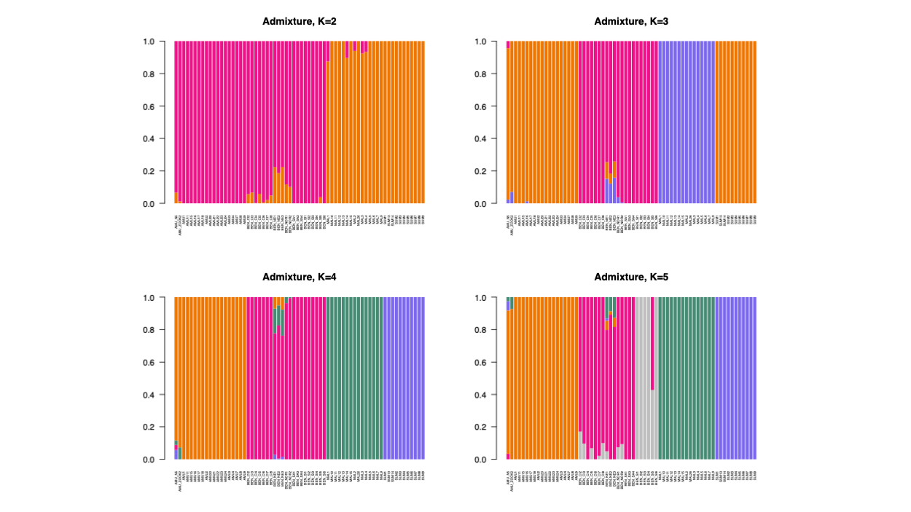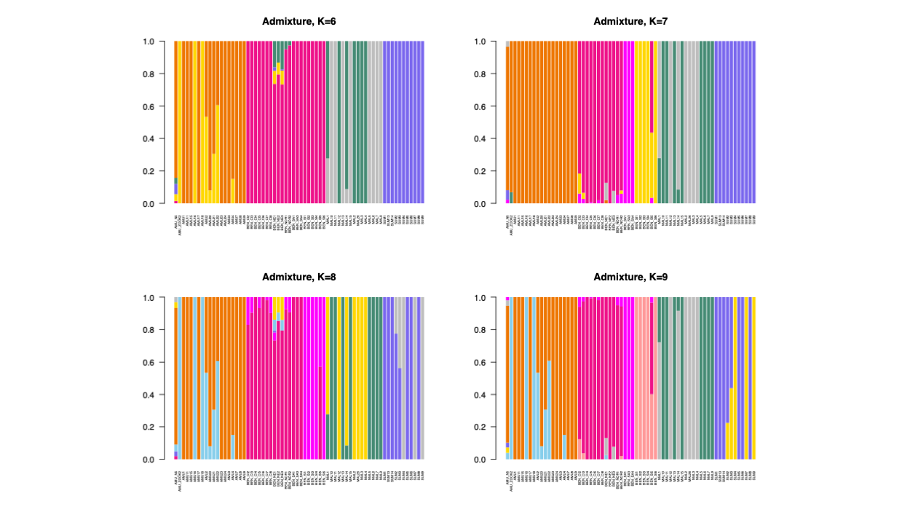

Supplementary Figure 2: ADMIXTURE plots for all tigers for K values 2-9.

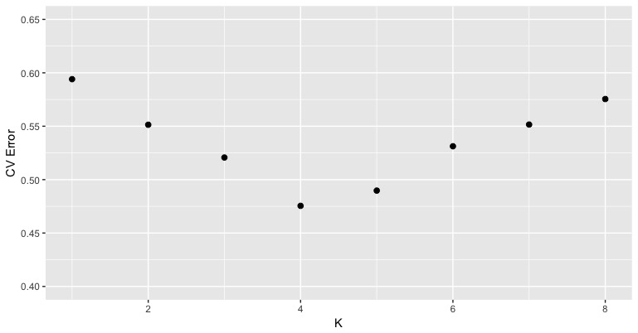

Supplementary Figure 3: Cross-validation error for runs of ADMIXTURE across different values of K.

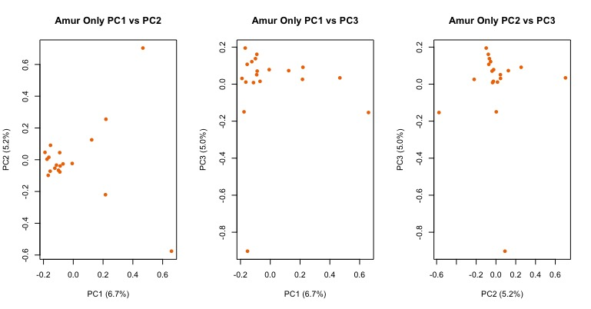a.

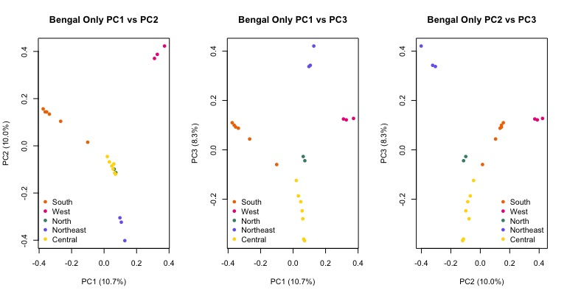b.

c.

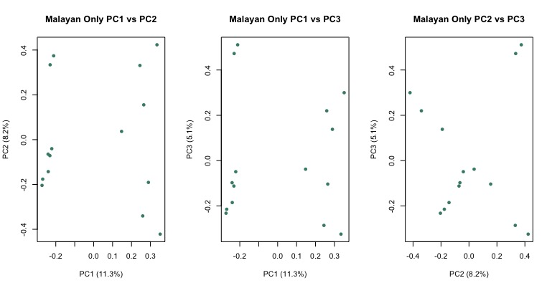

d.

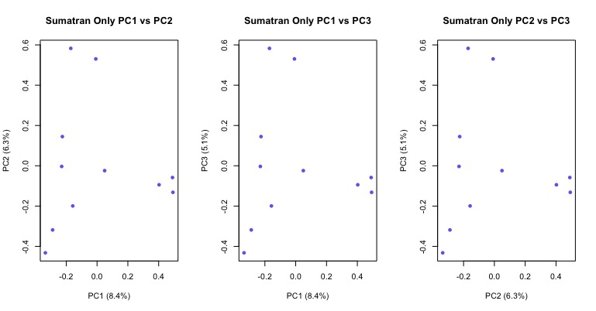

Supplementary Figure 4a (Amur), b (Bengal), c (Malayan) and d (Sumatran): PCA of individual sub-species as computed by VCFtools.

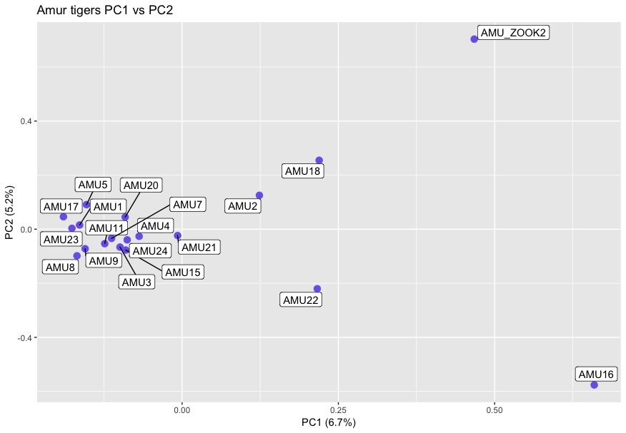

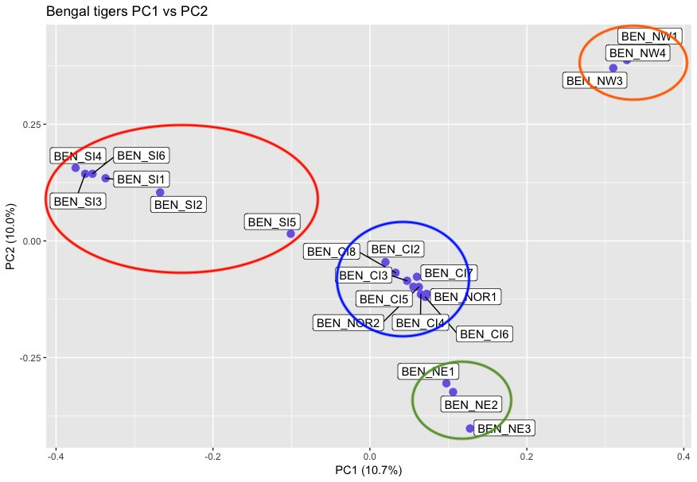b.

c.

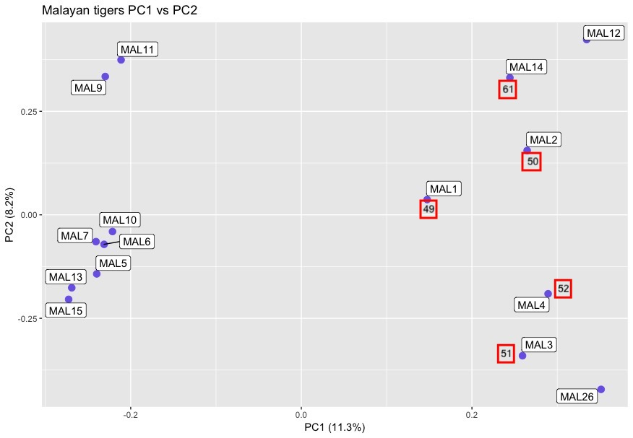

Supplementary Figure 5 a, b, c: Within subpopulation PCA for Amur, Bengal and Malayan populations as computed by VCFtools with individuals labeled.

a.

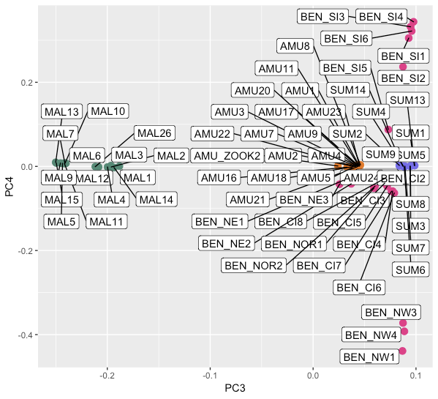

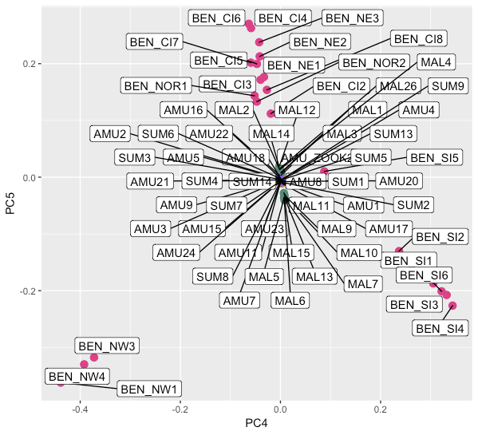

b.



Supplementary Figure 6: PCA separation of Bengal and Malayan tiger populations across (a) PC axis 3 vs 4 and (b) PC axis 4 vs 5.

Supplementary Figure 7a: Encounter rate for heterozygous SNVs as across the genome for various species. For most species, these are based on published estimates from single genomes. The error bar for the four tiger subspecies represented standard deviation across the mean.

Supplementary Figure 7 b: Heterozygous SNV encounter rate for all individuals

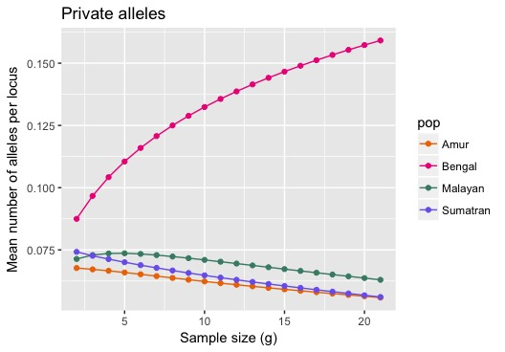 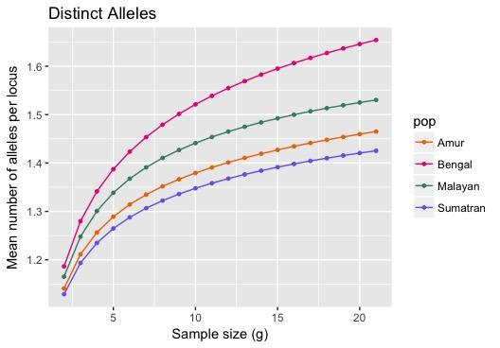

Supplementary Figure 8: ADZE plots of private alleles (alleles not found in other populations; left panel) and distinct (alleles unique to any given population, but allowing overlaps between populations).

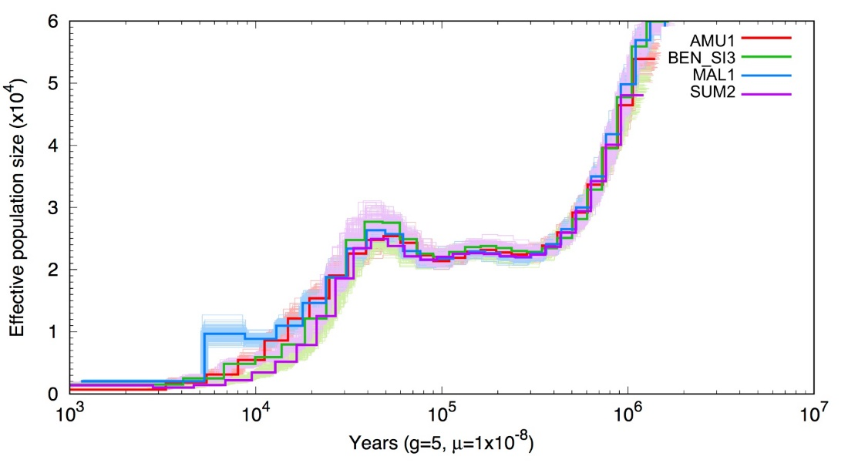

Supplementary Figure 9: PSMC plot for a single high coverage individual from each subspecies. Our plot is consistent with that observed by Liu et al (2018).



Supplementary Figure 10: Comparison of PCA first 2 PC axes computed on observed and simulated data. Observed data consisted on 259,499 SSWW sites in non-transcribed regions at least 50 kb away from any known gene, selected to minimize the importance of background selection and GC-biased gene conversion. The simulated scenario corresponds to that shown in Figure 6, with parameter values taken from Supplementary tables 7 and 8.

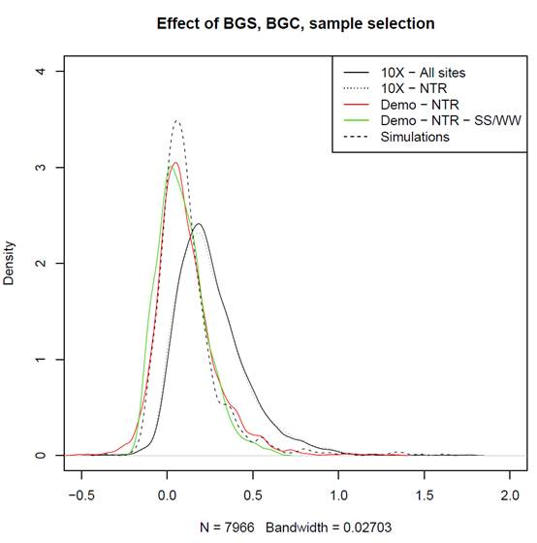

Supplementary Figure 11: Effect of background selection, biased gene conversion and sample selection on mPBS distributions in Siberian tigers. The black solid line represents mPBS values obtained when considering all sites and all individuals with average coverage above 10X (“10X – All sites”). The dashed thin black line corresponds to the same individuals but excluding transcribed regions and 50 kb flanking regions (“10X – NTR”). The red curve is computed using the same individuals that were used for demographic inference in non-transcribed regions (“Demo – NTR”). The green curve is obtained after filtering out sites potentially affected by biased gene conversion (“Demo – NTR – SS/WW”). Finally, the dashed black line corresponds to simulated values under the demographic model inferred from NTR-SS/WW sites (“Simulations”).

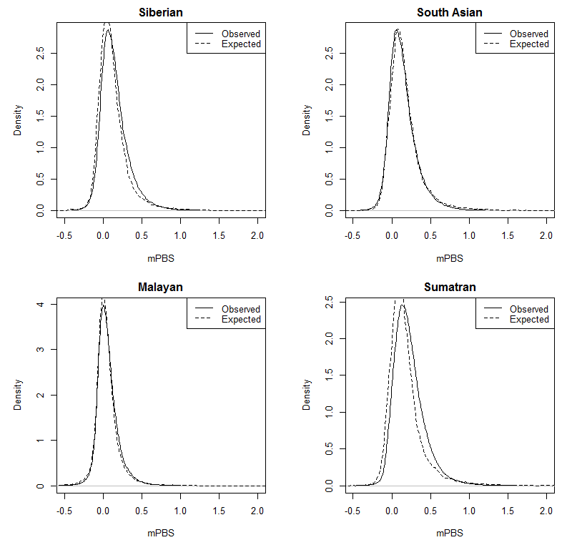

Supplementary Figure 12: Observed and expected mPBS distributions. For each population, we represented the observed against expected mPBS values obtained using simulations under a purely neutral model based on inferred demographic parameters. mPBS values have been computed using the same individuals as for demographic inference (Supplementary Table 7, Dataset 1).













Supplementary Figure 13: Runs of Homozygosity predicted by GARLIC (Szpiech et al 2017)

**Supplementary tables**

Supplementary Table 1: List of tiger samples used within the coverage, in addition to sequencing information and associated AZA studbook numbers if associated.

|  |  |  |  |  |  |  |  |
| --- | --- | --- | --- | --- | --- | --- | --- |
| Map number | Sample ID | % bases covered | average depth | Source | Sample courtesy | SSB number | ancestry/location |
| 1 | AMU_ZOOK2 | 99 | 26.8784 | Captive | Published |  |  |
| 2 | AMU1 | 100 | 27.6484 | Captive | Omaha Zoological Society | 4203 | F1 |
| 3 | AMU2 | 100 | 26.6904 | Captive | San Diego Zoo | 260 | F1 |
| 4 | AMU3 | 91 | 4.43384 | Captive | Omaha Zoological Society | 3957 | F1 |
| 5 | AMU4 | 100 | 22.0467 | Wild | WCS Russia Program |  | Nezhinka river, Primorskii |
| 6 | AMU5 | 99 | 17.6047 | Wild | WCS Russia Program |  | Vyazemsky, Khabarovskii |
| 7 | AMU7 | 99 | 8.41758 | Wild | WCS Russia Program |  | Solontsovyi village, Khabarovskii |
| 8 | AMU8 | 99 | 14.387 | Wild | WCS Russia Program |  | Blagodatnoye, Primorskii |
| 9 | AMU9 | 100 | 19.2591 | Wild | WCS Russia Program |  | Blagodatnoye, Primorskii |
| 10 | AMU11 | 99 | 18.1544 | Wild | WCS Russia Program |  | Kunaleyka, Primorskii |
| 12 | AMU15 | 97 | 5.7804 | Captive | San Francisco Zoo | 4500 | F2 |
| 13 | AMU16 | 94 | 4.55855 | Captive | San Diego Zoo | 2686 | F2 |
| 14 | AMU17 | 96 | 5.39823 | Captive | San Diego Zoo | 5049 | F2 |
| 15 | AMU18 | 97 | 5.48226 | Captive | San Diego Zoo | 2879 | F2 |
| 16 | AMU20 | 100 | 27.6484 | Captive | Omaha Zoological Society | 2429 | F1 |
| 17 | AMU21 | 98 | 8.18089 | Captive | Omaha Zoological Society | 4013 | F2 |
| 18 | AMU22 | 96 | 5.92546 | captive | Omaha Zoological Society | 4187 | F2 |
| 19 | AMU23 | 94 | 4.8623 | captive | San Diego Zoo | 4638 | F2 |
| 20 | AMU24 | 100 | 17.1433 | Wild | WCS Russia Program |  | Nezhinka river, Primorskii |
| 21 | BEN_CI2 | 99 | 8.7746 | Wild | CCMB, Anuradha Reddy |  | Chandrapur |
| 22 | BEN_CI3 | 99 | 23.6797 | Wild | Wildlife Institute of India |  | Kanha Tiger Reserve |
| 23 | BEN_CI4 | 99 | 14.378 | Wild | Wildlife Institute of India |  | Kanha Tiger Reserve |
| 24 | BEN_CI5 | 99 | 14.6175 | Wild | Wildlife Institute of India |  | Kanha Tiger Reserve |
| 25 | BEN_CI6 | 99 | 18.9152 | Wild | Wildlife Institute of India |  | Kanha Tiger Reserve |
| 26 | BEN_CI7 | 99 | 9.33063 | Wild | Wildlife Institute of India |  | Kanha Tiger Reserve |
| 27 | BEN_CI8 | 90 | 5.23045 | Wild | CCMB, Anuradha Reddy |  | Pench Tiger Reserve |
| 28 | BEN_NE1 | 100 | 21.5036 | Wild | Aranyak |  | Assam |
| 29 | BEN_NE2 | 100 | 22.5455 | wild | Aranyak |  | Assam |
| 30 | BEN_NE3 | 99 | 14.8182 | wild | Aranyak |  | Assam |
| 31 | BEN_NOR1 | 99 | 22.7056 | wild | Wildlife Institute of India |  | Corbett Tiger Reserve |
| 32 | BEN_NOR2 | 100 | 23.6836 | wild | Wildlife Institute of India |  | Corbett Tiger Reserve |
| 33 | BEN_NW1 | 83 | 5.56259 | wild | Wildlife Institute of India |  | Ranthambore Tiger Reserve |
| 34 | BEN_NW3 | 100 | 21.6486 | wild | NCBS |  | Ranthambore Tiger Reserve |
| 35 | BEN_NW4 | 99 | 24.0216 | wild | NCBS |  | Ranthambore Tiger Reserve |
| 36 | BEN_SI1 | 100 | 20.5914 | wild | NCBS |  | Bandipur Tiger Reserve |
| 37 | BEN_SI2 | 99 | 9.14737 | wild | NCBS |  | Waynad Wildlife Sanctuary |
| 38 | BEN_SI3 | 100 | 21.6486 | wild | Kerala Forest Department |  | Waynad Wildlife Sanctuary |
| 39 | BEN_SI4 | 99 | 24.0216 | wild | Kerala Forest Department |  | Waynad Wildlife Sanctuary |
| 40 | BEN_SI5 | 99 | 13.0038 | wild | Kerala Forest Department |  | Periyar Tiger Reserve |
| 41 | BEN_SI6 | 100 | 18.3987 | wild | Kerala Forest Department |  | Waynad Wildlife Sanctuary |
| 49 | MAL1 | 100 | 32.8678 | wild caught | Omaha Zoological Society | 149 | Wild caught, Terenggan, Paka |
| 50 | MAL2 | 100 | 31.7846 | wild caught | El Paso zoo | 194 | Wild caught, Kelantan |
| 51 | MAL3 | 100 | 29.5029 | wild caught | San Diego Zoo | 196 | Wild caught, Kelantan |
| 52 | MAL4 | 100 | 21.9693 | wild caught | San Diego Zoo | 220 | Wild caught, Jeli |
| 53 | MAL5 | 93 | 4.19328 |  | San Diego Zoo | 37 | F1 |
| 54 | MAL6 | 96 | 4.74293 |  | San Diego Zoo | 184 | F2 |
| 55 | MAL7 | 95 | 4.99761 |  | WCS, Bronx Zoo | 190 | F2, sibling of 184 |
| 56 | MAL9 | 96 | 5.39176 |  | Omaha Zoological Society | 173 | F1, sibling of 66 |
| 57 | MAL10 | 97 | 6.18214 |  | San Diego Zoo | 168 | F2, sibling of 184 |
| 58 | MAL11 | 95 | 5.01651 |  | San Diego Zoo | 212 | F2 |
| 59 | MAL12 | 94 | 4.92575 |  | Omaha Zoological Society | 214 | F2, sibling of 212 |
| 60 | MAL13 | 96 | 5.91426 |  | San Diego Zoo | 66 | F1, sibling of 37 |
| 61 | MAL14 | 99 | 16.2318 |  | Omaha Zoological Society | 137 | Wild caught, Pehang |
| 62 | MAL15 | 97 | 6.14838 |  | San Diego Zoo | 67 | F2, sibling of 212 |
| 63 | MAL26 | 95 | 5.30186 |  | San Diego Zoo | 244 | F1 |
| 64 | SUM1 | 100 | 30.5978 |  | Omaha Zoological Society | 527 | F1 |
| 65 | SUM2 | 100 | 31.2564 |  | Omaha Zoological Society | 564 | F2 |
| 66 | SUM3 | 96 | 5.24071 |  | San Francisco Zoo | 722 | F2 |
| 67 | SUM4 | 91 | 4.45531 |  | San Diego Zoo | 311 | F2 |
| 68 | SUM5 | 95 | 4.74431 |  | San Diego Zoo | 381 | F2 |
| 69 | SUM6 | 100 | 21.6518 |  | San Diego Zoo | 1282 | F2 |
| 70 | SUM7 | 95 | 4.92926 |  | San Diego Zoo | 316 | F2, sibling of 311 |
| 71 | SUM8 | 97 | 6.3304 |  | San Diego Zoo | 1110 | F2 |
| 72 | SUM9 | 97 | 6.38643 |  | San Diego Zoo | 312 | F2, sibling of 311 |
| 73 | SUM13 | 99 | 14.8678 |  | San Diego Zoo | 768 | F2 |
| 74 | SUM14 | 96 | 5.75034 |  | San Diego Zoo | 1281 | F2, sibling of 1282 |

Supplementary Table 2: Assemblathon-2 statistics of new genome compared with PanTig1.0 (Cho et al., 2013).

|  |  |  |
| --- | --- | --- |
|  | Belahat 10x (Maltig1.0) | PanTig1.0 |
| Contig N50 | 1.8 Mb | 39 kb |
| Contig L90 | 13,816 | 62,406 |
| Scaffold N50 | 21.3 Mb | 8.9 Mb |
| Scaffold L90 | 109 | 284 |
| % Scaffold Ns | 1.31% | 2.44% |
| Number of contigs | 36,444 | 126,370 |
| Number of scaffolds | 10,077 | 1,479 |

Supplementary Table 3: Details of analyses and samples used

|  |  |  |  |
| --- | --- | --- | --- |
| Analysis | SNP calling method | SNP Filters | Individuals used |
| **Population Clustering** |  |  |  |
| ADMIXTURE | freebayes | Q=30, GQ=30, DP=10, maf=0.025, max_miss=5% | ALL |
| PCA | freebayes | Q=30, GQ=30, DP=10, maf=0.025, max_miss=5% | ALL |
| NetStruct | freebayes | Q=30, GQ=30, DP=10, maf=0.025, max_miss=5% | ALL |
| FST | freebayes | Q=30, GQ=30, DP=10, maf=0.025, max_miss=5% | ALL |
| **Genetic Diversity** |  |  |  |
| SNV encounter rate | freebayes | Q=30, GQ=30, DP=10, maf=0.025, max_miss=5% | BEN_SI6, BEN_SI4, BEN_SI3, BEN_SI1, BEN_NW4, BEN_NW3, BEN_NOR1, BEN_NOR2, BEN_NE1, BEN_NE2, BEN_CI8, BEN_CI6, BEN_CI4, BEN_CI3, SUM13, SUM6, SUM2, SUM1, MAL14, MAL4, MAL3, MAL2, MAL1, AMU24, AMU11, AMU9, AMU5, AMU4, AMU2, AMU1 |
| ADZE | freebayes | Q=30, GQ=30, DP=10, maf=0.025, max_miss=5% | ALL |
| Nucleotide diversity | freebayes | Q=30, GQ=30, DP=10, maf=0.025, max_miss=5% | ALL |
| **Demographic history** |  |  |  |
| PSMC | bcftools | DP=10, maxDP=2*(average depth) | AMU1, MAL1, SUM2, BEN_SI3 |
| FastSimcoal (Global demographic history) | freebayes | Q=30, GQ=30, DP=10, regions within 50Kb of transcribing regions removed | SUM2, SUM1, SUM6, BEN_SI3, BEN_SI4, BEN_SI1, MAL1, MAL2, MAL3, MAL4, AMU2, AMU1, AMU4 |
| FastSimcoal (Bengal tiger demographic history) | freebayes | Q=30, GQ=30, DP=10, regions within 50Kb of transcribing regions removed | MAL1, MAL2, MAL3, BEN_CI3, BEN_CI6, BEN_NE2, BEN_NE1, BEN_NW4, BEN_NW3, BEN_SI3, BEN_SI4, BEN_SI1 |
| **Selection scans** |  |  |  |
| mPBS | freebayes | Q=30, GQ=30, DP=10 | BEN_SI6, BEN_SI5, BEN_SI4, BEN_SI3, BEN_SI1, BEN_NW4, BEN_NW3, BEN_NOR1, BEN_NOR2, BEN_NE1, BEN_NE2, BEN_NE3, BEN_CI6, BEN_CI5, BEN_CI4, BEN_CI3, SUM13, SUM6, SUM2, SUM1, MAL14, MAL4, MAL3, MAL2, MAL1, AMU24, AMU20,AMU11,AMU9, AMU8, AMU5, AMU4, AMU2, AMU1, AMU_ZOOK2 |
| **Inbreeding** |  |  |  |
| bcftools ROH | freebayes | Q=30, GQ=30, DP=10, maf=0.025, max_miss=5%, noSex | BEN_SI6, BEN_SI5, BEN_SI4, BEN_SI3, BEN_SI1, BEN_NW4, BEN_NW3, BEN_NOR1, BEN_NOR2, BEN_NE1, BEN_NE2, BEN_NE3, BEN_CI8, BEN_CI6, BEN_CI5, BEN_CI4, BEN_CI3, SUM13, SUM6, SUM2, SUM1, MAL14, MAL4, MAL3, MAL2, MAL1, AMU24, AMU20, AMU9, AMU5, AMU4, AMU2, AMU1, AMU_ZOOK2 |
| GARLIC | freebayes | Q=30, GQ=30, DP=10, maf=0.025, max_miss=5%, noSex | ALL |

Supplementary Table 4: Selected samples and number of retained sites for the two datasets used in demographic inference.

|  |  |  |  |  |  |  |  |
| --- | --- | --- | --- | --- | --- | --- | --- |
|  | # SUM  inds | # BEN  inds | # MAL  inds | # AMU  inds | Samples | # polymorphic sites without filtering | # polymorphic sites after filtering |
| Dataset 1 | 3 | 3 | 4 | 3 | SUM2, SUM1, SUM6,  BEN_SI3, BEN_SI4, BEN_SI1, MAL1, MAL2, MAL3, MAL4, AMU2, AMU1, AMU4 | 2,892,663 | 265,560 |
| Dataset 2 | 0 | 9 | 3 | 0 | MAL1, MAL2, MAL3, BEN_CI3, BEN_CI6, BEN_NE2, BEN_NE1, BEN_SA4, BEN_SA3, BEN_SI3, BEN_SI4, BEN_SI1 | 2,935,205 | 267,933 |

Supplementary Table 5: Weighted FST between putative Bengal sub-populations as computed by VCFtools.

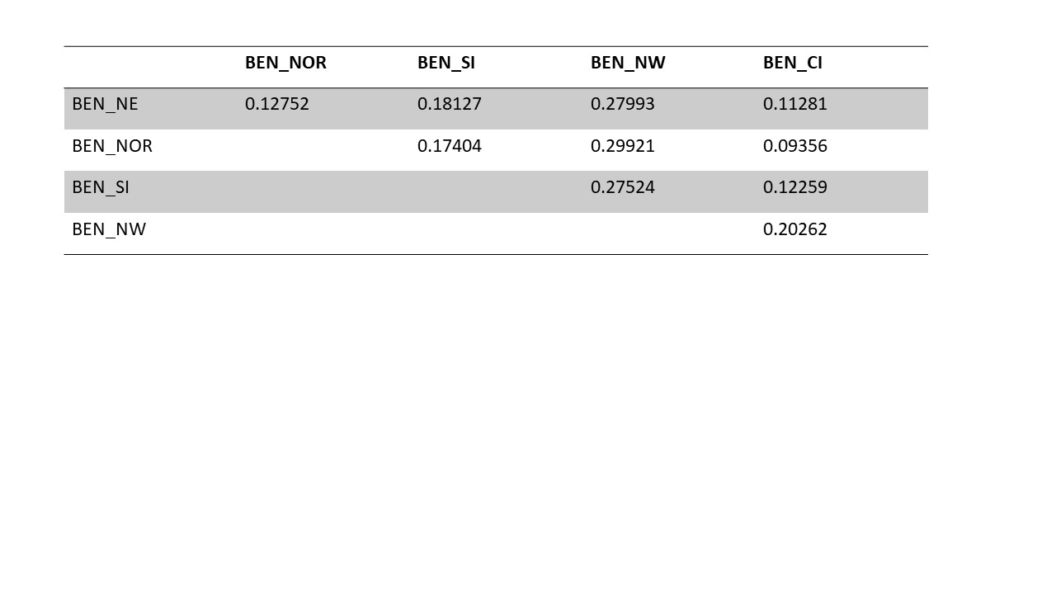

Supplementary Table 6: Nucleotide diversity (pi) for different sub-species as computed by VCFtools.

|  |  |
| --- | --- |
| Population | π |
| Bengal | 0.00047 |
| Amur | 0.00033 |
| Sumatran | 0.00029 |
| Malayan | 0.00037 |

Supplementary Table 7: Estimated demographic parameters and confidence intervals for the modeling of the four subspecies differentiation from an Asian metapopulation

|  |  |  |  |  |
| --- | --- | --- | --- | --- |
| **Parameter acronyms** | **Parameter descriptions** | **Maximum likelihood estimate** | **lower  limit CI95%** | **upper limit CI95%** |
| N_ANCEST | Ancestral Asian metapopulation size | 112,088 | 106,999 | 128,083 |
| N_ASIA | Asian metapopulation size | 8,281 | 6,443 | 15,953 |
| N_SUM | Sumatra population size | 5,380 | 3,765 | 11,892 |
| N_BEN | Bengal population size | 5,606 | 4,395 | 11,866 |
| N_MAL | Malayan population size | 12,801 | 7,338 | 13,392 |
| N_AMU | Amur population size | 9,735 | 3692 | 12872 |
| TD_SUM | Sumatran divergence time | 9,147 | 6,378 | 9,650 |
| TD_BEN | Bengal divergence time | 11,842 | 9,900 | 13,795 |
| TD_MAL | Malayan divergence time | 7,775 | 2,820 | 8,490 |
| TD_AMU | Amur divergence time | 7,562 | 3,248 | 8,118 |
| IB_SUM | Sumatran initial bottleneck (founder effect) | 0.1241 | 0.0427 | 0.2329 |
| IB_BEN | Bengal initial bottleneck (founder effect) | 0.0827 | 0.0024 | 0.0987 |
| IB_MAL | Malayan initial bottleneck (founder effect) | 0.0032 | 0.0015 | 0.0179 |
| IB_AMU | Amur initial bottleneck (founder effect) | 0.0153 | 0.0023 | 0.0514 |
| RB_SUM | Sumatran recent bottleneck | 0.2035 | 0.1044 | 0.2959 |
| RB_BEN | Bengal recent bottleneck | 0.3106 | 0.3006 | 0.3777 |
| RB_MAL | Malayan recent bottleneck | 0.1204 | 0.0844 | 0.1457 |
| RB_AMU | Amur recent bottleneck | 0.2372 | 0.1768 | 0.2726 |
| Nm_SUM | SUM immigration rate | 0.1137 | 0.0004 | 0.2862 |
| Nm_BEN | BEN immigration rate | 3.1138 | 2.5340 | 4.7430 |
| Nm_MAL | MAL immigration rate | 0.0118 | 0.0008 | 1.0269 |
| Nm_AMU | AMU immigration rate | 0.2040 | 0.0008 | 1.1302 |
| IB_ANC | Ancestral Asian bottleneck | 1.0684 | 1.0156 | 1.2742 |
| T_BOT | Time of ancestral bottleneck | 234,238 | 196,525 | 245,795 |

Population sizes (N) are in number of diploid individuals assuming a mutation rate of 0.35e-8 (Liu et al. 2018). Times (T) are in years assuming a generation time of 5 years. Immigration rates (Nm) values are expressed as twice the number of diploids entering the population per generation, coming from the Asian metapopulation. Bottlenecks intensities (IB and RB) are indicated as bottleneck duration in units of 2N generations, but they were modeled as instantaneous bottlenecks (see fastsimcoal manual http://cmpg.unibe.ch/software/fastsimcoal2/man/fastsimcoal26.pdf, p. 27).

Supplementary Table 8: Estimated demographic parameters and confidence intervals for the modeling of four Bengal population differentiation from an Indian metapopulation

|  |  |  |  |  |
| --- | --- | --- | --- | --- |
| **Parameter acronyms** | **Parameter descriptions** | **Maximum likelihood estimate** | **lower limit CI95%** | **upper limit CI95%** |
| N_ANCEST | Ancestral Asian metapopulation size | 122,089 | 120,570 | 123,548 |
| N_META_IND | Indian metapopulation size | 7,987 | 7,459 | 11,208 |
| N_BEN_CI | CI population size | 4,481 | 3,099 | 11,440 |
| N_BEN_NE | NE population size | 11,525 | 5,208 | 13,160 |
| N_BEN_NW | NW population size | 4,742 | 2,026 | 11,575 |
| TD_BEN_CI | CI divergence time | 2,040 | 999 | 2,986 |
| TD_BEN_NE | NE divergence time | 6,784 | 5,924 | 8,109 |
| TD_BEN_NW | NW divergence time | 1,186 | 935 | 2,541 |
| TD_BEN_SI | SI divergence time | 1,548 | 971 | 2,429 |
| TD_BEN | Indian metapopulation divergence time | 8,462 | 8,056 | 9,110 |
| IB_BEN_CI | CI initial bottleneck (founder effect) | 0.0056 | 0.0025 | 0.0381 |
| IB_BEN_NE | NE initial bottleneck | 0.0166 | 0.0018 | 0.0644 |
| IB_BEN_SA | NW initial bottleneck | 0.3110 | 0.1137 | 0.4939 |
| IB_BEN_SI | SI initial bottleneck | 0.0078 | 0.0014 | 0.0119 |
| IB_META_IND | Indian metapopulation initial bottleneck | 0.0527 | 0.0364 | 0.0674 |
| RB_BEN_CI | CI recent bottleneck | 0.0042 | 0.0021 | 0.0375 |
| RB_BEN_NE | NE recent bottleneck | 0.0598 | 0.0028 | 0.0836 |
| RB_BEN_NW | NW recent bottleneck | 0.2076 | 0.0189 | 0.4141 |
| NM__Asia2IND | Indian immigration rate (from Asia) | 0.2031 | 0.0004 | 0.3015 |
| NM__BEN_CI | CI immigration rate | 0.0049 | 0.0010 | 1.1668 |
| NM__BEN_NE | NE immigration rate | 0.0104 | 0.0004 | 0.6793 |
| NM__BEN_NW | NW immigration rate | 0.2746 | 0.0004 | 0.7654 |
| NM__BEN_SI | SI immigration rate | 0.0103 | 0.0005 | 1.4335 |

Population sizes (N) are in number of diploid individuals, assuming a mutation rate of 0.35e-8 (Liu et al. 2018). Times (T) are in years, assuming a generation time of 5 years. Immigration rates (Nm) values are expressed as twice the number of diploids entering the population per generation, coming from the Asian metapopulation. Bottlenecks intensities (IB and RB) are indicated as bottleneck duration in units of 2N generations, but they were modeled as instantaneous bottlenecks (see fastsimcoal manual http://cmpg.unibe.ch/software/fastsimcoal2/man/fastsimcoal26.pdf, p. 27). The values of the following parameters BEN_SI were fixed to previously estimated values: N_BEN_SI=5606, RB_BEN_SI=0.3106.

References

Altschul SF, Gish W, Miller W, Myers EW, Lipman DJ. Basic local alignment search tool. Journal of molecular biology. 1990 Oct 5;215(3):403-10.

[Cho YS, Hu L, Hou H, Lee H, Xu J, Kwon S, et al. The tiger genome and comparative analysis with lion and snow leopard genomes. Nat Commun. 2013;4:2433.](http://paperpile.com/b/WVhwZD/ryjd)

Liu Y-C, Sun X, Driscoll C, Miquelle DG, Xu X, Martelli P, et al. Genome-wide evolutionary analysis of natural history and adaptation in the world’s tigers. Curr Biol. 2018;28(23):3840–9.

Pouyet F, Aeschbacher S, Thiéry A, Excoffier L. Background selection and biased gene conversion affect more than 95% of the human genome and bias demographic inferences. Elife [Internet]. 2018 Aug 23;7. Available from: <http://dx.doi.org/10.7554/eLife.36317>

Szpiech ZA, Jakobsson M, Rosenberg NA. ADZE: a rarefaction approach for counting alleles private to combinations of populations. Bioinformatics. 2008 Sep 8;24(21):2498-504

**Supplemental files**

Fastsimcoal input files used to estimate the Asian tiger population demography

|  |
| --- |
| TIGERS8e.tpl |
| //Simple model of tiger differentiation, no bottleneck  5 samples to simulate  //Population effective sizes  N_SUM  N_BEN  N_MAL  N_AMU  N_GHOST  //Samples sizes  6  6  8  6  0  //Growth rates : negative growth implies population expansion  0  0  0  0  0  //Number of migration matrices : 0 implies no migration between demes  2  //Migration matrix 0  0 0 0 0 0  0 0 0 0 0  0 0 0 0 0  0 0 0 0 0  0 0 0 0 0  //Migration matrix 1  0 0 0 0 MIG_SUM  0 0 0 0 MIG_BEN  0 0 0 0 MIG_MAL  0 0 0 0 MIG_AMU  0 0 0 0 0  //historical event: time, source, sink, migrants, new deme size, new growth rate, migration matrix index  16  0 0 0 0 1 0 0  50 0 0 0 RB_SUM 0 0 instbot  50 1 1 0 RB_BEN 0 0 instbot  50 2 2 0 RB_MAL 0 0 instbot  50 3 3 0 RB_AMU 0 0 instbot  50 0 0 0 1 0 1  TD_MAL 2 2 0 IB_MAL 0 1 instbot  TD_MAL 2 4 1 1 0 1  TD_AMU 3 3 0 IB_AMU 0 1 instbot  TD_AMU 3 4 1 1 0 1  TD_BEN 1 1 0 IB_BEN 0 1 instbot  TD_BEN 1 4 1 1 0 1  TD_SUM 0 0 0 IB_SUM 0 1 instbot  TD_SUM 0 4 1 1 0 1  TDMAX 4 4 0 R_ANC 0 0 //Ancestral population size change after last divergence  TANCBOT 4 4 0 IB_ANC 0 0 instbot //Ancestral inst bot possible speciation...  //Number of independent loci [chromosome]  1 0  //Per chromosome: Number of contiguous linkage Block: a block is a set of contiguous loci  1  //per Block:data type, number of loci, per generation recombination and mutation rates and optional parameters  FREQ 1 0 1e-8 OUTEXP |

|  |
| --- |
| TIGERS9B3Mv1_r8e.est |
| // Priors and rules file  // *********************  [PARAMETERS]  //#isInt? #name #dist.#min #max  //all Ns are in number of haploid individuals  //Population sizes -----------------------------------------  1 N_ANCEST unif 10000 100000 output REFERENCE //Ancestral size (meta pop size as well)  1 N_GHOST unif 1000 100000 output  1 N_SUM unif 1000 10000 output bounded  1 N_BEN unif 1000 10000 output bounded  1 N_MAL unif 1000 10000 output bounded  1 N_AMU unif 1000 10000 output bounded  //Divergence times -----------------------------------------  1 TD_SUM unif 400 1000 output bounded  1 TD_BEN unif 100 1000 output bounded  1 TD_MAL unif 100 1000 output bounded  1 TD_AMU unif 100 1000 output bounded  //Bottleneck intensities -----------------------------------  0 IB_SUM logunif 0.001 1 output  0 IB_BEN logunif 0.001 1 output  0 IB_MAL logunif 0.001 1 output  0 IB_AMU logunif 0.001 1 output  0 RB_SUM unif 0.01 1 output  0 RB_BEN unif 0.01 1 output  0 RB_MAL unif 0.01 1 output  0 RB_AMU unif 0.01 1 output  0 IB_ANC logunif 0.001 2 output  //Gene flow rates ------------------------------------------  0 Nm_SUM logunif 1e-4 5 output bounded  0 Nm_BEN logunif 1e-4 5 output bounded  0 Nm_MAL logunif 1e-4 5 output bounded  0 Nm_AMU logunif 1e-4 5 output bounded  //Ancestral population size change ------------------------  1 TPLUSANCBOT unif 1e3 1e5 hide  [RULES]  [COMPLEX PARAMETERS]  //Ancestral population size change ------------------------  1 MAX1 = TD_SUM%max%TD_BEN hide  1 MAX2 = MAX1%max%TD_MAL hide  1 TDMAX = MAX2%max%TD_AMU hide  1 TANCBOT = TDMAX+TPLUSANCBOT output  //Ancestral resize  0 R_ANC = N_ANCEST/N_GHOST hide  0 R_PREV = N_PREV/N_ANCEST hide  //Migration rates ------------------------------------------  0 MIG_SUM = Nm_SUM/N_SUM hide  0 MIG_BEN = Nm_BEN/N_BEN hide  0 MIG_MAL = Nm_MAL/N_MAL hide  0 MIG_AMU = Nm_AMU/N_AMU hide |

*Fastsimcoal input files used to estimate the Bengal tiger population demography conditional on estimated demography of Asian tigers*

Note that fixed parameter values taken from the previous estimation are rescaled parameters that take into account the mutation rate assumed in these estimations (1e-8 per site per generation, instead of 0.35 e-8 per site per generation used to compute estimated values reported in Supplementary Tables 7 and 8).

|  |
| --- |
| TIGERS8e.tpl |
| //Simple model of tiger differentiation, no bottleneck  9 samples to simulate  //Population effective sizes  3766  N_META_IND  8960  6814  N_GHOST_ASIA  N_BEN_CI  N_BEN_NE  N_BEN_SA  N_BEN_SI  //Samples sizes  0  0  6  0  0  4  4  4  6  //Growth rates : negative growth implies population expansion  0  0  0  0  0  0  0  0  0  //Number of migration matrices : 0 implies no migration between demes  2  //Migration matrix 0  0 0 0 0 0 0 0 0 0  0 0 0 0 0 0 0 0 0  0 0 0 0 0 0 0 0 0  0 0 0 0 0 0 0 0 0  0 0 0 0 0 0 0 0 0  0 0 0 0 0 0 0 0 0  0 0 0 0 0 0 0 0 0  0 0 0 0 0 0 0 0 0  0 0 0 0 0 0 0 0 0  //Migration matrix 1  0 0 0 0 3.018842e-05 0 0 0 0  0 0 0 0 m_Asia2IND 0 0 0 0  0 0 0 0 1.321606e-06 0 0 0 0  0 0 0 0 2.993084e-05 0 0 0 0  0 0 0 0 0 0 0 0 0  0 m_BEN_CI 0 0 0 0 0 0 0  0 m_BEN_NE 0 0 0 0 0 0 0  0 m_BEN_SA 0 0 0 0 0 0 0  0 m_BEN_SI 0 0 0 0 0 0 0  //historical event: time, source, sink, migrants, new deme size, new growth rate, migration matrix index  26  T_RB 0 0 0 0.2034946 0 0 instbot //Recent bottleneck in SUM  T_RB 2 2 0 0.1204263 0 0 instbot //Recent bottleneck in MAL  T_RB 3 3 0 0.237151 0 0 instbot //Recent bottleneck in AMU  T_RB 5 5 0 RB_BEN_CI 0 0 instbot //Recent bottlenecks in INDIA  T_RB 6 6 0 RB_BEN_NE 0 0 instbot  T_RB 7 7 0 RB_BEN_SA 0 0 instbot  T_RB 8 8 0 0.3105766 0 0 instbot  T_RB 0 0 0 1 0 1  TD_BEN_CI 5 5 0 IB_BEN_CI 0 1 instbot //Old bottlenecks at divergence time in INDIA  TD_BEN_CI 5 1 1 1 0 1  TD_BEN_NE 6 6 0 IB_BEN_NE 0 1 instbot  TD_BEN_NE 6 1 1 1 0 1  TD_BEN_SA 7 7 0 IB_BEN_SA 0 1 instbot  TD_BEN_SA 7 1 1 1 0 1  TD_BEN_SI 8 8 0 IB_BEN_SI 0 1 instbot  TD_BEN_SI 8 1 1 1 0 1  TD_META_IND 1 1 0 IB_META_IND 0 1 instbot  TD_META_IND 1 4 1 1 0 1  640 0 0 0 0.124119 0 1 instbot //Old bottleneck in SUM  640 0 4 1 1 0 1  544 2 2 0 0.003208539 0 1 instbot //Old bottlenecks in MAL  544 2 4 1 1 0 1  529 3 3 0 0.01528991 0 1 instbot //Old bottleneck in AMU  529 3 4 1 1 0 1  TDMAX 4 4 0 RES_ANC 0 0 //Ancestral population size change after last divergence  16397 4 4 0 1.068355 0 0 instbot //Instantaneous bottleneck in ancestral population  //Number of independent loci [chromosome]  1 0  //Per chromosome: Number of contiguous linkage Block: a block is a set of contiguous loci  1  //per Block:data type, number of loci, per generation recombination and mutation rates and optional parameters  FREQ 1 0 1.0e-8 OUTEXP |

|  |
| --- |
| TIGERS9B3Mv1_r8e.est |
| // Priors and rules file  // *********************  [PARAMETERS]  //#isInt? #name #dist.#min #max  //all Ns are in number of haploid individuals  //Population sizes -----------------------------------------  1 N_ANCEST unif 1000 50000 output REFERENCE //Ancestral size (meta pop size as well)  1 N_META_IND unif 5000 100000 output  1 N_BEN_CI unif 1000 10000 output bounded  1 N_BEN_NE unif 1000 10000 output bounded  1 N_BEN_SA unif 1000 10000 output bounded  1 N_BEN_SI unif 3924 3924 output bounded //Fixed to previously estimated value  1 N_GHOST_ASIA unif 5797 5797 hide //Fixed to previously estimated value  1 T_RB unif 57 57 hide //Fixed to rescaled time  //Divergence times -----------------------------------------  1 TD_META_IND unif 100 900 output bounded  0 TD_REL_BEN_CI unif 0 1 hide bounded  0 TD_REL_BEN_NE unif 0 1 hide bounded  0 TD_REL_BEN_SA unif 0 1 hide bounded  0 TD_REL_BEN_SI unif 0 1 hide bounded  //Bottleneck intensities -----------------------------------  0 RB_BEN_CI logunif 0.001 1 output  0 RB_BEN_NE logunif 0.001 1 output  0 RB_BEN_SA logunif 0.001 1 output  //0 RB_BEN_SI logunif 0.001 1 output  0 IB_BEN_CI logunif 0.001 1 output  0 IB_BEN_NE logunif 0.001 1 output  0 IB_BEN_SA logunif 0.001 1 output  0 IB_BEN_SI logunif 0.001 1 output  0 IB_META_IND logunif 0.001 1 output  //Gene flow rates ------------------------------------------  0 NM__Asia2IND logunif 1e-4 5 output  0 NM__BEN_CI logunif 1e-4 5 output  0 NM__BEN_NE logunif 1e-4 5 output  0 NM__BEN_SA logunif 1e-4 5 output  0 NM__BEN_SI logunif 1e-4 5 output  [RULES]  [COMPLEX PARAMETERS]  //Divergence times ----------------------------------------  1 TDS_META_IND = TD_META_IND-T_RB hide  1 TD_PLUS_BEN_CI = TD_REL_BEN_CI * TDS_META_IND hide  1 TD_PLUS_BEN_NE = TD_REL_BEN_NE * TDS_META_IND hide  1 TD_PLUS_BEN_SA = TD_REL_BEN_SA * TDS_META_IND hide  1 TD_PLUS_BEN_SI = TD_REL_BEN_SI * TDS_META_IND hide  1 TD_BEN_CI = TD_PLUS_BEN_CI + T_RB output  1 TD_BEN_NE = TD_PLUS_BEN_NE + T_RB output  1 TD_BEN_SA = TD_PLUS_BEN_SA + T_RB output  1 TD_BEN_SI = TD_PLUS_BEN_SI + T_RB output  1 TDMAX = TD_META_IND %max% 829 output  //Migration rates ------------------------------------------  0 m_Asia2IND = NM__Asia2IND/N_META_IND hide  0 m_BEN_CI = NM__BEN_CI/N_BEN_CI hide  0 m_BEN_NE = NM__BEN_NE/N_BEN_NE hide  0 m_BEN_SA = NM__BEN_SA/N_BEN_SA hide  0 m_BEN_SI = NM__BEN_SI/N_BEN_SI hide  //Ancestral resize  0 RES_ANC = N_ANCEST/N_GHOST_ASIA hide |