SUPPORTING INFORMATION

APPENDIX 1: Table S1. Population’s origins of fresh plant tissue samples used for the SSRs analyses of Afzelia savannah species (N = sample size per population)

APPENDIX 2: Table S2. Herbarium material used for the SSRs analyses of Afzelia savannah species

APPENDIX 3: Table S3. Mean Log-likelihood for each number of genetic clusters (K) obtained from the use of STRUCTURE software on the SSR data of Afzelia.

APPENDIX 4: Table S4. Estimated proportion of null alleles per SSR locus in Afzelia species according to INEst software.

APPENDIX 5: Figure S1. Distribution map of A. africana (triangles) and A. quanzensis (stars) samples analysed and their location in African savannah biogeographic zones delineated by Linder et al. (2012)

APPENDIX 6: Figure S2. Genetic structure of African diploid Afzelia species using SSRs (N = 241 A. Africana; N = 113 A. quanzensis), using the tess3r software. The ancestry proportions inferred in each of K ancestral populations (different colours) are shown for each individual, represented by a vertical bar.

APPENDIX 7a: Figure S3a. The number of K (1-10) ancestry components best explaining the genetic structure of A. africana assessed using the cross-entropy criterion obtained from the sNMF program on SNP data. The best-fitting model (i.e., the model with the lowest minimal cross-entropy) had three ancestry components (K = 3) identified for the 30 individuals used with 2800 polymorphic SNPs.

APPENDIX 7b: Figure S3b. The number of K (1-10) ancestry components best explaining the genetic structure of A. quanzensis assessed using the cross-entropy criterion obtained from the sNMF program on SNP data. The best-fitting model (i.e., the model with the lowest minimal cross-entropy) is not clearly identified for the 12 individuals used with 3841 polymorphic SNPs.

APPENDIX 1: Table S1.
Species | Country | Population | Latitude | Longitude | N
A. africana | Benin | Bassila | 1.556 | 9.263 | 32
 |  | Lama | 2.135 | 6.977 | 34
 |  | ParcW | 2.992 | 11.503 | 24
 |  | Pendjari | 1.525 | 10.932 | 25
 |  | Pénéssoulou | 1.556 | 9.267 | 40
 | Burkina-Faso | Comoé | 4.593 | 9.915 | 2
 |  | Pama | 0.782 | 11.251 | 3
 | Cameroon | Ngambetica | 11.296 | 4.789 | 7
 |  | Sibati | 13.666 | 5.267 | 7
 |  | Yoko | 12.314 | 5.431 | 2
 | Senegal | Casamance | -16.002 | 12.799 | 4
 | Togo | Notsé | 1.289 | 6.958 | 12
A. quanzensis | Kenya | witu | -2.384 | 40.521 | 49
 |  | Gede | -3.301 | 39.996 | 31
 |  | kwalé | -4.183 | 39.440 | 3
 | DRC | Lubembe | -10.917 | 22.535 | 10
 | Zimbabwe | Victoria falls | -17.933 | 25.833 | 1

APPENDIX 2: Table S2.
Species | Geographic origin | Herbarium | Collectors | Voucher
A. quanzensis | Mozambique | WAG | na | WAG1704773
 | Mozambique | WAG | na | WAG1704771
 | Mozambique | WAG | na | WAG1704769
 | Mozambique | WAG | na | WAG1704765
 | Mozambique | WAG | na | WAG1704764
 | Mozambique | WAG | na | WAG1704757
 | Tanzanie | WAG | na | WAG1704751
 | Tanzanie | WAG | na | WAG1704749
 | Tanzanie | WAG | na | WAG1704744
 | Afrique du sud | WAG | na | WAG1704737
 | RDC | WAG | Duvigneaud & Timperman | 2496
 | Angola | WAG | R. Dechamps & F. Kurta | 1302
 | Mozambique | WAG | de Koning Jan | 8109
 | Mozambique | WAG | Groenendi E.M.C. | 266
 | Mozambique | WAG | Van de Koning | 9575
 | Tanzanie | WAG | J.C. Lovett | 4915
 | Tanzanie | WAG | Mwangoka, M.A. | 350
A. africana | RCA | BRLU | Tisserant | 3046
 | RCA | BRLU | Tisserant | 2407
 | Cameroun | BRLU | de Wilde W.J.J.O. | 2793
 | Ouganda | BRLU | R.G. Sangstes | S. 223
 | Guinea-Bissau | BRLU | Verjans J.-M. | na
 | Guinea-Bissau | BRLU | Malaisse F. | na
 | Guinnea-Bissau | BRLU | Kasper & Descheres | na
 | Cameroun | BR | C. Geerling & J. Nene | 4708
 | Cameroon | BR | Geerling, C. | 4708
 | Cameroon | BR | Wit, P. | 2944
 | Cameroon | BR | Zon, A.P.M. van der | 2579
 | Cameroon | BR | Wilde, W.J.J.O. de | 2793
 | Ghana | BR | Jongkind, C.C.H. | 2510
 | Ghana | BR | Schmidt, H.H. | 1782
 | Ghana | BR | Morton, J.K. | 1918
 | Ghana | BR | Cudjoe, F.S. | 623
 | Ghana | BR | Jongkind, C.C.H. | 1963
 | Ghana | BR | Schmidt, H.H. | 3370
 | Ivory Coast | BR | Geerling, C. | 2044
 | Ivory Coast | BR | Versteegh, C. | 521
 | Ivory Coast | BR | Wilde, W.J.J.O. de | 783
 | Togo | BR | Thijssen, M.T. | 222
 | Ivory Coast | BR | Wilde, J.J.F.E. de | 3474
 | Ivory Coast | BR | Versteegh, C. | 325
 | Ivory Coast | BR | Oldeman, R.A.A. | 332
 | Ivory Coast | BR | Jongkind, C.C.H. | 4410
 | Nigeria | BR | Chapman, J.D. | 2752
 | Nigeria | BR | Geerling, C. | 3122
 | Nigeria | BR | Leeuw, P.N. de | 70
 | Burkina Faso | BR | Küppers, K. | 1036
 | Sierra Leone | BR | Pollard, B.J. | 1405
 | Siera Leone | BR | Cole, E.A. | 121
 | Guinea-Bissau | BR | Espirito Santo, J.V.G. do | 1508
 | Guinea-Bissau | BR | Espirito Santo, J.V.G. do | 3469
 | Senegal | BR | Adam, J.-.G. | 8685
 | Ghana | BR | Jongkind, C.C.H. | 2440

APPENDIX 3: Table S3.
 |  | A. africana |  | A. quanzensis
K | Reps | Mean LnP(K) | Stdev LnP(K) | Mean LnP(K) | Stdev LnP(K)
1 | 10 | -4002.9 | 0.7 | -1607.3 | 1.8
2 | 10 | -4221.9 | 56.2 | -1740.9 | 54.5
3 | 10 | -5885.3 | 904.0 | -1975.4 | 304.8
4 | 10 | -4215.0 | 203.6 | -1892.1 | 419.5
5 | 10 | -7510.4 | 8117.3 | -2139.3 | 235.3
6 | 10 | -4558.1 | 192.1 | -2932.4 | 1572.9

APPENDIX 4: Table S4.
 | A. quanzensis |  | A. africana
Locus | p_{ij} | SE | p_{ij} | SE
R9-48_Q4 | 0.61 | 0.04 | 0.25 | 0.03
R9-01_Q1 | 0.03 | 0.03 | 0.01 | 0.02
R9-07_Q4 | 0.14 | 0.05 | 0.03 | 0.03
R9-19_Q2 | 0.28 | 0.04 | 0.24 | 0.03
R9-65_Q1 | 0.00 | 0.005 | 0.11 | 0.03
R9-61_Q2 | 0.02 | 0.04 | 0.00 | 0.00

APPENDIX 5: Figure S1.
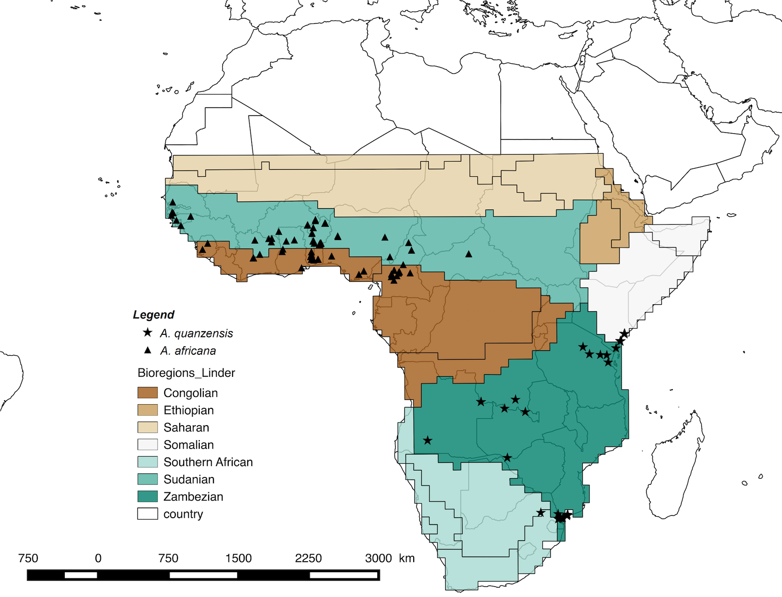

APPENDIX 6: Figure S2.
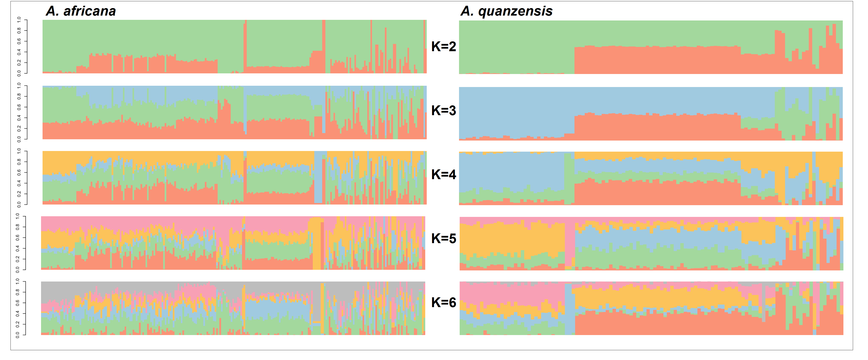

APPENDIX 7a: Figure S3a.
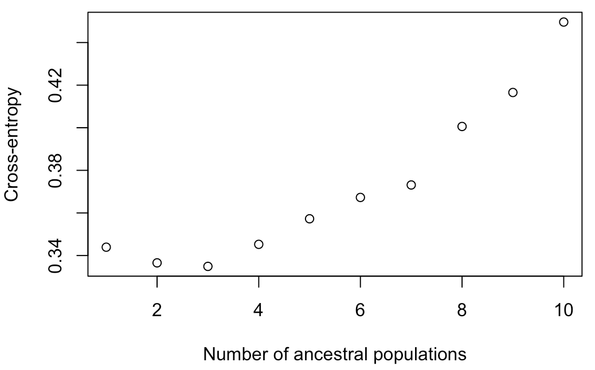

APPENDIX 7b: Figure S3b.
