Supplemental Figure 1
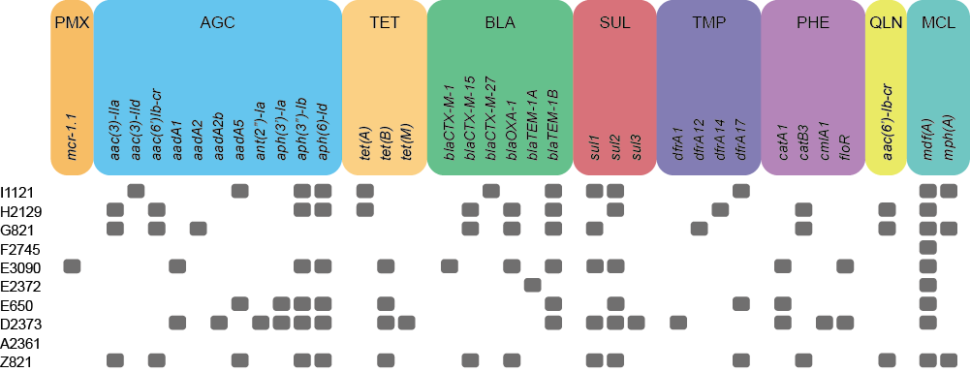
Supplemental Figure 1: Colistin-resistant nosocomial Escherichia strains carry diverse acquired antibiotic resistance genes.
Antibiotic resistance genes in the genome sequences were detected by ResFinder 3.2 ⁴⁰. Classes of antibiotic resistance genes are abbreviated as follow: PMX, polymyxin resistance; AGC, aminoglycoside resistance; TET, tetracycline resistance; BLA, beta-lactam resistance; SUL, sulfonamide resistance; TMP, trimethoprim resistance; PHE, phenicol resistance; QLN, quinolone resistance; MCL, Macrolide.

