Supplementary data 3: KEGG pathway diagrams

Ten significantly-changed KEGG pathways were identified by GSEA. The KEGG diagrams of DNA replication, cell cycle, ECM receptor interaction and oxidative phosphorylation are shown in the main paper. The diagrams of the other 6 significantly changed KEGG pathways are listed below. Intensity of colour in diagrams represents gene log₂FC ranging from -0.8 to 0.8 with downregulation in green and upregulation in red.

Focal adhesion
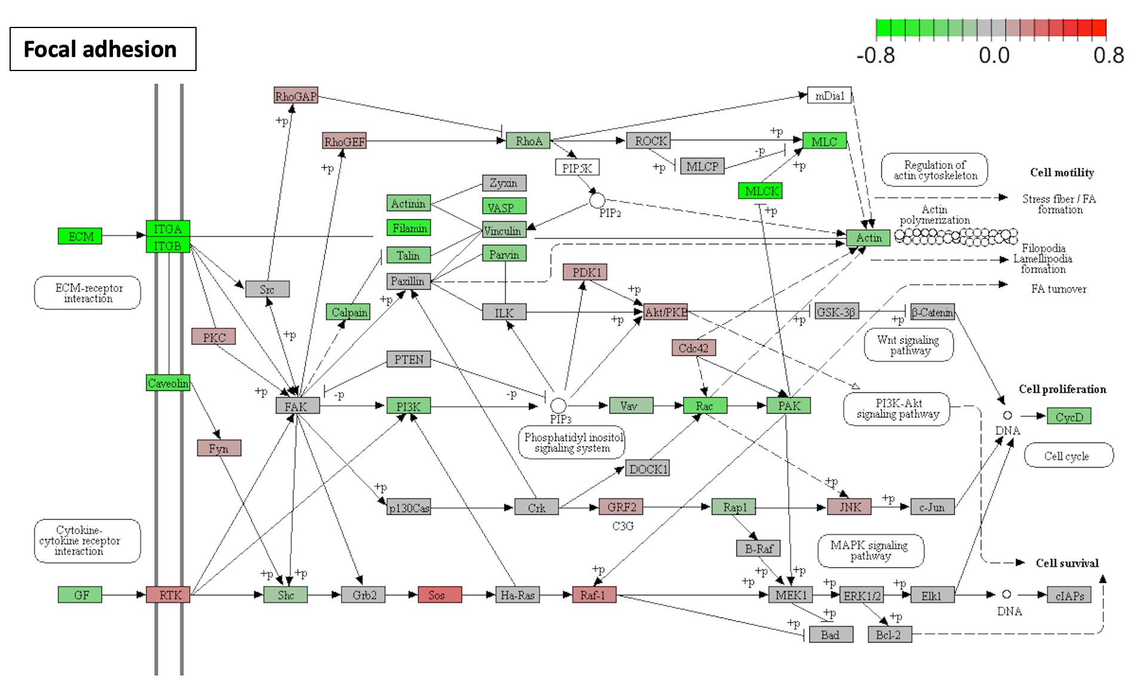
Fatty acid metabolism
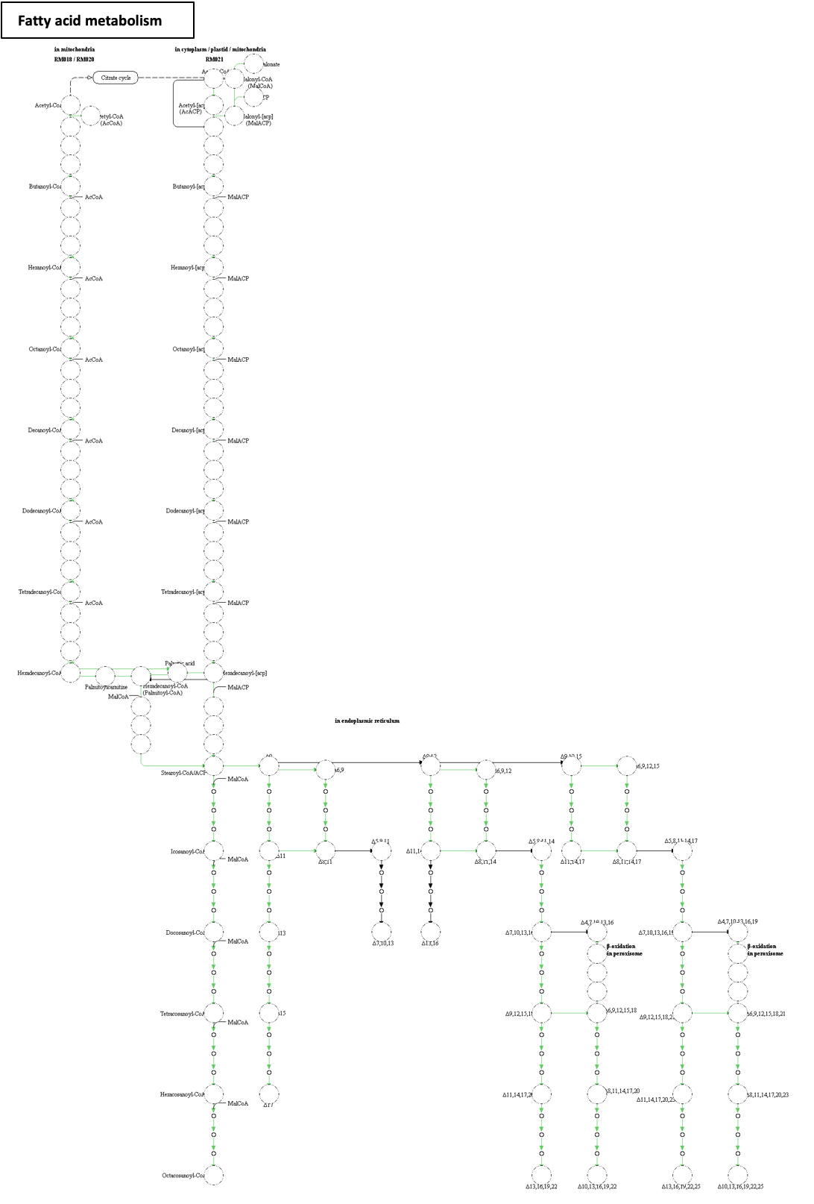
Beta-Alanine metabolism
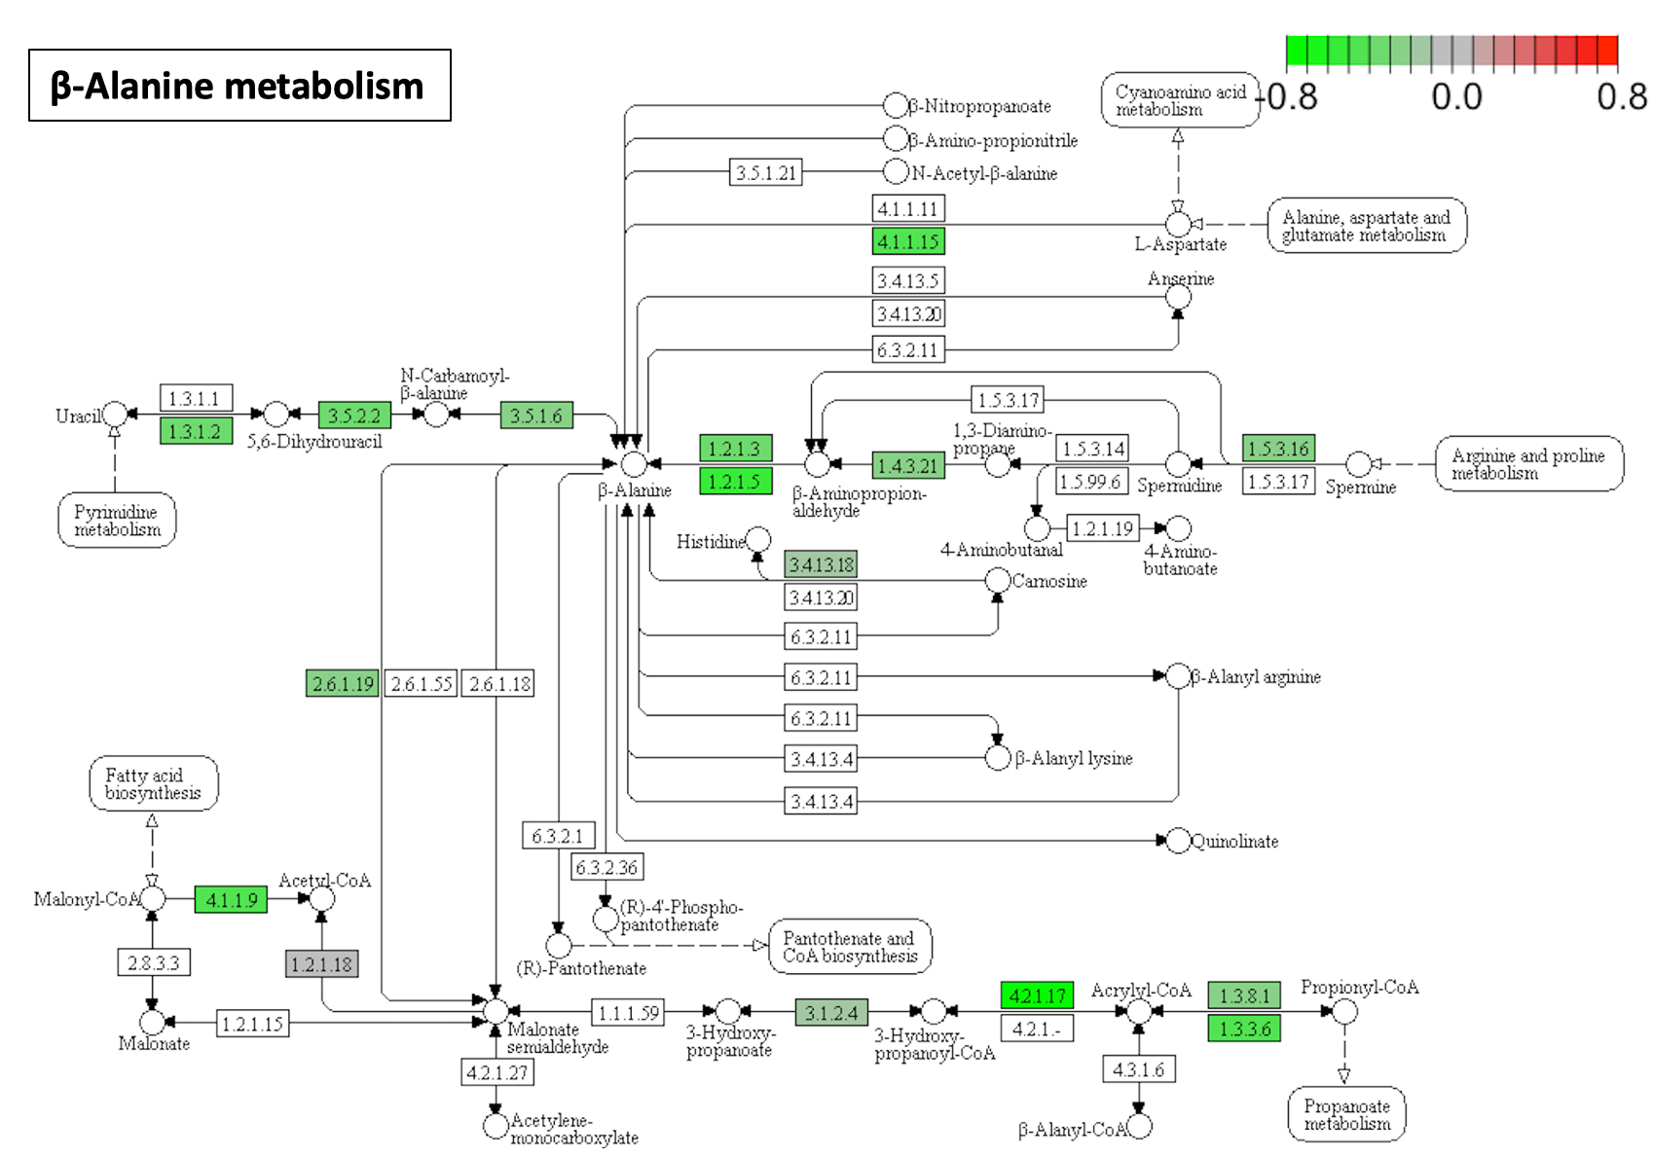
Glutathione metabolism
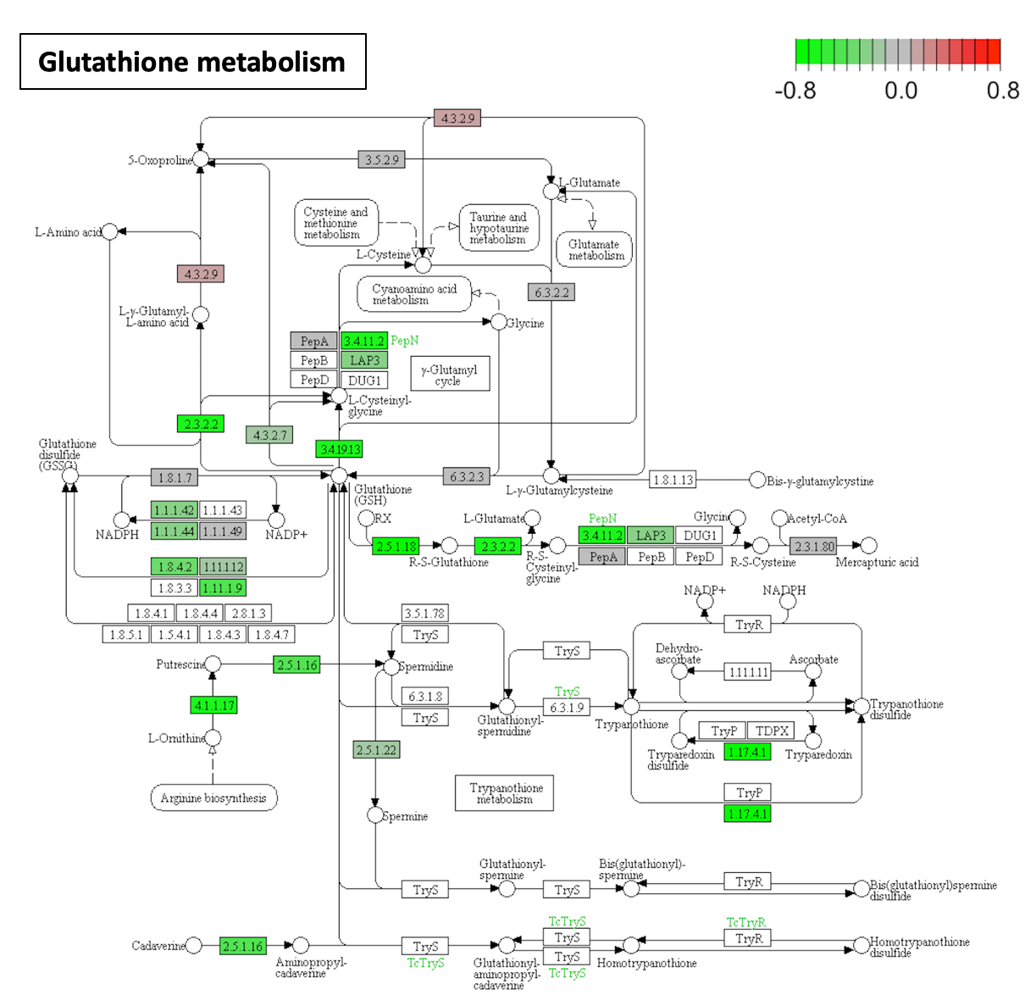
Pyrimidine metabolism
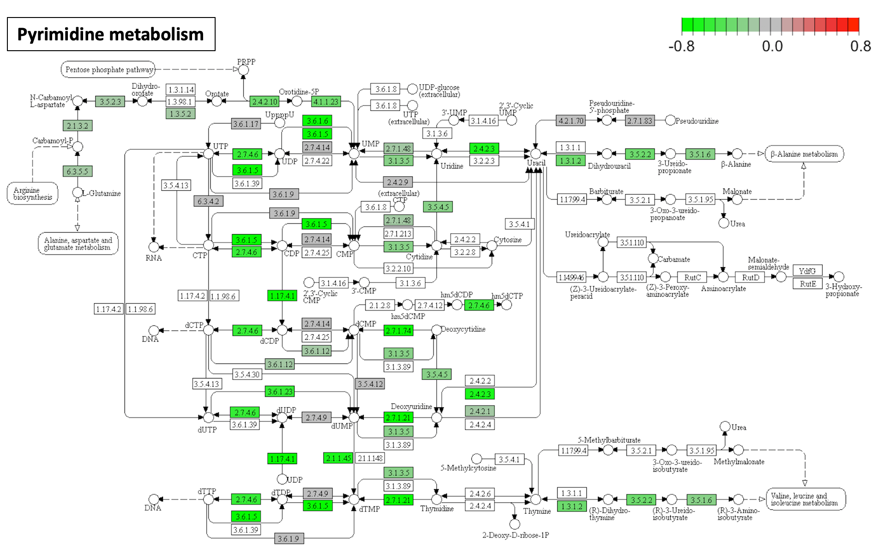

Butanoate metabolism
