Wilde, L.R., J.E. Simmons, R.J. Swift, and N.R. Senner. The anatomy of a phenological mismatch: interacting consumer demand and resources characteristics determine the consequences of mismatching.

Supplemental Materials: Appendix A

Table S1. Model selection table of logistic models predicting godwit chick mass from weekly captures (n = 103) of godwit chicks near Beluga River, AK from 2009 ̶ 2019. Following Senner et al. (2017) asymptotic mass was set to the adult average (~ 249 g). Initial values were set prior to modelling: T_{i} = 10.7, K = 0.12. Chick identity (ID) was included as a random intercept for variables (✓), and all models had at least one random intercept term. Parameter estimates were averaged from 100 iterations.
Model no. | Variable | Value | Random  intercept | ΔAIC_{c} | logLik | Model  weight (w_{i}) | No. parameters
2 | T_{i} | ~ 1 ` | ✓ | 0.0 | -528.0 | 0.98 | 6
 | K | ~ 1 ` | ✓
4 | T_{i} | ~ year | ✓ | 6.9 | -528.5 | 0.02 | 9
 | K | ~ 1 `
10 | T_{i} | ~ year | ✓ | 11.7 | -525.9 | >0.01 | 14
 | K | ~ year
1 | T_{i} | ~ 1 ` | ✓ | 17.5 | -538.3 | >0.01 | 4
 | K | ~ 1 `
8 | T_{i} | ~ 1 ` | ✓ | 21.2 | -535.6 | >0.01 | 9
 | K | ~ year
5 | T_{i} | ~ year |  | 35.5 | -542.8 | >0.01 | 9
 | K | ~ 1 ` | ✓
11 | T_{i} | ~ year |  | 40.0 | -540.1 | >0.01 | 14
 | K | ~ year | ✓
7 | T_{i} | ~ 1 ` |  | 78.8 | -564.5 | >0.01 | 9
 | K | ~ year | ✓
3 | T_{i} | ~ 1 ` |  | 80.7 | -570.4 | >0.01 | 4
 | K | ~ 1 ` | ✓
9 | T_{i} | ~ 1 ` | ✓ | 136.4 | -593.1 | >0.01 | 9
 | K | ~ year | ✓
12 | T_{i} | ~ year | ✓ | 183.5 | -602.4 | >0.01 | 14
 | K | ~ year | ✓
6 | T_{i} | ~ year | ✓ | 188.4 | -605.2 | >0.01 | 9
 | K | ~ 1 ` | ✓

Table S2. Model selection of random effects (top) and timescale (bottom) in a generalized additive model (GAM) to predict body condition index (BCI) of godwit chicks near Beluga River, AK from 2009 ̶ 2019. Timescale is the period over which parameters in the global model were averaged for model smoothing.

Random intercepts
 | ΔAIC_{c} | Deviance | Model weight (w_{i}) | No. parameters
~ 1 | 0 | 11.6 | 0.42 | 4
~ 1|chick | 4.2 | 14.5 | 0.22 | 59
~ 1|brood + 1|chick | 5.0 | 16.1 | 0.17 | 51
~ 1|year | 5.2 | 17.5 | 0.10 | 9
~ 1|year + |brood | 7.8 | 19.0 | 0.04 | 52
~ 1|brood | 8.1 | 19.3 | 0.03 | 47
~ 1|year + 1|chick/brood | 11.9 | 23.5 | >.01 | 64
Timescale
 | ΔAIC_{c} | Deviance | Model weight (w_{i}) | log-  Likelihood
7-day avg. | 0 | 12.7 | 0.69 | -39.6
3-day avg. | 2.3 | 13.0 | 0.22 | -40.8
day of | 4.7 | 134 | 0.06 | -42.0
1-day avg. | 6.4 | 13.6 | 0.03 | -42.8

Table S3. Comparison by AIC_{c} value among candidate models with predictor variables of godwit chick growth (n = 89) from 2009 – 2019, excluding chicks from 2014 (which lacked recaptures). Growth was estimated from body condition index (BCI) scores obtained from weekly captures. Continuous predictors were averaged over a 7-day period prior to BCI estimation. Inclusion in a model is indicated by a beta coefficient for predictors and plus signs (+) for smoothing terms.
Intercept | Invertebrate  biomass | Invertebrate  body size | Hatch date |  | s(Chick age) | df | Log-likelihood | AIC_{c} | ΔAIC_{c} | model weight
0.445 | 0.006 |  | -0.254 |  | + | 10 | -22.915 | 70.651 | 0 | 0.75
0.396 | 0.006 | 0.019 | -0.264 |  | + | 12 | -22.506 | 73.095 | 2.444 | 0.22
0.498 | 0.006 |  |  |  | + | 8 | -30.107 | 79.422 | 8.771 | 0.01
0.507 | 0.006 |  | -0.22 |  |  | 3 | -35.684 | 79.838 | 9.188 | 0.01
0.578 | 0.006 | -0.034 |  |  | + | 9 | -29.768 | 81.256 | 10.605 | 0.004
0.428 | 0.005 | 0.032 | -0.233 |  |  | 5 | -35.494 | 81.701 | 11.051 | 0.003
0.517 | 0.005 |  |  |  |  | 3 | -39.643 | 85.564 | 14.914 | 0
0.541 | 0.005 | -0.01 |  |  |  | 4 | -39.626 | 87.722 | 17.071 | 0
0.929 |  |  | -0.198 |  | + | 7 | -38.597 | 94.041 | 23.39 | 0
0.714 |  | 0.075 | -0.237 |  | + | 8 | -37.562 | 94.675 | 24.025 | 0
0.929 |  |  |  |  | + | 6 | -41.381 | 97.02 | 26.369 | 0
0.929 |  |  | -0.206 |  |  | 3 | -45.415 | 97.109 | 26.458 | 0
0.696 |  | 0.082 | -0.241 |  |  | 3 | -44.356 | 97.183 | 26.533 | 0
0.854 |  | 0.027 |  |  | + | 7 | -41.299 | 99.125 | 28.474 | 0
0.929 |  |  |  |  |  | 2 | -48.25 | 100.639 | 29.988 | 0
0.817 |  | 0.039 |  |  |  | 2 | -48.003 | 102.284 | 31.633 | 0

Table S4. Group levels (i.e., random effects) from a Bayesian hierarchical model predicting the daily survival rate of Hudsonian godwit chicks from 2009 ̶ 2019 near Beluga River, AK. Individual histories were grouped by study year, brood, and plot.
Group level | Posterior Mean (SD) | 95% Credible Interval | Effective Sample Size | Ȓ
2009 | 0.05 (13.64) | -28.12, 30.87 | 14279 | 1.0
2010 | 0.01 (13.67) | -28.99, 29.99 | 15274 | 1.0
2011 | 0.1 (13.49) | -30.53, 27.12 | 15000 | 1.0
2014 | -0.15 (13.37) | -28.87, 27.64 | 15000 | 1.0
2015 | 0.05 (13.6) | -28.91, 28.86 | 15167 | 1.0
2016 | 0.08 (7.13) | -23.6, 2.56 | 14041 | 1.1
2019 | 0.11 (6.1) | -12.08, 11.35 | 14901 | 1.2
2009GN001 | 0.14 (8.86) | -17.3, 18.24 | 15000 | 1.0
2009GN002 | 0.06 (8.76) | -17.72, 17.84 | 16088 | 1.0
2009GN003 | -0.08 (8.67) | -17.92, 16.96 | 14798 | 1.0
2009GN007 | 0.11 (8.69) | -17.57, 17.56 | 16964 | 1.0
2009GN010 | -0.02 (8.73) | -17.27, 17.91 | 15639 | 1.0
2009GN012 | 0.11 (8.56) | -16.36, 18.09 | 14182 | 1.0
2009GN014 | 0.02 (8.76) | -18.02, 17.25 | 14961 | 1.0
2009GN018.2 | 0 (8.73) | -17.93, 17 | 14634 | 1.0
2009GN022 | -0.01 (8.65) | -18.94, 16.39 | 15000 | 1.0
2009GN027 | -0.01 (8.67) | -17.87, 16.76 | 14758 | 1.0
2009GN0282 | 0.08 (8.63) | -17.23, 17.5 | 15000 | 1.0
2009GN044 | -0.1 (8.71) | -17.64, 17.27 | 14861 | 1.0
2009GN045 | -0.1 (8.78) | -18.39, 16.86 | 16001 | 1.0
2009GN046 | -0.2 (8.7) | -18.62, 16.41 | 14546 | 1.0
2009GN047 | 0 (8.59) | -16.63, 17.95 | 15000 | 1.0
2009GN049 | 0.03 (8.62) | -17.17, 17.34 | 15000 | 1.0
2010GN11 | -0.02 (8.7) | -17.03, 17.74 | 14803 | 1.0
2010GN47 | 0.02 (8.81) | -18.13, 17.77 | 14507 | 1.0
2010GN58 | -0.06 (8.77) | -18.62, 17.25 | 14934 | 1.0
2010GN61 | -0.04 (8.75) | -18.04, 17.51 | 14517 | 1.0
2010GN62 | 0.02 (8.7) | -17.51, 17.35 | 14532 | 1.0
2010GN63 | -0.06 (8.7) | -17.69, 17.42 | 15466 | 1.0
2010GNGPM | -0.1 (8.59) | -18.01, 16.85 | 15080 | 1.0
2010GNHUYU | -0.01 (8.67) | -18.03, 17.33 | 15000 | 1.0
2010GNPE | -0.01 (8.74) | -17.29, 18.19 | 14097 | 1.0
2010GNUL | 0.01 (8.78) | -18.5, 16.97 | 15142 | 1.0
2010GNXEXY | 0.1 (8.63) | -16.61, 17.69 | 15418 | 1.0
2010GNYN2 | 0.07 (8.64) | -17.32, 17.49 | 16213 | 1.0
2010GNYTXL | -0.01 (8.51) | -18.03, 16.35 | 14345 | 1.0
2011GN13 | -0.01 (8.67) | -17.26, 17.53 | 15000 | 1.0
2011GNAPAU | -0.07 (8.74) | -18.48, 16.33 | 15215 | 1.0
2011GNC4T6 | -0.09 (8.7) | -17.62, 17.25 | 15352 | 1.0
2011GNC8J2 | 0 (8.71) | -17.68, 17.39 | 15627 | 1.0
2011GNCT | -0.03 (8.65) | -17.23, 17.63 | 14886 | 1.0
2011GNE5E9 | -0.01 (8.66) | -18.19, 16.62 | 16547 | 1.0
2011GNEAE7 | 0.02 (8.71) | -17.49, 17.98 | 15237 | 1.0
2011GNEE | -0.1 (8.68) | -17.61, 17.29 | 15149 | 1.0
2011GNH7T2 | -0.02 (8.79) | -18.41, 17.55 | 15870 | 1.0
2011GNH8LO | -0.02 (8.69) | -17.94, 17.17 | 15000 | 1.0
2011GNJ5K7 | -0.06 (8.63) | -17.96, 16.89 | 15812 | 1.0
2011GNJ6J0 | -0.01 (8.76) | -17.6, 17.41 | 15054 | 1.0
2011GNJTMU | -0.15 (8.72) | -17.57, 17.3 | 14835 | 1.0
2011GNK0PM | -0.02 (8.69) | -18.08, 16.74 | 15140 | 1.0
2011GNK4T7 | 0.04 (8.68) | -17.54, 17.8 | 14034 | 1.0
2011GNM2P2 | 0.06 (8.59) | -17.17, 17.36 | 15133 | 1.0
2011GNM3U0 | -0.05 (8.56) | -17.72, 16.9 | 14778 | 1.0
2011GNN8X3 | 0.05 (8.85) | -17.29, 18.38 | 14942 | 1.0
2011GNTANA | -0.1 (8.67) | -17.42, 17.53 | 15048 | 1.0
2011GNV9C0 | 0.1 (8.66) | -17.55, 17.17 | 15378 | 1.0
2011GNX50H | -0.04 (8.69) | -17.13, 17.56 | 17680 | 1.0
2011GNX6H3 | 0 (8.75) | -17.21, 18.3 | 15552 | 1.0
2011GNY9L6 | 0.05 (8.69) | -17.11, 17.55 | 14683 | 1.0
2014BHD17 | -0.09 (8.65) | -16.81, 18.31 | 15443 | 1.0
2014BHD19 | 0.06 (8.56) | -17.82, 16.69 | 15000 | 1.0
2014BJL17 | 0.03 (8.74) | -17.33, 17.81 | 14793 | 1.0
2014BJL18 | 0.08 (8.62) | -16.91, 17.5 | 15561 | 1.0
2014BJL19 | 0.01 (8.74) | -16.72, 18.86 | 14404 | 1.0
2014BJL25 | 0.12 (8.63) | -18.14, 16.59 | 15273 | 1.0
2014GJM06 | -0.11 (8.65) | -16.67, 18.44 | 15000 | 1.0
2015GJM05 | 0.08 (8.6) | -16.51, 18.2 | 15402 | 1.0
2015GJM18 | -0.03 (8.65) | -17.03, 18.23 | 15705 | 1.0
2015GJM35 | 0.09 (8.66) | -17.71, 17.12 | 15000 | 1.0
2015GJM36 | -0.02 (8.59) | -17.06, 17.39 | 14401 | 1.011
2015JAK05 | 0.04 (8.66) | -17.56, 17.46 | 14887 | 1.0
2015JAK21 | 0.01 (8.71) | -16.73, 18.05 | 16195 | 1.0
2015JMH10 | 0.01 (8.76) | -18.48, 16.96 | 15801 | 1.0
2015JMH20 | 0.1 (8.82) | -17.38, 18.13 | 15056 | 1.0
2015JMH28 | 0.01 (8.81) | -18.11, 17.84 | 16209 | 1.0
2015KJP18 | -0.01 (8.68) | -18.69, 16.75 | 14590 | 1.0
2015KJP44 | 0.08 (8.63) | -16.9, 17.92 | 15242 | 1.0
2015RJS05 | -0.03 (8.57) | -18.11, 16.63 | 14870 | 1.0
2015RJS05 | 0.01 (8.62) | -16.81, 17.7 | 15000 | 1.0
2015U1MUV | -0.08 (8.74) | -18.08, 17.02 | 15000 | 1.0
2016KRS48 | -9.52 (7.63) | -23.78, 7.31 | 12247 | 1.02
2016LKF04 | 0.56 (8.09) | -15.47, 16.61 | 13272 | 1.0
2016LKF22 | 0.01 (7.83) | -14.38, 15.86 | 15014 | 1.01
2016MLS14 | 0.93 (7.97) | -15.23, 16.6 | 13951 | 1.0
2016MLS37 | 1.58 (6.71) | -11.8, 15.43 | 12726 | 1.01
2016RIG15 | -0.33 (6.32) | -12.24, 13.79 | 12952 | 1.01
2016RJS04 | 0.4 (7.66) | -13.98, 16 | 12602 | 1.0
2016RJS07 | 0.16 (7.88) | -14.45, 16.73 | 12428 | 1.01
2016RJS10 | -3.46 (5.03) | -14.37, 6.13 | 12259 | 1.08
2016RJS16 | 3 (7.09) | -11.12, 17.81 | 12935 | 1.02
2019GB01 | -7.09 (3.08) | -13.5, -1.65 | 14744 | 1.01
2019GB02 | -2.31 (4.56) | -11.09, 7.26 | 14948 | 1.05
2019GB03 | -7.96 (4.41) | -15.49, 1.97 | 13044 | 1.07
2019GN01 | 1.6 (4.38) | -6.11, 11.44 | 15159 | 1.08
2019GN02 | 10.11 (5.97) | -0.66, 22.54 | 15057 | 1.02
2019GN03 | -8.88 (4.4) | -16.79, 0.63 | 13173 | 1.07
2019GN05 | 2.89 (6.6) | -7.96, 16.62 | 14273 | 1.04
2019GN06 | 8.15 (5.67) | -2.12, 19.74 | 14424 | 1.01
2019GN08 | 0.65 (2.99) | -5.79, 5.92 | 13055 | 1.01
2019GN09 | 6.69 (6.41) | -6.64, 19.79 | 12900 | 1.01
2019GN10 | -3.69 (6.79) | -15.05, 11.02 | 12128 | 1.01
2019GN11 | -5.76 (3.11) | -12.24, 0.12 | 13962 | 1.02
2019GN12 | 8.23 (5.62) | -1.68, 19.93 | 14157 | 1.01
South Plot | 0.26 (4.43) | -8.25, 9.21 | 14071 | 1.16
North Plot | 3.28 (4.78) | -3.97, 14.22 | 12493 | 1.02

Table S5. Seasonal daily survival rates (DSR) of Hudsonian godwit chicks (n = 122) in Beluga River, AK among study years. DSR estimates from a Bayesian hierarchical model were extrapolated to 28 days as an estimate of percent fledged, and associated delta error is reported.
Year | No.  chicks | DSR  (mean) | SD | 95% credible  interval | Estimated % fledged  (± delta error)
2009 | 16 | 0.931 | 0.088 | 0.871, 0.964 | 22.11 (±19.13)
2010 | 16 | 0.913 | 0.178 | 0.810, 0.963 | 14.75 (±36.69)
2011 | 24 | 0.964 | 0.072 | 0.929, 0.982 | 45.84 (±51.22)
2014 | 07 | 0.849 | 0.174 | 0.672, 0.939 | 3.18 (±1.88)
2015 | 17 | 0.868 | 0.139 | 0.781, 0.924 | 5.16 (±3.00)
2016 | 20 | 0.936 | 0.097 | 0.890, 0.963 | 24.71 (±28.95)
2019 | 22 | 0.944 | 0.070 | 0.906, 0.967 | 29.79 (±21.54)

Table S6. Model selection table comparing univariate linear models of population mismatch models predicting seasonal fledging rates in a population of Hudsonian godwits near Beluga River, AK from 2009 – 2019.
Model | logLikelihood | AIC_{c} | ΔAIC_{c} | Model  weight (w_{i}) | R²
Whole Demand | -25.14 | 64.27 | 0 | 0.43 | 0.55
Difference in  peak dates | -25.31 | 64.63 | 0.35 | 0.36 | 0.48
Peak Demand | -28.54 | 67.08 | 2.81 | 0.11 | 0.26
Curve height | -26.62 | 67.23 | 2.96 | 0.10 | 0.25

Figure S1. Map of North and South plots near the township of Beluga River, AK (house icon). The study areas is in southcentral Alaska on the west coast of the upper Cook Inlet. (Inset) The two, 100-m transects for daily invertebrate capture using pitfall traps (2009 ̶ 2011) or modified malaise traps (2014 ̶ 2016, 2019). Transects were placed according to ASDN protocols (https://www.manomet.org/wp-content/uploads/old-files/ASDN_Protocol_V5_20Apr2014.pdf).
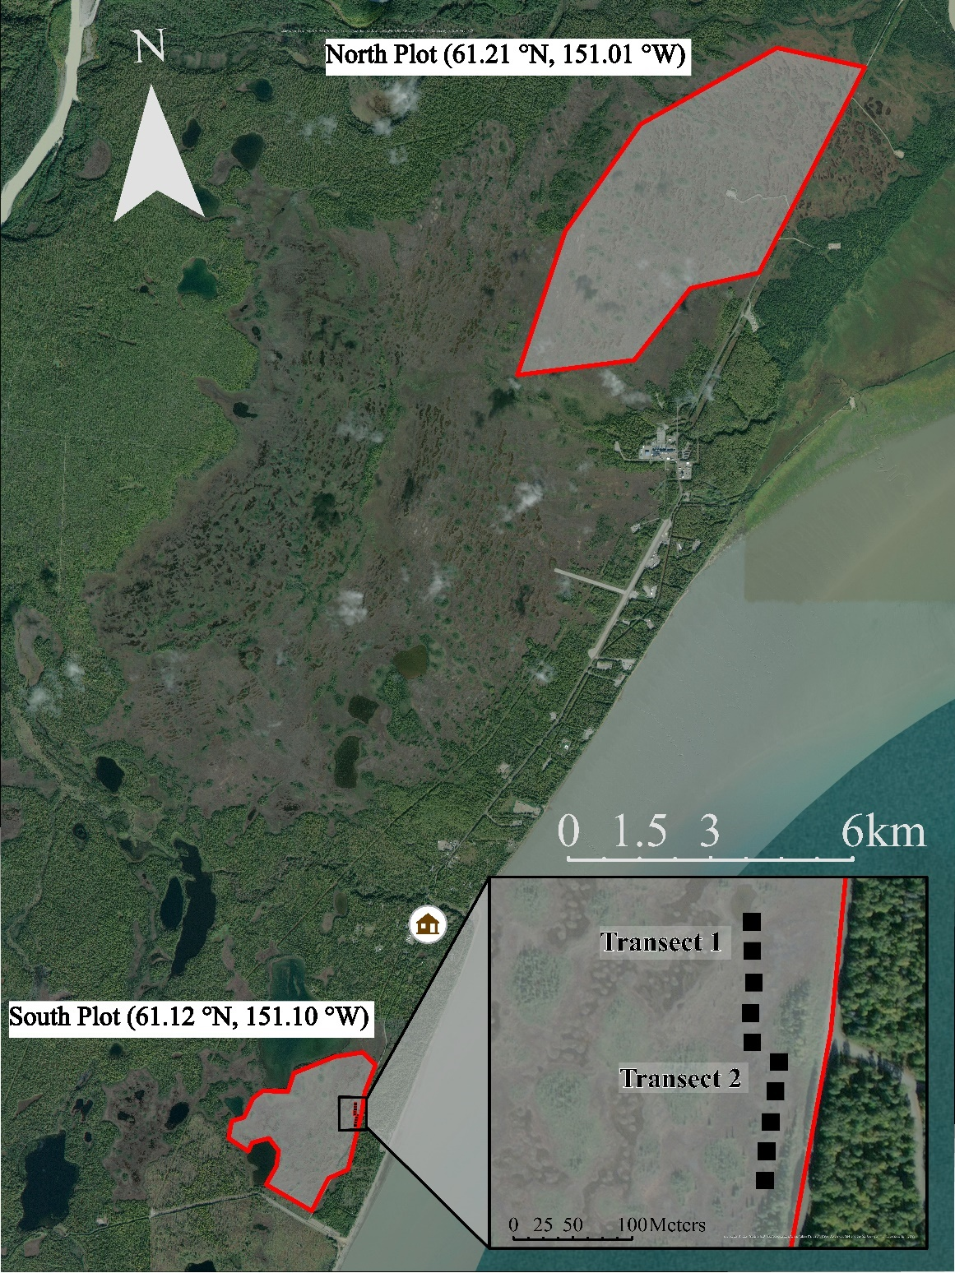

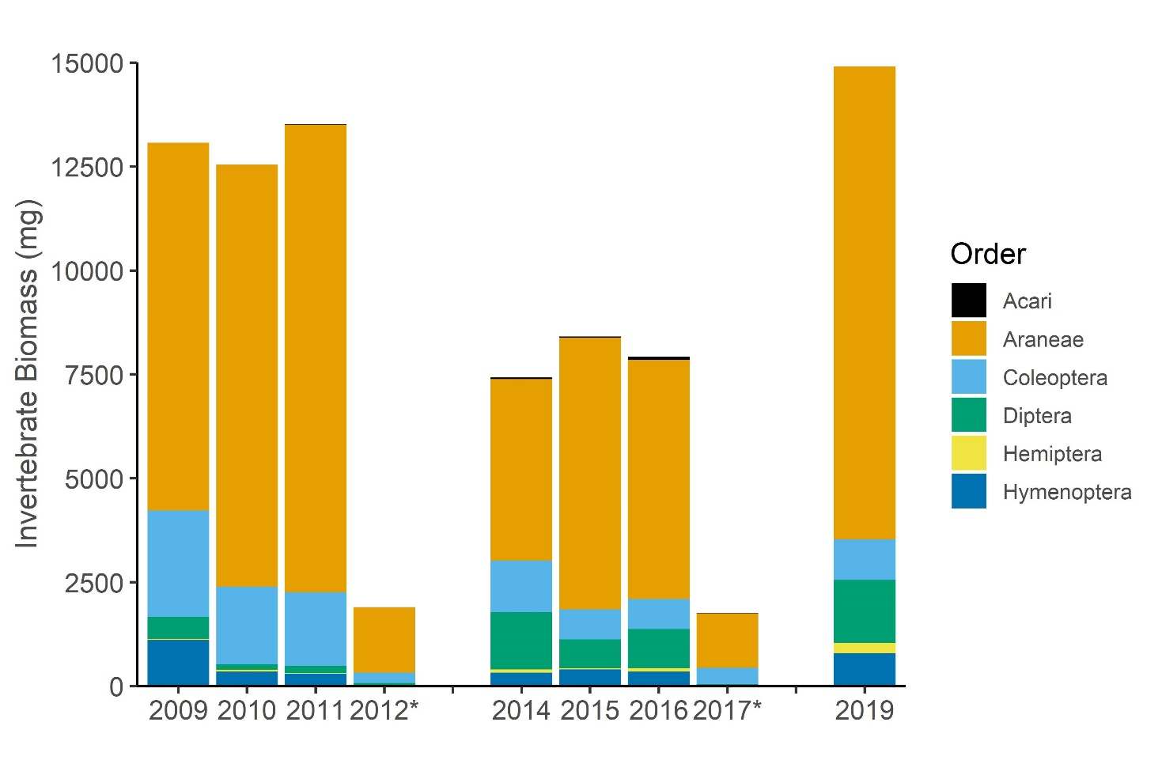
Figure S2. Interannual comparison of the available biomass and composition by each of the major Orders consumed by foraging godwit chicks. Invertebrates were monitored near Beluga River, AK from 2009 ̶ 2019. Biomass was determined using taxon-specific, length-weight relationships (Rogers et al., 1977; Ganihar, 1997; Robinson et al., 2018). The 2012 and 2017 seasons (*) were short seasons and do not represent the extent of the available energy. No monitoring occurred in 2013 and 2018.

- Rogers, L. E., Buschbom, R. L., & Watson, C. R. (1977). Length-Weight Relationships of Shrub-Steppe Invertebrates. Annals of the Entomological Society of America, 70(1), 51–53. doi: 10.1093/aesa/70.1.51
- Ganihar, S. R. (1997). Biomass estimates of terrestrial arthropods based on body length. Journal of Biosciences, 22(2), 219–224. doi: 10.1007/BF02704734
- Robinson, S. I., McLaughlin, Ó. B., Marteinsdóttir, B., & O’Gorman, E. J. (2018). Soil temperature effects on the structure and diversity of plant and invertebrate communities in a natural warming experiment. Journal of Animal Ecology, 87(3), 634–646. doi: 10.1111/1365-2656.12798

Figure S3. Effect of median invertebrate body size (mg) on the body condition index (BCI) of Hudsonian godwit chicks monitored near Beluga River, AK from 2009 - 2019. BCI is the ratio of observed to expected weight gain. BCI = 1 (dashed line) means individuals grew as expected, while BCI > 1 and BCI < 1 indicate better or worse than expected, respectively.
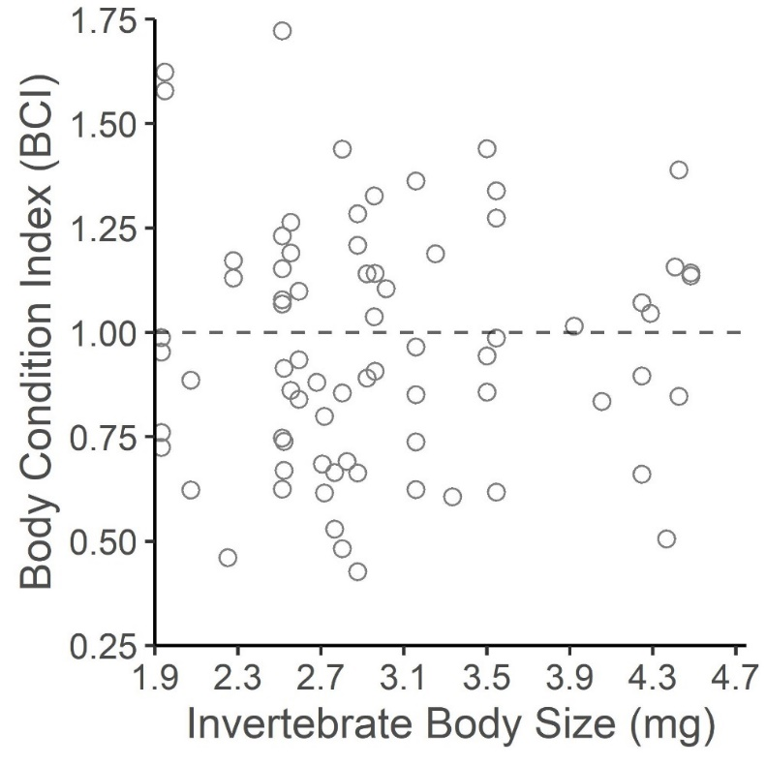

Figure S4. Overlap models of invertebrate biomass and Hudsonian godwit chick Whole Demand model (i.e., cumulative energetic requirements; kJ d⁻¹) for each year where both invertebrates and chicks were monitored between 2009 - 2019. Curves are represented as seasonal proportions, with the overlapping region (red, shaded) as a measure of ‘matching’. Each tile is a season.

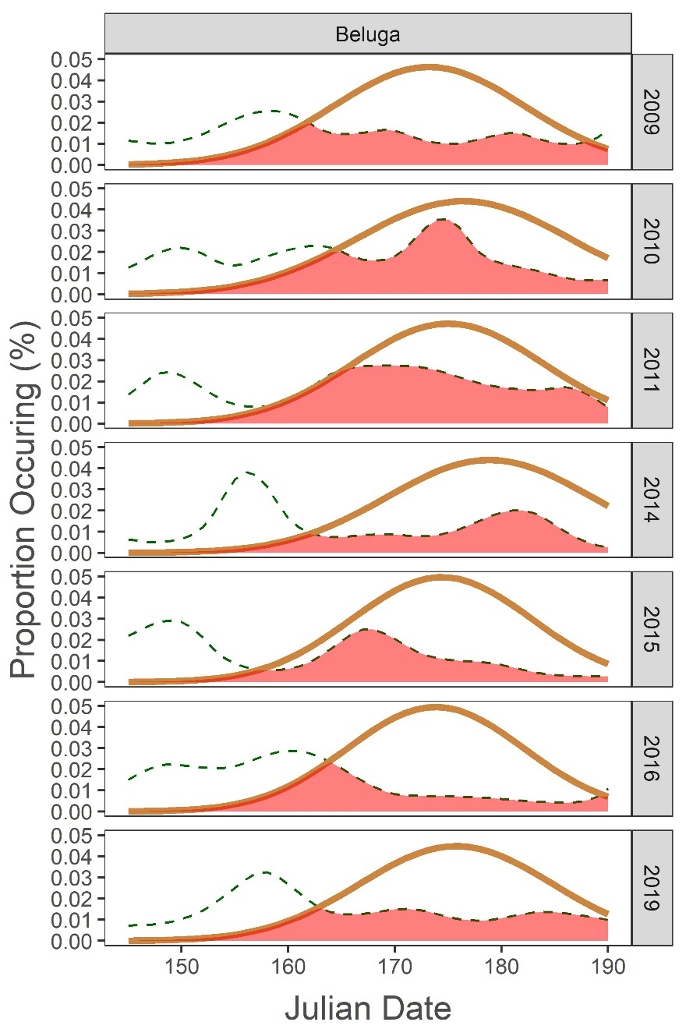

Figure S5. Overlap models of invertebrate biomass and Hudsonian godwit chick Peak Demand model (i.e., number of godwit chicks at age of peak growth rate per day) for each year where both invertebrates and chicks were monitored between 2009 - 2019. Curves are represented as seasonal proportions, with the overlapping region (red, shaded) as a measure of ‘matching’. Each tile is a season.
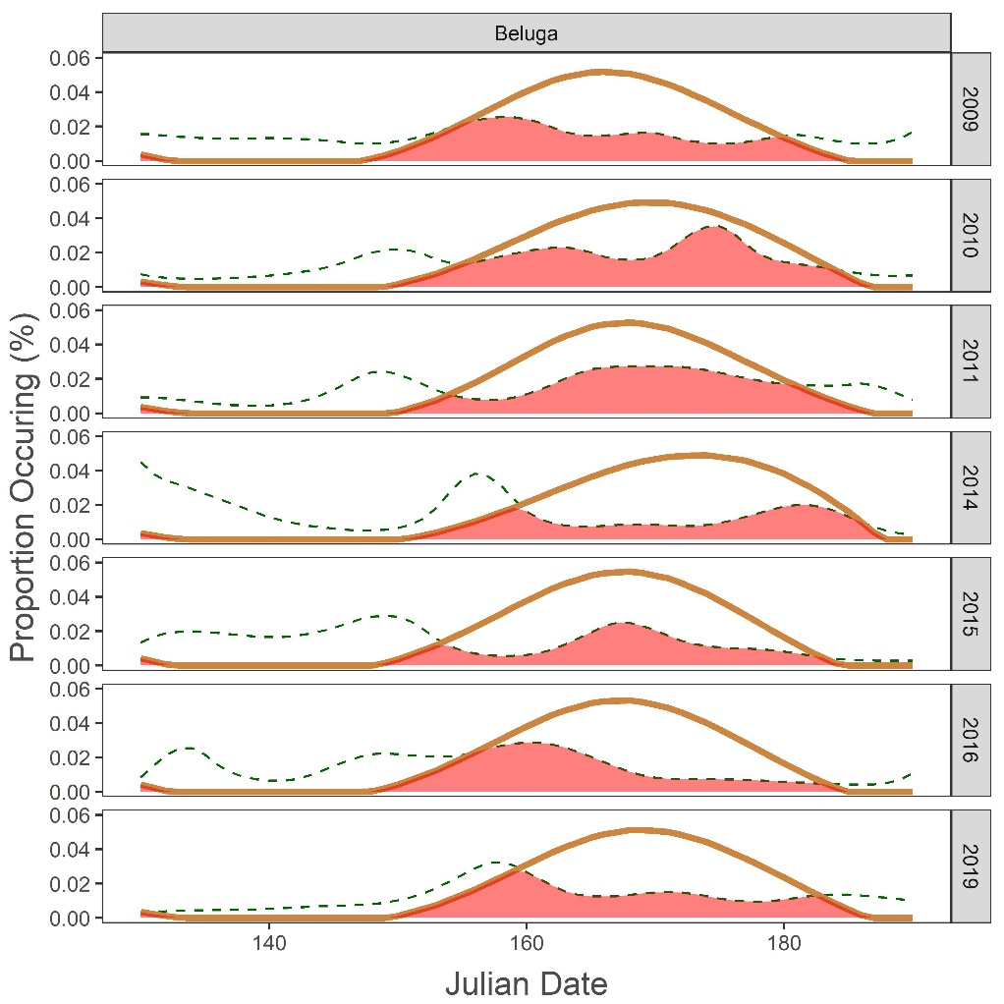

Wilde, L.R., J.E. Simmons, R.J. Swift, and N.R. Senner. Rethinking phenological mismatches: Improved estimates of predator and prey phenology clarify the effects of climate change on the reproductive success of a long-distance migratory bird.

Supplemental Materials: Appendix B

#Define terms for run.jags model in R

#NH[i,j]: matrix of encounter history beginning and ending on #first and last day of the season

#insect[i,j]: matrix of daily invertebrate biomass estimates from #3-day average prior to each day

#size[i,j]: matrix of median invertebrate body size estimates from #3-day average prior to each day

#hatch[i]: vector of hatch date

#age[i,j]: matrix of chick age for each day of individual’s life

#plot[i]: vector of study plot (North = 2, South = 1)

#brood[i]: vector of brood ID

#year[i]: vector of study year (2009 = 1, 2010 = 2, ... 2019 = 7)

#
#

#script to impement model in R v3.6.0 or later

#load the packages
x <- c("runjags", "rjags", "arm"); lapply(x, require, character.only = T)

#
#

# ensures that all parameters would be output. Otherwise, runjags has a ceiling on the number of parameters summarized
runjags.options(force.summary=T)

#
#

#define functions to calculate the last day alive, first day alive:
get.last <- function(m) max(which(m %in% c(0,1)))
get.first <- function(m) min(which(m %in% c(0,1)))

# build logit and inverse logit functions:
fn_logit <- function(X) log(X / (1 - X))
fn_invlogit <- function(X) 1/(1+exp(-(X)))

#
#

#
init <- Sys.time() # record the start time for the example script

# identify first and last day each individual was alive
f <- as.numeric(apply(NH, 1, get.first))
l <- as.numeric(apply(NH, 1, get.last)) # last day that each nest was alive

#
#

#define MCMC simulation settings
adapt <- 600 #number of iterations to discard
bi <- 1000 #number of burn in, discarded before chains stabilize
ni <- 5000 #number of iterations to run
nt <- 3 #thinning factor
nc <- 3 #number of chains to run, my CORE i7 has 6 cores

#
#

# begin model in run.jags

cat("model {
for(i in 1:nnest){
for(j in f[i]:(l[i]-1)){
logit(phi[i,j]) <- intercept + w.a* eff_biomass*insect[i,j] + w.b*eff_size*size[i,j] + w.c*eff_size_age_interaction*age[i,j]*size[i,j] + w.d*eff_hatch*hatch[i,1] + w.e*eff_age*age[i,j] + alpha[plot[j]] + alpha1[brood[j]] + alpha2[year[j]]
}
}
# likelihood:
for(i in 1:nnest){
for(j in (f[i]+1):l[i]){
mu[i,j]<-phi[i,j-1]*NH[i,j-1]
NH[i,j]~dbern(mu[i,j])
}
}

#
#

#monitor loglik for WAIC calculation
loglikcell[i,j] <- logdensity.cat(NH[i,j],mu[i,j])

#get row sum - for heirarchical model
loglik[i] <- sum(loglikcell[i,])
#
#

# create model selection process using indicator-variable approach:

#hold variance constant
tau.total ~ dgamma(3.29,7.8)
K <- w.a + w.b + w.c + w.d + w.e
tau.model <- K*tau.total

#weights priors
w.a ~ dbern(0.5)
w.b ~ dbern(0.5)
w.c ~ dbern(0.5)
w.d ~ dbern(0.5)
w.e ~ dbern(0.5)

#priors are diffuse, intercept restricted close to zero

# parameter priors
intercept~dnorm(0,0.01)
eff_age~dnorm(0,25)
eff_size~dnorm(0,25)
eff_size_age_interaction~dnorm(0,25)
eff_biomass~dnorm(0,25)
eff_hatch~dnorm(0,25)

#random effect priors
for(j in 1:n.plot){
alpha[j]~dnorm(0,tau.plot) ###I(-2,2)
}
#int.plot ~ dnorm(0,0.001) #initial intercept of plot effect
tau.plot<-pow(sigma.plot, -2)
sigma.plot~dunif(0,25)

#
for(j in 1:n.brood){
alpha1[j]~dnorm(0,tau.brood) ###I(-98,98)
}
#int.brood ~ dnorm(0,0.001)
tau.brood<-pow(sigma.brood, -2)
sigma.brood~dunif(0,25)

#
for(j in 1:n.year){
alpha2[j]~dnorm(0,tau.year) ###I(-7,7)
}
#int.year ~ dnorm(0,0.001)
tau.year<-pow(sigma.year, -2)
sigma.year~dunif(0,25)

# back-transform expected DSR and nest survival to fledging

dsr_mean <- 1/(1+exp(-(intercept)))
nsurv_mean <- dsr_mean^d

}",fill=TRUE)
}
> sink()

#run the model with constant insect effect

#
#

global_BF <-run.jags( model="HUGO_match.model_global.txt", data=list(NH=NH,insect=zinsect,size=zsize,plot=plot,year=year,brood=brood,l=l,f=f,d=d,age=zage,hatch=hatch,nnest=nrow(NH),n.year=n.year,n.plot=n.plot,n.brood=n.brood),monitor=c("dsr_mean","nsurv_mean","eff_age","eff_size_age_interaction","eff_size"," eff_biomass",eff_hatch","intercept","w.a","w.b","w.c","w.d",”w.e","loglik"),inits=function(){list(intercept=rnorm(1,0,0.2),eff_bimoass=runif(1),eff_size_age_interaction=runif(1),eff_age=runif(1),eff_hatch=runif(1),alpha=runif(n.plot),eff_size=runif(1),alpha1=runif(n.brood),alpha2=runif(n.year))},thin=nt, n.chains=nc, burnin=bi,adapt=adapt,sample=ni,psrf.target=1.1, method='rjparallel')

