The Lithuanian reference genome LT1 - a human de novo genome assembly from the Baltic States
Authors:
Hui-Su Kimª*, Asta Blazyte^{a,b}, Sungwon Jeon^{a,b}, Changhan Yoon^{a,b}, Yeonkyung Kimª, Changjae Kim^{c}, Dan Bolser^{d,}, Ji-Hye Ahn^{c}, Jeremy S. Edwards^{e}, and Jong Bhak^{a,b,c,d}* ¶,
^{a)} Korean Genomics Center (KOGIC), Ulsan National Institute of Science and Technology (UNIST), Ulsan 44919, Republic of Korea
^{b)} Department of Biomedical Engineering, College of Information-Bio Convergence Engineering, Ulsan National Institute of Science and Technology (UNIST), Ulsan 44919, Republic of Korea
^{c)} Clinomics LTD, Ulsan National Institute of Science and Technology (UNIST), Ulsan 44919, Republic of Korea
^{d)} Geromics Inc, Office 261, 23 Kings Street, Cambridge, United Kingdom
^{e)} Department of Chemistry and Chemical Biology, University of New Mexico, Albuquerque, NM 87131, USA
* Corresponding authors

Emails: hskim3824@gmail.com (HK)*, astulaaa@unist.ac.kr (AB), jsw0061@unist.ac.kr (SJ), vteddy@unist.ac.kr (CY), yk1107kim@gmail.com (YK), kchangjae@gmail.com (CK), dan.bolser@gmail.com (DB), jhahn@clinomics.co.kr (JA), jsedwards@salud.unm.edu (JE), jongbhak@genomics.org (JB)*.

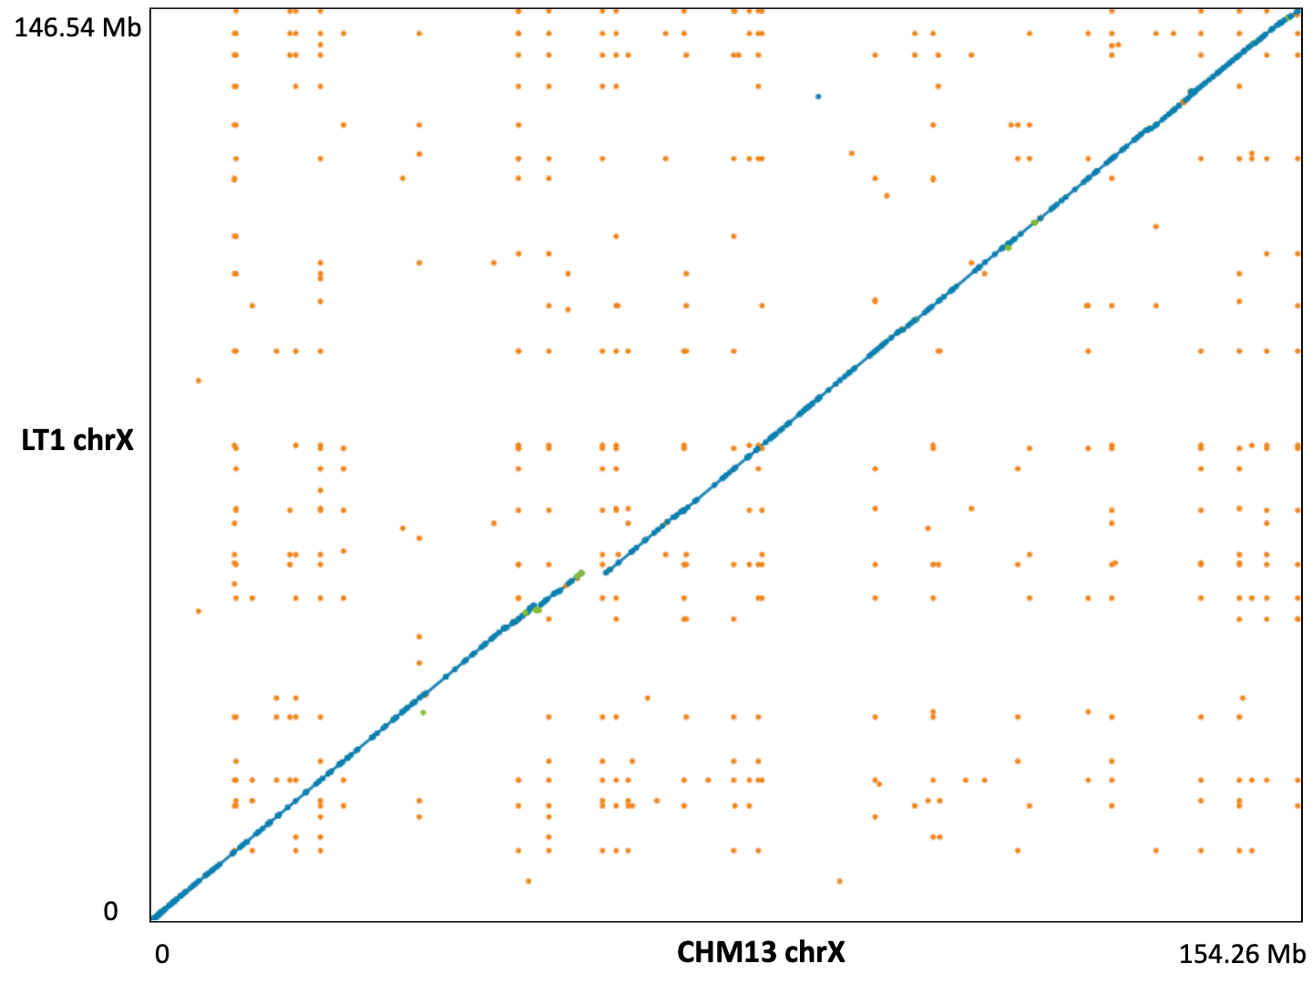
Fig. S1. Comparison of chromosome X between LT1 and CHM13. Blue dots represent unique forward alignments and green dots unique reverse alignments, respectively. Orange dots denote repetitive alignments.
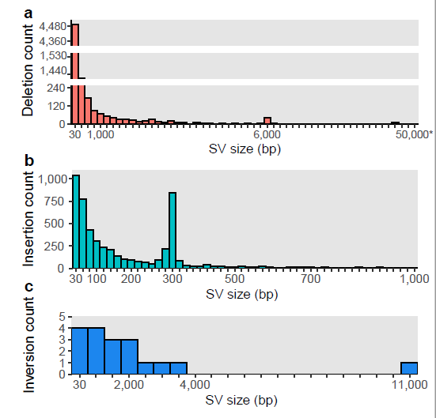
Fig. S2. Complete size distribution of the consensus a) deletions, b) insertions, and c) inversions found in LT1. Number of bins: a) 54, b) 50, c) 21, respectively. Gaps on deletions Y axis are from 250 to 1,198 and from 1,550 to 4,000, aiming to reduce the overrepresentation of the first 2 bins.

