Supplementary Material 2

Table 1. Overall changes in hunting
Change | Mean (%) | 95% CI (Direct)
Don’t know | 27.23 | 19.19 – 36.36
Increase | 56.12 | 40.33 – 74.54
Decrease | 6.03 | 0.77 – 13.03
No Change | 10.15 | 5.05 – 16.16

Table 2. Change in hunting of taxa
Species | Change | Mean (%) | 95% CI (Direct)
Mammal | Same | 7.05 | 2.02 – 12.12
 | Not Hunted | 15.13 | 8.08 – 22.22
 | Increased | 55.10 | 45.46 – 65.66
 | Decreased | 5.04 | 1.01 – 10.01
 | Don’t know | 17.20 | 10.01 – 25.25
Birds | Same | 16.12 | 9.09 – 23.23
 | Not Hunted | 21.22 | 13.13 – 29.30
 | Increased | 35.30 | 26.26 – 44.44
 | Decreased | 5.04 | 1.01 – 10.01
 | Don’t know | 22.28 | 14.14 – 31.31
Rept. Amph. | Same | 18.19 | 11.11 – 26.26
 | Not Hunted | 30.27 | 21.21 – 39.39
 | Increased | 15.11 | 8.08 – 22.22
 | Decreased | 2.02 | 0 – 5.05
 | Don’t know | 34.41 | 25.25 – 43.43
Fish Crust. | Same | 13.10 | 7.07 – 20.20
 | Not Hunted | 12.12 | 6.06 – 19.19
 | Increased | 43.40 | 34.34 – 53.54
 | Decreased | 5.08 | 1.01 – 10.01
 | Don’t know | 26.18 | 18.18 – 35.35

Table 3. Who is hunting
Who | Mean (%) | 95% CI (Direct)
Resident Hunters | 63.62 | 54.54 – 72.72
Resident (out of work) | 39.34 | 29.29 – 49.49
Returnees | 20.24 | 12.12 – 28.28
No hunting | 18.16 | 11.11 – 25.25
Mixed Groups | 17.12 | 10.09 – 24.24
Don’t know | 10.11 | 5.04 – 16.16
Outsiders | 6.05 | 2.02 – 11.11

Table 4. Where hunting took place
Location | Mean | 95% CI (Direct)
Reserve Forest | 43.40 | 34.34 – 53.53
Village Land | 32.32 | 23.23 – 41.41
Protected Area | 28.26 | 19.19 – 37.37
Private Land | 27.30 | 18.18 – 36.36
Territorial Forest | 22.20 | 14.14 – 31.31
No hunting | 20.23 | 12.12 – 28.28
Don’t Know | 8.13 | 3.03 – 14.14

Table 5. Changes in motivation to hunt
Motivation | Change | Mean (%) | 95% CI (Direct)
Household  Consumption | Same | 13.13 | 7.07 – 20.20
 | Not a motive | 7.13 | 2.02 – 12.12
 | Increased | 53.15 | 43.43 – 63.03
 | Decreased | 5.06 | 1.01 – 10.10
 | Don’t know | 21.24 | 13.13 – 29.29
Local market | Same | 17.18 | 10.10 – 25.25
 | Not a motive | 25.23 | 17.17 – 34.34
 | Increased | 14.12 | 8.08 – 21.21
 | Decreased | 14.16 | 8.08 – 21.21
 | Don’t know | 29.30 | 20.20 – 38.38
Medicine | Same | 14.12 | 8.08 – 21.21
 | Not a motive | 31.35 | 22.22 – 40.40
 | Increased | 12.12 | 6.06 – 19.19
 | Decreased | 2.98 | 0 – 7.07
 | Don’t know | 39.43 | 30.03 – 49.49
Outside Market | Same | 9.13 | 4.04 – 15.15
 | Not a motive | 30.25 | 21.21 – 39.39
 | Increased | 11.05 | 5.05 – 17.17
 | Decreased | 10.07 | 4.04 – 16.16
 | Don’t know | 39.45 | 30.03 – 49.49
Sports/Recreation | Same | 7.02 | 3.03 – 12.12
 | Not a motive | 24.25 | 16.16 – 33.33
 | Increased | 34.36 | 25.25 – 43.43
 | Decreased | 6.08 | 2.02 – 11.11
 | Don’t know | 28.26 | 19.19 – 37.37
Trade | Same | 13.12 | 7.07 – 20.20
 | Not a motive | 34.30 | 25.25 – 43.43
 | Increased | 5.07 | 1.01 – 10.01
 | Decreased | 4.04 | 1.01 – 8.08
 | Don’t know | 43.49 | 34.32 – 53.53

Table 6. Local factors causing increase in hunting
Changes | Mean (%) | 95% CI (Direct)
Lack of enforcement | 36.40 | 27.27 – 45.45
Food Disruption | 32.31 | 23.23 – 41.41
Recreation | 32.31 | 23.23 – 41.41
Seasonal Occupation Loss | 24.18 | 16.16 – 33.33
No Tourist | 21.17 | 14.14 – 29.30
No Increase | 19.19 | 12.12 – 27.27
Community Bonding | 18.16 | 11.11 – 26.26
Don’t Know | 12.14 | 6.06 – 19.19
Supplementary Income | 7.05 | 2.02 – 12.12
Others | 6.07 | 2.02 – 11.11

Table 7. Overall changes in enforcement
Enforcement | Change | Mean (%) | 95% CI (Direct)
Forest Department | Don’t know | 15.13 | 8.08 – 22.22
 | Not present | 18.20 | 11.11 – 26.26
 | Same as before | 34.34 | 25.25 – 44.44
 | Decreased | 12.15 | 6.06 – 19.19
 | Increased | 20.19 | 12.12 – 28.28
Police Department | Don’t know | 26.29 | 18.18 – 35.35
 | Not present | 28.33 | 19.19 – 37.37
 | Same as before | 29.26 | 20.20 – 38.38
 | Decreased | 7.11 | 3.03 – 12.12
 | Increased | 9.13 | 4.04 – 15.15
Customs | Don’t know | 39.27 | 30.03 – 48.48
 | Not present | 45.40 | 35.35 – 55.56
 | Same as before | 9.09 | 4.04 – 15.15
 | Decreased | 5.08 | 1.01 – 10.01
 | Increased | 1.02 | 0 – 3.03
Community | Don’t know | 31.26 | 22.22 – 40.04
 | Not present | 39.39 | 29.29 – 49.49
 | Same as before | 12.10 | 6.06 – 19.19
 | Decreased | 10.12 | 5.05 – 16.16
 | Increased | 7.07 | 2.02 – 12.12
Paramilitary | Don’t know | 38.43 | 29.29 – 48.48
 | Not present | 49.48 | 39.39 – 59.60
 | Same as before | 7.11 | 2.02 – 12.12
 | Decreased | 3.01 | 0 – 7.07
 | Increased | 1.98 | 0 – 5.05

Table 8. Challenges to enforcement
Changes | Mean (%) | 95% CI (Direct)
Lack of Manpower | 49.59 | 39.39 – 59.60
Logistical Challenges | 38.44 | 29.29 – 48.48
Lack of mobility | 38.44 | 29.29 – 48.48
Increased Hunting | 36.37 | 27.27 – 45.45
Communication | 27.27 | 19.19 – 36.36
Increased local support | 27.27 | 19.18 – 36.35
Don’t Know | 14.11 | 6.67 – 19.10
None | 13.22 | 7.07 – 20.20
Diversion | 13.22 | 7.07 – 20.20
Others | 6.04 | 1.01 – 11.10

Table 9. Strategies to deal with hunting
Strategy | Change | Mean (%) | 95% CI (Direct)
More Enforcement | Don’t know | 37.37 | 28.28 – 47.47
 | Implemented but didn’t work | 4.05 | 1.01 – 8.08
 | Implemented but don’t know if it worked | 15.14 | 8.08 – 22.22
 | Implemented & worked | 13.12 | 7.07 – 20.20
 | Not implemented | 30.20 | 21.21 – 39.39
Provision Food | Don’t know | 34.35 | 25.25 – 43.43
 | Implemented but didn’t work | 8.08 | 3.03 – 14.14
 | Implemented but don’t know if it worked | 22.24 | 14.14 – 30.30
 | Implemented & worked | 17.24 | 10.10 – 25.25
 | Not implemented | 18.17 | 11.11 – 26.26
Monetary Assistance | Don’t know | 46.39 | 36.36 – 56.57
 | Implemented but didn’t work | 5.02 | 1.01 – 10.10
 | Implemented but don’t know if it worked | 10.11 | 5.05 – 16.16
 | Implemented & worked | 4.01 | 1.01 – 8.08
 | Not implemented | 34.32 | 25.25 – 43.43
Awareness | Don’t know | 35.43 | 26.26 – 44.44
 | Implemented but didn’t work | 5.05 | 1.01 – 10.01
 | Implemented but don’t know if it worked | 11.11 | 5.05 - 17.17
 | Implemented & worked | 8.02 | 3.03 – 14.14
 | Not implemented | 40.29 | 30.30 – 49.50
Communication | Don’t know | 36.35 | 27.27 – 45.45
 | Implemented but didn’t work | 9.05 | 4.04 – 15.15
 | Implemented but don’t know if it worked | 15.17 | 8.08 – 22.22
 | Implemented & worked | 8.12 | 3.03 – 14.14
 | Not implemented | 31.37 | 22.22 – 40.04
Logistic Support | Don’t know | 46.51 | 37.37 – 56.57
 | Implemented but didn’t work | 5.06 | 1.01 – 10.01
 | Implemented but don’t know if it worked | 11.11 | 5.05 – 17.17
 | Implemented & worked | 6.08 | 2.02 – 11.11
 | Not implemented | 31.25 | 22.22 – 40.40

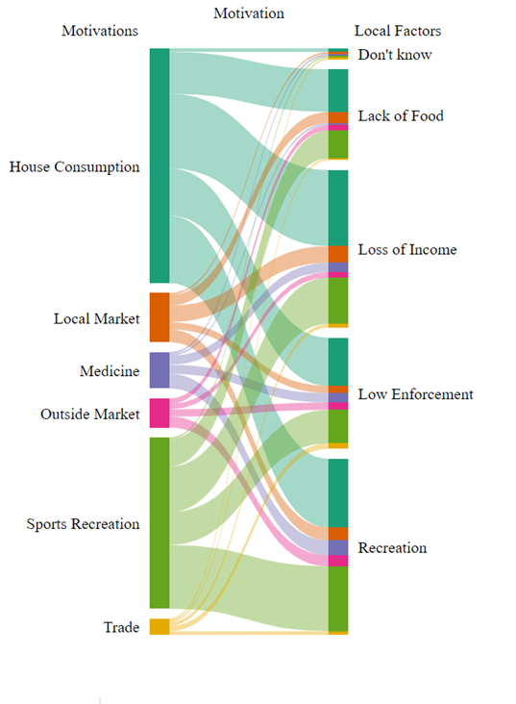
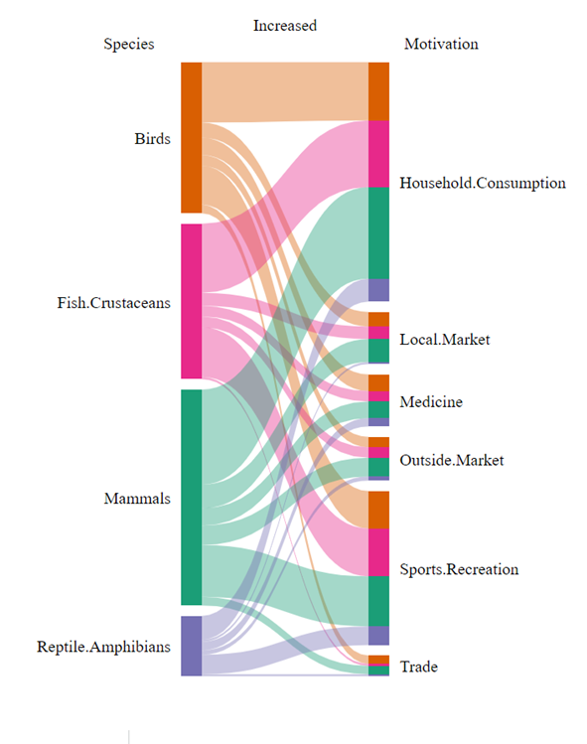

Fig 1. Left: a. Association between the change in motivations to hunt and the lockdown-specific local factors were perceived to have resulted in an increase. Local factors were binned from the set displayed in figure 4C. Right: b. Association between the change in motivations to hunt and change in hunting pressure on different taxa during lockdown

