Supplementary Material
Online Resource 1. List of species observed across the different land-use sites.
Taxa | Lime bay state reserve | Tasman national park (a) | Tasman national park (b) | Plantation (a) | Plantation (b) | Pasture
BIRDS (Honeyeaters)
Melithreptus affinis | 6 | 7
Melithreptus validirostris |  | 6 | 7 | 6
Nesoptilotis flavicollis | 31 | 14 | 7 | 4
Anthochaera paradoxa | 19 | 12 | 3 | 5
Anthochaera chrysoptera | 18 | 5 | 2
Phylidonyris novaehollandiae | 30 | 1
Phylidonyris pyrrhopterus | 11 | 20 | 17 | 45 | 18
Acanthorhynchus tenuirostris |  | 2 |  | 1
BEES
Native bees
Exoneura | 54 | 11 | 55 | 5 | 32 | 27
Lasioglossum | 9 |  | 6 |  | 5 | 28
Others | 17 | 1 | 14 | 4 | 4 | 12
Introduced Bees
Bombus terrestris | 1 | 2 | 6 | 2 | 3 | 2
Apis mellifera | 22 | 22 | 65 | 13 | 30 | 59
BEETLES
Tenebrionidae |  |  | 6 |  | 2 | 5
Scarabaeidae | 41 |  | 48
Buprestidae | 1 |  | 4
Oedemeridae | 46 | 6 | 53 | 26 | 32
Elateridae |  |  | 1
Cantharidae |  |  |  |  | 101
Lycidae | 13 |  | 17 |  | 2
Cleridae | 2 |  | 11
Cerambycidae | 5 |  | 1
BUTTERFLIES
Pieris rapae | 1 |  |  | 3 | 4 | 14
Heteronympha merope |  |  | 16 | 1 | 4
Vanessa itea |  |  | 3 | 1 | 2
Vanessa kershawi |  |  | 2 | 2 | 9
Junonia villida |  |  |  |  |  | 4
Neolucia agricola |  |  | 1
Graphium macleayanum |  |  |  | 7
Hesperilla donnysa |  |  |  | 10

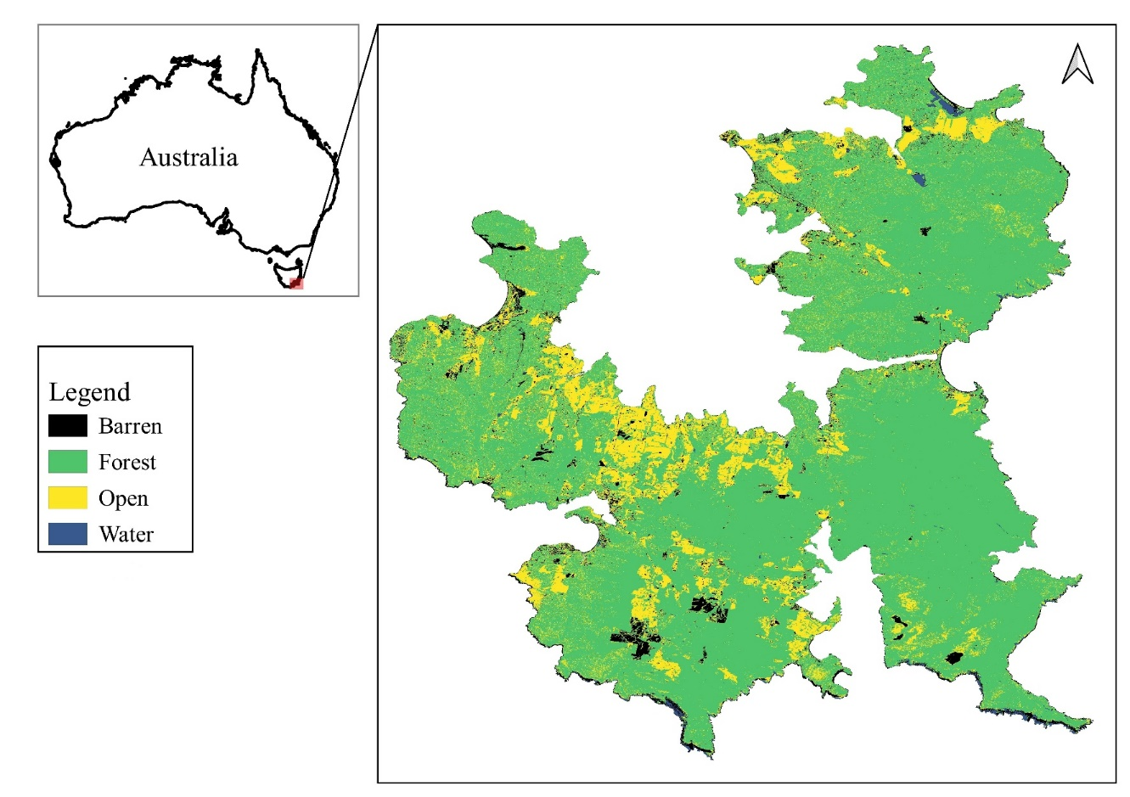
Online Resource 2. Land-cover of the Tasman and Forestier Peninsula with forest (green), open (yellow), baren (black) and water (blue) classes.

Online Resource 3. Confusion matrix of the classified land-cover image which includes forest, open, baren and water classes. Reference and prediction refer to the validation data and the predicted land-cover image, respectively.
 |  | Reference
 |  | Forest | Open | Barren | Water
Prediction | Forest | 96 | 2 | 2 | 0
 | Open | 6 | 87 | 7 | 0
 | Barren | 1 | 19 | 79 | 1
 | Water | 28 | 16 | 0 | 56

Online Resource 4. Sensitivity and specificity of each of the land-cover classes
 | Forest | Open | Barren | Water
Sensitivity | 0.7328 | 0.7016 | 0.8977 | 0.9825
Specificity | 0.9851 | 0.9529 | 0.9327 | 0.8717

Online Resource 5. Percentage of forest and open land cover at 100 m and 2000 m radius from the centre of the 2-ha plot. Percentage of barren and water later cover not included.
Plot code | Forest.100 | Open.100 | Forest.2000 | Open.2000
EX2 | 99.684 | 0.316 | 84.655 | 6.992
EX3 | 100.000 | 0.000 | 90.661 | 5.508
EX4 | 100.000 | 0.000 | 92.159 | 5.930
EY1 | 98.722 | 0.000 | 89.839 | 6.746
EY2 | 100.000 | 0.000 | 87.116 | 10.204
EY3 | 98.403 | 0.639 | 92.664 | 6.252
FX0 | 98.071 | 1.929 | 96.430 | 1.936
FX2 | 99.359 | 0.641 | 96.966 | 1.145
FX4 | 100.000 | 0.000 | 96.161 | 1.570
FX7 | 95.833 | 3.205 | 95.804 | 1.347
FX8 | 90.260 | 5.195 | 96.815 | 1.939
FX9 | 89.068 | 7.717 | 96.461 | 2.390
LX1 | 92.698 | 7.302 | 82.053 | 12.182
LX2 | 91.667 | 8.013 | 81.363 | 11.759
LX3 | 88.535 | 11.465 | 79.081 | 12.504
LY1 | 93.910 | 6.090 | 84.440 | 12.910
LY2 | 94.340 | 5.660 | 86.445 | 11.730
LY4 | 82.595 | 17.405 | 86.552 | 11.493
NX1 | 98.397 | 1.603 | 68.320 | 18.953
NX2 | 96.190 | 3.175 | 69.121 | 17.524
NX3 | 97.785 | 2.215 | 66.726 | 18.851
NY1 | 84.444 | 15.556 | 71.584 | 16.345
NY2 | 47.588 | 11.254 | 68.299 | 17.359
NY3 | 59.683 | 15.556 | 69.103 | 17.427
PX2 | 3.165 | 96.835 | 42.214 | 54.631
PX3 | 20.755 | 75.157 | 46.953 | 50.194
PX4 | 6.731 | 93.269 | 52.135 | 45.565
PY2 | 10.759 | 79.747 | 36.272 | 59.115
PY3 | 0.000 | 91.429 | 37.133 | 58.661
PY4 | 6.013 | 84.494 | 39.258 | 57.082
TX1 | 77.636 | 20.447 | 80.613 | 15.150
TX2 | 84.227 | 15.457 | 82.653 | 14.782
TX3 | 99.045 | 0.955 | 81.066 | 17.461
TY0 | 93.930 | 6.070 | 71.601 | 25.976
TY1 | 88.782 | 11.218 | 74.124 | 23.885
TY2 | 94.586 | 5.414 | 81.080 | 17.909

Online Resource 6. Percentage of forest and open land cover at 500 m and 2000 m radius from the centre of the 1000 m transect. Percentage of barren and water later cover not included.
Plot Code | Forest.500 | Open.500 | Forest.2000 | Open.2000
LX | 77.249 | 9.912 | 81.024 | 12.027
LY | 86.959 | 12.523 | 85.824 | 12.359
PY | 22.144 | 73.394 | 37.189 | 58.645
PX | 38.653 | 58.661 | 43.592 | 53.299
TY | 83.142 | 15.940 | 73.906 | 24.118
TX | 92.745 | 7.038 | 82.734 | 14.501
NX | 90.460 | 8.929 | 68.714 | 17.805
NY | 46.654 | 6.858 | 68.370 | 17.282
EX | 99.491 | 0.395 | 90.363 | 5.447
EY | 94.369 | 0.599 | 92.727 | 4.784

Online Resource 7. The RMSE and R2 and RMSE of the different butterfly count model along with the variable importance (gini values) of the different predictors.
Model | Predictors | RMSE | R2 | Predictors | Gini values
Butterfly count model | pasture + plantation+ protected.area + forest.500 + open.500 | 3.448 | 0.019 | forest.500 | 121.730
 |  |  |  | open.500 | 96.567
 |  |  |  | plantation | 13.468
 |  |  |  | protected.area | 12.104
 |  |  |  | pasture | 3.441

Online Resource 8. Variable importance (gini values) of the top 10 predictors of the different pollinator count models
Model | Predictors | Gini values
Honeyeater count | - forest.2000 | 136.492699
 | - open.2000 | 134.955890
 | - Eucalyptus | 91.420123
 | - Symphyomyrtus | 30.876710
 | - LU_protected.area | 24.544626
 | - LU_pasture | 19.752531
 | - LU_plantation | 5.531838
Native bee count | - forest.2000 | 59.91558522
 | - genera_Pultenaea | 57.62292383
 | - open.2000 | 54.30421052
 | - genera_Leucopogon | 53.99463337
 | - genera_Acacia | 18.81130382
 | - genera_Goodenia | 10.03147224
 | - genera_Pimelea | 7.80471331
 | - genera_Olearia | 6.68817358
 | - LU_pasture | 5.96508320
 | - genera_Leptospermum | 5.11976439
Introduced bee count | - open.100 | 38.05639442
 | - forest.100 | 36.27041769
 | - genera_Acacia | 19.88738334
 | - genera_Melaleuca | 18.74869533
 | - genera_Pomaderris | 12.88385697
 | - genera_Pimelea | 11.96128822
 | - genera_Lissanthe | 6.00771167
 | - genera_Pultenaea | 5.55470149
 | - LU_protected.area | 3.59441529
 | - LU_plantation | 3.28012755
Beetle count | - genera_Leptospermum | 2.162004e+03
 | - forest.100 | 7.262206e+02
 | - open.100 | 6.908810e+02
 | - LU_plantation | 1.155066e+02
 | - LU_protected.area | 9.003934e+01
 | - genera_Pultenaea | 7.575783e+01
 | - genera_Pomaderris | 4.617187e+01
 | - genera_Acacia | 3.255777e+01
 | - genera_Pimelea | 2.400601e+01
 | - LU_pasture | 2.212450e+01

