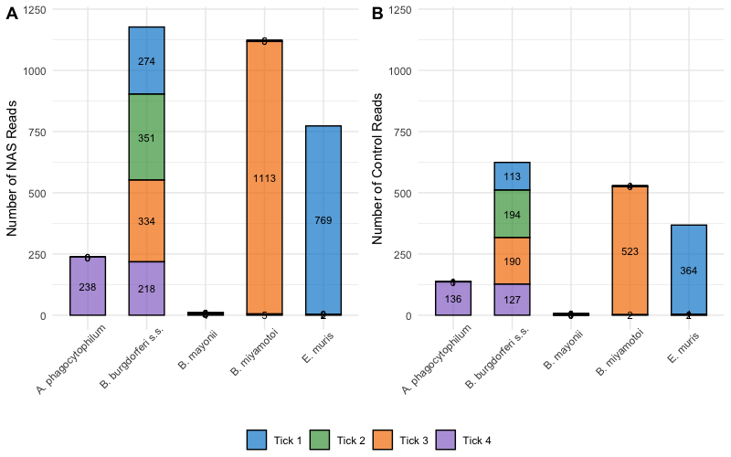
Supplemental Figure 2. Number of nanopore reads assigned taxonomic classification at the level of pathogen species using the kraken2 pipeline. The tick-borne agent B. (Borreliella) mayonii was not detected in these samples and was included to confirm of sample infections with the related pathogen B. (Borreliella) burgdorferi s.s. (A) Number of classified NAS reads (B) Number of classified control reads.

