Supplementary data for:
MetaScore: A novel machine-learning based approach to improve traditional scoring functions for scoring protein-protein docking conformations

Yong Jung^{1,2,5}, Cunliang Geng⁸, Alexandre M. J. J. Bonvin⁸, Li C. Xue^{8,9*}, Vasant G. Honavar^{1,2,3,4,5,6,7*}
¹Bioinformatics & Genomics Graduate Program, Pennsylvania State University, University Park, PA 16802, USA;
²Artificial Intelligence Research Laboratory, Pennsylvania State University, University Park, PA 16802, USA;
³Center for Big Data Analytics and Discovery Informatics, Pennsylvania State University, University Park, PA 16823, USA;
⁴Institute for Computational and Data Sciences, Pennsylvania State University, University Park, PA 16802, USA;
⁵Huck Institutes of the Life Sciences, Pennsylvania State University, University Park, PA 16802, USA;
⁶Clinical and Translational Sciences Institute, Pennsylvania State University, University Park, PA 16802, USA;
⁷College of Information Sciences & Technology, Pennsylvania State University, University Park, PA 16802, USA;
⁸Bijvoet Centre for Biomolecular Research, Faculty of Science - Chemistry, Utrecht University, Padualaan 8, 3584 CH Utrecht, the Netherlands;
⁹Center for Molecular and Biomolecular Informatics, Radboudumc, Greet Grooteplein 26-28, 6525 GA Nijmegen, the Netherlands.
*Correspondence: vhonavar@psu.edu. Li.Xue@radboudumc.nl

Supplementary Table S1. BLAST parameters.
Query Length | Substitution Matrix | Gap Open Cost | Gap Extend Cost
<35 | PAM-30 | 9 | 1
35-50 | PAM-70 | 10 | 1
50-85 | BLOSUM-80 | 10 | 1
>85 | BLOSUM-62 | 11 | 1

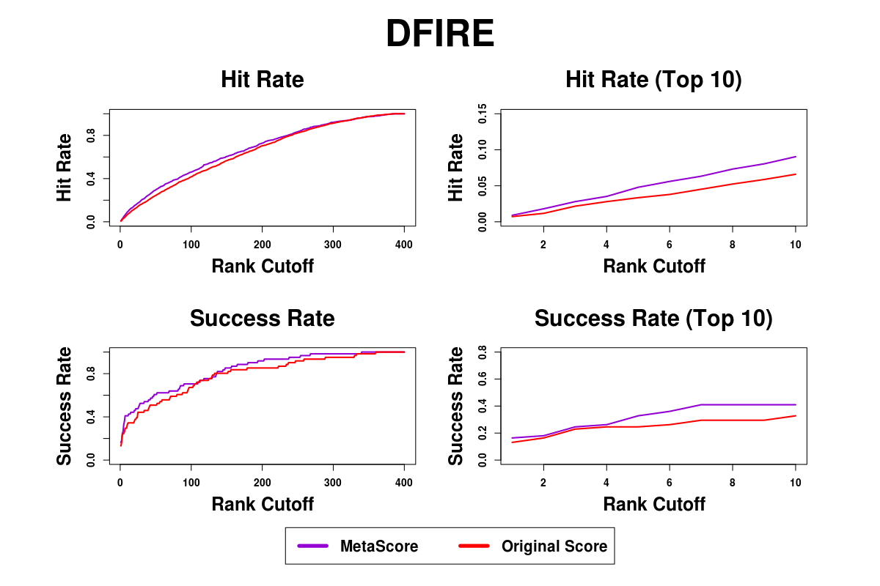
Supplementary Figure S1. Success rates and hit rates plotted against the top m conformations for a classical scoring method (DFIRE), machine learning-based method using RF, and the combined method of the two methods using BM4 decoy set. There are four panels. Top-left panel shows hit rates for conformations of top m ranging from 1 to 400; Top-right panel shows hit rates for conformations of top m ranging from 1 to 10; Bottom-left panel shows success rates for conformations of top m ranging from 1 to 400; Bottom-right panel shows success rates for conformations of top m ranging from 1 to 10.
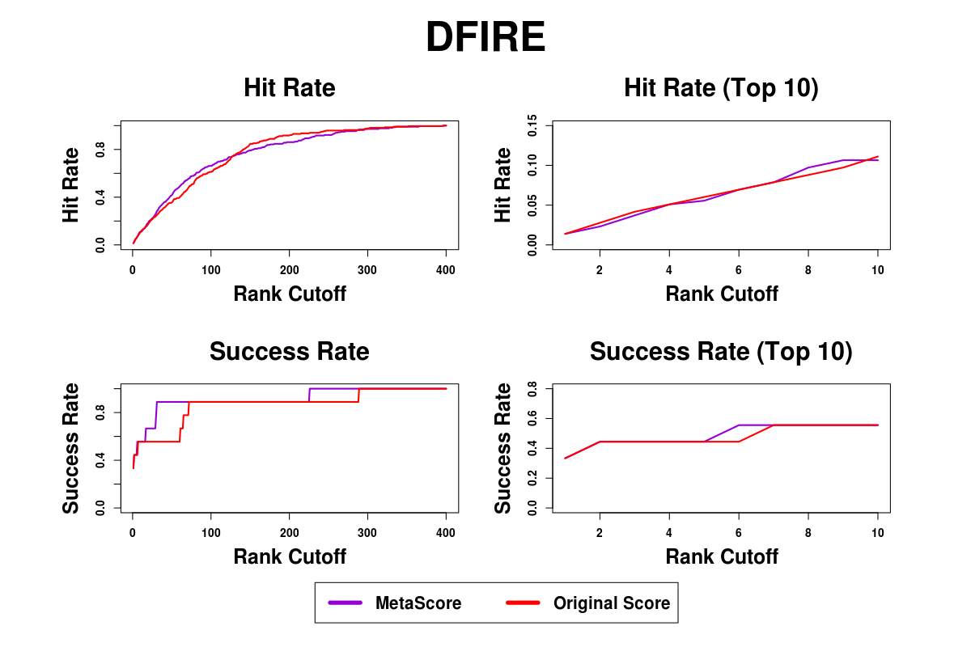
Supplementary Figure S2. Success rates and hit rates plotted against the top m conformations for a classical scoring method (DFIRE), machine learning-based method using RF, and the combined method of the two methods using BM5 decoy set. There are four panels. Top-left panel shows hit rates for conformations of top m ranging from 1 to 400; Top-right panel shows hit rates for conformations of top m ranging from 1 to 10; Bottom-left panel shows success rates for conformations of top m ranging from 1 to 400; Bottom-right panel shows success rates for conformations of top m ranging from 1 to 10.
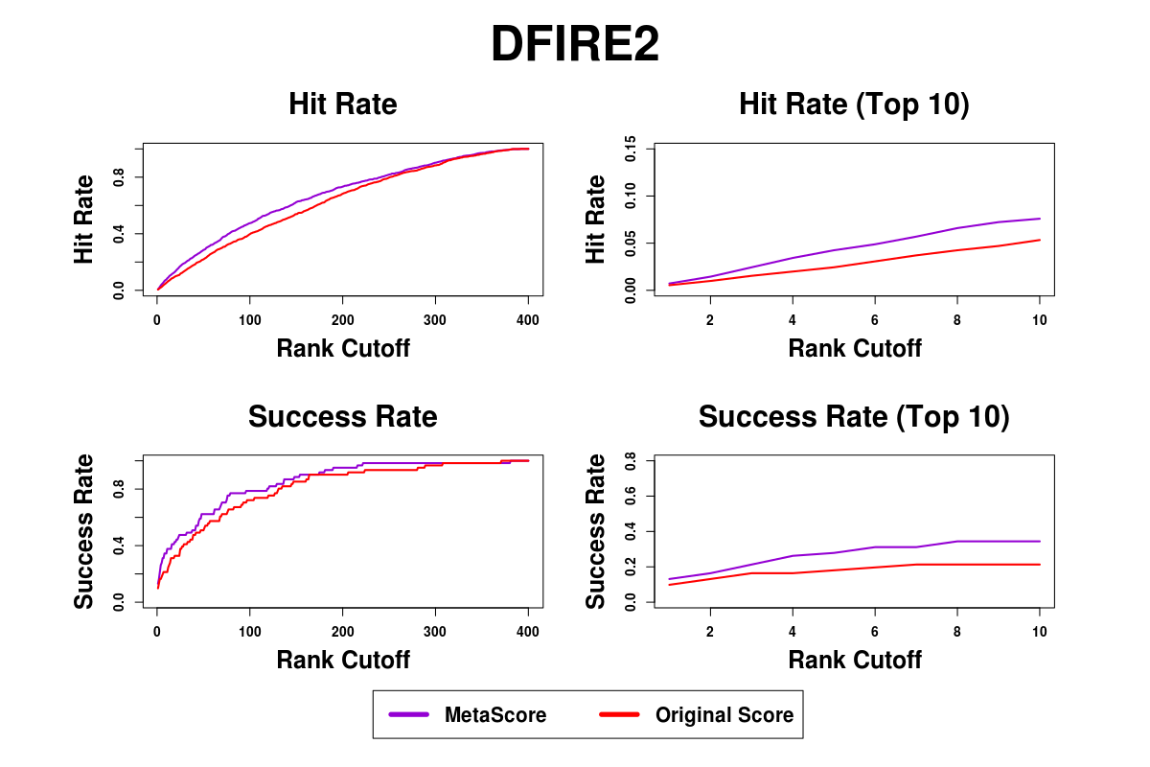
Supplementary Figure S3. Success rates and hit rates plotted against the top m conformations for a classical scoring method (DFIRE2), machine learning-based method using RF, and the combined method of the two methods using BM4 decoy set. There are four panels. Top-left panel shows hit rates for conformations of top m ranging from 1 to 400; Top-right panel shows hit rates for conformations of top m ranging from 1 to 10; Bottom-left panel shows success rates for conformations of top m ranging from 1 to 400; Bottom-right panel shows success rates for conformations of top m ranging from 1 to 10.

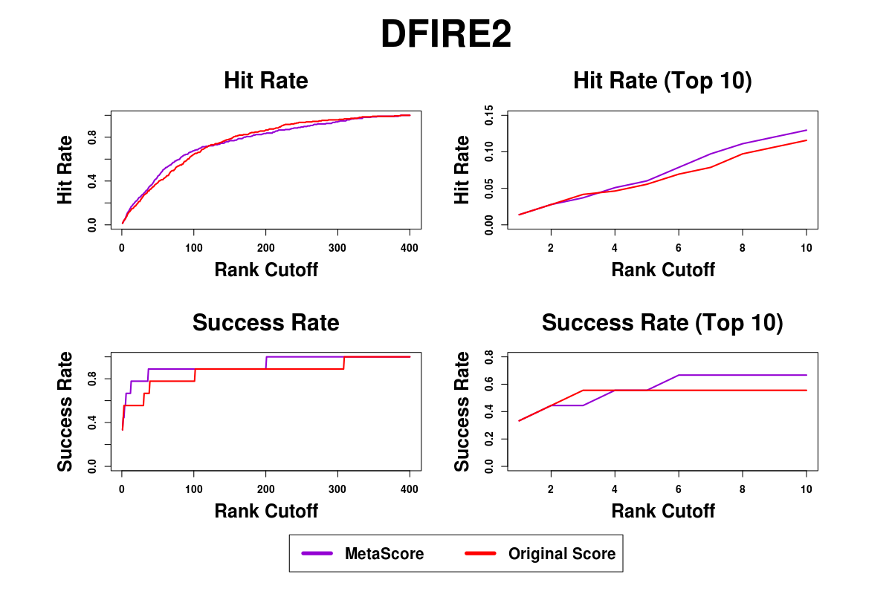
Supplementary Figure S4. Success rates and hit rates plotted against the top m conformations for a classical scoring method (DFIRE2), machine learning-based method using RF, and the combined method of the two methods using BM5 decoy set. There are four panels. Top-left panel shows hit rates for conformations of top m ranging from 1 to 400; Top-right panel shows hit rates for conformations of top m ranging from 1 to 10; Bottom-left panel shows success rates for conformations of top m ranging from 1 to 400; Bottom-right panel shows success rates for conformations of top m ranging from 1 to 10.
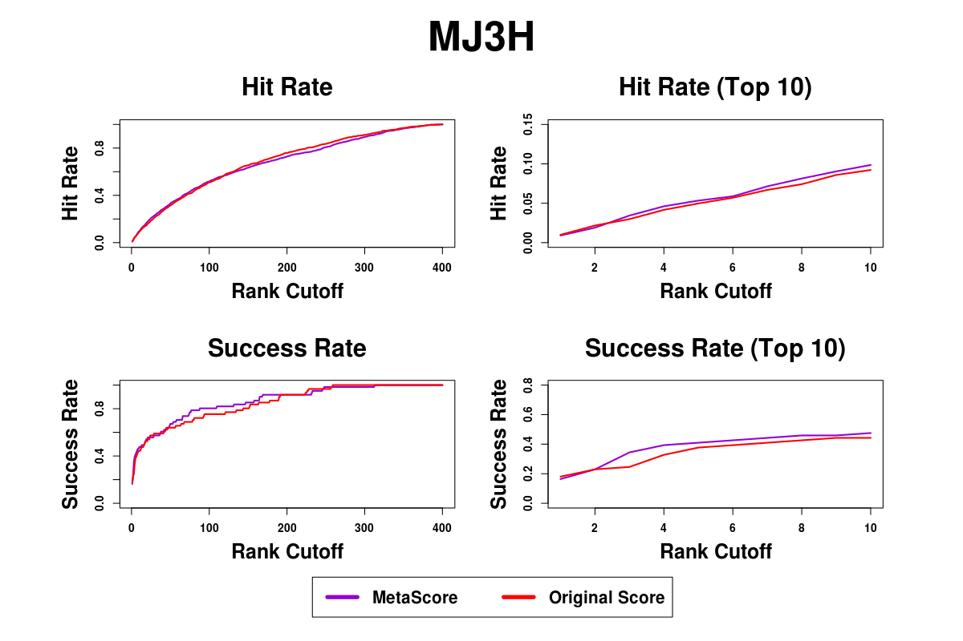
Supplementary Figure S5. Success rates and hit rates plotted against the top m conformations for a classical scoring method (MJ3H), machine learning-based method using RF, and the combined method of the two methods using BM4 decoy set. There are four panels. Top-left panel shows hit rates for conformations of top m ranging from 1 to 400; Top-right panel shows hit rates for conformations of top m ranging from 1 to 10; Bottom-left panel shows success rates for conformations of top m ranging from 1 to 400; Bottom-right panel shows success rates for conformations of top m ranging from 1 to 10.
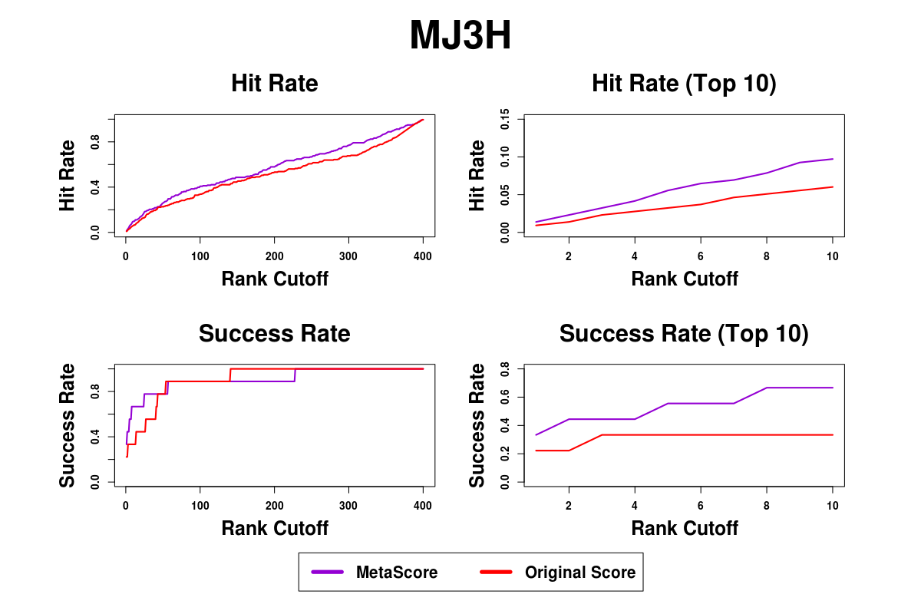
Supplementary Figure S6. Success rates and hit rates plotted against the top m conformations for a classical scoring method (MJ3H), machine learning-based method using RF, and the combined method of the two methods using BM5 decoy set. There are four panels. Top-left panel shows hit rates for conformations of top m ranging from 1 to 400; Top-right panel shows hit rates for conformations of top m ranging from 1 to 10; Bottom-left panel shows success rates for conformations of top m ranging from 1 to 400; Bottom-right panel shows success rates for conformations of top m ranging from 1 to 10.
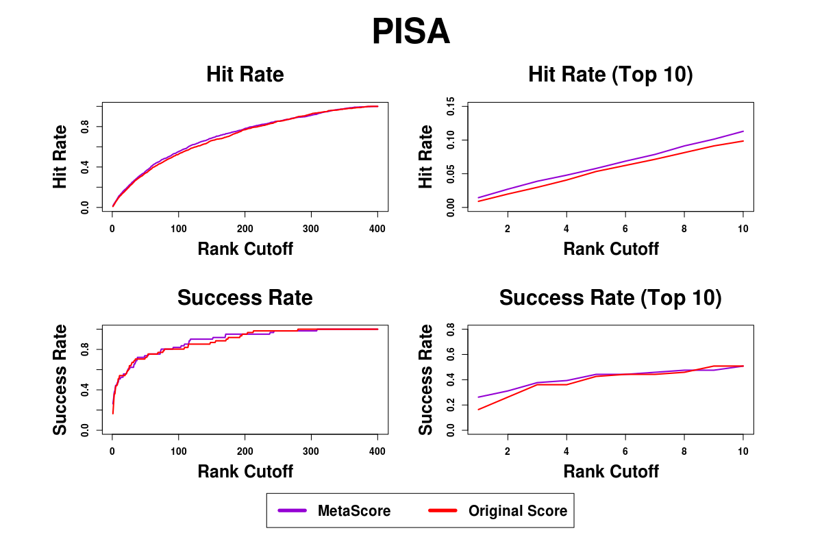
Supplementary Figure S7. Success rates and hit rates plotted against the top m conformations for a classical scoring method (PISA), machine learning-based method using RF, and the combined method of the two methods using BM4 decoy set. There are four panels. Top-left panel shows hit rates for conformations of top m ranging from 1 to 400; Top-right panel shows hit rates for conformations of top m ranging from 1 to 10; Bottom-left panel shows success rates for conformations of top m ranging from 1 to 400; Bottom-right panel shows success rates for conformations of top m ranging from 1 to 10.
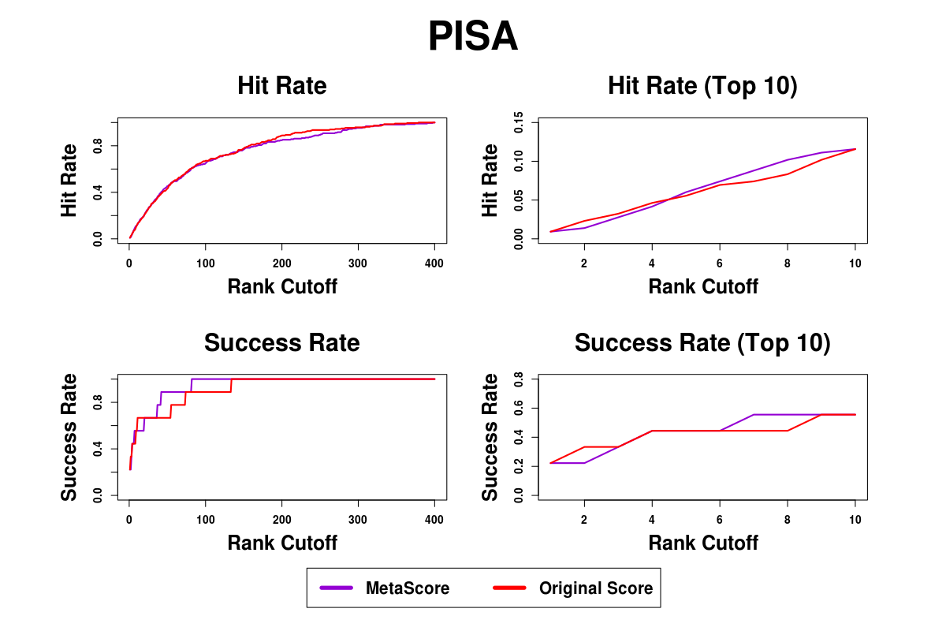
Supplementary Figure S8. Success rates and hit rates plotted against the top m conformations for a classical scoring method (PISA), machine learning-based method using RF, and the combined method of the two methods using BM5 decoy set. There are four panels. Top-left panel shows hit rates for conformations of top m ranging from 1 to 400; Top-right panel shows hit rates for conformations of top m ranging from 1 to 10; Bottom-left panel shows success rates for conformations of top m ranging from 1 to 400; Bottom-right panel shows success rates for conformations of top m ranging from 1 to 10.
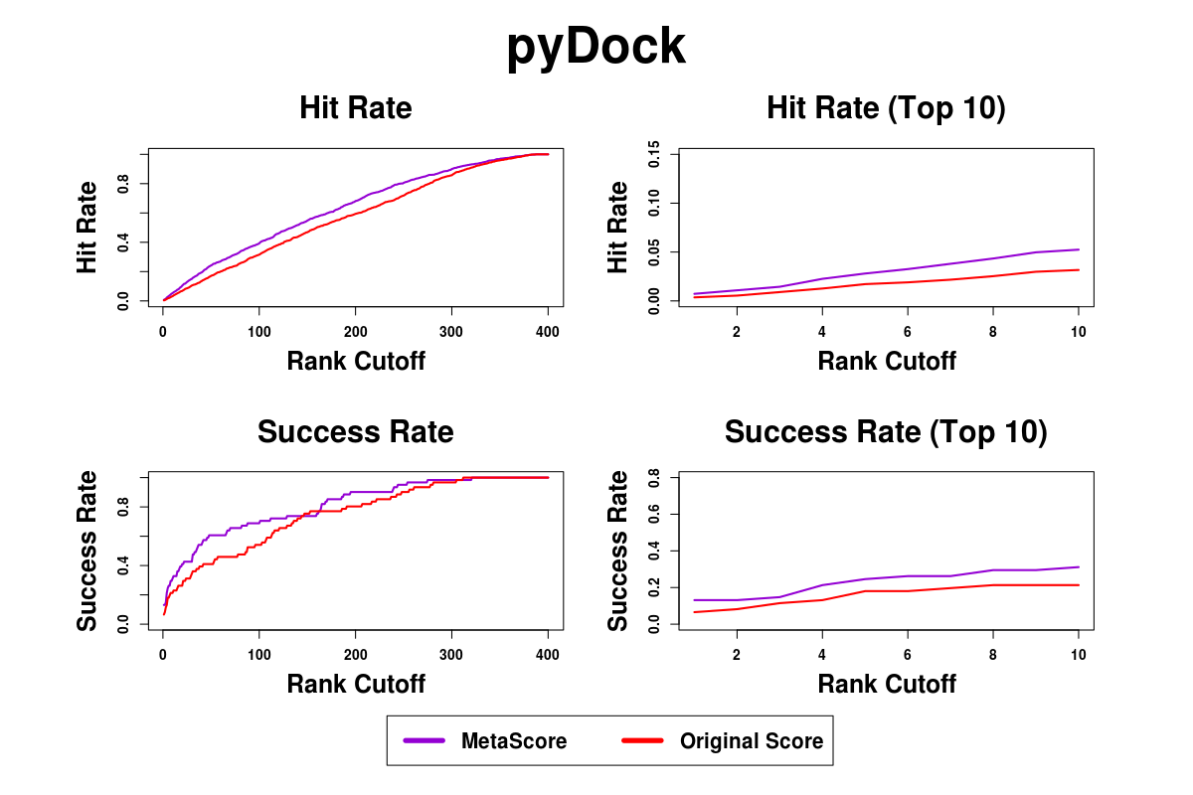
Supplementary Figure S9. Success rates and hit rates plotted against the top m conformations for a classical scoring method (pyDock), machine learning-based method using RF, and the combined method of the two methods using BM4 decoy set. There are four panels. Top-left panel shows hit rates for conformations of top m ranging from 1 to 400; Top-right panel shows hit rates for conformations of top m ranging from 1 to 10; Bottom-left panel shows success rates for conformations of top m ranging from 1 to 400; Bottom-right panel shows success rates for conformations of top m ranging from 1 to 10.
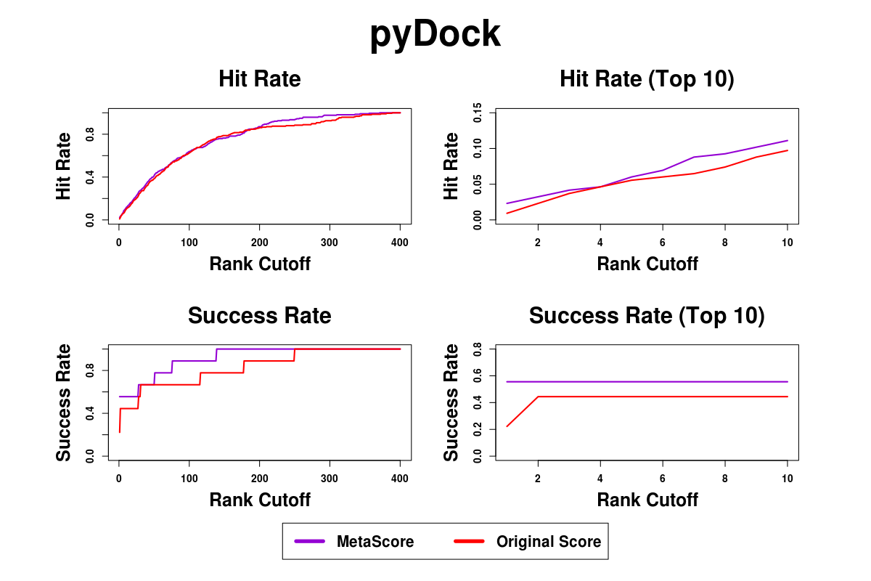
Supplementary Figure S10. Success rates and hit rates plotted against the top m conformations for a classical scoring method (pyDock), machine learning-based method using RF, and the combined method of the two methods using BM5 decoy set. There are four panels. Top-left panel shows hit rates for conformations of top m ranging from 1 to 400; Top-right panel shows hit rates for conformations of top m ranging from 1 to 10; Bottom-left panel shows success rates for conformations of top m ranging from 1 to 400; Bottom-right panel shows success rates for conformations of top m ranging from 1 to 10.
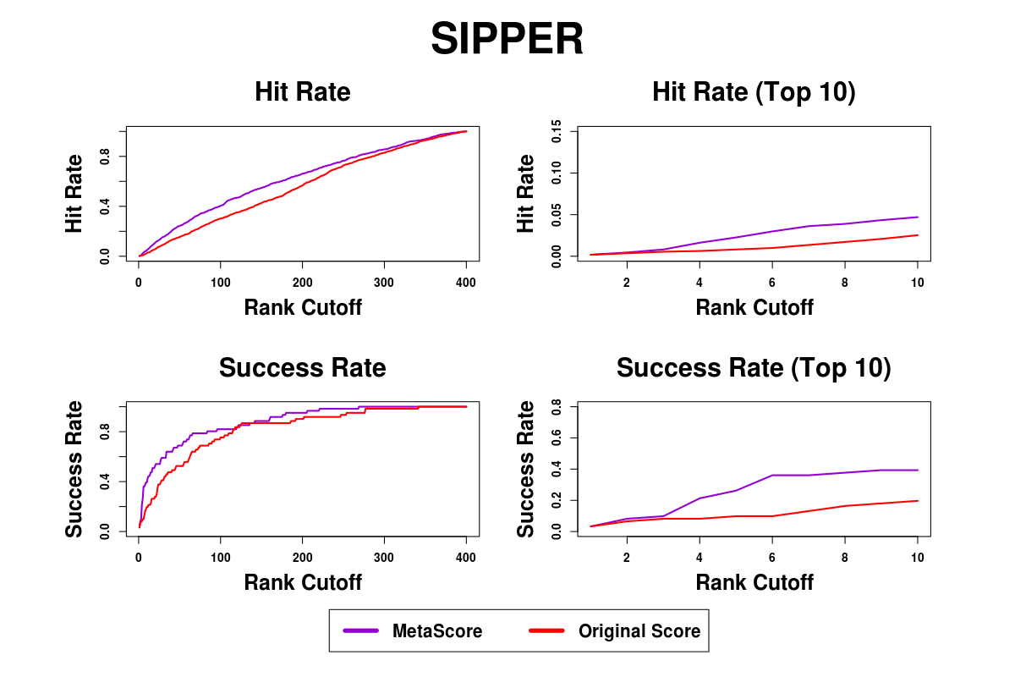
Supplementary Figure S11. Success rates and hit rates plotted against the top m conformations for a classical scoring method (SIPPER), machine learning-based method using RF, and the combined method of the two methods using BM4 decoy set. There are four panels. Top-left panel shows hit rates for conformations of top m ranging from 1 to 400; Top-right panel shows hit rates for conformations of top m ranging from 1 to 10; Bottom-left panel shows success rates for conformations of top m ranging from 1 to 400; Bottom-right panel shows success rates for conformations of top m ranging from 1 to 10.
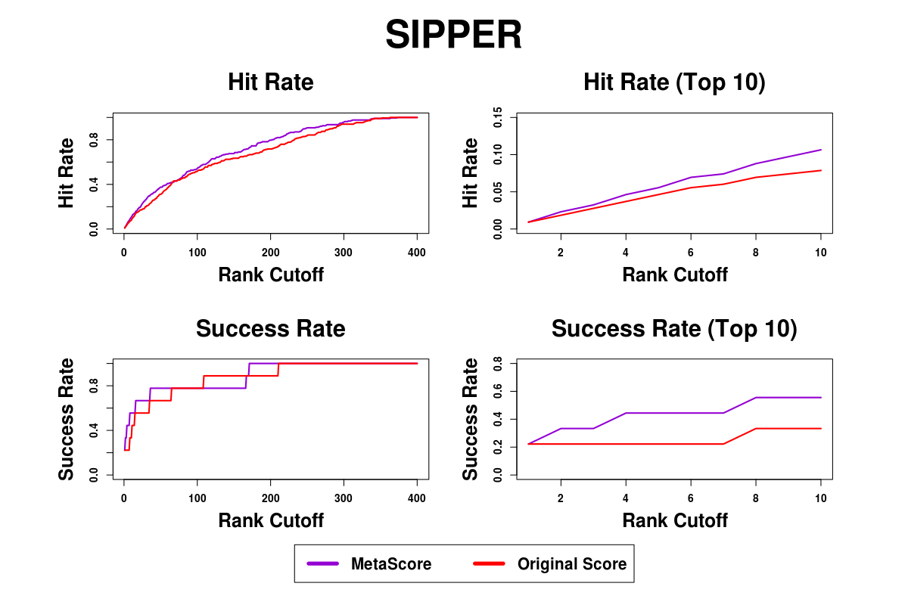
Supplementary Figure S12. Success rates and hit rates plotted against the top m conformations for a classical scoring method (SIPPER), machine learning-based method using RF, and the combined method of the two methods using BM5 decoy set. There are four panels. Top-left panel shows hit rates for conformations of top m ranging from 1 to 400; Top-right panel shows hit rates for conformations of top m ranging from 1 to 10; Bottom-left panel shows success rates for conformations of top m ranging from 1 to 400; Bottom-right panel shows success rates for conformations of top m ranging from 1 to 10.
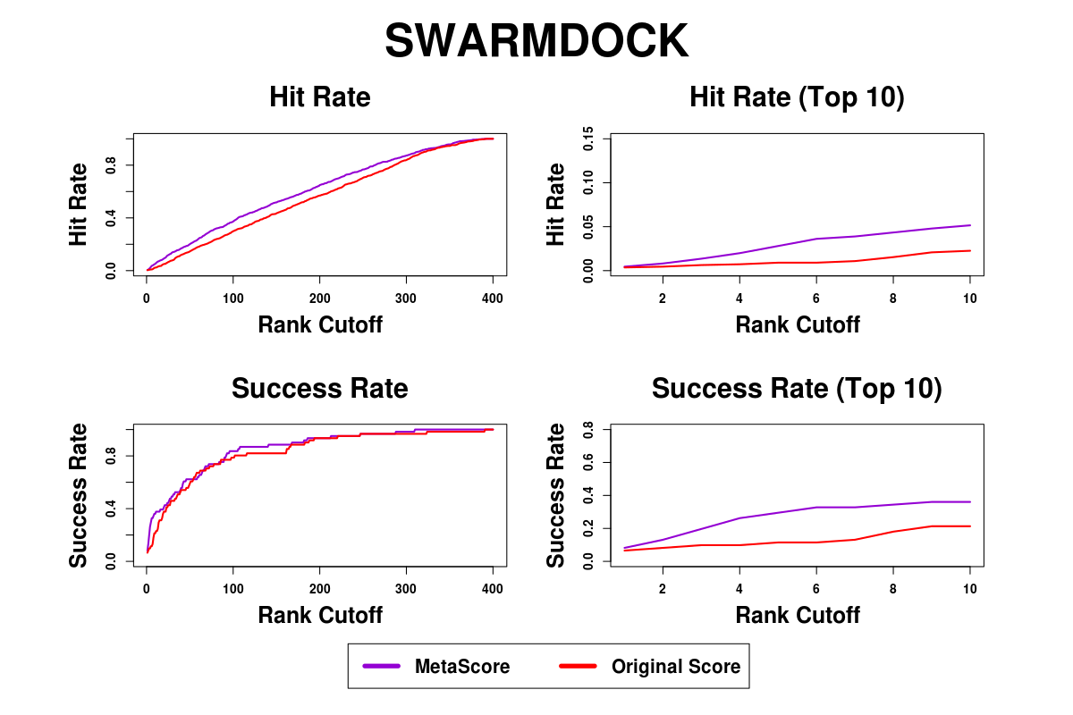
Supplementary Figure S13. Success rates and hit rates plotted against the top m conformations for a classical scoring method (SWARMDOCK), machine learning-based method using RF, and the combined method of the two methods using BM4 decoy set. There are four panels. Top-left panel shows hit rates for conformations of top m ranging from 1 to 400; Top-right panel shows hit rates for conformations of top m ranging from 1 to 10; Bottom-left panel shows success rates for conformations of top m ranging from 1 to 400; Bottom-right panel shows success rates for conformations of top m ranging from 1 to 10.
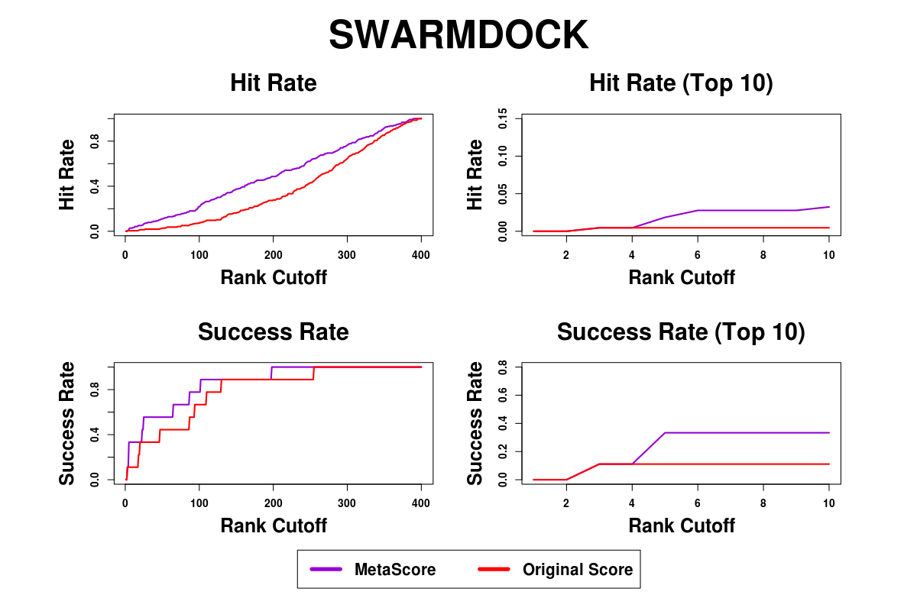
Supplementary Figure S14. Success rates and hit rates plotted against the top m conformations for a classical scoring method (SWARMDOCK), machine learning-based method using RF, and the combined method of the two methods using BM5 decoy set. There are four panels. Top-left panel shows hit rates for conformations of top m ranging from 1 to 400; Top-right panel shows hit rates for conformations of top m ranging from 1 to 10; Bottom-left panel shows success rates for conformations of top m ranging from 1 to 400; Bottom-right panel shows success rates for conformations of top m ranging from 1 to 10.
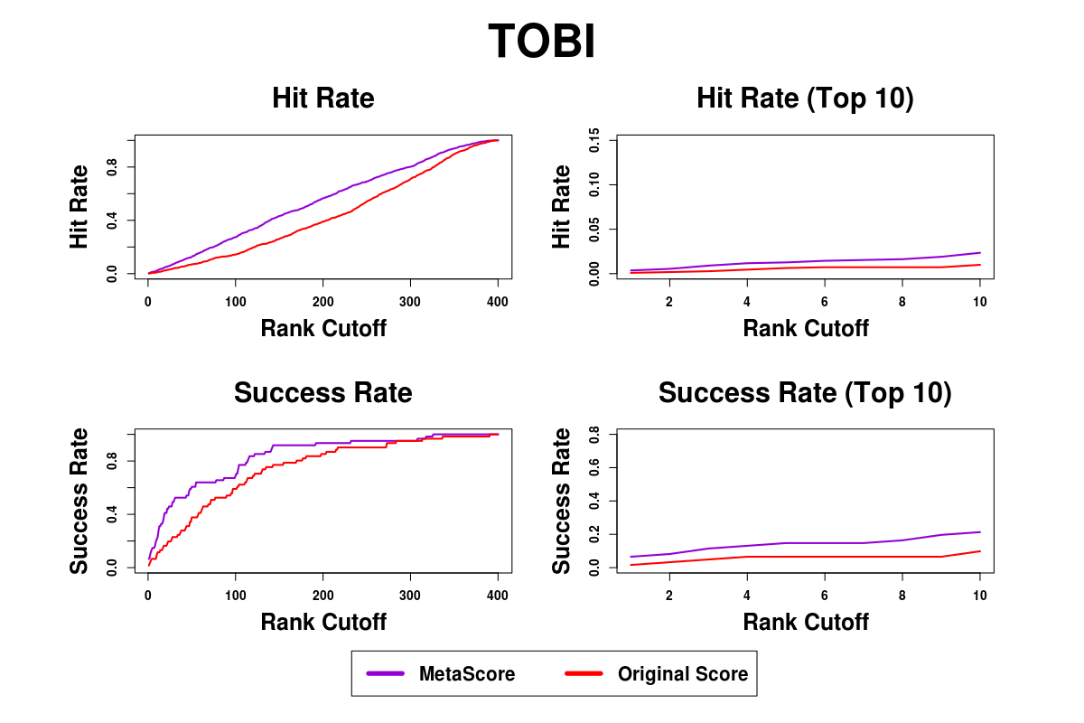
Supplementary Figure S15. Success rates and hit rates plotted against the top m conformations for a classical scoring method (TOBI), machine learning-based method using RF, and the combined method of the two methods using BM4 decoy set. There are four panels. Top-left panel shows hit rates for conformations of top m ranging from 1 to 400; Top-right panel shows hit rates for conformations of top m ranging from 1 to 10; Bottom-left panel shows success rates for conformations of top m ranging from 1 to 400; Bottom-right panel shows success rates for conformations of top m ranging from 1 to 10.
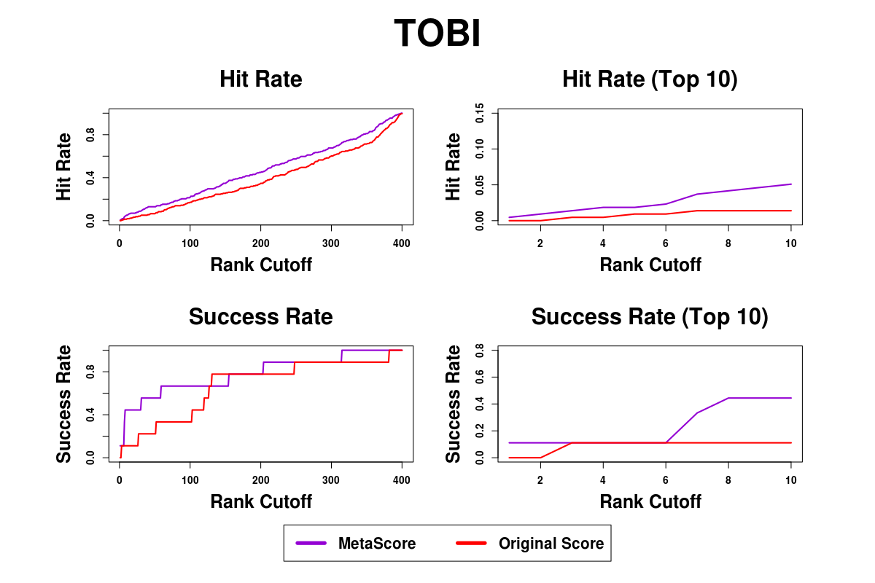
Supplementary Figure S16. Success rates and hit rates plotted against the top m conformations for a classical scoring method (TOBI), machine learning-based method using RF, and the combined method of the two methods using BM5 decoy set. There are four panels. Top-left panel shows hit rates for conformations of top m ranging from 1 to 400; Top-right panel shows hit rates for conformations of top m ranging from 1 to 10; Bottom-left panel shows success rates for conformations of top m ranging from 1 to 400; Bottom-right panel shows success rates for conformations of top m ranging from 1 to 10.

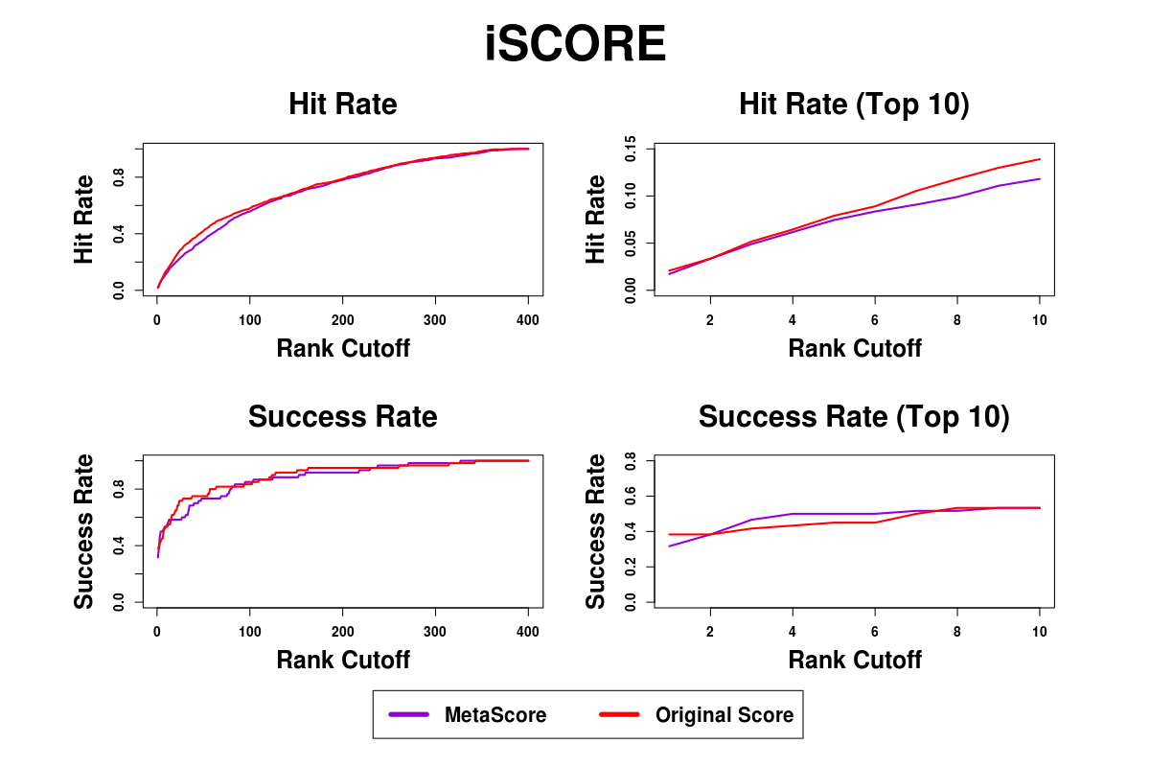
Supplementary Figure 17. Success rates and hit rates plotted against the top m conformations for a classical scoring method (iSCORE), machine learning-based method using RF, and the combined method of the two methods using BM4 decoy set. There are four panels. Top-left panel shows hit rates for conformations of top m ranging from 1 to 400; Top-right panel shows hit rates for conformations of top m ranging from 1 to 10; Bottom-left panel shows success rates for conformations of top m ranging from 1 to 400; Bottom-right panel shows success rates for conformations of top m ranging from 1 to 10.

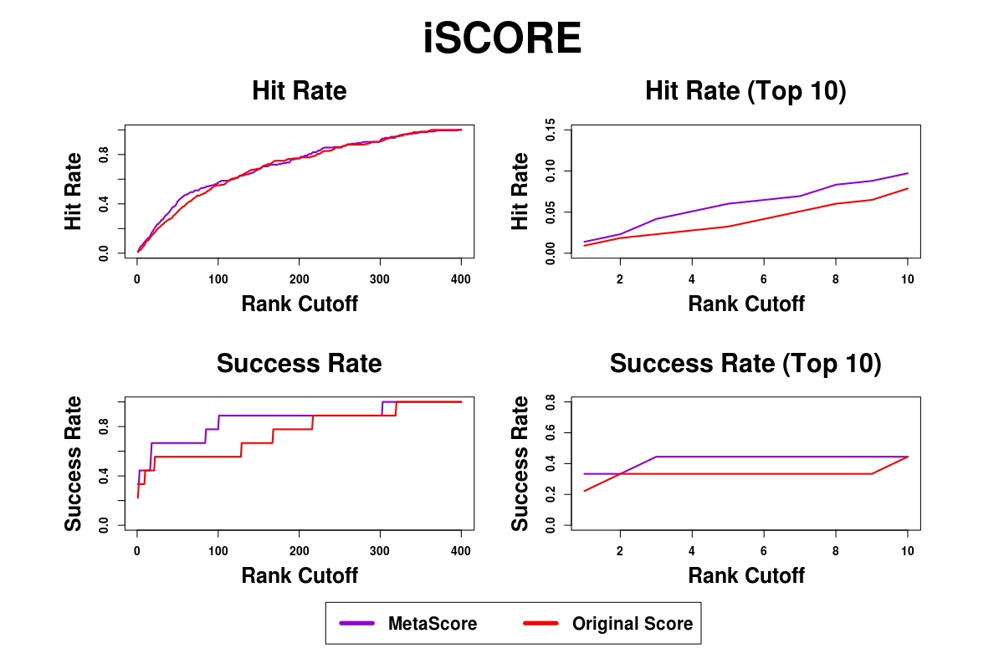
Supplementary Figure 18. Success rates and hit rates plotted against the top m conformations for a classical scoring method (iSCORE), machine learning-based method using RF, and the combined method of the two methods using BM5 decoy set. There are four panels. Top-left panel shows hit rates for conformations of top m ranging from 1 to 400; Top-right panel shows hit rates for conformations of top m ranging from 1 to 10; Bottom-left panel shows success rates for conformations of top m ranging from 1 to 400; Bottom-right panel shows success rates for conformations of top m ranging from 1 to 10.

