Supplementary data

Oxytocin promotes epicardial cell activation and heart regeneration after cardiac injury

Aaron H. Wasserman^{1,2}, Yonatan R. Lewis-Israeli^{1,2}, Amanda R. Huang^{1,2}, McKenna D. Dooley^{1,2}, Allison L. Mitchell^{1,2}, Manigandan Venkatesan^{1,2} and Aitor Aguirre^{1,2}

¹Division of Developmental and Stem Cell Biology, Institute for Quantitative Health Science and Engineering (IQ), Michigan State University, East Lansing, MI, USA
²Department of Biomedical Engineering, College of Engineering, Michigan State University, East Lansing, MI, USA

Corresponding author: aaguirre@msu.edu

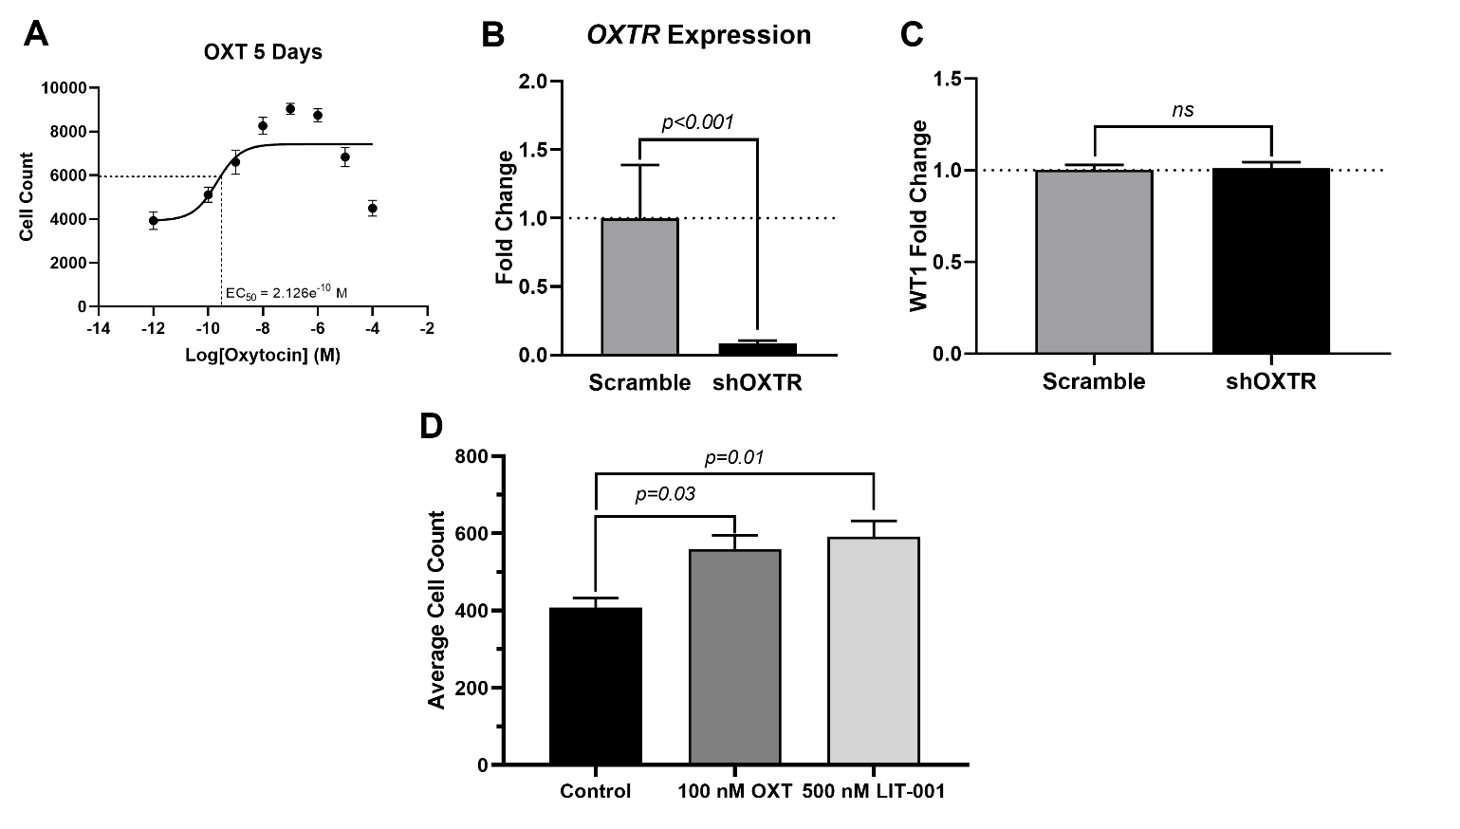
Supplementary Figure 1. A) Dose-response data for hEpiCs exposed to different concentrations of OXT over the course of 5 days as determined by automated cell counting. B) qRT-PCR for OXTR expression in scrambled and shOXTR-knockdown hEpiCs. C) hEpiC differentiation efficiency in both cell lines, expressed as percent WT1⁺ cells relative to each other at day 25 of differentiation. D) Absolute cell counts of scramble hEpiCs exposed to 100 nM OXT and 500 nM LIT-001, a non-peptide OXTR agonist.

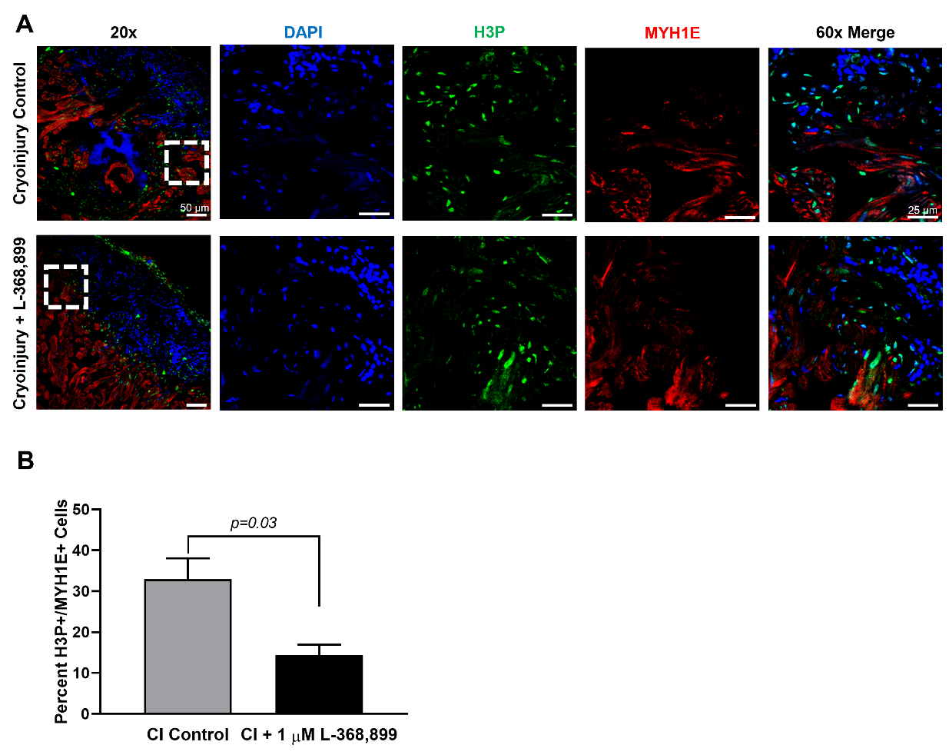

Supplementary Figure 2. Inhibition of oxytocin signaling also affects cardiomyocyte proliferation during zebrafish heart regeneration. Confocal immunofluorescent images (A) and quantification (B) of proliferating cardiomyocytes in cryoinjured zebrafish hearts at 3 dpi. In (A), cardiomyocytes are labeled with MYH1E (red), proliferating cells are labeled with H3P (green), nuclei are labeled with DAPI (blue); First images are low magnification (scale bar: 50 µm), last 4 images are high magnification of the area demarcated by the dashed white box (scale bar: 25 µm); n=4 images.

