Supporting Information

Hydrothermal Synthesis of Clove Buds-Derived Multifunctional Carbon Dots Passivated with PVP- Antioxidants, Catalysis, and Bioimaging Applications
Anurag Kumar Pandey ª, Kamakshi Bankoti ^{b}, Tapan Kumar Nath ^{c}, Santanu Dhara ^{b *}
ª School of Nano Science and Technology, Indian Institute of Technology Kharagpur, Kharagpur, West Bengal – 721302
^{b} School of Medical Science and Technology, Indian Institute of Technology Kharagpur, Kharagpur, West Bengal – 721302
^{c} Department of Physics, Indian Institute of Technology Kharagpur, Kharagpur, West Bengal – 721302

* Corresponding author
Prof. Santanu Dhara (Professor) School of Medical Science and Technology IIT Kharagpur 721302, West Bengal., India Email: sdhara@smst.iitkgp.ac.in Phone: +91-3222-282306

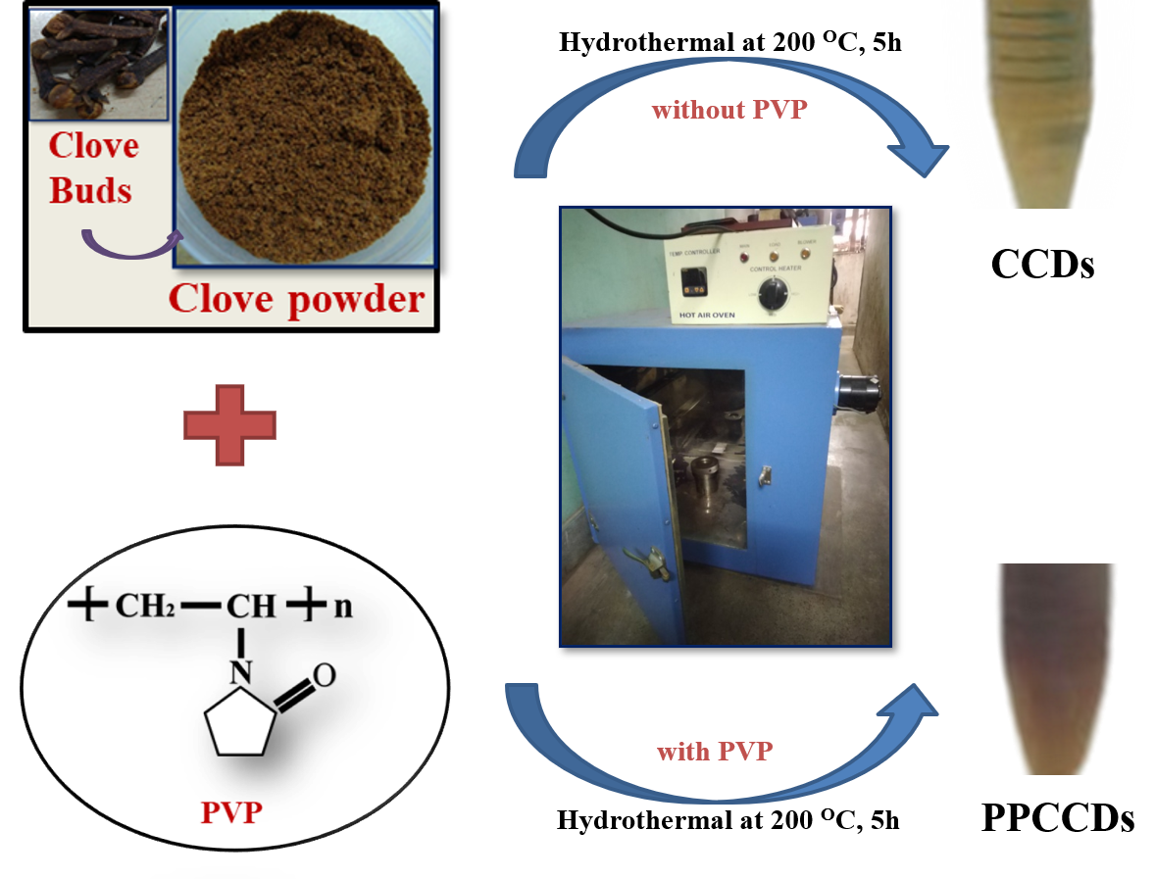
Fig. S.1 Schematic of process involve in synthesis of PVP-passivated clove-derived carbon dots (PPCCDs) and non-passivated clove-derived carbon dots (CCDs)
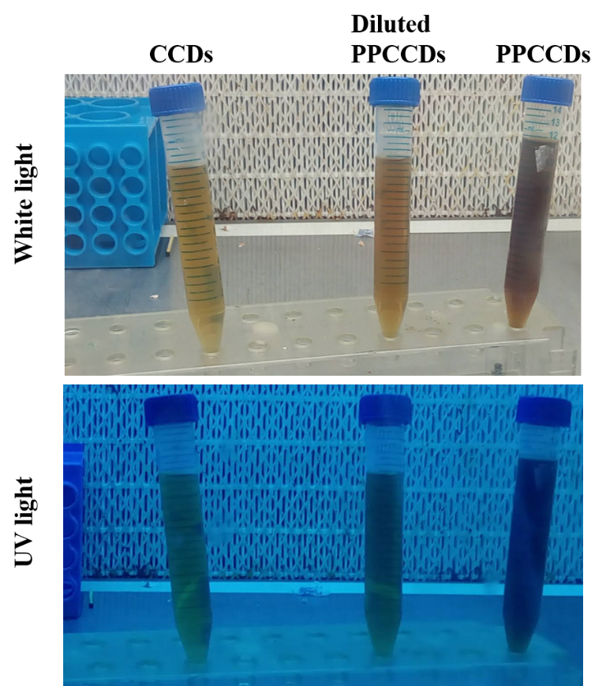
Fig. S.2 White light and ultraviolet light exposer of as-synthesized PPCCDs and CCDs.
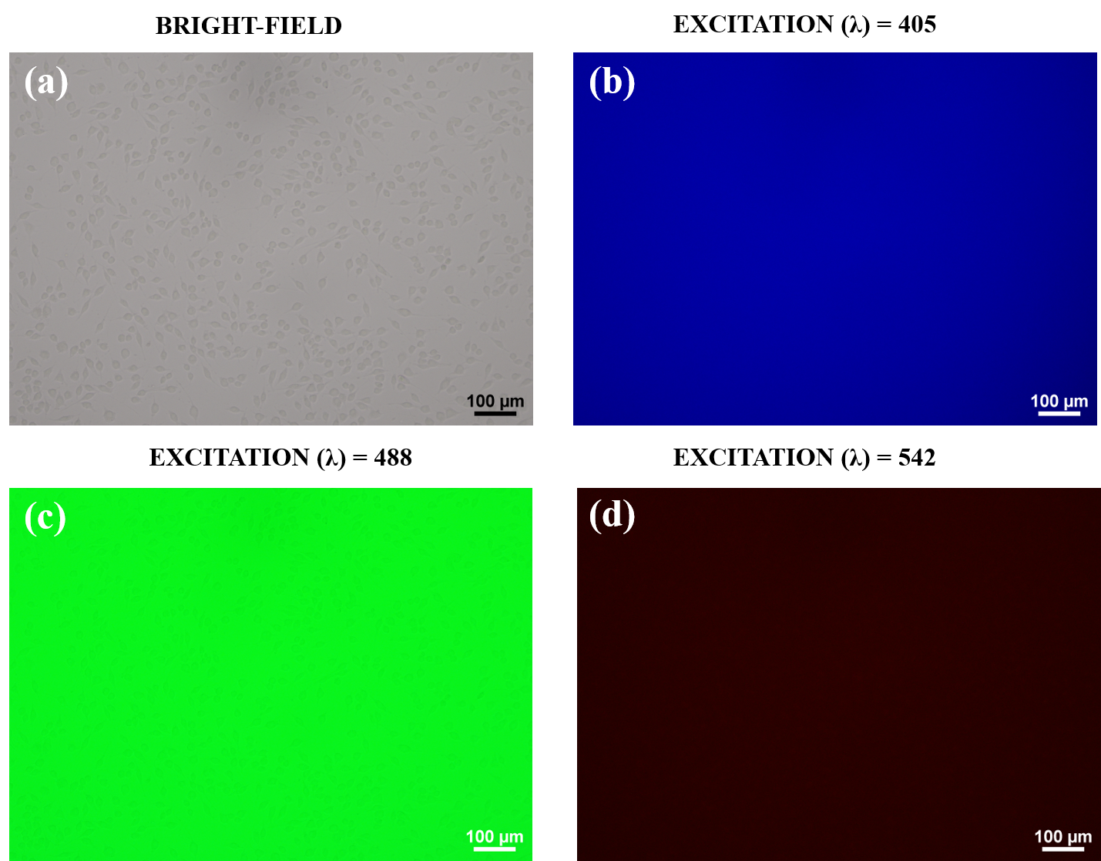

Fig. S.3 The untreated fibroblast cells (without PPCCDs labelling) excited by laser of wavelength 405 nm, 488 nm, and 542 nm, respectively. Scale bar: 100 µm.

Quantum yield- The quantum yield (Q) is ratio of photon absorb to photon emitted which help to determine the comparative yield of desired sample (CDs) with respect to standard sample. The quinine sulfate used as standard sample in the experiment. The quantum yield of PPCCDs and CCDs were calculated using the following equation.
Quantum Yield (Q) = Q_{R} 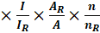
Where, A and A_{R} belongs to absorbance, I and I_{R} is integrated emission intensity, n and n_{R} is refractive index of solvent used for both CDs and reference, and Q_{R} refers the quantum yield of standard quinine sulfate. The calculation of quantum yield of CCDs and PPCCDs were obtain from the slope of Fig S4 and are shown in Table S1.
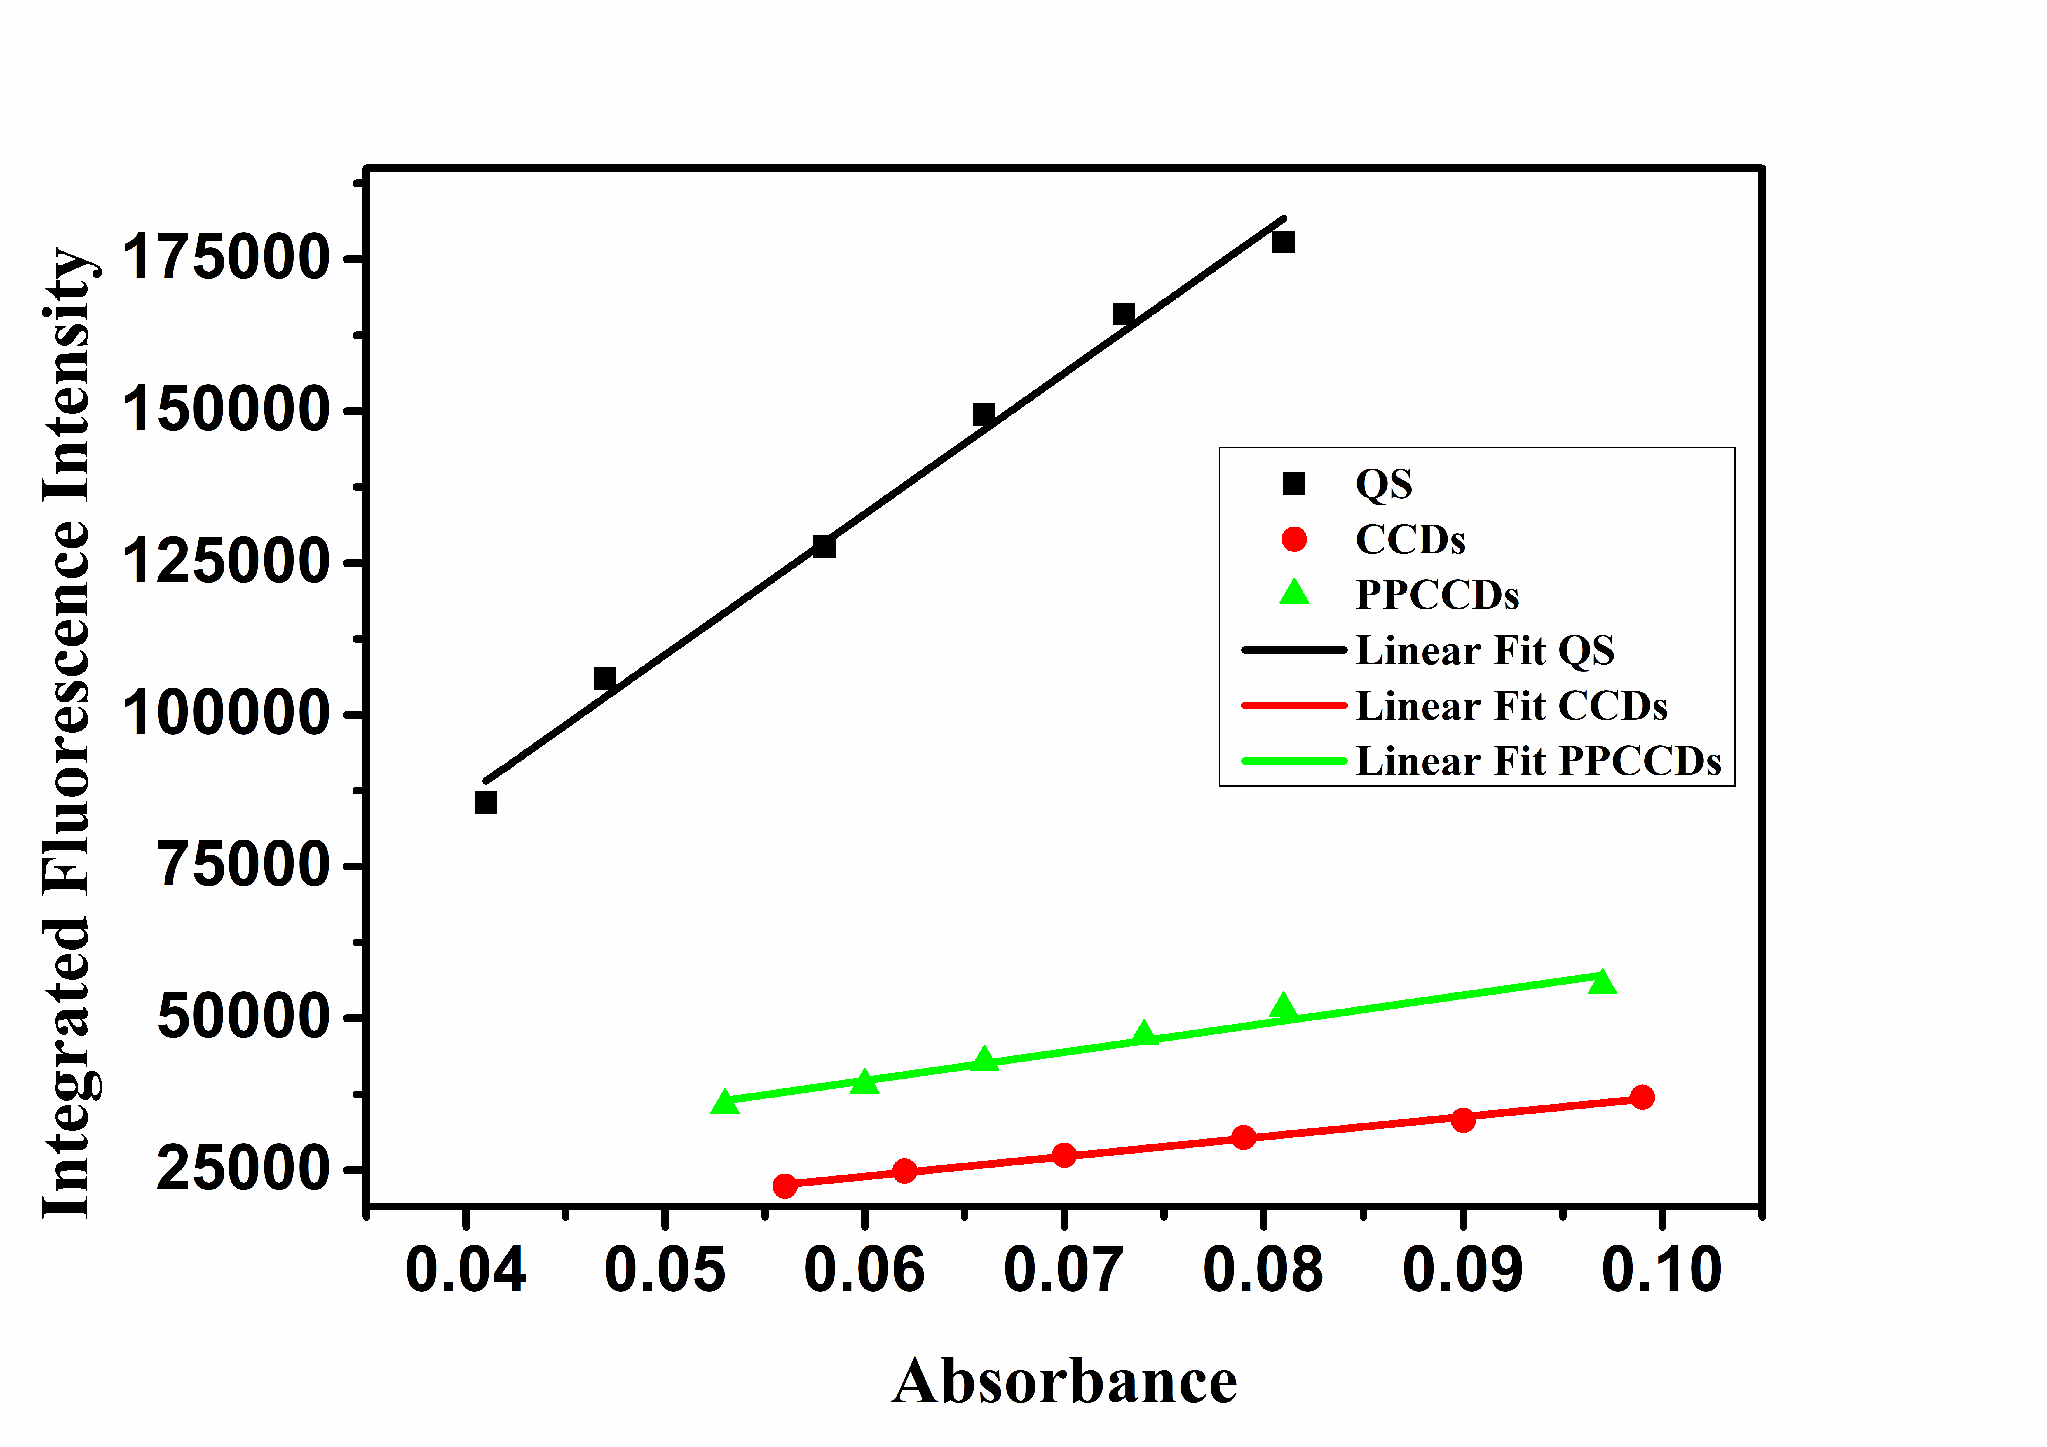
Fig. S4 Quantum yield plot of PPCCDs and CCDs considering quinine sulfate as standard.
Table S.1 Calculation of Quantum yield of CCDs and PPCCDs considering quinine sulfate as standard.
S. No. | Sample | Slope | Refractive index solvent (ɳ) | Quantum Yield (%)
1 | Quinine sulfate | 2315780 | 1.33 | 54
2 | CCDs | 327486 | 1.33 | 7.6
3 | PPCCDs | 468711 | 1.33 | 10.9

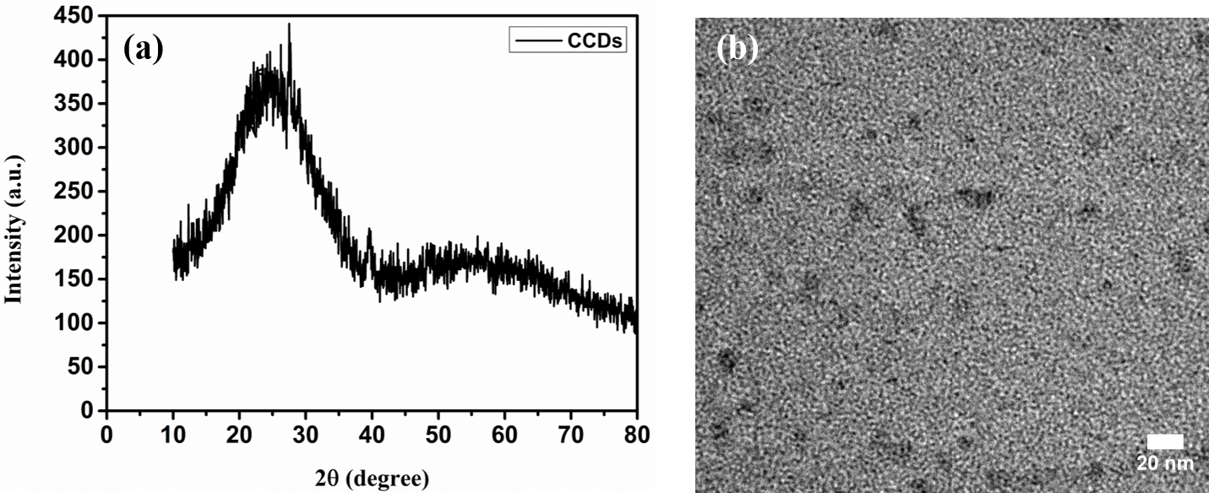
Fig. S.5 (a) XRD spectra (b) TEM image of clove derived carbon dots (CCDs).
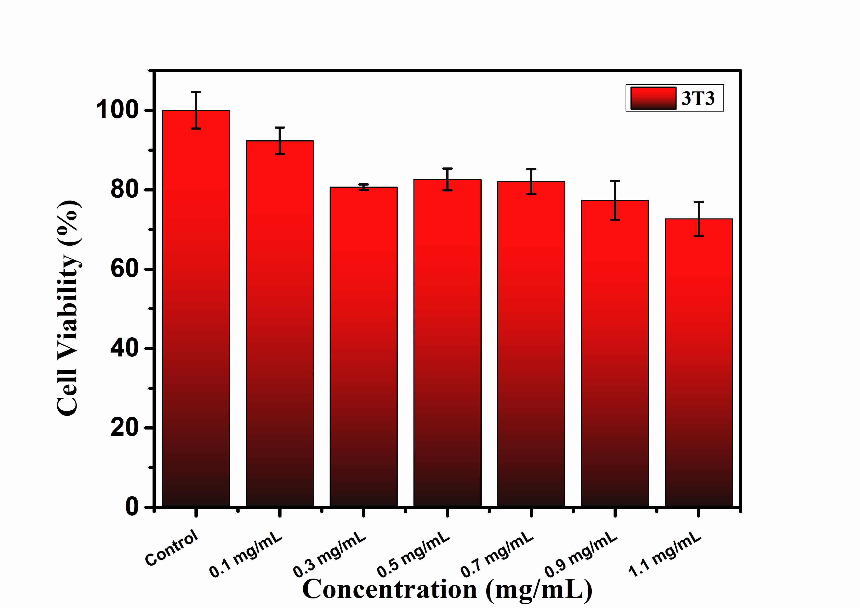
Fig. S.6 Cell viability study of PPCCDs over 3T3 cells
Table S.2 Comparison of antioxidant efficacy of various carbon dots from derived from different carbon precursors.
Carbon precursor | DPPH Antioxidant Activity (%) | Superoxide Radical Inhibition (%) | Ref.
Pomelo and ammonium persulfate | 56 | 88 | [1]
Pomelo juice and sulfamic acid | 62 | 82 | [2]
Proanthocyanidin and ethylenediamine | 30 | - | [3]
Polyethyleneimine and cysteine | 74.8 | 68 | [4]
Selenocysteine | 70 | - | [5]
Black soya beans | 62.8 | 81.3 | [6]
PPCCDs | 94 | 89 | This work

Table S.3 Comparison of rate constant performances of various nano-catalyst over degradation of Rhodamine-B
Nanomaterials | K_{app} (10⁻³ min⁻¹) | K (s⁻¹ g) | Ref.
Au/CeO₂-TiO₂ nano-hybrid | 223.9 | 0.196 | [7]
Au nanocrystal  Ag nanocrystal | 0.033  0.007 | - | [8]
ZnCO₂O₄ nano-dice | 70.4 | - | [9]
CDs | 34 | - | [10]
N-CQDs | 22.4 | - | [11]
PPCCDs | 88.7 | 7.39 | This work

Table S.4 Comparison of various surface passivated carbon dots with their quantum yield and multifunctional aspect.
Carbon precursors with passivating agent | Methods | Quantum yield (%) | Applications | Ref.
Curcumin, PEI | Hydrothermal | 2.28 | Imaging, sensing | [12]
Glycerol, (TTDDA) | Microwave | 12.02 | Bioimaging | [13]
Chitosan, PEG | microwave | 5.06 |  | [14]
Galactose, Polydopamine | microwave | 4.6 | In-vivo imaging | [15]
Clove, PVP | Hydrothermal | 10.9 | Bioimaging, Antioxidant, catalyst | This work

References
[1] J. Shen, S. Shang, X. Chen, D. Wang, Y. Cai, Highly fluorescent N, S-co-doped carbon dots and their potential applications as antioxidants and sensitive probes for Cr (VI) detection, Sensors Actuators, B Chem. 248 (2017) 92–100. https://doi.org/10.1016/j.snb.2017.03.123.
[2] J. Shen, T. Zhang, Y. Cai, X. Chen, S. Shang, J. Li, Highly fluorescent N,S-co-doped carbon dots: Synthesis and multiple applications, New J. Chem. 41 (2017) 11125–11137. https://doi.org/10.1039/c7nj00505a.
[3] D. Yang, L. Li, L. Cao, Y. Zhang, M. Ge, R. Yan, W.F. Dong, Superior reducing carbon dots from proanthocyanidin for free-radical scavenging and for cell imaging, Analyst. 146 (2021) 2330–2338. https://doi.org/10.1039/d0an02479a.
[4] P. Das, S. Ganguly, S. Margel, A. Gedanken, Immobilization of Heteroatom-Doped Carbon Dots onto Nonpolar Plastics for Antifogging, Antioxidant, and Food Monitoring Applications, Langmuir. 37 (2021) 3508–3520. https://doi.org/10.1021/acs.langmuir.1c00471.
[5] J. Shi, Y. Pu, J.X. Wang, D. Wang, J.F. Chen, Synthesis of ultrasmall and monodisperse selenium-doped carbon dots from amino acids for free radical scavenging Rina Su, Ind. Eng. Chem. Res. 59 (2020) 16876–16883. https://doi.org/10.1021/acs.iecr.0c03402.
[6] J. Jia, B. Lin, Y. Gao, Y. Jiao, L. Li, C. Dong, S. Shuang, Highly luminescent N-doped carbon dots from black soya beans for free radical scavenging, Fe3+ sensing and cellular imaging, Spectrochim. Acta - Part A Mol. Biomol. Spectrosc. 211 (2019) 363–372. https://doi.org/10.1016/j.saa.2018.12.034.
[7] P. Saikia, A.T. Miah, P.P. Das, Highly efficient catalytic reductive degradation of various organic dyes by Au/CeO2-TiO2 nano-hybrid, J. Chem. Sci. 129 (2017) 81–93. https://doi.org/10.1007/s12039-016-1203-0.
[8] J. Piella, F. Merkoçi, A. Genç, J. Arbiol, N.G. Bastús, V. Puntes, Probing the surface reactivity of nanocrystals by the catalytic degradation of organic dyes: The effect of size, surface chemistry and composition, J. Mater. Chem. A. 5 (2017) 11917–11929. https://doi.org/10.1039/c7ta01328k.
[9] P.C. Nagajyoyhi, K.C. Devarayapalli, T.V.M. Sreekanth, S.V.P. Vattikuti, J. Shim, Effective catalytic degradation of rhodamine B using ZnCO2O4 nanodice, Mater. Res. Express. 6 (2019) 0–6. https://doi.org/10.1088/2053-1591/ab3bbf.
[10] Y. Zhou, E.M. Zahran, B.A. Quiroga, J. Perez, K.J. Mintz, Z. Peng, P.Y. Liyanage, R.R. Pandey, C.C. Chusuei, R.M. Leblanc, Size-dependent photocatalytic activity of carbon dots with surface-state determined photoluminescence, Appl. Catal. B Environ. 248 (2019) 157–166. https://doi.org/10.1016/j.apcatb.2019.02.019.
[11] Y. Cheng, M. Bai, J. Su, C. Fang, H. Li, J. Chen, J. Jiao, Synthesis of fluorescent carbon quantum dots from aqua mesophase pitch and their photocatalytic degradation activity of organic dyes, J. Mater. Sci. Technol. 35 (2019) 1515–1522. https://doi.org/10.1016/j.jmst.2019.03.039.
[12] T. Pal, S. Mohiyuddin, G. Packirisamy, Facile and Green Synthesis of Multicolor Fluorescence Carbon Dots from Curcumin: In Vitro and in Vivo Bioimaging and Other Applications, ACS Omega. 3 (2018) 831–843. https://doi.org/10.1021/acsomega.7b01323.
[13] C. Liu, P. Zhang, F. Tian, W. Li, F. Li, W. Liu, One-step synthesis of surface passivated carbon nanodots by microwave assisted pyrolysis for enhanced multicolor photoluminescence and bioimaging, J. Mater. Chem. 21 (2011) 13163. https://doi.org/10.1039/c1jm12744f.
[14] A. Sachdev, I. Matai, S.U. Kumar, B. Bhushan, P. Dubey, P. Gopinath, A novel one-step synthesis of PEG passivated multicolour fluorescent carbon dots for potential biolabeling application, RSC Adv. 3 (2013) 16958. https://doi.org/10.1039/c3ra42415d.
[15] J.S. Pappalardo, J.R. MacAiran, A. MacIna, A. Poulhazan, V. Quattrocchi, I. Marcotte, R. Naccache, Effects of polydopamine-passivation on the optical properties of carbon dots and its potential use: In vivo, Phys. Chem. Chem. Phys. 22 (2020) 16595–16605. https://doi.org/10.1039/d0cp01938k.

