Supplemental File 1

Supplemental File 1, Figure S1

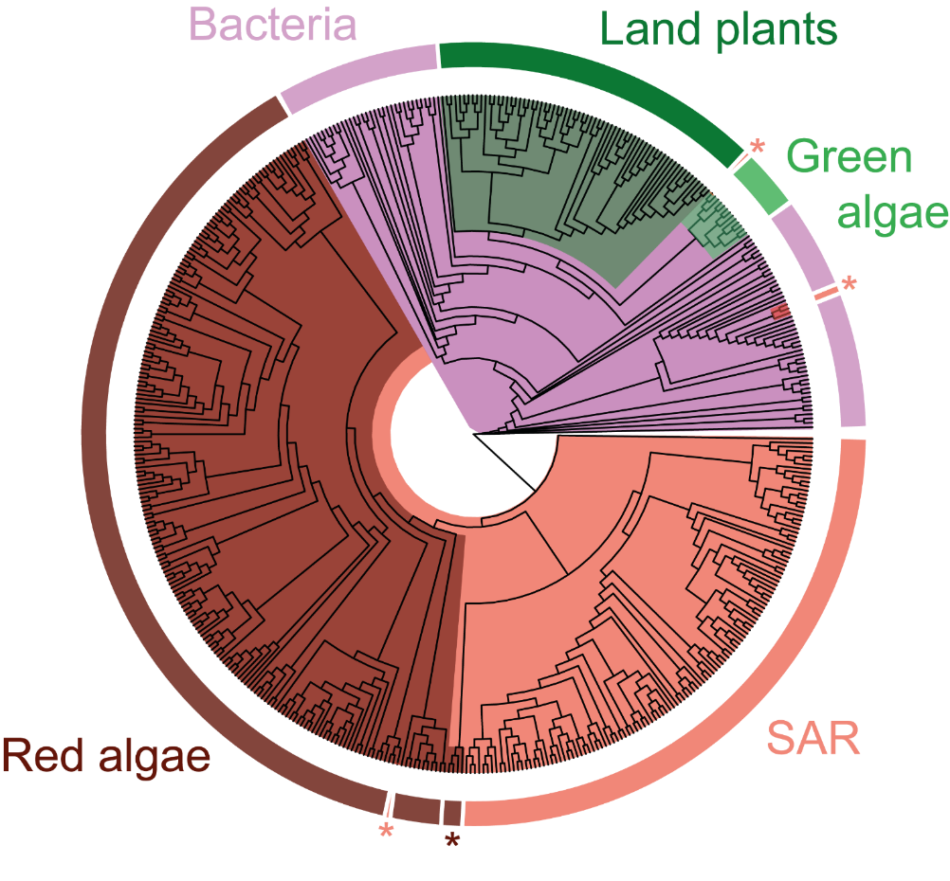

Supplemental Figure S1. A phylogenetic tree of species in this study. Evolutionary history has been inferred from a multiple sequence alignment of the rbcL coding sequence in each species. The phylogeny is displayed as a cladogram for ease of visualisation, and species membership to different taxonomic groups (labelled) are highlighted by colour. Dark brown: red algae (Rhodophyta; n = 201). Light brown: SAR supergroup (Stramenopiles, Alveolates, and Rhizaria; n = 129). Lilac: bacteria (Bacteria; n = 78). Dark green: land plants (Streptophyta; n = 68). Light green: green algae (Chlorophyta; n = 12). Species at terminal nodes which are likely misplaced in this phylogeny are marked by an asterisk (*).

Supplemental File 1, Table S1
Table S1. Summary of the percentile rate of nucleotide and protein evolution in each rubisco subunit in context of all other genes in each taxonomic group. Data have been calculated between each pairwise combination of species within a taxonomic group for which either a nuclear (land plants, green algae, red algae, SAR) or bacterial (bacteria) genome could be acquired. Statistics are rounded to three decimal places, and include the median, first quartile (Q1), third quartile (Q3), the interquartile range (IQR), the mean and the standard error (S.E.).

Taxonomic Group | Rubisco Subunit | Sequence | Percentile Rate
 |  |  | Median | Q1 | Q3 | IQR | Mean | S.E.
Bacteria | rbcL | Nucleotide | 2.583 | 0.856 | 5.641 | 4.785 | 4.711 | 0.315
Land plants |  |  | 0.057 | 0.016 | 0.170 | 0.154 | 0.362 | 0.100
Green algae |  |  | 0.042 | 0.019 | 0.088 | 0.069 | 0.052 | 0.016
Red algae |  |  | 0.043 | 0.030 | 0.206 | 0.176 | 0.133 | 0.040
SAR |  |  | 1.065 | 0.308 | 2.781 | 2.473 | 6.392 | 2.035
Bacteria | RbcL | Protein | 2.647 | 0.960 | 5.122 | 4.162 | 3.983 | 0.244
Land plants |  |  | 2.187 | 1.573 | 3.314 | 1.741 | 3.095 | 0.201
Green algae |  |  | 0.979 | 0.476 | 1.695 | 1.219 | 1.173 | 0.343
Red algae |  |  | 0.953 | 0.900 | 1.139 | 0.238 | 1.184 | 0.190
SAR |  |  | 3.055 | 2.358 | 4.059 | 1.702 | 6.878 | 1.618
Bacteria | rbcS | Nucleotide | 25.114 | 14.814 | 39.697 | 24.883 | 28.233 | 0.836
Land plants |  |  | 64.057 | 52.487 | 76.510 | 24.023 | 61.859 | 1.089
Green algae |  |  | 3.953 | 1.896 | 5.653 | 3.757 | 5.208 | 2.087
Red algae |  |  | 1.253 | 1.008 | 1.963 | 0.955 | 1.392 | 0.204
SAR |  |  | 7.048 | 1.269 | 15.865 | 14.595 | 20.456 | 5.489
Bacteria | RbcS | Protein | 41.876 | 24.325 | 52.759 | 28.434 | 38.893 | 0.844
Land plants |  |  | 52.024 | 36.134 | 67.519 | 31.384 | 52.231 | 1.002
Green algae |  |  | 14.360 | 10.353 | 17.700 | 7.347 | 14.662 | 2.028
Red algae |  |  | 8.708 | 7.083 | 16.700 | 9.617 | 11.424 | 1.698
SAR |  |  | 16.717 | 4.676 | 20.884 | 16.208 | 21.167 | 3.874

Supplemental File 1, Table S2
Supplemental File 1, Table S2. Summary of the percentile rate of nucleotide and protein evolution in each rubisco subunit in context of all other enzyme-encoding genes in each taxonomic group. Data have been calculated between each pairwise combination of species within a taxonomic group for which either a nuclear (land plants, green algae, red algae, SAR) or bacterial (bacteria) genome could be acquired. Statistics are rounded to three decimal places, and include the median, first quartile (Q1), third quartile (Q3), the interquartile range (IQR), the mean and the standard error (S.E.).

Taxonomic Group | Rubisco Subunit | Sequence | Percentile Rate
 |  |  | Median | Q1 | Q3 | IQR | Mean | S.E.
Bacteria | rbcL | Nucleotide | 3.090 | 0.993 | 7.016 | 6.023 | 5.573 | 0.365
Land plants |  |  | 0.070 | 0.031 | 0.174 | 0.143 | 0.384 | 0.108
Green algae |  |  | 0.057 | 0.053 | 0.061 | 0.008 | 0.056 | 0.002
Red algae |  |  | 0.092 | 0.076 | 0.161 | 0.085 | 0.152 | 0.037
SAR |  |  | 0.618 | 0.302 | 2.871 | 2.569 | 5.885 | 1.952
Bacteria | RbcL | Protein | 2.978 | 0.961 | 5.706 | 4.745 | 4.334 | 0.274
Land plants |  |  | 2.688 | 1.868 | 4.146 | 2.278 | 3.802 | 0.234
Green algae |  |  | 0.228 | 0.191 | 0.284 | 0.093 | 0.333 | 0.114
Red algae |  |  | 0.510 | 0.452 | 0.887 | 0.435 | 0.923 | 0.262
SAR |  |  | 2.778 | 1.874 | 3.709 | 1.835 | 6.657 | 1.684
Bacteria | rbcS | Nucleotide | 30.412 | 18.002 | 46.773 | 28.771 | 32.932 | 0.944
Land plants |  |  | 71.256 | 60.765 | 83.175 | 22.410 | 68.478 | 1.055
Green algae |  |  | 2.862 | 1.017 | 5.632 | 4.615 | 4.291 | 1.815
Red algae |  |  | 1.038 | 0.523 | 2.165 | 1.642 | 1.406 | 0.305
SAR |  |  | 6.782 | 1.068 | 16.591 | 15.523 | 20.672 | 5.402
Bacteria | RbcS | Protein | 47.314 | 29.298 | 56.569 | 27.271 | 43.035 | 0.887
Land plants |  |  | 61.809 | 45.382 | 76.873 | 31.491 | 60.920 | 1.016
Green algae |  |  | 18.046 | 12.067 | 23.666 | 11.599 | 17.880 | 2.612
Red algae |  |  | 12.160 | 8.291 | 21.634 | 13.343 | 15.306 | 2.460
SAR |  |  | 21.205 | 4.505 | 27.904 | 23.399 | 22.595 | 3.859

Supplemental File 1, Table S3
Supplemental File 1, Table S3. Summary of the rate of nucleotide and protein evolution in each Calvin-Benson-Bassham cycle enzyme as a percentage ratio (%) of that measured in the rubisco large subunit (rbcL/RbcL). Data have been calculated between each pairwise combination of species within the land plant clade for which a nuclear genome could be acquired. Statistics are rounded to three decimal places, and include the median, first quartile (Q1), third quartile (Q3), the interquartile range (IQR), the mean and the standard error (S.E.). RBCS: rubisco small subunit. PGK: phosphoglycerate kinase. GAPDH-A: glyceraldehyde-3-phosphate dehydrogenase A subunit. GAPDH-B: glyceraldehyde-3-phosphate dehydrogenase B subunit. TPI: triose phosphate isomerase. FBA: fructose-bisphosphate aldolase. FBP: fructose-1,6-bisphosphatase. TKL: transketolase. SBP: sedoheptulose-bisphosphatase. RPI: ribose 5-phosphate isomerase. RPE: ribulose-p-3-epimerase. PRK: phosphoribulokinase.
Enzyme | Sequence | % of rbcL/RbcL Molecular Evolution
 |  | Median | Q1 | Q3 | IQR | Mean | S.E.
RBCS | Nucleotide | 336.230 | 303.768 | 465.258 | 161.490 | 14215.472 | 6977.094
PGK |  | 194.398 | 154.133 | 260.690 | 106.557 | 10222.926 | 8653.225
GAPDH-A |  | 211.457 | 181.128 | 268.329 | 87.201 | 12074.030 | 9018.351
GAPDH-B |  | 146.379 | 112.891 | 298.844 | 185.954 | 3293.398 | 1821.487
TPI |  | 216.343 | 173.907 | 284.861 | 110.954 | 5679.185 | 3315.866
FBA |  | 221.158 | 168.605 | 302.040 | 133.435 | 10306.953 | 8831.565
FBP |  | 292.943 | 235.488 | 399.049 | 163.561 | 10201.657 | 5517.012
TKL |  | 239.675 | 202.167 | 303.532 | 101.365 | 9195.482 | 5239.744
SBP |  | 232.694 | 204.043 | 305.004 | 100.962 | 4667.535 | 3302.289
RPI |  | 426.887 | 268.135 | 694.738 | 426.602 | 15006.493 | 11123.542
RPE |  | 204.113 | 181.546 | 283.966 | 102.419 | 5462.525 | 4008.166
PRK |  | 223.418 | 159.157 | 288.776 | 129.619 | 3818.743 | 2612.882
RBCS | Amino Acid | 677.203 | 513.747 | 880.073 | 366.326 | 13630.350 | 6097.334
PGK |  | 188.897 | 128.489 | 271.151 | 142.662 | 1478.183 | 1094.706
GAPDH-A |  | 168.140 | 103.943 | 231.241 | 127.298 | 7539.044 | 5584.847
GAPDH-B |  | 102.634 | 69.460 | 180.491 | 111.031 | 7341.694 | 5148.096
TPI |  | 227.879 | 190.426 | 290.050 | 99.624 | 3948.902 | 2281.597
FBA |  | 145.765 | 107.797 | 180.354 | 72.556 | 5257.912 | 5090.570
FBP |  | 267.831 | 189.307 | 397.150 | 207.842 | 25149.320 | 19153.272
TKL |  | 284.397 | 225.285 | 339.574 | 114.289 | 5429.319 | 3058.388
SBP |  | 141.192 | 96.510 | 217.906 | 121.396 | 2784.952 | 2048.169
RPI |  | 186.521 | 114.161 | 284.244 | 170.083 | 12075.717 | 11840.183
RPE |  | 233.601 | 167.671 | 306.208 | 138.536 | 2686.190 | 1714.928
PRK |  | 167.644 | 132.689 | 248.041 | 115.352 | 1892.755 | 1245.509

Supplemental File 1, Table S4
Supplemental File 1, Table S4. One-Sample Wilcoxon Signed Rank Test to assess significant differences in the rate of nucleotide and amino acid evolution between the rubisco large subunit (rbcL/RbcL) and each respective Calvin-Benson-Bassham cycle enzyme. A non-parametric test was used as data failed to conform to normality (Shapiro-Wilk test; p < 0.05). Statistics are rounded to three decimal places and corrected significance values are represented as α levels, where; α = 0.001 if P < 0.001, α = 0.01 if 0.001 < P < 0.01, α = 0.05 if 0.01 < P < 0.05, and α = ns if P > 0.05. Calvin-Bensen-Bassham cycle enzymes/subunits are abbreviated following the convention in table S3.

Enzyme | Nucleotide |  | Protein
 | Statistic | α | Statistic | α
RBCS | 2476425 | 0.001 | 2476417 | 0.001
PGK | 51040 | 0.001 | 48937 | 0.001
GAPDH-A | 55278 | 0.001 | 49267 | 0.001
GAPDH-B | 2550 | 0.001 | 1689 | 0.01
TPI | 59685 | 0.001 | 59570 | 0.001
FBA | 8984 | 0.001 | 7727 | 0.001
FBP | 60378 | 0.001 | 60261 | 0.001
TKL | 60378 | 0.001 | 60378 | 0.001
SBP | 59684 | 0.001 | 50188 | 0.001
RPI | 37128 | 0.001 | 33896 | 0.001
RPE | 45450 | 0.001 | 45030 | 0.001
PRK | 50721 | 0.001 | 49118 | 0.001

Supplemental File 1, Table S5
Supplemental File 1, Table S5. The gene loci encoding the putative photosynthetic isoforms of Calvin-Benson-Bassham cycle enzymes in Arabidopsis thaliana. Accession numbers for each gene are provided as identification codes relating to The Arabidopsis Information Resource (TAIR; https://www.arabidopsis.org/) database. Phosphoglycerate kinase (PGK). Glyceraldehyde-3-phosphate dehydrogenase A subunit (GAPDH-A). Glyceraldehyde-3-phosphate dehydrogenase B subunit (GAPDH-B). Triose phosphate isomerase (TPI). Fructose-bisphosphate aldolase (FBA). Fructose-1,6-bisphosphatase (FBP). Transketolase (TKL). Sedoheptulose-bisphosphatase (SBP). Ribose 5-phosphate isomerase (RPI). Ribulose-p-3-epimerase (RPE). Phosphoribulokinase (PRK).

Gene | TAIR ID
PGK | AT1G56190  AT3G12780
GAPDH-A | AT1G12900  AT3G26650
GAPDH-B | AT1G42970
TPI | AT2G21170
FBA | AT2G21330  AT4G38970
FBP | AT3G54050
TKL | AT3G60750
SBP | AT3G55800
RPI | AT3G04790
RPE | AT5G61410
PRK | AT1G32060

