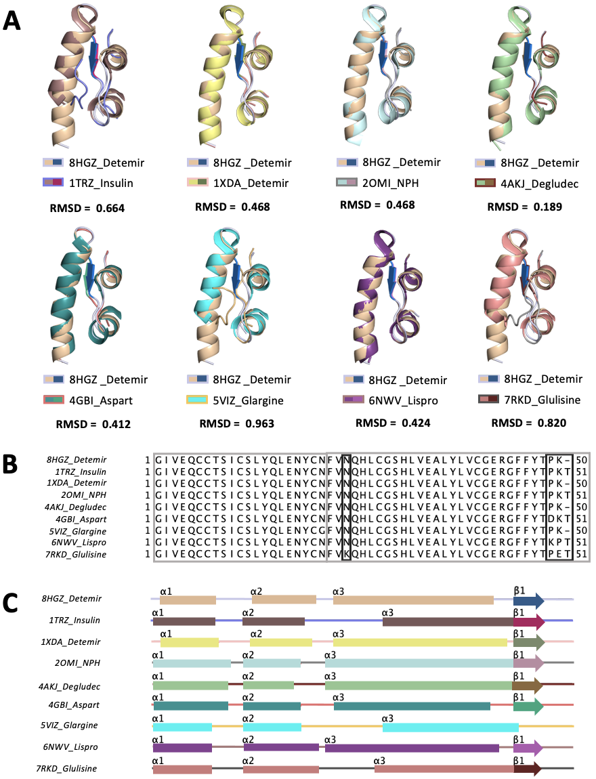
Supplementary Figure 1. Alignment of detemir structure at cryogenic temperature with insulin analogs. (A) The monomer form of detemir (PDB ID: 8HGZ) is superposed with insulin analogs in PyMOL. Each structure is colored based on a secondary structure (helix, beta sheet and loop) which is detailly represented in Panel C. (B) Sequence alignment is performed using Jalview, and (C) secondary structures are indicated with different colors for each insulin homologs based on PDB IDs. (PDB ID: 1TRZ native human insulin; PDB ID: 1XDA insulin detemir; PDB ID: 2OMI NPH insulin analog; PDB ID: 4AKJ insulin degludec; PDB ID: 4GBI insulin aspart; PDB ID: 5VIZ insulin glargine; PDB ID: 6NWV; insulin lispro; PDB ID: 7RKD insulin glulisine.) Coordinates of the detemir structure have been deposited in the Protein Data Bank under accession code 8HGZ.

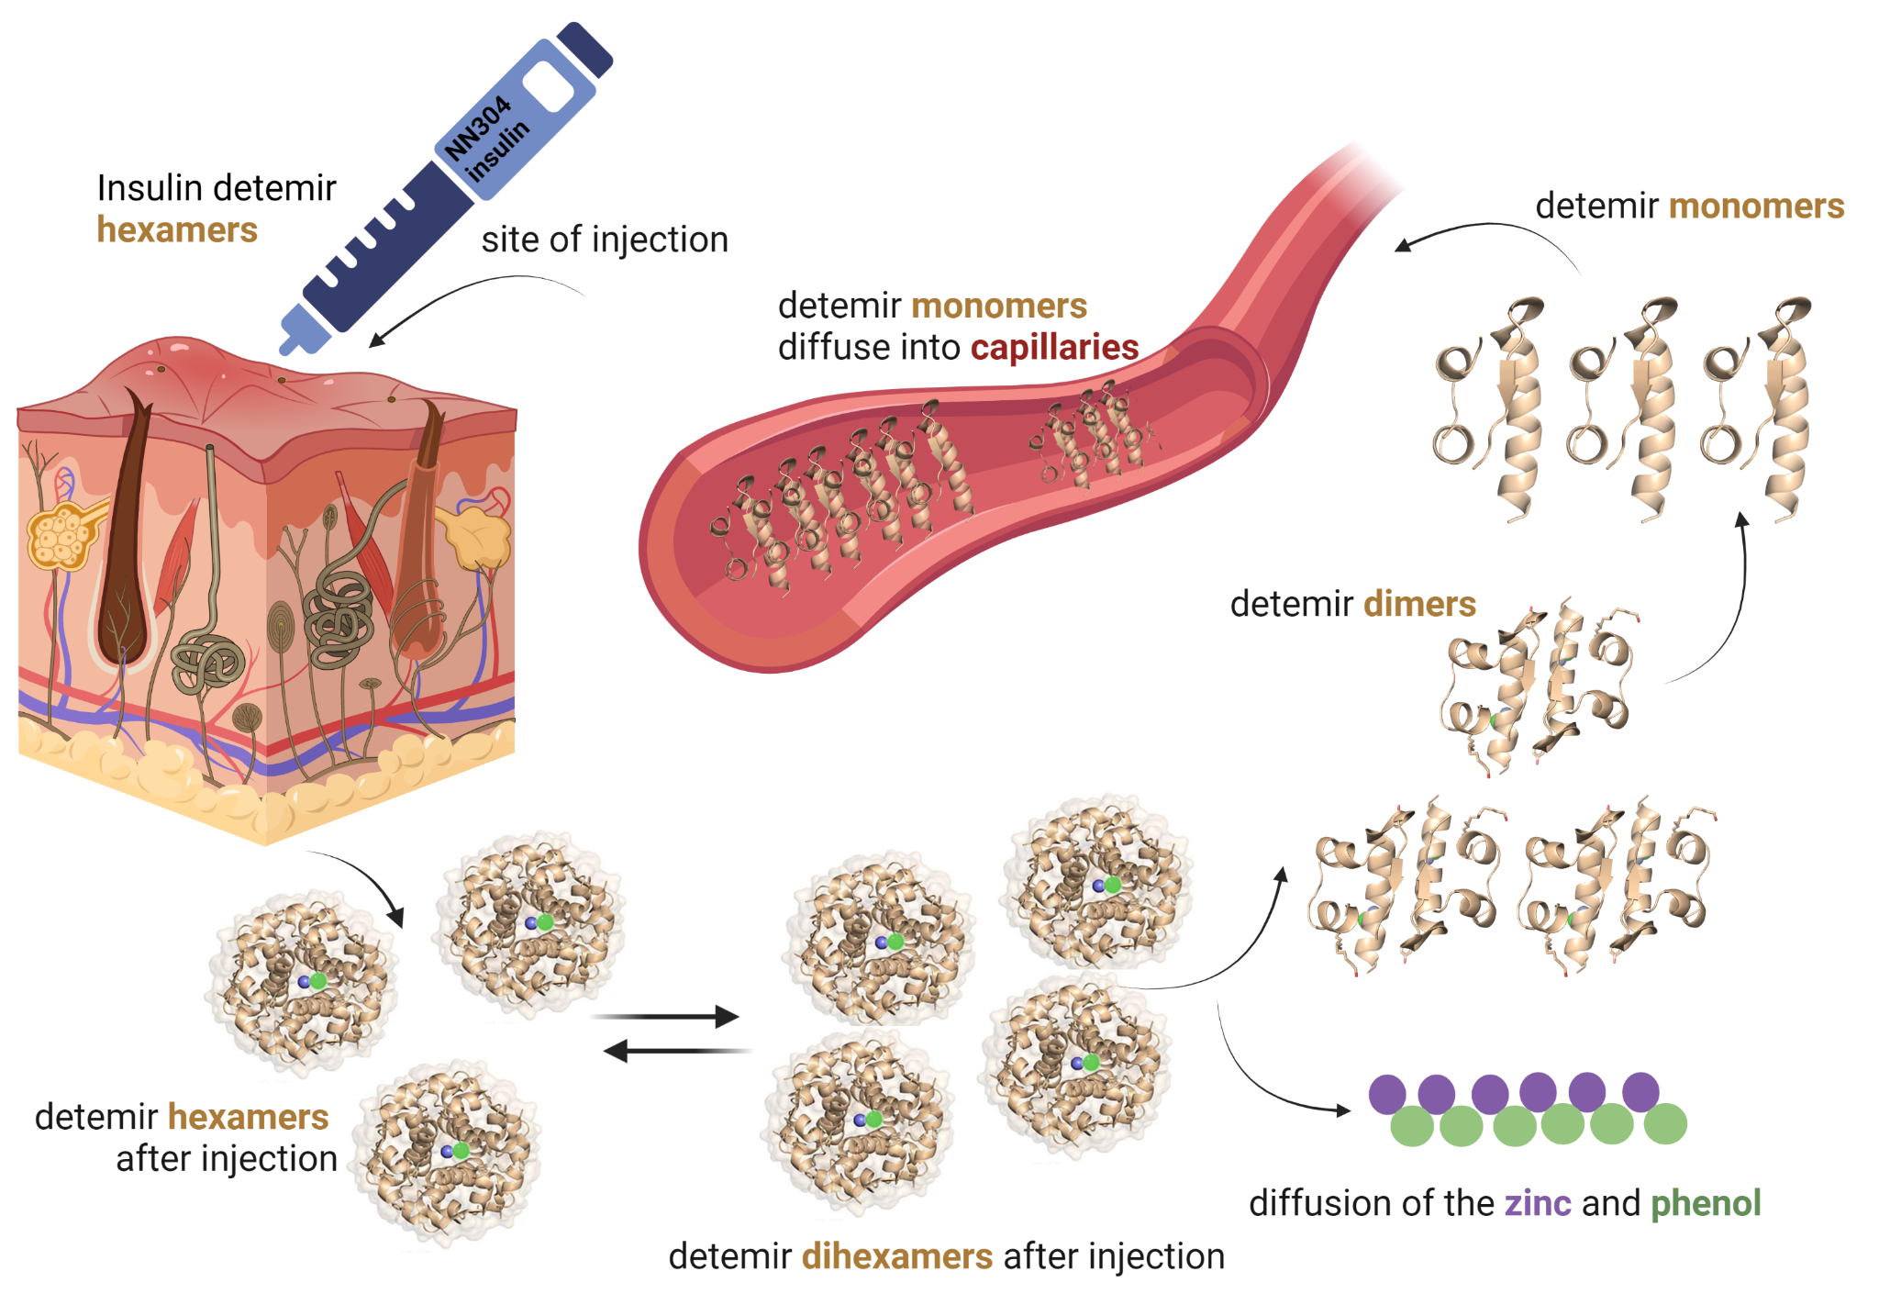
Supplementary Figure 2: Summary of the action mechanism of the insulin detemir. Once insulin is injected subcutaneously hexamer or dihexamers diffuse and dissociate slowly in the blood. Insulin detemir dihexamers, hexamers, dimers, and monomers are colored in wheat, zinc and phenol are shown as circles and colored in purple and green, respectively.

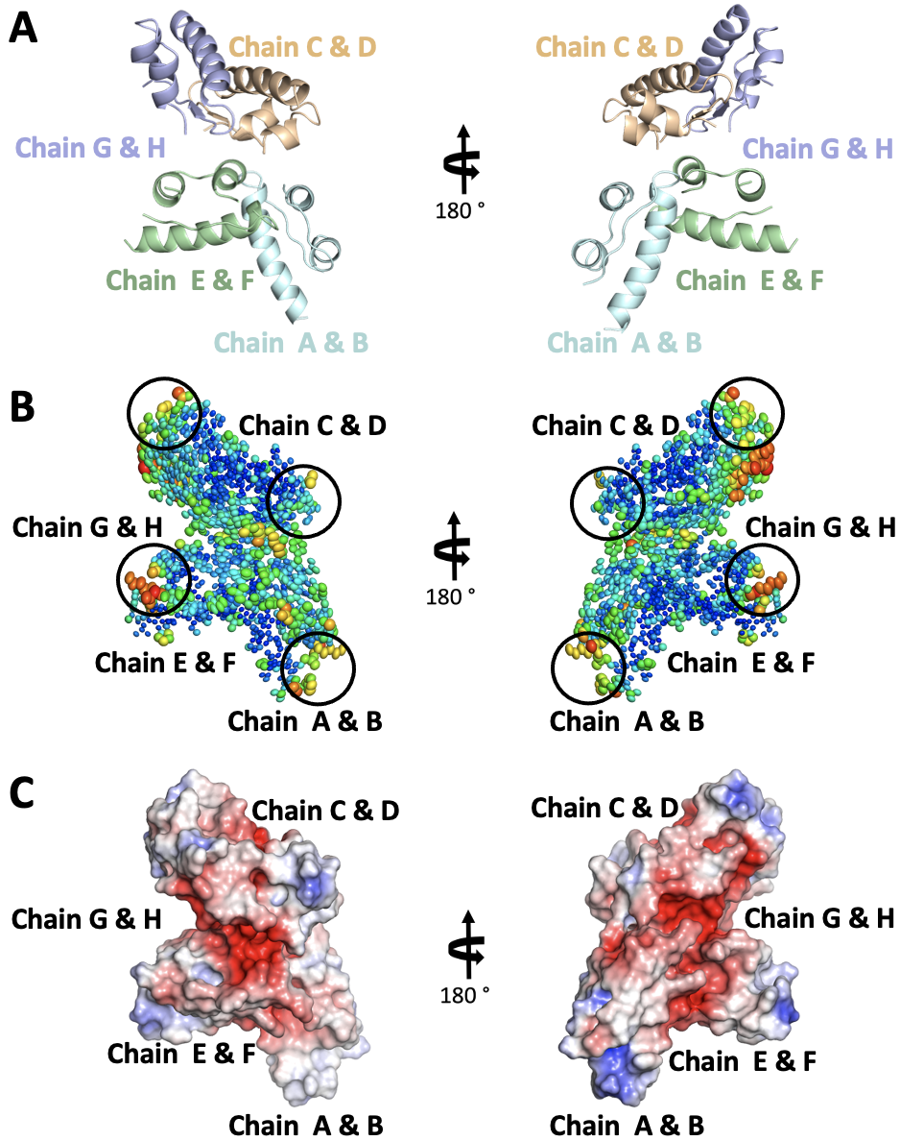
Supplementary Figure 3. Ellipsoid and electrostatic representation of 8HGZ structure at cryogenic temperature. (A) Each monomer of detemir is indicated with a distinct color. (B) Detemir is shown with the ellipsoid presentation to highlight the stable/flexible regions shown in warmer colors. The binding site of myristic acid (MYR) is indicated with circles.. (C) Electrostatics is generated to show the surface charges on detemir by using the APBS electrostatic plug in of PyMOL.

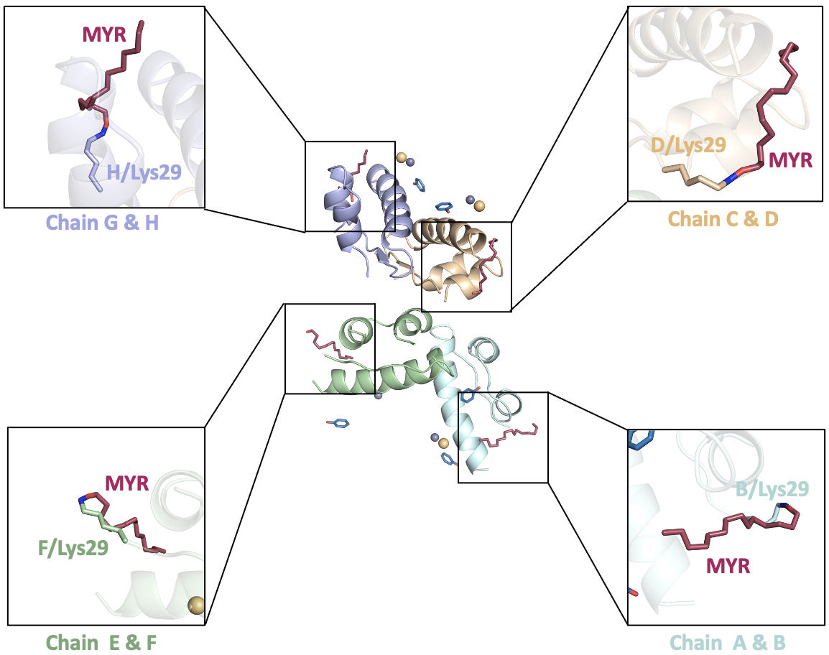
Supplementary Figure 4. Covalent bond representation between myristic acid (MYR) and detemir. The binding of each MYR to detemir is shown with stick representation. The residues are highlighted based on atom representation to indicate the covalent bond with MYR.

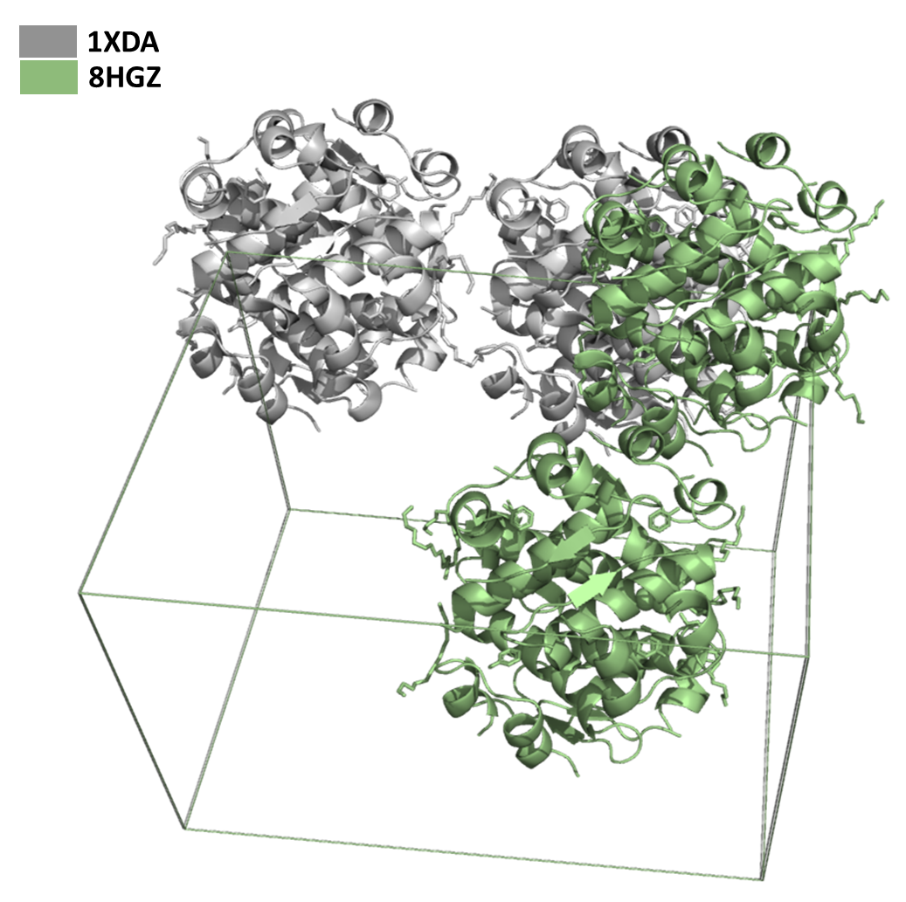
Supplementary Figure 5. Superimposed two detemir structures in unit cell mode. 8HGZ structure is colored in green, while the 1XDA structure is colored in gray.
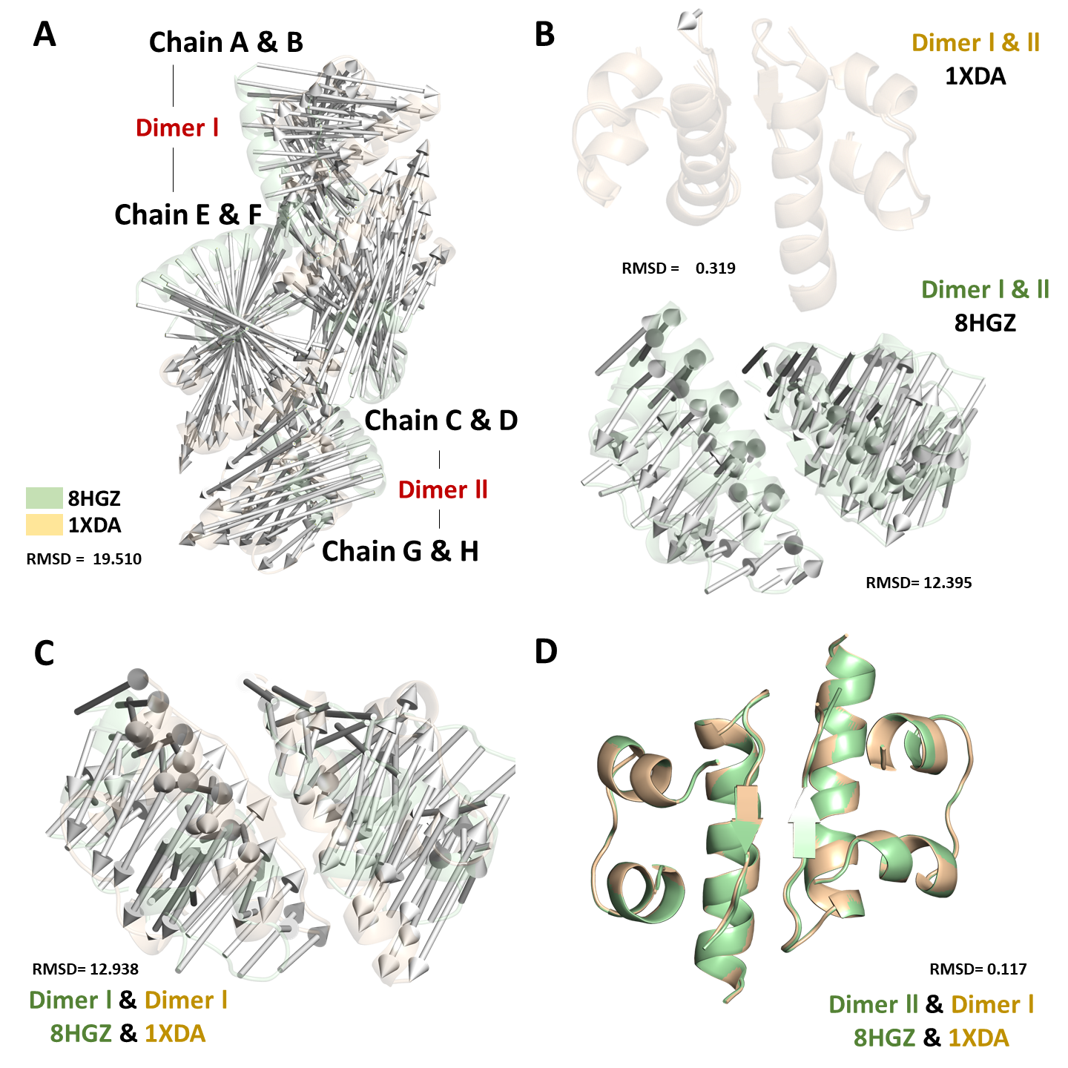
Supplementary Figure 6. A significant conformational change observed between 1XDA and 8HGZ structures in modevectors mode. (A) The oligomeric 1XDA and 8HGZ structures could not be superimposed thoroughly due to the distinct alternative dimeric conformation of the 8HGZ structure (RMSD: 19.510). (B) Each dimer of the 1XDA structure was superposed with an overall RMSD of 0.319, while each dimer of the 8HGZ structure could not be superposed thoroughly due to the distinct alternative conformation of the 1st dimer (RMSD: 12.395). (C) 1st dimer of the 8HGZ structure could not be superposed with 1st dimer of the 1XDA structure thoroughly due to distinct alternative conformation of the 1st dimer (RMSD: 12.938). (D) 2nd dimer of the 8HGZ structure was perfectly superposed with 1st dimer of the 1XDA structure with overall RMSD of 0. 117. Normal Mode Analysis of 1XDA and 8HGZ structures has been demonstrated by the arrows/vectors using the modevectors.py script in PyMOL.
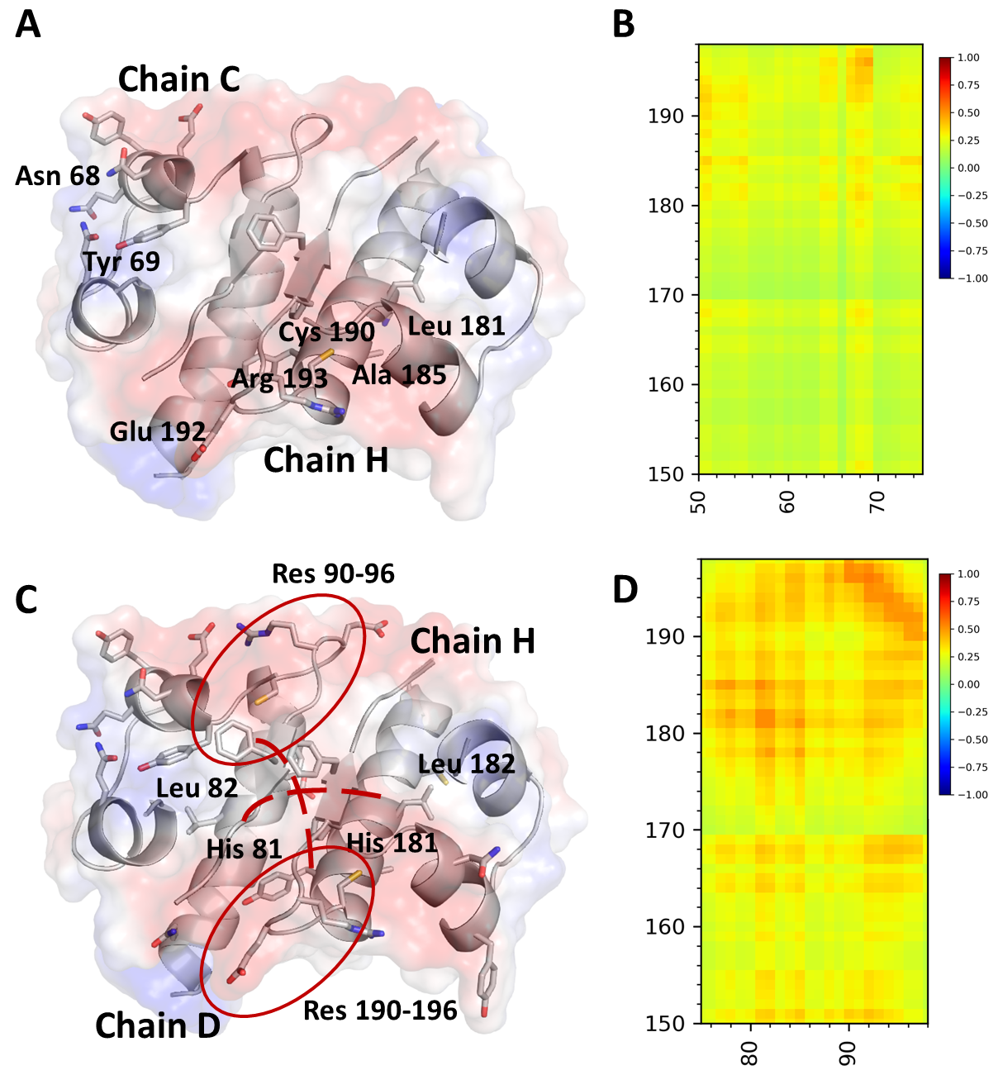
Supplementary Figure 7. Gaussian Network Model (GNM) analysis results for the 2nd dimer of the 8HGZ structure. The 2nd dimer (chain C&D and chain G&H) is more correlated than the first dimer (chain A&B and chain E&F; Fig.4A, bottom). The sliced model representation of the 2nd dimer has been calculated with GNM (B, D), supplemented with cartoon and electrostatic surface mode to show the correlated motion of the dimer (A, C).
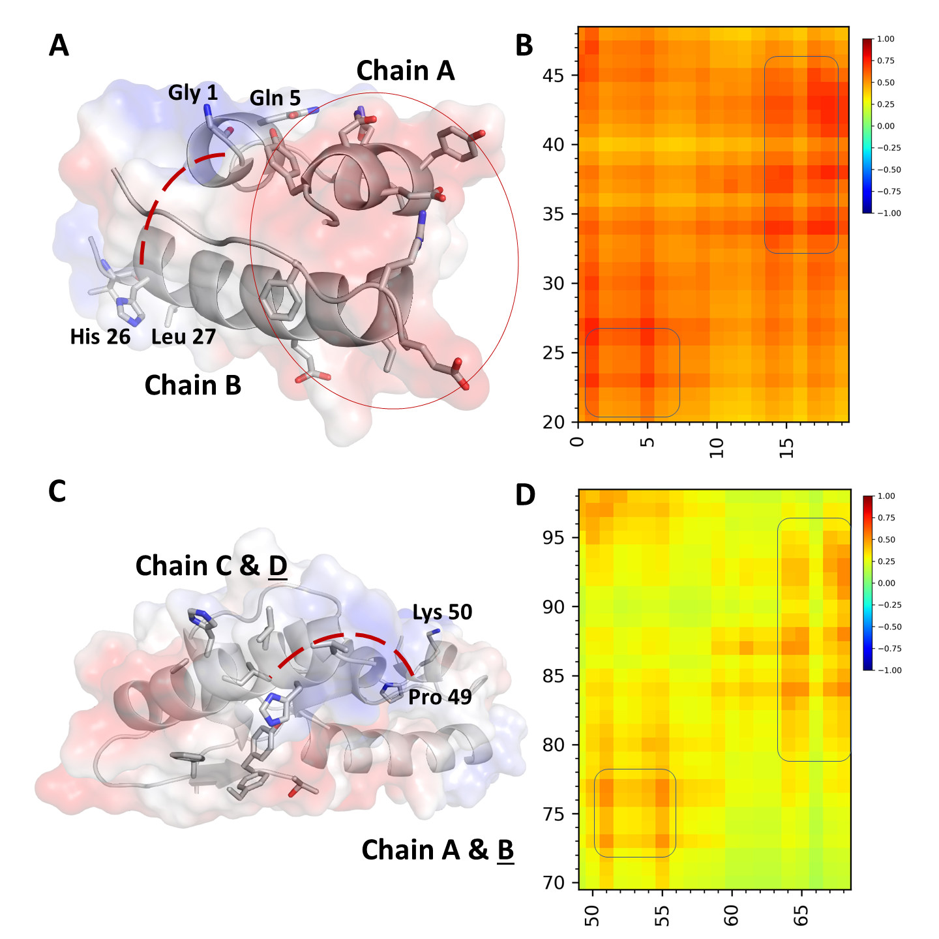
Supplementary Figure 8. Gaussian Network Model (GNM) analysis results for intra- and intercorrelation motion in chain A&B and chain C&D. The sliced model representation of chain A&B and chain C&D have been calculated with GNM (B, D), which is supplemented with cartoon and electrostatic surface mode to show the correlated motion of these chains (A, C). The C-terminal residues in chain B are highly correlated with chain D. Moving direction is emphasized by the red dashed line.
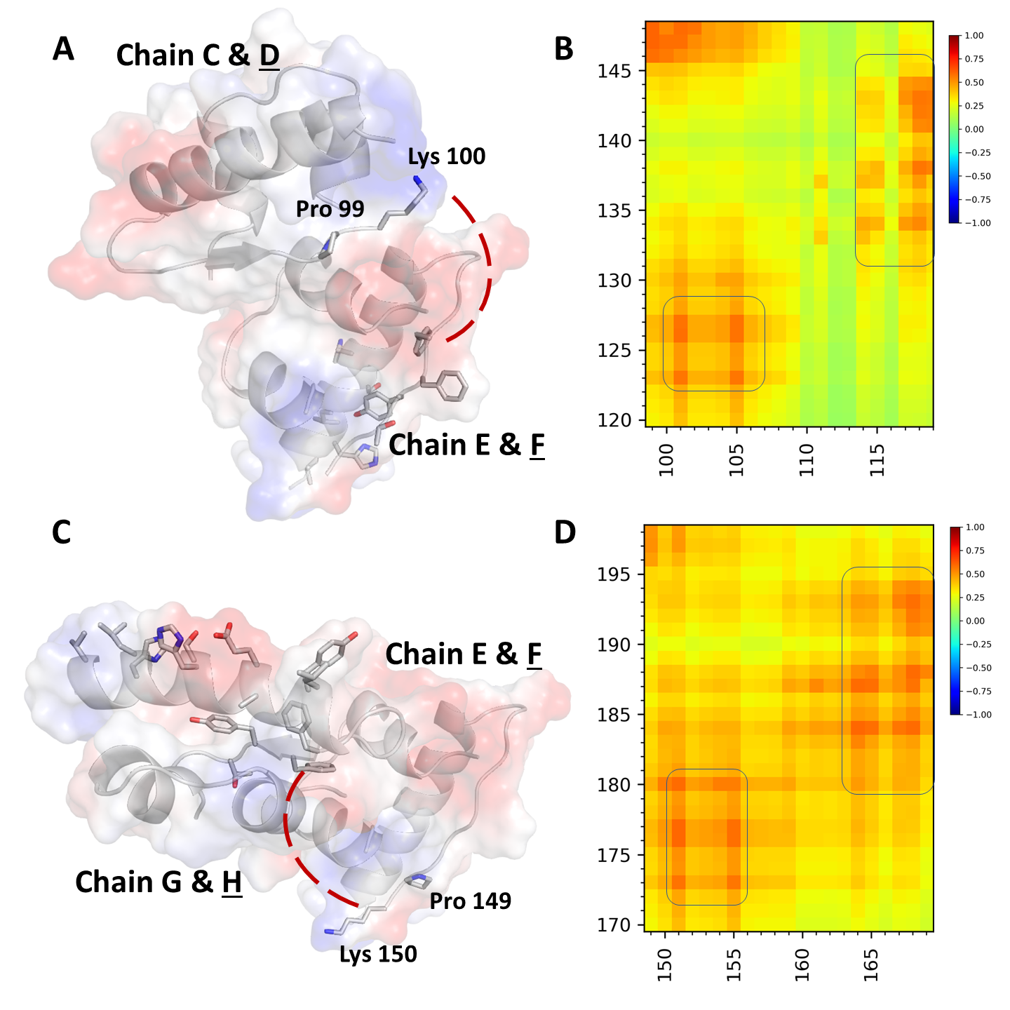
Supplementary Figure 9. Gaussian Network Model (GNM) analysis results for intra- and intercorrelation motion in chain C&D, chain E&F, and chain G&H. The sliced model representation of chain E&F and chain G&H has been calculated with GNM (B, D), which is supplemented with cartoon and electrostatic surface mode to show the correlated motion of these chains (A, C). The C-terminal residues in chain D are highly correlated with chain F; the last residues of chain F are highly correlated with chain H. Moving direction is emphasized by the red dashed line.

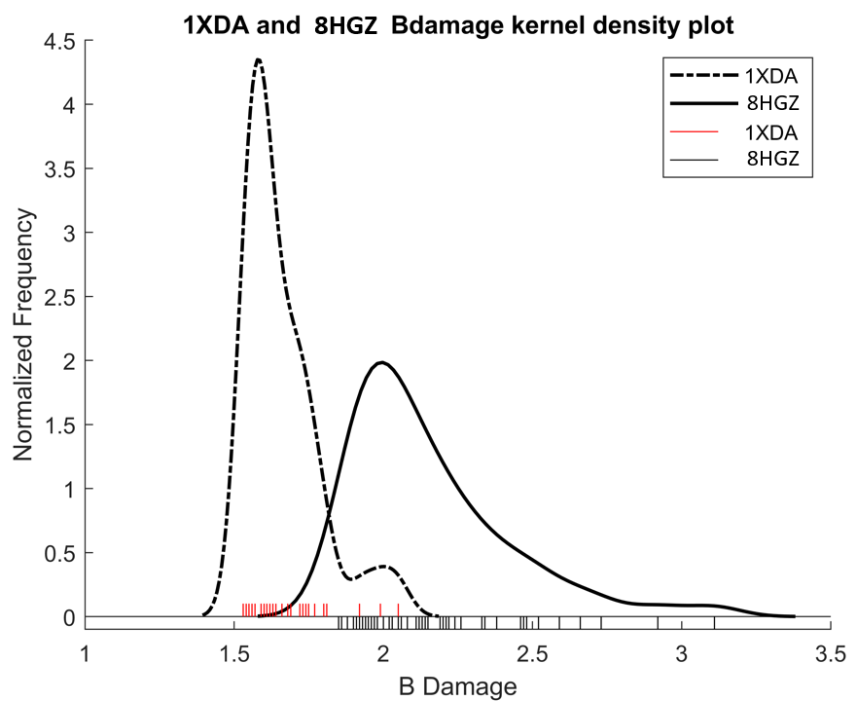
Supplementary Figure 10. Radiation damage values were calculated using RABDAM software. Comparison of the BDamage distribution plot of the 8HGZ and 1XDA structures. The highest BDamage value of 3.11 was observed on the Glu 154 O atom (1312) of the 8HGZ structure, while in 1XDA structure, the highest BDamage value (2.05) was observed on the Asn 18 C atom (541) in chain C.

