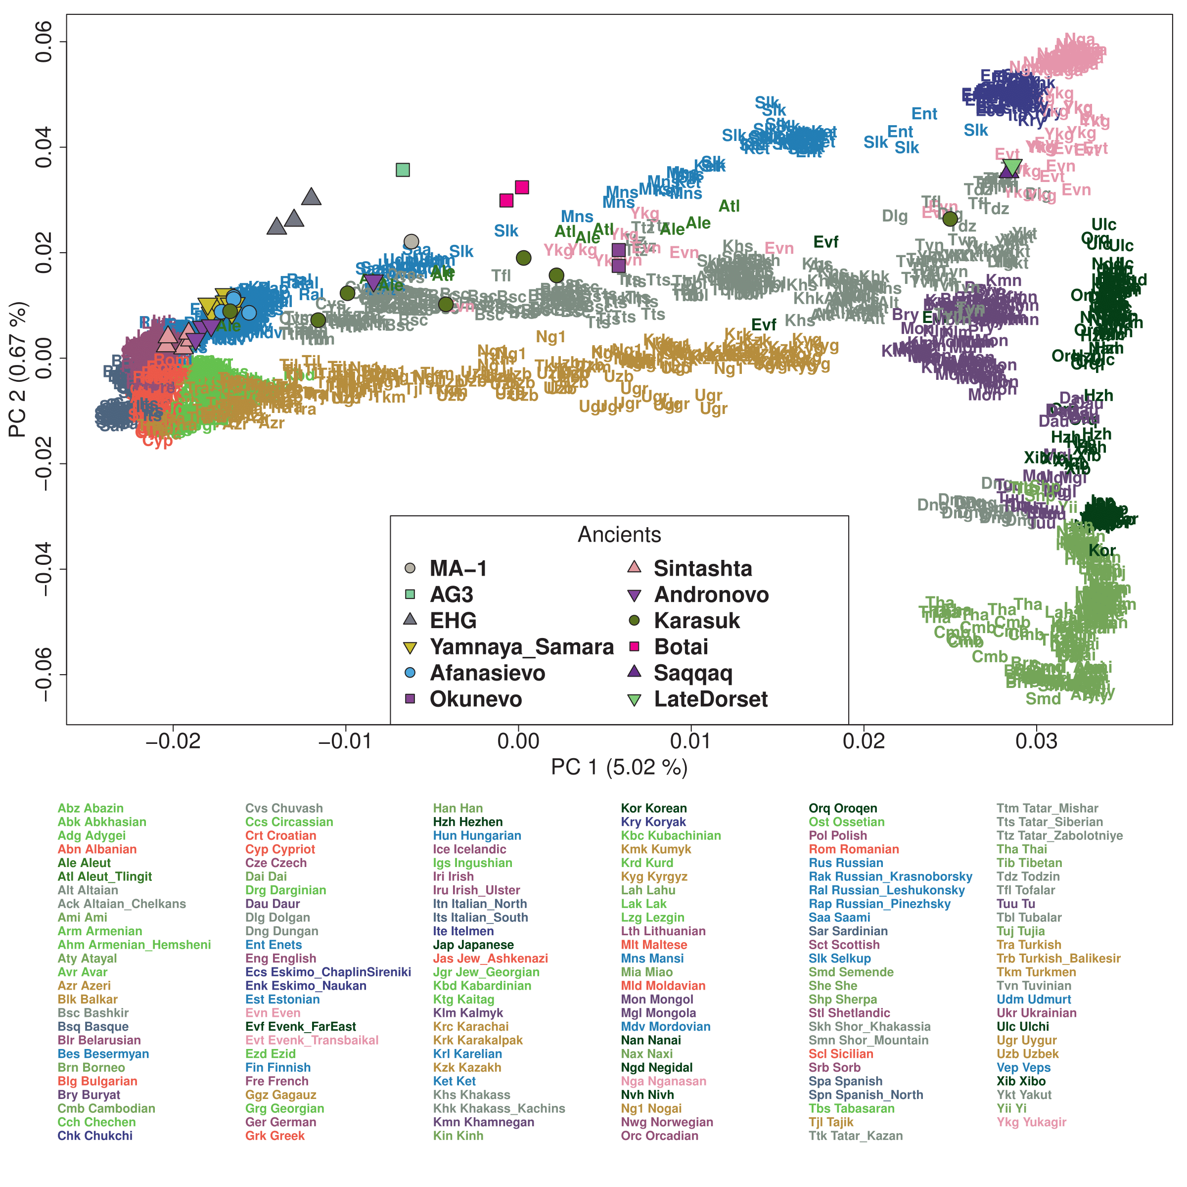

Figure S1. The first two PCs summarizing the genetic structure within 2,077 Eurasian individuals. The two PCs generally mirror geography. PC1 separates western and eastern Eurasian populations, with many inner Eurasians in the middle. PC2 separates eastern Eurasians along the north-south cline and also separates Europeans from West Asians. Ancient individuals (color-filled shapes), including two Botai individuals, are projected onto PCs calculated from present-day individuals.

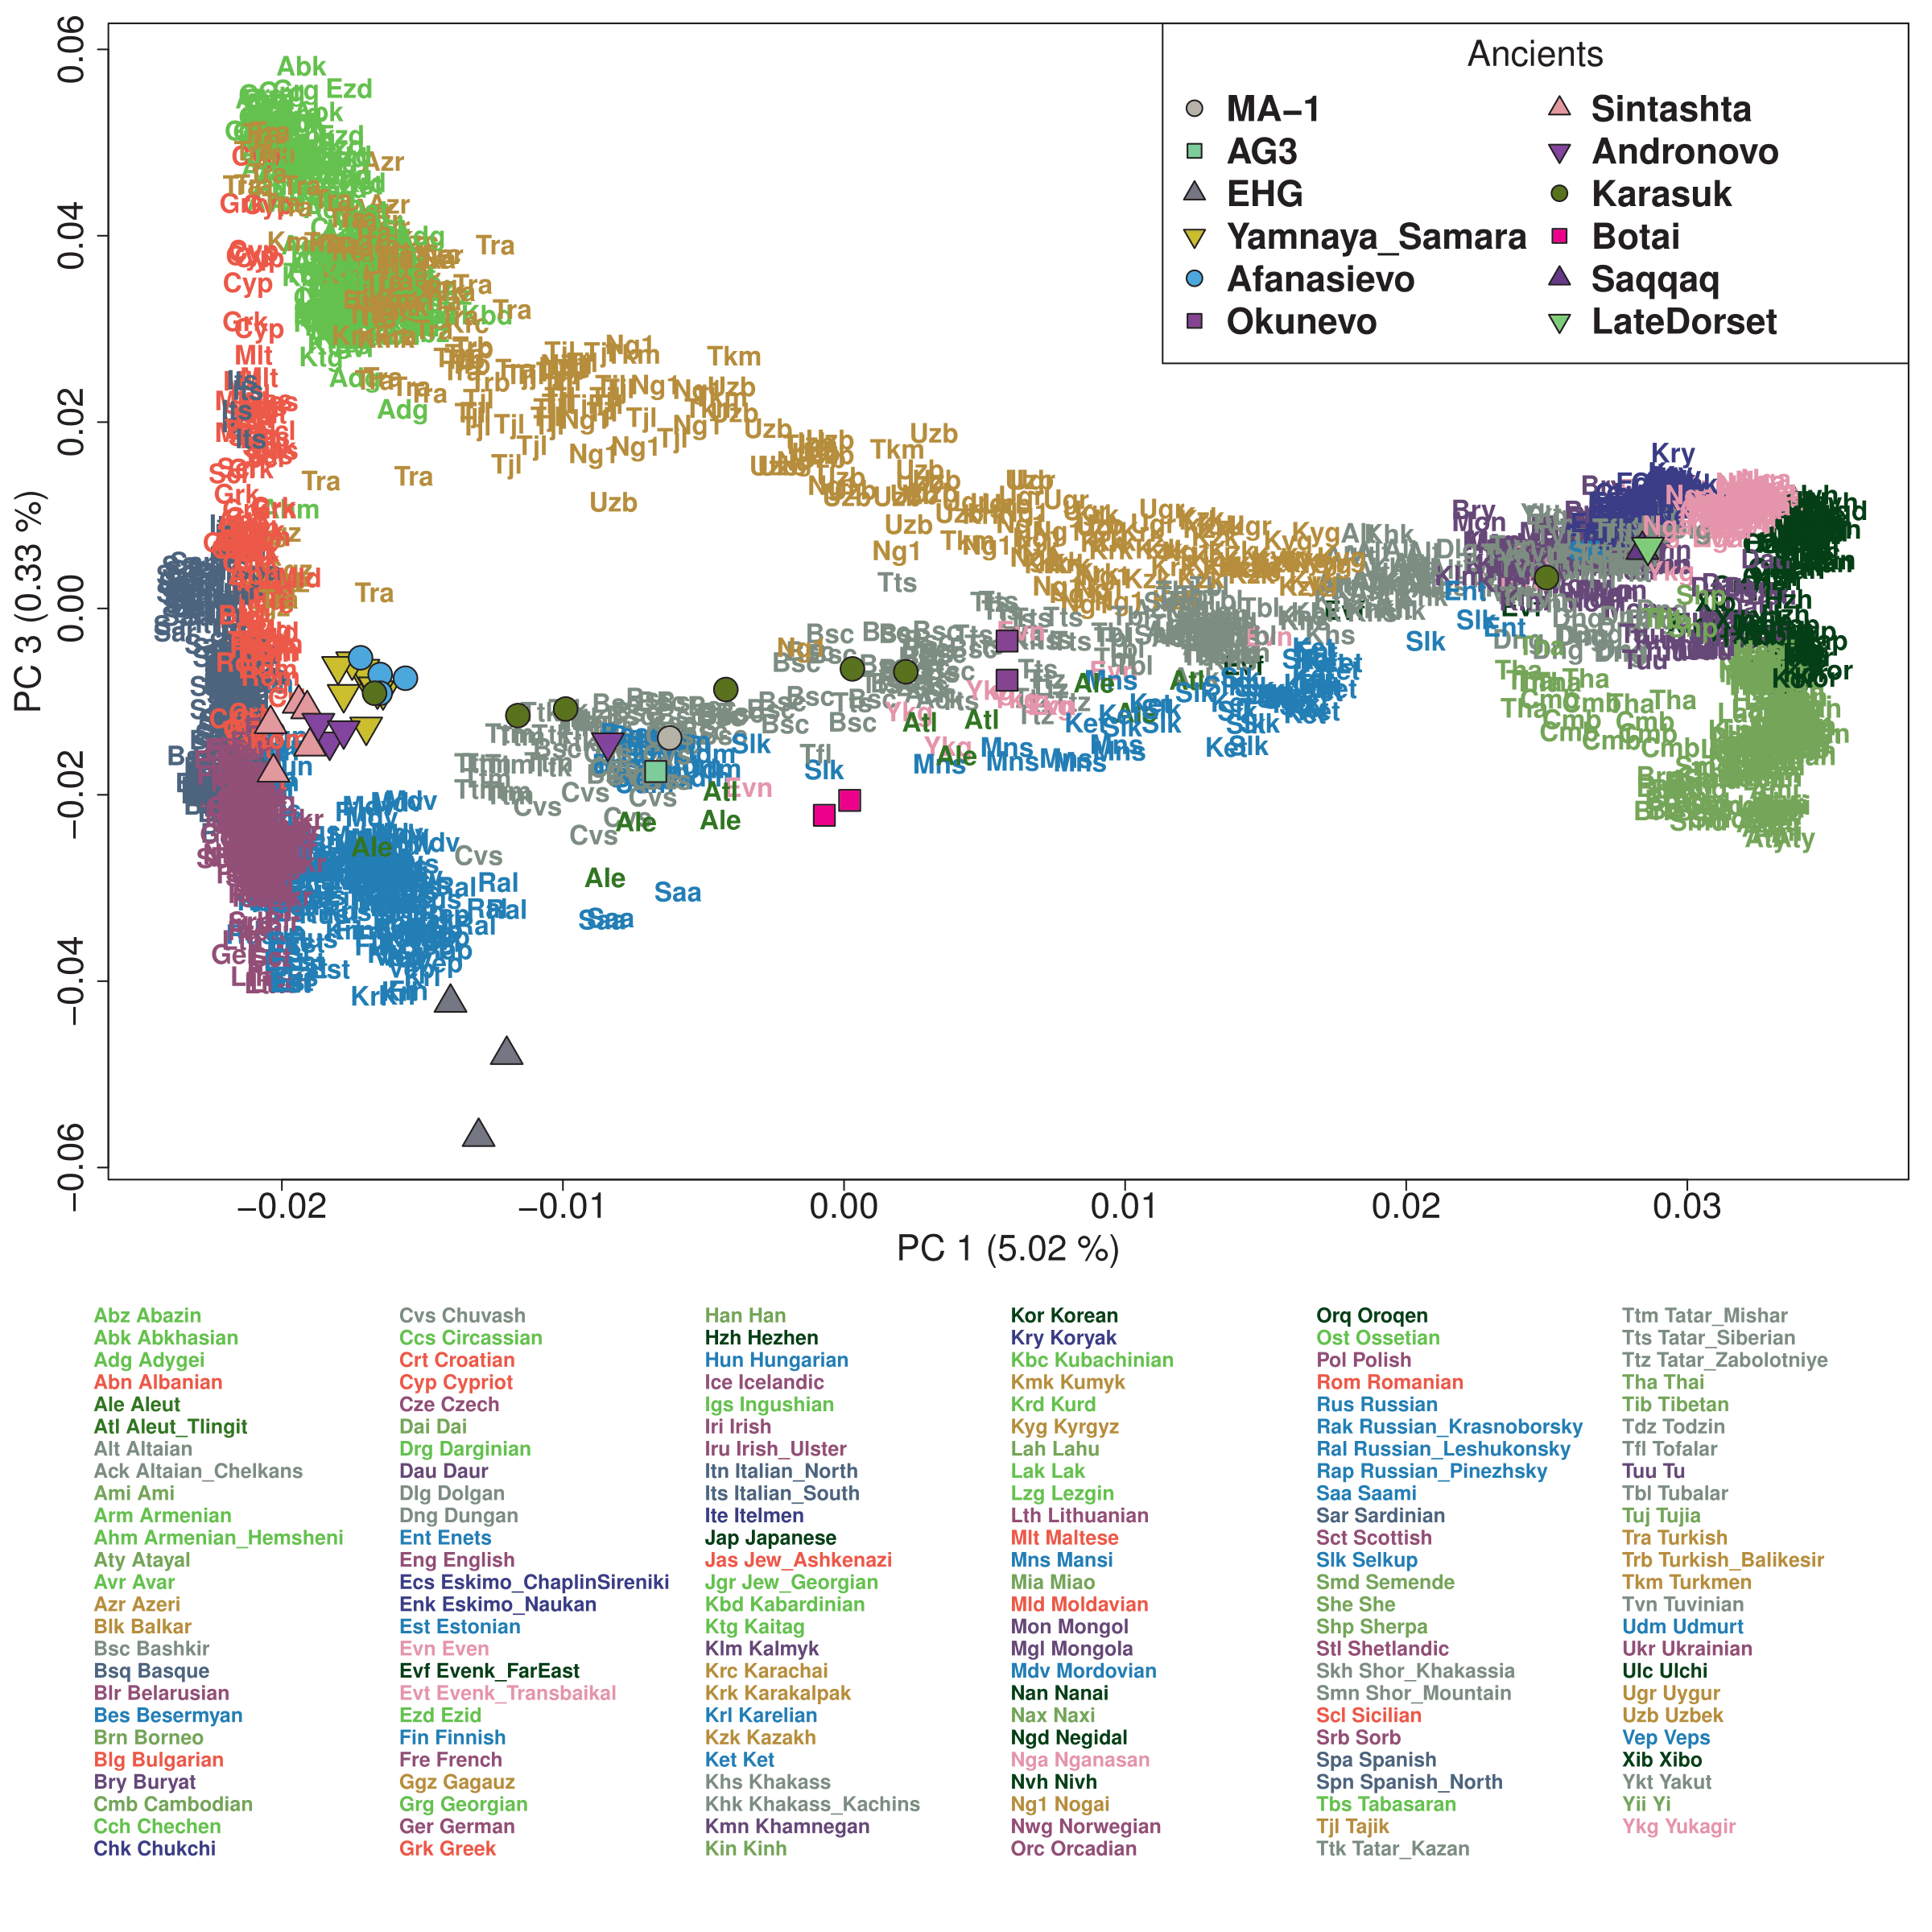

Figure S2. The third PC of Eurasians separate West Asian populations (top on PC3) from Europeans (bottom on PC3). Inner Eurasians with high proportion of western Eurasian ancestry are differentially attracted to West Asians and Europeans. Ancient individuals (color-filled shapes), including two Botai individuals, are projected onto PCs calculated from present-day individuals.

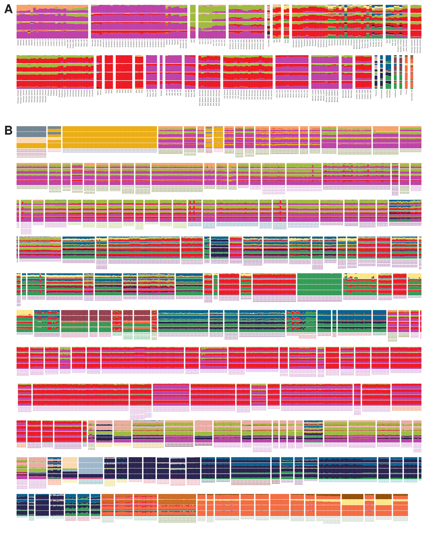

Figure S3. Unsupervised genetic clustering of present-day and ancient individuals using ADMIXTURE. We present results for K values 6, 9, 15 and 17 (ordered from bottom to top). We separately plot (A) ancient and (B) present-day individuals.

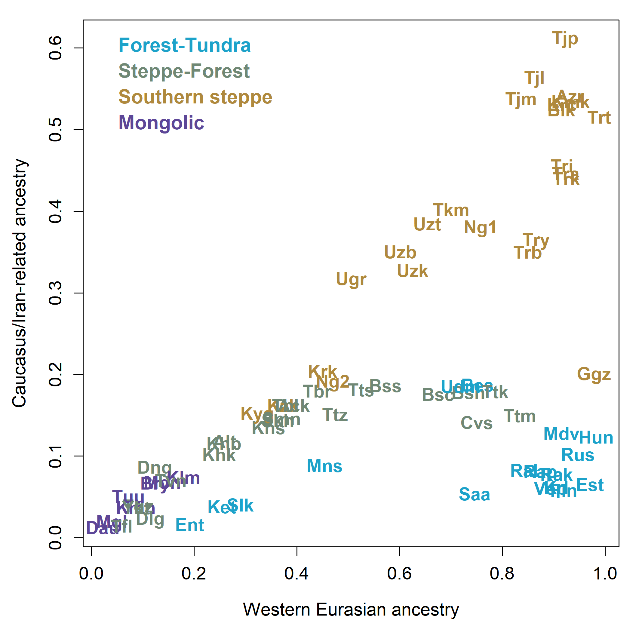

Figure S4. High levels of ancestry related to Caucasus, Iran and South Asian populations separate the southern steppe cline populations (light brown color) from the steppe-forest cline populations (dark green color). To estimate overall western Eurasian ancestry proportion, we sum up four components in our ADMIXTURE results (K=15), which are the dominant components in Neolithic Anatolians (“Anatolia_N”), Mesolithic western European hunter-gatherers (“WHG”), early Holocene Caucasus hunter-gatherers (“CHG”) and Lodhi from northern India, respectively. The “Caucaus/Iran” related ancestry is a fraction of it, calculated by summing up the last two components.

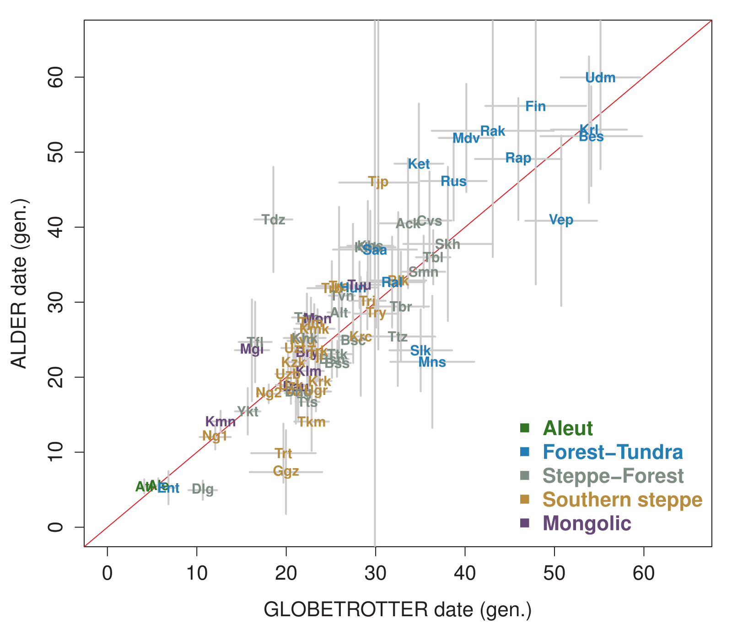

Figure S5. Admixture date estimates based on a single-pulse model. The estimates from the GLOBETROTTER analysis (x-axis) and those from ALDER (y-axis) match well with each other (Pearson’s r² = 0.75 after removing Lithuanians for having a very old ALDER estimate; y = x marked with the red line). Horizontal and vertical bars represent ± 1 SE associated with each estimate. SE is estimated by bootstrapping (GLOBETROTTER) or by leave-one-chromosome-out jackknifing (ALDER). For ALDER, we apply a minimum distance of 1 cM between two SNP bins.

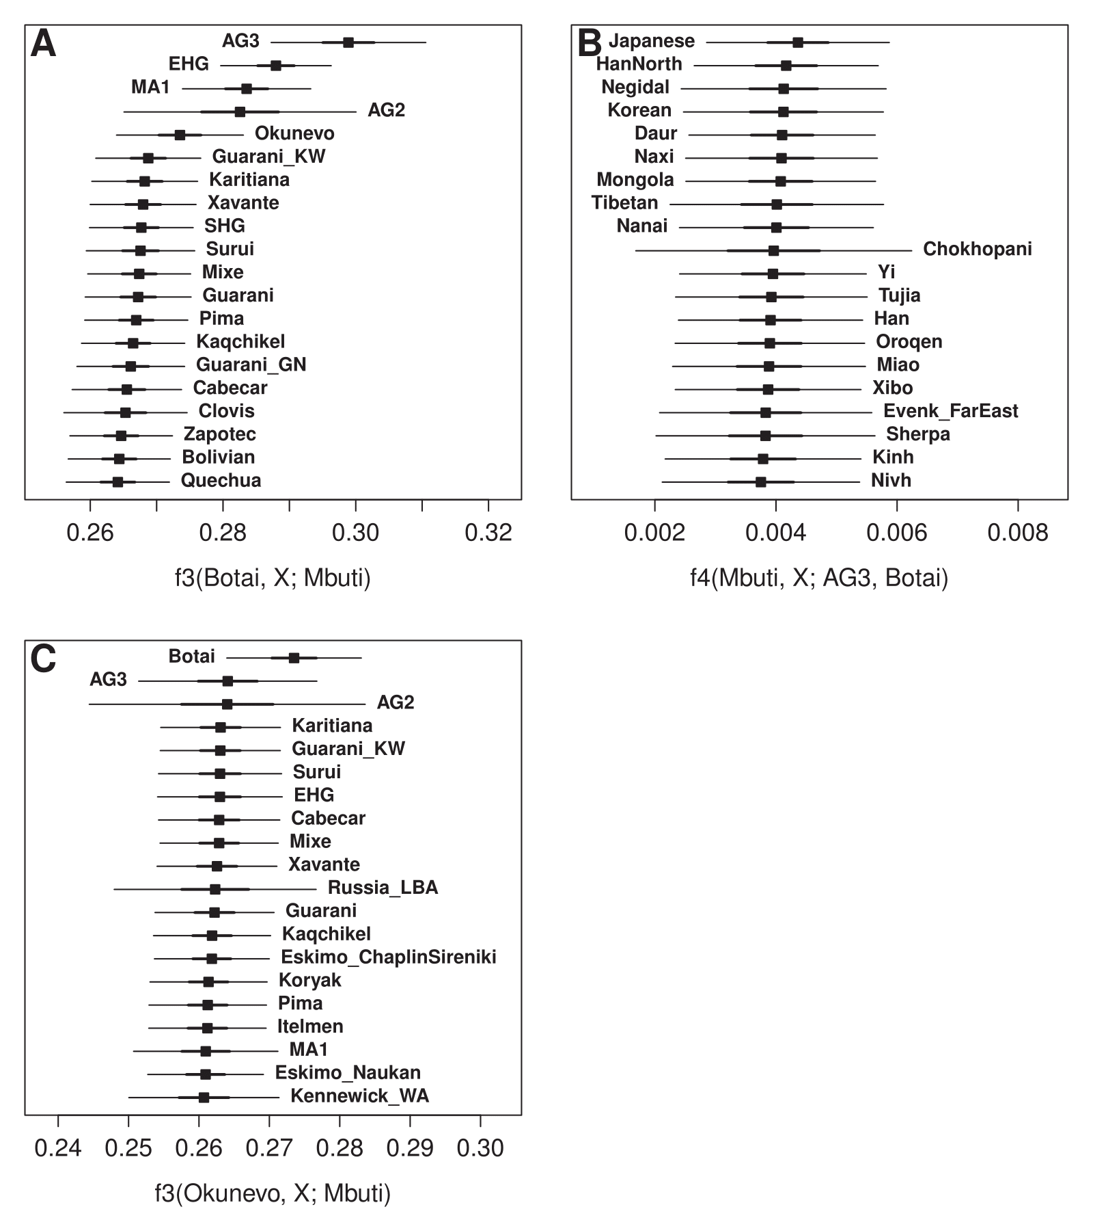

Figure S6. Genetic affinity of the Eneolithic Botai culture individuals from Kazakhstan and the Middle Bronze Age Okunevo culture individuals from the Altai-Sayan region measured by f-statistics. (A) ANE-related ancient groups show the highest level of shared genetic drift with Botai, measured by the outgroup f₃ statistic. (B) The Botai has extra genetic affinity with contemporary eastern Eurasian groups compared to an Upper Paleolithic Siberian AG3. (C) Okunevo has the highest outgroup f₃ statistic with Botai, followed by other ANE-related populations, including Native Americans. The most positive 20 signals are presented. Thick and thin horizontal bars represent ± 1 and 3 SEs, respectively.

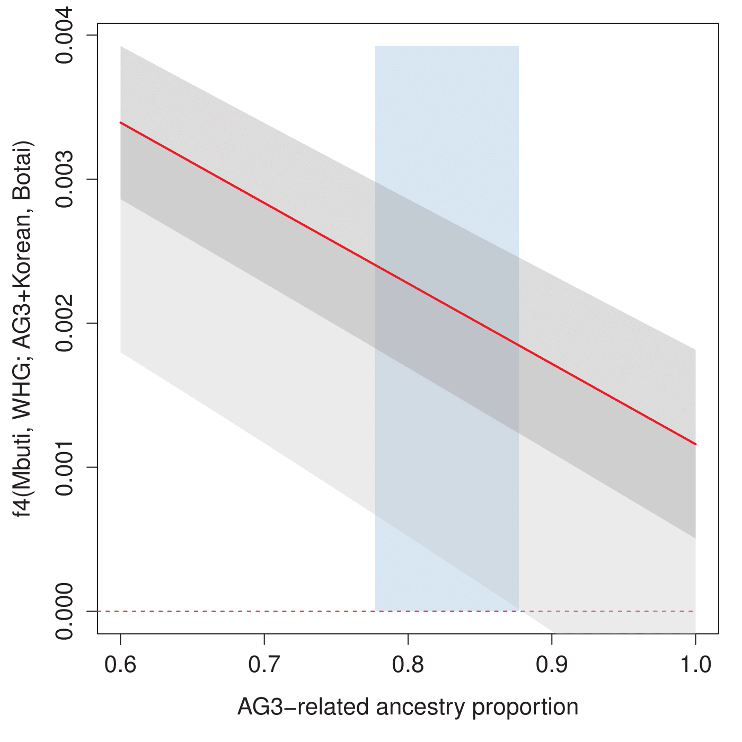

Figure S7. The extra genetic affinity between WHG and Botai not explained by a two-way admixture model of AG3+Korean. We calculated f₄ statistic in the form of f₄(Mbuti, WHG, AG3+Korean, Botai) for a grid of admixture proportions (x-axis) using the weighted mean allele frequency of AG3 and Korean. The solid red line shows the f₄ value. Darker and lighter grey shades mark ± 1 SE and -3 SE ranges, respectively. Blue shades mark the range of AG3-related ancestry proportion estimated by qpAdm (estimate ± 2 SE; 0.777-0.877). WHG and Botai shows an unexplained affinity (≥ 3.0 SE) in this range.

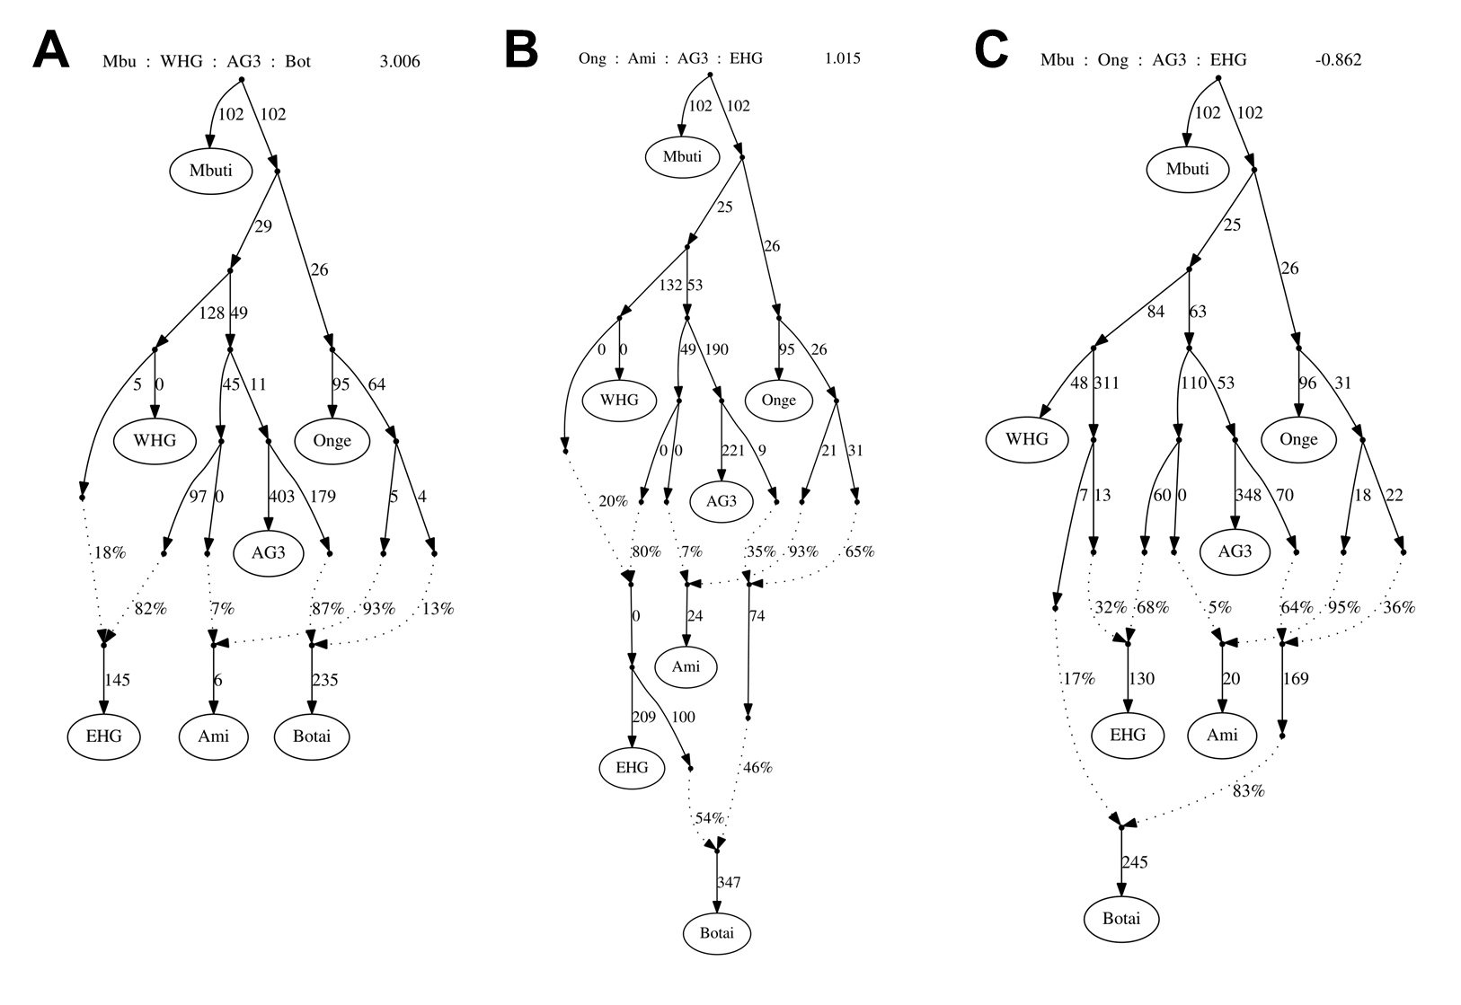

Figure S8. Graph-based modeling of Botai using qpGraph. (A) Botai is modeled as a mixture of AG3- and Ami-related lineages. The model underestimates the affinity between WHG and Botai: (observed – expected) = 3.0 SE for f₄(Mbuti, WHG; AG3, Botai). (B, C) The best three-way models add an additional gene flow from either an EHG- or a WHG-related lineage into Botai. No f-statistic deviates significantly from the model expectation. The most deviant f-statistic is shown on top (observed – expected). Standard errors are estimated by 5 cM block jackknifing.

Figure S9. Frequency distribution map of the Y-chromosomal haplogroup R1b-P343(xM269) identified in the Eneolithic Botai individual. All modern Eurasian samples with this haplogroup tested to date for the downstream markers fall into R1b-M73 branch, suggesting Botai sample be one of its earliest representatives.

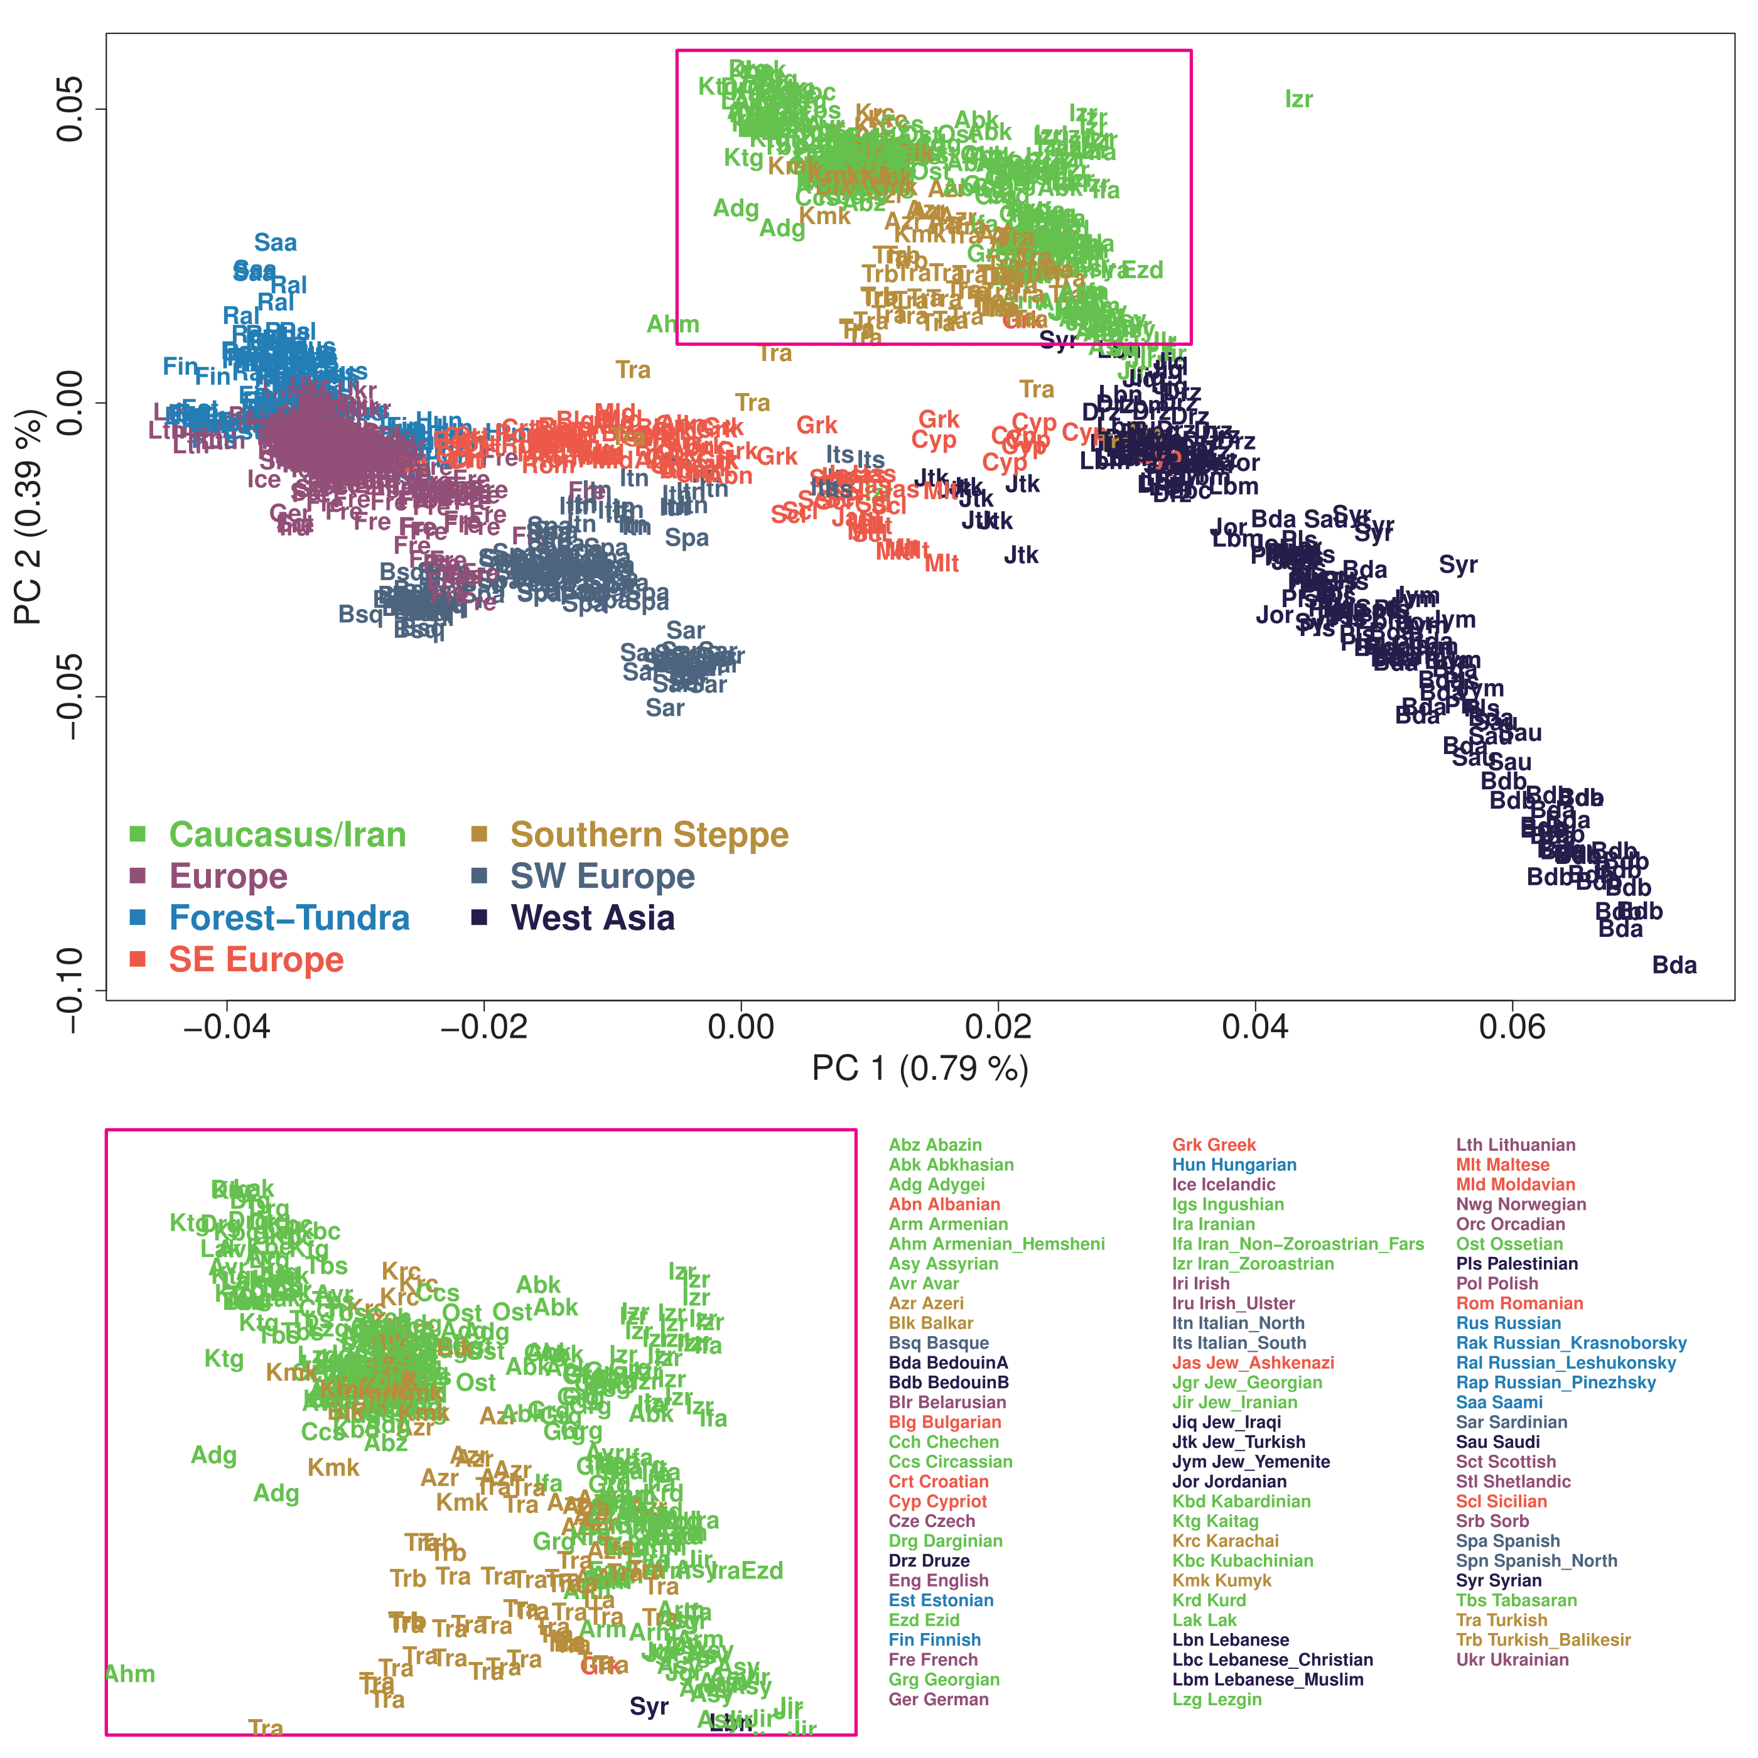

Figure S10. The first two PCs summarizing the genetic structure within 1,238 western Eurasian individuals. Two parallel clines summarize the genetic structure of western Eurasians, one for Europeans (left) and the other for Near Easterners (right). Caucasus populations are located at the top of the Near Eastern cline (magenta-colored box). The zoom-in plot on the bottom shows distinct locations of northeast, northwest and south Caucasians.

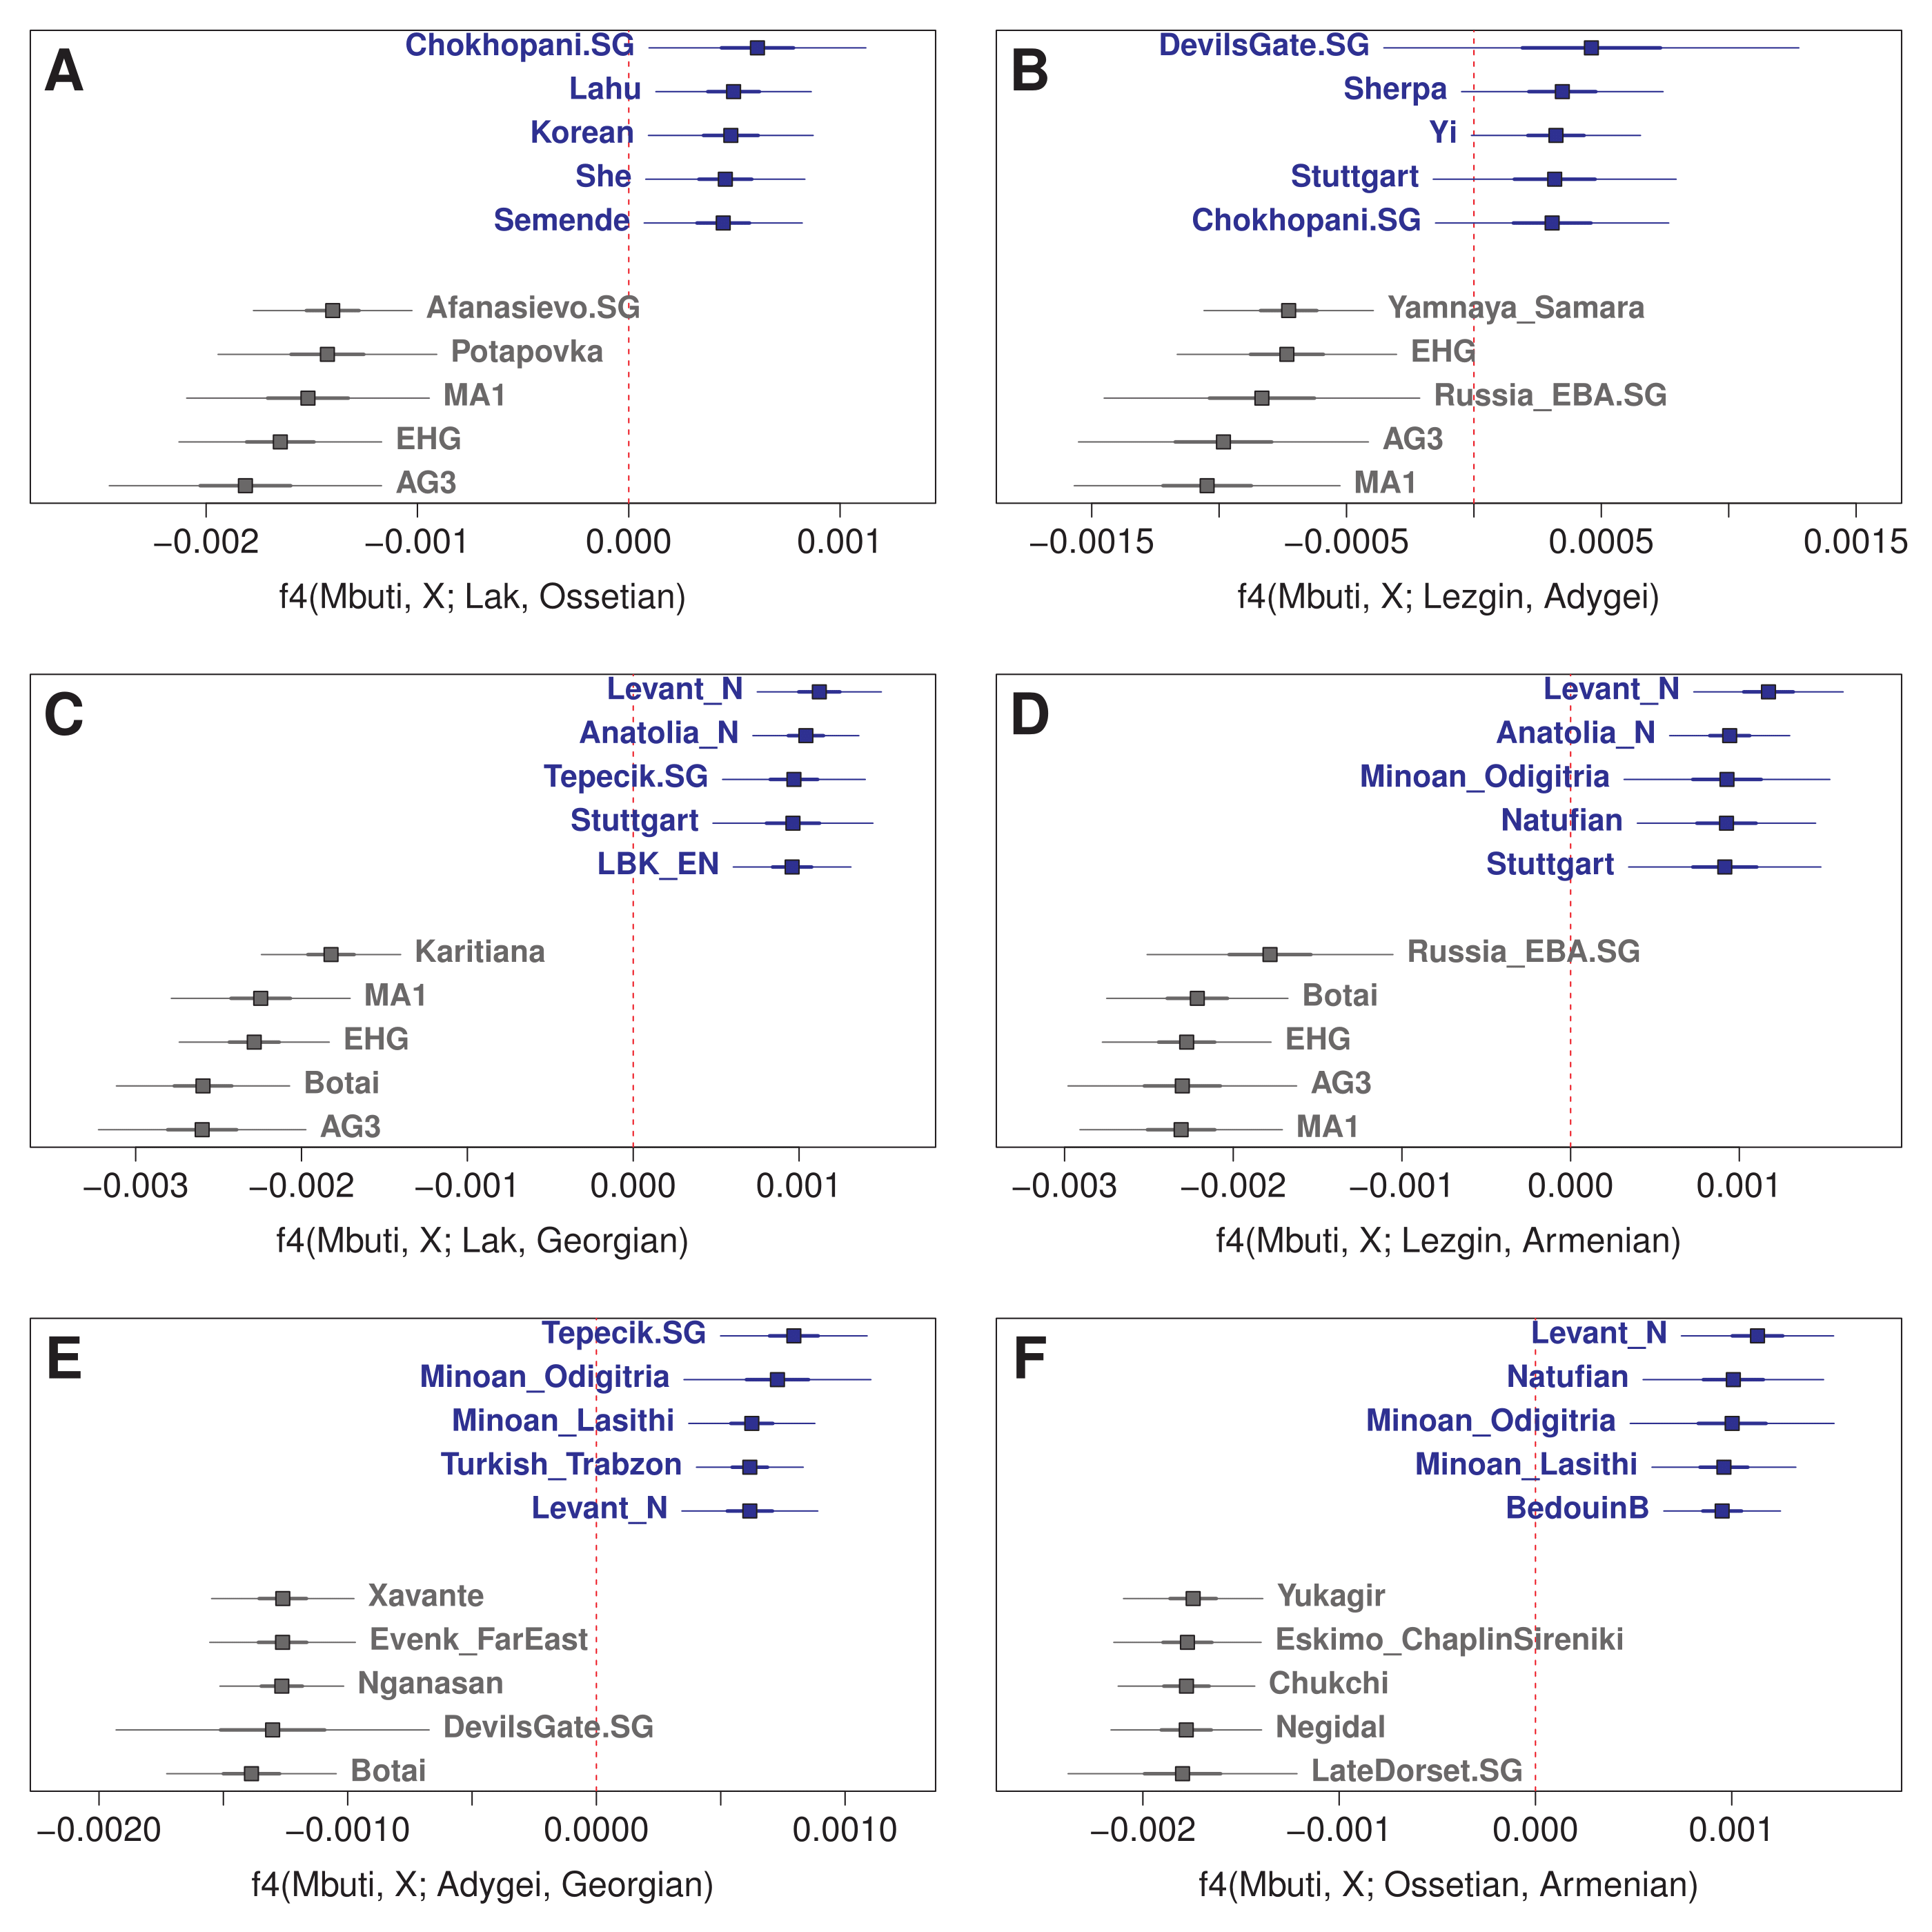

Figure S11. Quantification of the genetic differentiation between Caucasus populations using f₄ statistics. For each pair of representative Caucasus populations, we calculated f₄ symmetry statistics for world-wide populations (X) using Mbuti as an outgroup. For each panel, we report the five most positive (blue) and the five most negative (grey) tests. (A, B) northeastern vs. northwestern Caucasus populations. (C, D) northeastern vs. south Caucasus populations. (E, F) northwestern vs. south Caucasus populations. Thick and thin horizontal lines mark ± 1 and 3 SEs estimated by 5 cM block jackknifing.

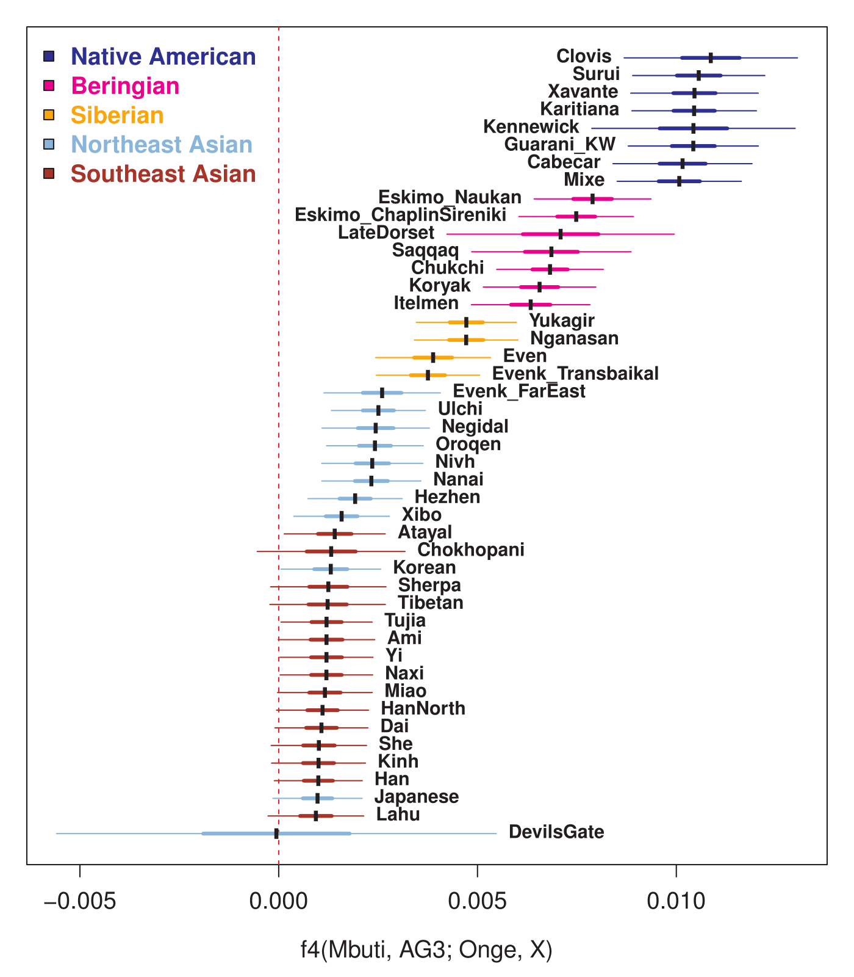

Figure S12. Genetic affinity of eastern Eurasian populations to AG3, in comparison to Onge in the Andaman islands, measured by f₄(Mbuti, AG3; Onge, X). Native Americans have the highest affinity with AG3, followed by Beringian and Siberian populations. Thick and thin horizontal bars represent ± 1 and 3 SEs, respectively.

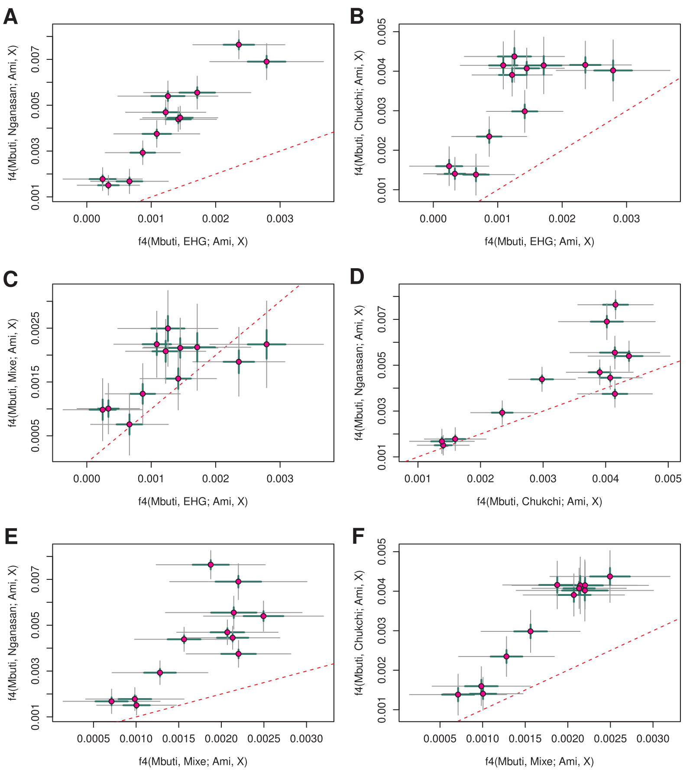

Figure S13. A comparison of the genetic affinity of northeast Asians to EHG, Nganasan, Chukchi and Mixe in comparison to southeast Asian Ami measured by f₄(Mbuti, X; Ami, northeast Asian). The EHG affinity is correlated well with affinity to (A) Nganasan, but the correlation is weaker with either (B) Chukchi or (C) Mixe. Northeast Asians are more closely related to Nganasan than they are to Chukchi or Mixe (D-F). Thick and thin bars represent ± 1 and 3 SEs, respectively. The red dotted line marks the line of identity (y = x).

Table S1. Metadata of 763 individuals newly genotyped in this study. Group labels, individual IDs, sex and sampling location are provided. “Analysis.group” is the group labels used for population genetic analysis. Eighteen individuals with “Ignore” in their analysis group label are not included in all analyses due to failure in initial QC. Thirty-three additional individuals with “_OL” at the end of their analysis group label are included in PCA and ADMIXTURE analyses but excluded from the following group-based analysis due to minor genetic difference from the other individuals in the same group.

[See the excel file]

Table S2. A list of 301 groups used for the population genetic analyses in this study. This list includes 73 inner Eurasian target groups (grouped to five categories in “Target” column), 167 contemporary and 61 ancient reference groups. “N” and “N.new” columns show the total number of individuals in each group and the number of newly produced individual data in this study. Groups with new data are marked by yellow color. For all groups, we provide mean latitude and longitude across individuals. For the 61 ancient groups, we additionally provide the original study reporting the samples and the individual IDs for convenient tracking of ancient samples. For each group, we assigned a unique three-letter code (“Symbol”) and used it across figures. 167 Globetrotter donor groups are categorized into 12 region-wide groups for visualizing their relative contribution to each recipient as marked in the “Globetrotter donor group” column. 94 groups used for the Eurasian EEMS analysis are marked in the “Eurasian EEMS” column. 21 groups used for the Caucasus EEMS analysis are marked in the “CaucasusEEMS” column.

[See the excel file]

Table S3. Admixture-f₃ test results for 73 inner Eurasian target populations. We tested all pairs of 238 reference groups (167 contemporary and 61 ancient; Table S2) for each target. Here we present the most significant test results (“f3.best”) with the associated Z-score (“Z.best”). Z-scores are calculated with 5 cM jackknifing standard error (SE). In addition, we present results for six pairs of references, one from (French, Georgian) and one from (Mixe, Nganasan, Ulchi), to highlight the differential affinity of inner Eurasians to various western and eastern Eurasian sources.

[See the excel file]

Table S4. A summary of GLOBETROTTER analysis results for 73 recipient populations. For each recipient group, the best model and the associated parameter estimates, using the “null.ind:0” option, are presented. Bootstrap p-values for the one-date models, using the “null.ind:1” option, were < 0.01 for all clusters. “Target.Group” column provides a grouping of 73 recipient populations into five categories (Table S2).

[See the excel file]

Table S5. QpAdm-based admixture models for individuals associated with the Botai and Okunevo cultures. In both cases, AG3+Korean provides a good fit, while the other ANE-proxies (EHG or Botai) do not. For Botai, we also repeated the analysis after adding WHG to the standard outgroup set, but obtained similar results. Adequate models (p ≥ 0.05) are marked by grey shade and bold face.

Target | Ref₁ | Ref₂ | Ref₃ | P-value | Coef₁¹ | Coef₂¹ | Coef₃₁ | OG²
Botai | AG3 | Korean |  | 0.286 | 0.827  (0.025) | 0.173  (0.025)
 | EHG | Korean |  | 3.20×10⁻¹⁷ | 0.793  (0.018) | 0.207  (0.018)
 | AG3 | Korean |  | 0.089 | 0.843  (0.024) | 0.157  (0.024) |  | +WHG
 | AG3 | EHG | Korean | 0.385³ | 0.650  (0.077) | 0.177  (0.069) | 0.173  (0.022) | +WHG
Okunevo | AG3 | Korean |  | 0.396 | 0.707  (0.031) | 0.293  (0.031)
 | EHG | Korean |  | 1.18×10⁻⁹ | 0.644  (0.021) | 0.356  (0.021)
 | Botai | Korean |  | 0.013 | 0.814  (0.028) | 0.186  (0.028)
¹ The estimated proportion of ancestry from the corresponding reference. 5 cM jackknifing SE is presented in the parenthesis.
² The set of outgroups used for each test. “+WHG” means that WHG is added into the standard set of outgroups: Mbuti, Natufian, Onge, Iran_N, Villabruna, Ami, Mixe. Otherwise, the standard set is used.
³ χ² p-value from qpAdm for the sufficiency of the admixture model (i.e. Botai does not deviate significantly from a mixture of the three references); when the three-way mixture model is compared to the nested two-way model (i.e. removing EHG from the references), a significant decrease in model fit is observed (χ² p = 0.016).

Table S6. A skeleton R1b tree comprised of positions covered by the 1240K capture panel. The genotypes of the Botai male TU45 are shown in green (positive), red (negative) or transparent (no call). The R1b-M73 (~M478) branch is marked in yellow.

[See the excel file]

Table S7. Two-way mixture modeling of populations in the Altai-Sayan region. We use ancient individuals associated with the Afanasievo or Sintashta cultures as one reference, and Nganasans, Ulchi or Koreans as the other reference. (A) χ² p-values for the admixture model fit. Large p-values suggest that the target does not significantly deviate from a mixture of the two references. Cases with p ≥ 0.05 are highlighted in gray color. (B) Models with p ≥ 0.05 were listed with estimates of the admixture coefficients for the two references (Coef₁ and Coef₂) and the associated 5cM jackknifing SE.

A. qpAdm p-value for the two-way mixture modeling
 | Afanasievo |  |  | Sintashta
 | Nganasan | Ulchi | Korean | Nganasan | Ulchi | Korean
Okunevo | 3.85×10⁻⁴ | 1.07×10⁻⁷ | 1.80×10⁻¹⁴ | 9.01×10⁻¹¹ | 1.08×10⁻¹⁸ | 4.98×10⁻³²
Andronovo | 2.51×10⁻⁷ | 1.05×10⁻⁷ | 4.02×10⁻⁸ | 7.60×10⁻¹ | 6.09×10⁻¹ | 3.68×10⁻¹
Mezhovskaya | 1.30×10⁻² | 2.20×10⁻² | 3.55×10⁻² | 5.13×10⁻² | 4.48×10⁻³ | 2.41×10⁻⁵
Karasuk | 1.13×10⁻¹ | 5.72×10⁻³ | 4.22×10⁻⁹ | 5.97×10⁻⁷ | 1.23×10⁻¹⁶ | 1.74×10⁻³⁸
Russia_IA | 2.97×10⁻¹ | 5.65×10⁻¹ | 5.04×10⁻⁷ | 4.11×10⁻³ | 1.74×10⁻⁹ | 1.20×10⁻²⁸
Altaian | 2.16×10⁻²⁵ | 1.20×10⁻¹ | 4.67×10⁻²³ | 2.63×10⁻¹³ | 1.52×10⁻² | 9.43×10⁻⁵⁴
Altaian_Chelkans | 4.50×10⁻³ | 7.08×10⁻² | 6.95×10⁻¹⁷ | 3.05×10⁻¹ | 3.93×10⁻⁸ | 2.93×10⁻⁴⁰
Khakass_Kachins | 3.14×10⁻¹⁰ | 8.28×10⁻¹ | 1.01×10⁻¹⁹ | 2.79×10⁻⁵ | 2.32×10⁻³ | 2.87×10⁻³⁹
Khakass_Koibals | 2.41×10⁻⁷ | 9.88×10⁻¹ | 1.76×10⁻¹⁹ | 2.74×10⁻⁴ | 2.39×10⁻⁴ | 6.49×10⁻⁴⁴
Khakass_Sagai | 7.28×10⁻⁴ | 1.07×10⁻² | 1.33×10⁻²⁴ | 7.40×10⁻² | 5.86×10⁻¹¹ | 2.20×10⁻⁵⁴
Shor_Khakassia | 4.17×10⁻² | 3.93×10⁻³ | 1.61×10⁻¹⁹ | 1.48×10⁻¹ | 1.06×10⁻⁹ | 1.34×10⁻⁴⁴
Shor_Mountain | 6.44×10⁻² | 1.13×10⁻³ | 1.87×10⁻²¹ | 1.02×10⁻¹ | 6.68×10⁻¹⁴ | 7.41×10⁻⁵⁰
Todzin | 2.54×10⁻³ | 1.19×10⁻¹ | 3.70×10⁻²⁴ | 9.40×10⁻³ | 7.36×10⁻³ | 7.09×10⁻³⁵
Tofalar | 4.72×10⁻² | 4.56×10⁻⁵ | 1.81×10⁻⁴⁵ | 1.37×10⁻¹ | 6.83×10⁻¹⁰ | 3.00×10⁻⁶⁵
Tubalar1 | 1.34×10⁻³ | 3.42×10⁻¹ | 7.18×10⁻²² | 5.13×10⁻³ | 7.54×10⁻¹³ | 2.48×10⁻⁵⁸
Tubalar2 | 1.92×10⁻³ | 9.11×10⁻¹ | 2.26×10⁻⁸ | 2.20×10⁻² | 2.23×10⁻⁶ | 5.27×10⁻³¹
Tuvinian | 2.43×10⁻¹⁹ | 5.96×10⁻¹ | 1.87×10⁻³² | 3.78×10⁻¹⁴ | 1.50×10⁻³ | 3.44×10⁻⁵⁶
B. Details for models with a good fit (p ≥ 0.05)
 | Ref₁ | Ref₂ | P-value | Coef₁ | Coef₂ | SE
Andronovo | Sintashta | Nganasan | 0.760 | 0.936 | 0.064 | 0.014
 | Sintashta | Ulchi | 0.609 | 0.943 | 0.057 | 0.013
 | Sintashta | Korean | 0.368 | 0.951 | 0.049 | 0.012
Mezhovskaya | Sintashta | Nganasan | 0.051 | 0.806 | 0.194 | 0.018
Karasuk | Afanasievo | Nganasan | 0.113 | 0.649 | 0.351 | 0.012
Russia_IA | Afanasievo | Nganasan | 0.297 | 0.527 | 0.473 | 0.014
 | Afanasievo | Ulchi | 0.565 | 0.579 | 0.421 | 0.012
Altaian | Afanasievo | Ulchi | 0.120 | 0.289 | 0.711 | 0.006
Altaian_Chelkans | Afanasievo | Ulchi | 0.071 | 0.428 | 0.572 | 0.010
 | Sintashta | Nganasan | 0.305 | 0.327 | 0.673 | 0.010
Khakass_Kachins | Afanasievo | Ulchi | 0.828 | 0.287 | 0.713 | 0.008
Khakass_Koibals | Afanasievo | Ulchi | 0.988 | 0.299 | 0.701 | 0.010
Khakass_Sagai | Sintashta | Nganasan | 0.074 | 0.293 | 0.707 | 0.008
Shor_Khakassia | Sintashta | Nganasan | 0.148 | 0.301 | 0.699 | 0.011
Shor_Mountain | Afanasievo | Nganasan | 0.064 | 0.353 | 0.647 | 0.011
 | Sintashta | Nganasan | 0.102 | 0.320 | 0.680 | 0.010
Todzin | Afanasievo | Ulchi | 0.119 | 0.173 | 0.827 | 0.010
Tofalar | Sintashta | Nganasan | 0.137 | 0.054 | 0.946 | 0.008
Tubalar1 | Afanasievo | Ulchi | 0.342 | 0.424 | 0.576 | 0.008
Tubalar2 | Afanasievo | Ulchi | 0.911 | 0.473 | 0.527 | 0.011
Tuvinian | Afanasievo | Ulchi | 0.596 | 0.199 | 0.801 | 0.006

Table S8. Multi-way admixture modeling results for the forest-tundra cline populations using qpAdm. For each model, a qpAdm p-value and estimates of admixture coefficients (± 1 SE) is shown. For the groups east and west of the Urals, three-way mixture models (EHG, WSH, Nganasan) and four-way ones (WHG, EEF, WSH, Nganasan) are presented, respectively. For Mansi, another four-way model including WHG as an additional source is also presented. We used Yamnaya_Samara and LBK_EN to represent the WSH and EEF ancestry, respectively.

A. Three-way mixture models for groups east of the Urals
Target | p-value | Coef_{EHG} | Coef_{WSH} | Coef_{Nganasan} | Coef_{WHG}
Enets | 0.098 | 0.093 ± 0.040 | 0.116 ± 0.038 | 0.791 ± 0.012 | NA
Selkup | 0.133 | 0.181 ± 0.028 | 0.163 ± 0.026 | 0.657 ± 0.008 | NA
Ket | 0.719 | 0.171 ± 0.028 | 0.135 ± 0.026 | 0.694 ± 0.008 | NA
Mansi | 0.008 | 0.130 ± 0.033 | 0.345 ± 0.031 | 0.525 ± 0.010 | NA
 | 0.684 | 0.059 ± 0.036 | 0.345 ± 0.028 | 0.541 ± 0.011 | 0.055 ± 0.015
B. Four-way mixture models for groups west of the Urals
Target | p-value | Coef_{WHG} | Coef_{EEF} | Coef_{WSH} | Coef_{Nganasan}
Saami | 0.104 | 0.161 ± 0.018 | 0.139 ± 0.039 | 0.413 ± 0.050 | 0.286 ± 0.014
Udmurt | 0.092 | 0.066 ± 0.012 | 0.136 ± 0.027 | 0.507 ± 0.035 | 0.291 ± 0.010
Besermyan | 0.085 | 0.049 ± 0.014 | 0.164 ± 0.031 | 0.532 ± 0.039 | 0.255 ± 0.010
Mordovian | 0.209 | 0.129 ± 0.010 | 0.310 ± 0.021 | 0.447 ± 0.026 | 0.114 ± 0.007
Veps | 0.377 | 0.165 ± 0.013 | 0.211 ± 0.027 | 0.487 ± 0.036 | 0.137 ± 0.010
Karelian | 0.420 | 0.161 ± 0.012 | 0.269 ± 0.023 | 0.455 ± 0.028 | 0.115 ± 0.008
Finnish | 0.273 | 0.167 ± 0.015 | 0.267 ± 0.029 | 0.457 ± 0.037 | 0.109 ± 0.011
Estonian | 0.067 | 0.167 ± 0.013 | 0.309 ± 0.026 | 0.461 ± 0.033 | 0.062 ± 0.008
Hungarian | 0.004 | 0.095 ± 0.011 | 0.456 ± 0.025 | 0.401 ± 0.031 | 0.047 ± 0.008
¹Russian | 0.010 | 0.140 ± 0.010 | 0.328 ± 0.020 | 0.452 ± 0.026 | 0.080 ± 0.007
²Russian (K) | 0.041 | 0.160 ± 0.014 | 0.311 ± 0.030 | 0.392 ± 0.037 | 0.137 ± 0.010
³Russian (L) | 0.204 | 0.141 ± 0.015 | 0.193 ± 0.032 | 0.497 ± 0.042 | 0.169 ± 0.011
⁴Russian (P) | 0.368 | 0.168 ± 0.015 | 0.238 ± 0.030 | 0.443 ± 0.039 | 0.151 ± 0.011
¹ Russians in HGDP (Human Genome Diversity Panel; n=22)
² Russians from Archangelsk Krasnoborsky (Russian_Krasnoborsky; n=6)
³ Russians from Archangelsk Leshukonsky (Russian_Leshukonsky; n=5)
⁴ Russians from Archangelsk Pinezhsky (Russia _Pinezhsky; n=5)

Table S9. Two- and three-way mixture modeling results of the Caucasus populations. For the two-way admixture model, we use Armenians and an ancient Scythian individual as two references. For the three-way admixture model, we add Nanai from the Russian Far East as the third reference, which is a proxy for the Eastern Eurasian ancestry in some north Caucasus populations. Several Caucasus populations are well approximated by the two-way model (χ² p ≥ 0.05; 7 of 22) and a majority of Caucasus populations are successfully modeled by the three references (χ² p ≥ 0.05; 15 of 22). Cases with p ≥ 0.05 are highlighted in gray color. “Coef” columns show the admixture proportion from the associated reference ± 1 SE estimated by the 5 cM jackknife method.

 | 2-way model |  |  | 3-way model
Target | p-value | Coef_{Armenian} | Coef_{Scythian} | p-value | Coef_{Armenian} | Coef_{Scythian} | Coef_{Nanai}
Abazin | 0.003 | 0.460 ± 0.053 | 0.540 ± 0.053 | 0.335 | 0.590 ± 0.044 | 0.359 ± 0.050 | 0.051 ± 0.011
Abkhasian | 0.001 | 0.814 ± 0.035 | 0.186 ± 0.035 | 0.001 | 0.839 ± 0.039 | 0.147 ± 0.044 | 0.014 ± 0.009
Adygei | 0.128 | 0.620 ± 0.035 | 0.380 ± 0.035 | 0.336 | 0.667 ± 0.035 | 0.312 ± 0.041 | 0.021 ± 0.009
Avar | 0.069 | 0.497 ± 0.046 | 0.503 ± 0.046 | 0.050 | 0.473 ± 0.056 | 0.539 ± 0.065 | -0.013 ± 0.015
Azeri | 8.85×10⁻⁹ | 0.679 ± 0.047 | 0.321 ± 0.047 | 3.33×10⁻⁴ | 0.814 ± 0.035 | 0.139 ± 0.040 | 0.047 ± 0.008
Balkar | 0.006 | 0.500 ± 0.048 | 0.500 ± 0.048 | 0.125 | 0.606 ± 0.045 | 0.352 ± 0.052 | 0.042 ± 0.011
Chechen | 0.249 | 0.586 ± 0.042 | 0.414 ± 0.042 | 0.150 | 0.579 ± 0.048 | 0.424 ± 0.056 | -0.003 ± 0.012
Circassian | 0.020 | 0.531 ± 0.046 | 0.469 ± 0.046 | 0.491 | 0.625 ± 0.041 | 0.334 ± 0.047 | 0.041 ± 0.011
Darginian | 0.002 | 0.437 ± 0.056 | 0.563 ± 0.056 | 0.004 | 0.390 ± 0.069 | 0.641 ± 0.079 | -0.031 ± 0.017
Georgian | 0.109 | 0.932 ± 0.025 | 0.068 ± 0.025 | 0.051 | 0.923 ± 0.030 | 0.079 ± 0.035 | -0.003 ± 0.008
Ingushian | 0.170 | 0.582 ± 0.040 | 0.418 ± 0.040 | 0.179 | 0.611 ± 0.043 | 0.373 ± 0.050 | 0.015 ± 0.012
Kabardinian | 0.019 | 0.500 ± 0.048 | 0.500 ± 0.048 | 0.362 | 0.593 ± 0.043 | 0.365 ± 0.049 | 0.042 ± 0.012
Kaitag | 0.014 | 0.504 ± 0.050 | 0.496 ± 0.050 | 0.037 | 0.450 ± 0.063 | 0.578 ± 0.073 | -0.029 ± 0.016
Karachai | 0.019 | 0.486 ± 0.046 | 0.514 ± 0.046 | 0.338 | 0.582 ± 0.042 | 0.378 ± 0.049 | 0.041 ± 0.011
Kubachinian | 0.008 | 0.558 ± 0.052 | 0.442 ± 0.052 | 0.022 | 0.510 ± 0.064 | 0.518 ± 0.073 | -0.029 ± 0.016
Kumyk | 0.012 | 0.609 ± 0.041 | 0.391 ± 0.041 | 0.055 | 0.664 ± 0.041 | 0.309 ± 0.047 | 0.027 ± 0.010
Lak | 0.056 | 0.494 ± 0.050 | 0.506 ± 0.050 | 0.083 | 0.454 ± 0.061 | 0.569 ± 0.071 | -0.023 ± 0.016
Lezgin | 0.060 | 0.577 ± 0.043 | 0.423 ± 0.043 | 0.036 | 0.557 ± 0.052 | 0.452 ± 0.060 | -0.010 ± 0.013
Nogai1 | 7.48×10⁻¹² | -0.352 ± 0.141 | 1.352 ± 0.141 | 0.495 | 0.462 ± 0.041 | 0.340 ± 0.047 | 0.198 ± 0.011
Nogai2 | 1.39×10⁻¹⁶ | -2.246 ± 0.365 | 3.246 ± 0.365 | 0.404 | 0.177 ± 0.037 | 0.343 ± 0.042 | 0.480 ± 0.010
Ossetian | 5.00×10⁻⁵ | 0.546 ± 0.046 | 0.454 ± 0.046 | 0.101 | 0.692 ± 0.037 | 0.258 ± 0.042 | 0.051 ± 0.009
Tabasaran | 1.73×10⁻⁴ | 0.545 ± 0.049 | 0.455 ± 0.049 | 2.72×10⁻⁴ | 0.497 ± 0.065 | 0.528 ± 0.076 | -0.024 ± 0.015

