Supplemental information for

Longitudinal increase in sleep problems is related to amyloid deposition in cortical regions with high Homer1 gene expression

Anders M Fjell^{1,2}, Donatas Sederevicius¹, Marhus H Sneve¹, Ann-Marie Glasø de Lange¹, Anne Cecilie Sjøli Bråthen¹, Kristine B Walhovd^{1,2}
1) Center for Lifespan Changes in Brain and Cognition, Department of Psychology, University of Oslo, Oslo, Norway
2) Department of radiology and nuclear medicine, Oslo University Hospital, Oslo, Norway

(1) Principal component analysis conducted to obtain a global amyloid factor
We ran a principal component analysis of all 34 cortical regions in each hemisphere to extract a component reflecting global amyloid uptake. This factor accounted for 68.1% of the total variance, with only two regions loading lower than .40 (right and left cuneus), indicating that this is a reasonable data reduction approach. The scree plot further showed that the 1st factor was effective in explaining a large proportion of the total variance, with little variance left to be accounted for by further factors.

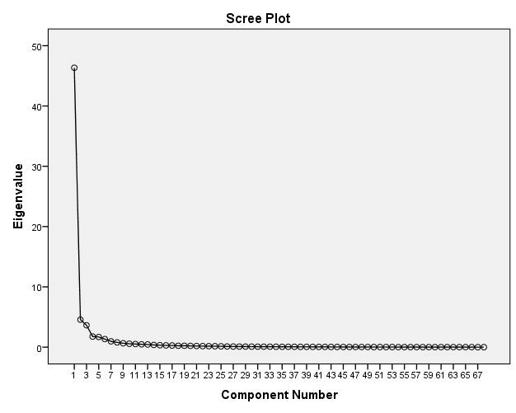
The loading of each of the cortical regions on this factor is shown in the table below, sorted by size:

Component Matrixª
 | Component
 | 1
rh insula | .960
lh precuneus | .945
lh insula | .944
rh inferiorparietal | .943
lh isthmuscingulate | .942
lh rostralanteriorcingulate | .939
lh posteriorcingulate | .938
lh supramarginal | .937
rh parsopercularis | .936
rh rostralmiddlefrontal | .931
rh parstriangularis | .929
lh middletemporal | .926
lh inferiortemporal | .926
rh superiorfrontal | .925
rh posteriorcingulate | .923
lh lateralorbitofrontal | .922
rh precuneus | .921
rh lateralorbitofrontal | .921
rh supramarginal | .920
lh superiortemporal | .919
rh rostralanteriorcingulate | .919
lh rostralmiddlefrontal | .919
rh medialorbitofrontal | .912
lh bankssts | .911
lh parsopercularis | .911
lh inferiorparietal | .910
rh inferiortemporal | .908
rh isthmuscingulate | .906
lh superiorfrontal | .905
rh parsorbitalis | .904
lh medialorbitofrontal | .897
rh superiortemporal | .895
lh parahippocampal | .891
lh parstriangularis | .891
rh caudalanteriorcingulate | .886
rh middletemporal | .883
lh parsorbitalis | .879
rh caudalmiddlefrontal | .872
rh superiorparietal | .866
lh caudalanteriorcingulate | .866
rh bankssts | .863
lh caudalmiddlefrontal | .863
lh fusiform | .852
rh fusiform | .840
rh parahippocampal | .825
lh superiorparietal | .821
lh frontalpole | .816
rh frontalpole | .811
lh temporalpole | .787
rh temporalpole | .741
lh transversetemporal | .728
rh transversetemporal | .713
lh postcentral | .702
lh paracentral | .694
rh paracentral | .669
rh postcentral | .662
lh precentral | .641
rh precentral | .636
rh lateraloccipital | .567
lh entorh inal | .563
rh entorh inal | .563
lh lateraloccipital | .538
lh pericalcarine | .513
rh pericalcarine | .496
rh lingual | .447
lh lingual | .445
lh cuneus | .376
rh cuneus | .319
Extraction Method: Principal Component Analysis.
a. 1 components extracted.

rh: right hemisphere
lh: left hemisphere

Distribution of all correlations between the Aβ – PSQI effect size and expression of all 20736 genes from the Allen Brain Atlas

The Homer1 correlation (r = .51) is among the 2.5% most highly positively correlated genes, which equals a two-tailed α-value of < .05.

Gene expression
HOMER1 expression levels were extracted from the 34 left-hemispheric cortical regions in the Desikan-Killian parcellation using methods described in (ref. French & Paus, 2015). Briefly, normalized microarray gene expression data was downloaded from the the Allen Brain Atlas, and for each donor all cortical samples were assigned to a surface region based on their MNI152 coordinates (which are provided when downloading the data). Summed over all donors, 1269 cortical samples were mapped to the 34 left-hemispheric regions; all regions were represented with sample data from at least three donors (28/34 regions had data from all donors), and at least six samples. For each region, median HOMER1 expression across donors was calculated and used to indicate regional variation in expression in the current analyses.
Follow-up analyses showed that the correlation between Aβ – PSQI effect size and HOMER1 expression was present in 6/6 donors. Here, we first converted the Aβ – PSQI effect size surface maps to 1mm³ MNI152 volume space. Next, and for each donor separately, we extracted Aβ – PSQI effect size estimates from each cortical gene expression sample available in that donor, based on the MNI-coordinates of the sample. All Aβ – PSQI effect size estimates falling within 3mm of the sample MNI-coordinate were considered representative of the sample and averaged. Following this approach, the number of gene expression samples associated with a location within the MNI152 cortical ribbon ranged between 210 and 517 across the six donors (210-269 excluding the two donors being represented with samples in both hemispheres). Spearman correlations testing the relationship between HOMER1 expression and Aβ – PSQI effect size at each donor's samples within the MNI152 cortical ribbon showed significant positive relationships in all donors (p-values ranging from <.01 to < 2e-10, rho between .11 and .30).
Figure showing an axial view of the cortical Aβ – PSQI effect size in MNI152-space (red-yellow cortical ribbon), and the gene expression samples from one of the donors with samples in both hemispheres (H0351.2001). Samples overlapping with the cortical ribbon were included in the analyses at the single-donor level.

The six donors in the Allen Human Brain Atlas Microarray Survey are described in detail in the Donor Profile Technical White Paper available at http://help.brain-map.org/display/humanbrain/Documentation. Importantly, none of the donors showed abnormal levels of amyloid plaques or neurofibrillary tangles.

Control analyses - Sleep, memory and depression
Participants underwent a visuo-constructive recall test (The Rey-Osterreith Complex Figure Text: CFT) (1), where they were asked to copy a complex figure on a sheet of paper. 30 minutes later, they were given an unannounced test, asked to reproduce the drawing from their memory. We calculated score at baseline and follow up, as well as annualized percent change in score across the three years between time points. Controlling for age, sleep problems at baseline correlated with recall at both time points (baseline r = -.34, p < .01, df = 60; follow-up r = -.32, p < .05, df = 61), but no significant relationship was found between PSQI and recall score change between time points. Correcting for depression score, PSQI at baseline still correlated significantly with recall score at baseline (r = -.30, p < .05, df = 58) and at follow up (r = -.26, p < .05, df = 58). None of the recall variables correlated with global Aβ accumulation.

We also tested the relationship between sleep problems and depressive symptoms. Controlling for age, PSQI at baseline (r = .39, p < .005, df = 58) and follow up (r = .32, p < .01) correlated with depressive symptoms at follow up. No correlations were found for depression symptom load at baseline. Increase in depressive symptom load between time points were associated with higher levels of sleep problems at follow up (r = .32, p < .01, df = 67), controlling for age and interval. Neither of the depression scores correlated with global Aβ accumulation. Adding sex as an additional covariate did not cause any of the relationships to go from significant to not significant. However, when sex was included, a relationship between increase in depression symptom load and increase in sleep problems between time points was significant (r = -.28, p < .05). Adding memory function at baseline, follow up as well as annualized percentage chance between time points as additional covariates did not cause any of the relationships to go from significant to not significant. Thus, memory and depressive symptoms are independently related to sleep problems, but neither seem to affect the sleep- Aβ accumulation pattern.

Age × PSQI interaction in explaining Aβ accumulation
Scatterplot illustrating mean Aβ accumulation values across all vertices in Figure 3 showing a significant age × PSQI interaction.

References
1. Poulton RG & Moffitt TE (1995) The Rey-Osterreith Complex Figure Test: norms for young adolescents and an examination of validity. Arch Clin Neuropsychol 10(1):47-56.

