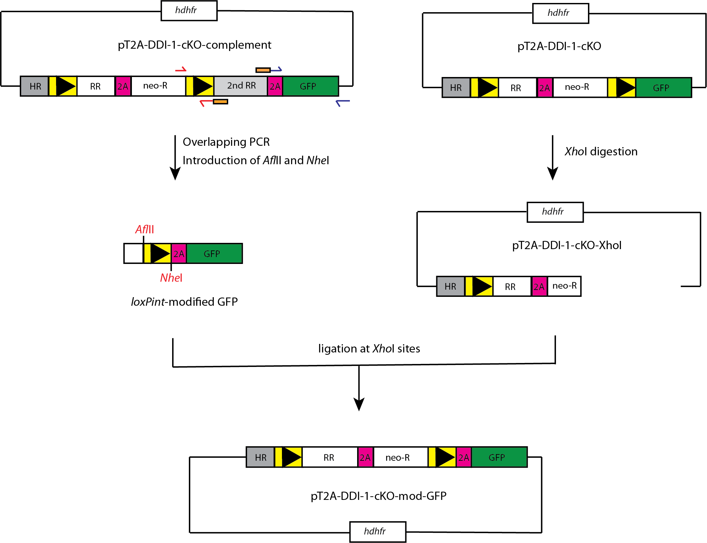

S1 Fig. Construction of pT2A-DDI-1-cKO modified GFP. The loxPint and gfp fragments were amplified from pT2A-DDI-1cKO-compliment. Overlapping PCR was performed to join the two fragments. The AflII and NheI restriction sites were introduced to facilitate further cloning. pT2A-DDI-1cKO was digested with XhoI. The digested fragment was ligated with loxPint-modified GFP fragment at XhoI site.

