**Supplementary Figures**

# Supplementary Figure 1

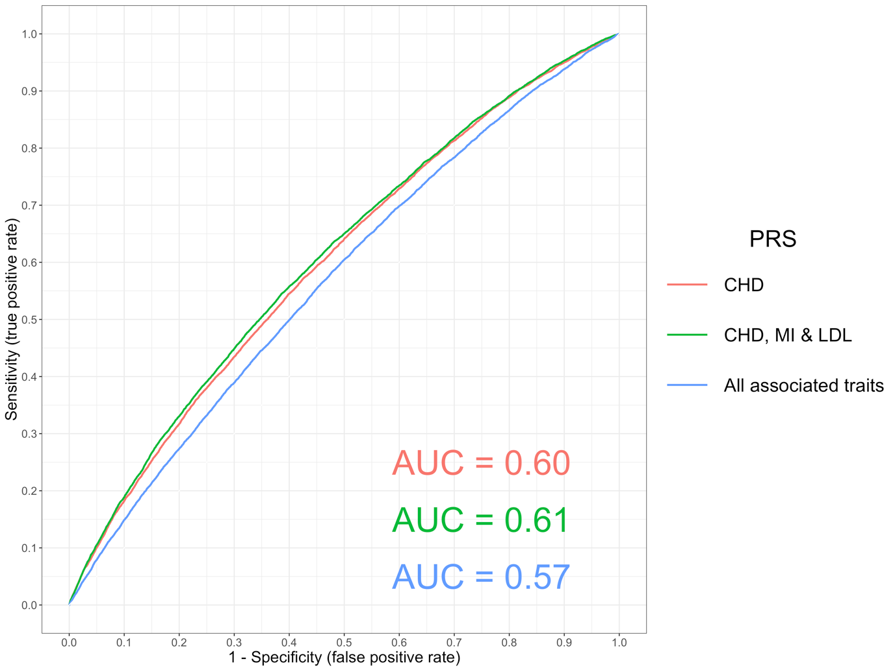

A receiver operating characteristic (ROC) curve to compare the sensitivity and specificity of polygenic risk scores (PRS) and individuals with ischaemic heart disease (defined using ICD 10 codes ‘I25’) in the UK Biobank study. The scores evaluated were 1. Coronary Heart Disease (CHD), 2. A combined scored of CHD, Myocardial Infarction (MI) & Low Density Lipoprotein cholesterol (LDL), 3. All traits with a p-value < 1 x 10-06 in our PRS analysis (excluding scores from GWAS overlapping with the UK Biobank sample). These were CHD, MI, LDL, Total cholesterol, Triglycerides, High Density Lipoprotein cholesterol, Years of schooling, Height and Waist Circumference. All PRS were constructed from GWAS using independent SNPs with P < 5 x 10-05.

# Supplementary Figure 2

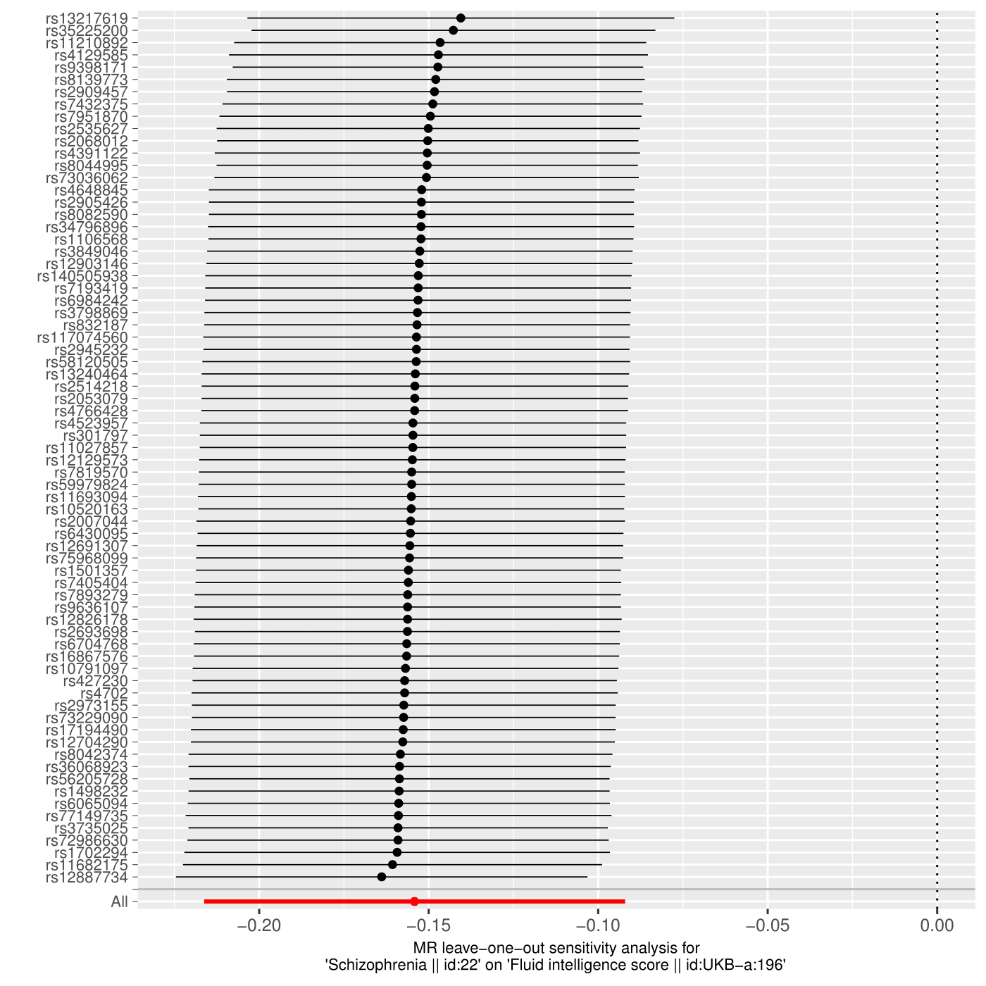

A plot illustrating a leave-one out analysis between schizophrenia genetic liability and fluid intelligence.

# Supplementary Figure 3

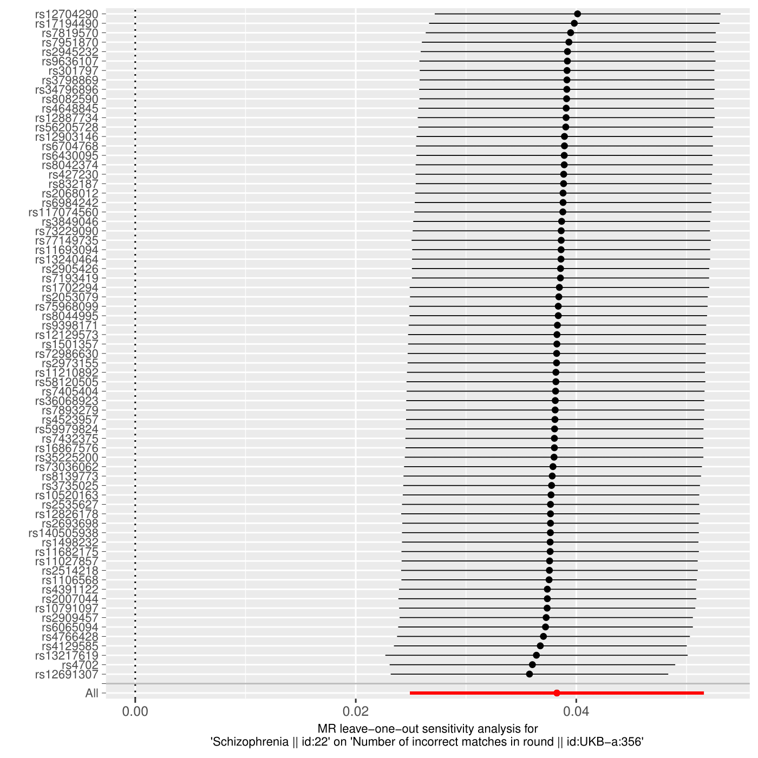

A plot illustrating a leave-one out analysis between schizophrenia genetic liability and ‘number of incorrect matches in a round’.

# Supplementary Figure 4

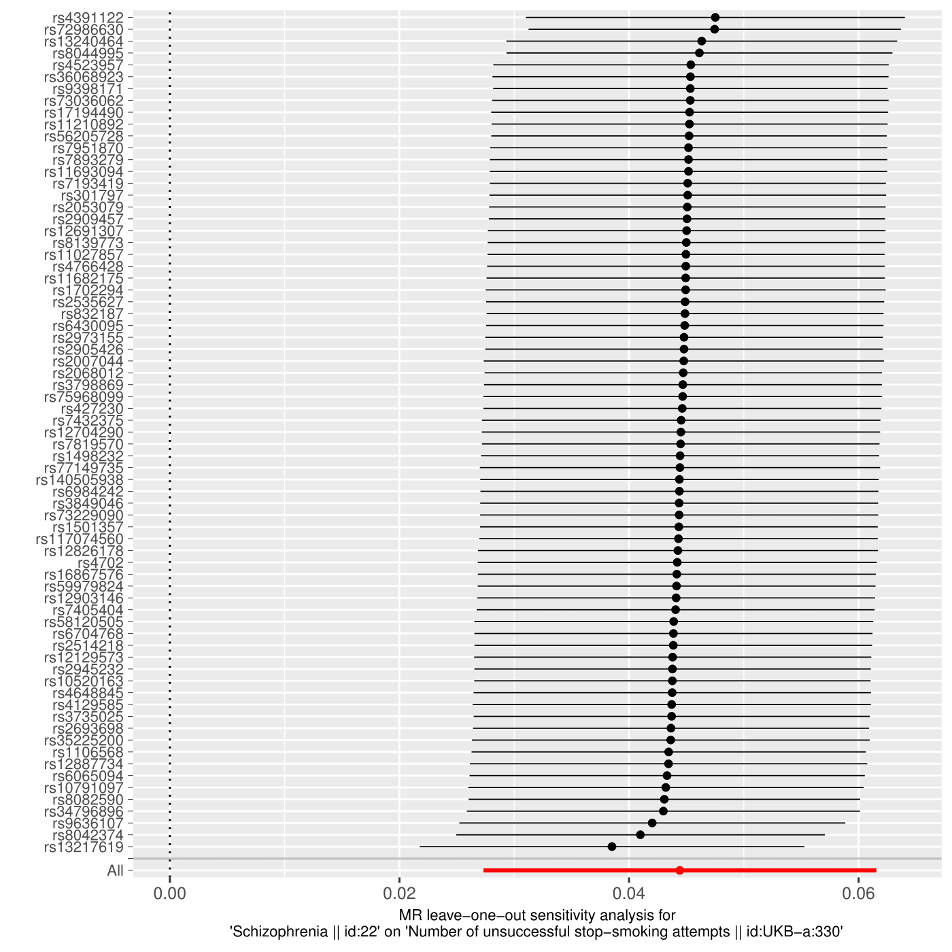

A plot illustrating a leave-one out analysis between schizophrenia genetic liability and ‘number of unsuccessful smoking attempts’.

# Supplementary Figure 5

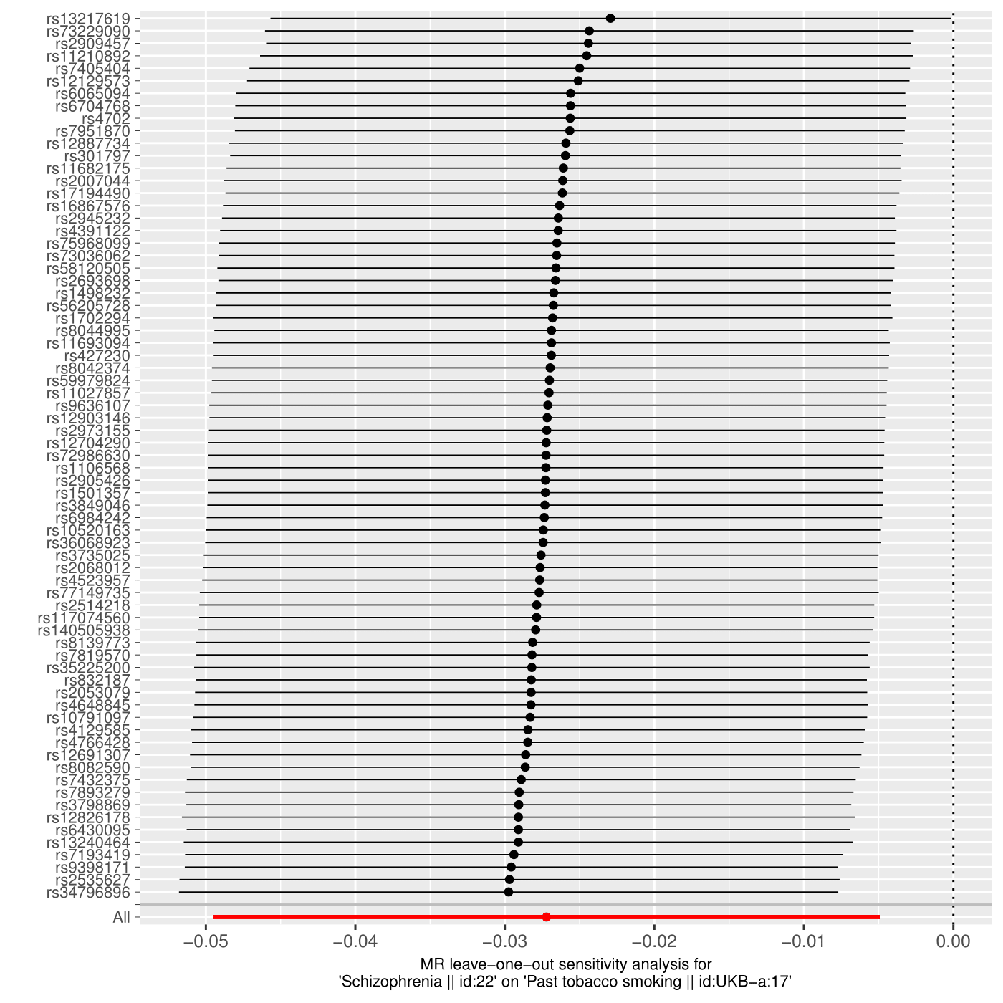

A plot illustrating a leave-one out analysis between schizophrenia genetic liability and past tobacco smoking.

# Supplementary Figure 6

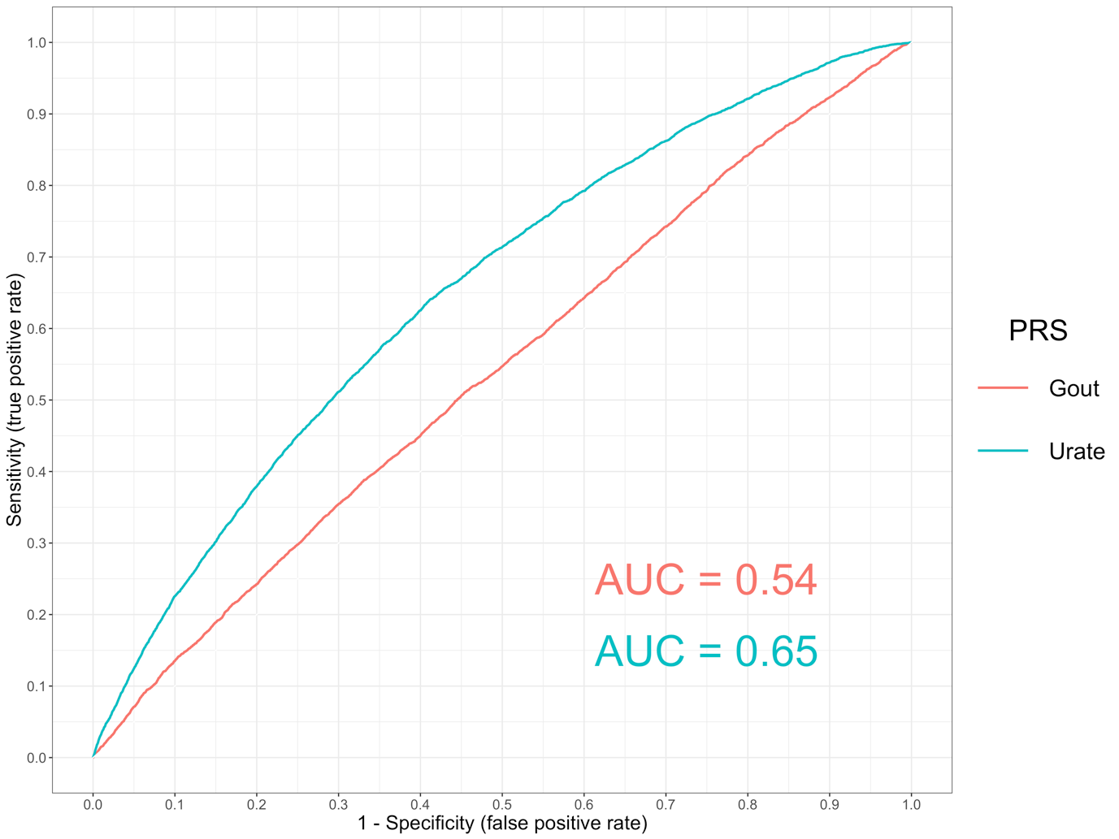

A receiver operating characteristic (ROC) curve to compare the sensitivity and specificity of polygenic risk scores (PRS) and individuals with self-reported gout in the UK Biobank study. The scores evaluated were gout and urate using independent SNPs identified by GWAS with P < 5 x 10-05.

# Supplementary Figure 7



A plot illustrating a leave-one out analysis between body mass index and triglycerides.

# Supplementary Figure 8



A plot illustrating a leave-one out analysis between triglycerides and urate.

# Supplementary Figure 9



A plot illustrating a leave-one out analysis between urate and gout.

# Supplementary Figure 10



A plot illustrating a leave-one out analysis between body mass index and gout.