Supplementary materials
Genetic variation in the Major Histocompatibility Complex and association with depression
Table of Contents
Supplementary figure 1: correlation between frequencies in the PGC and UKB 2
Supplementary figure 2: correlation between info scores in the PGC and UKB 3
Acknowledgements 4
Funding sources 5
Full author list for the Major Depressive Disorder Working Group of the Psychiatric Genomics Consortium 7

Supplementary figure 1: correlation between frequencies in the PGC and UKB
In Supplementary Figure 1, frequencies are expressed as -log₁₀ to highlight rare alleles.
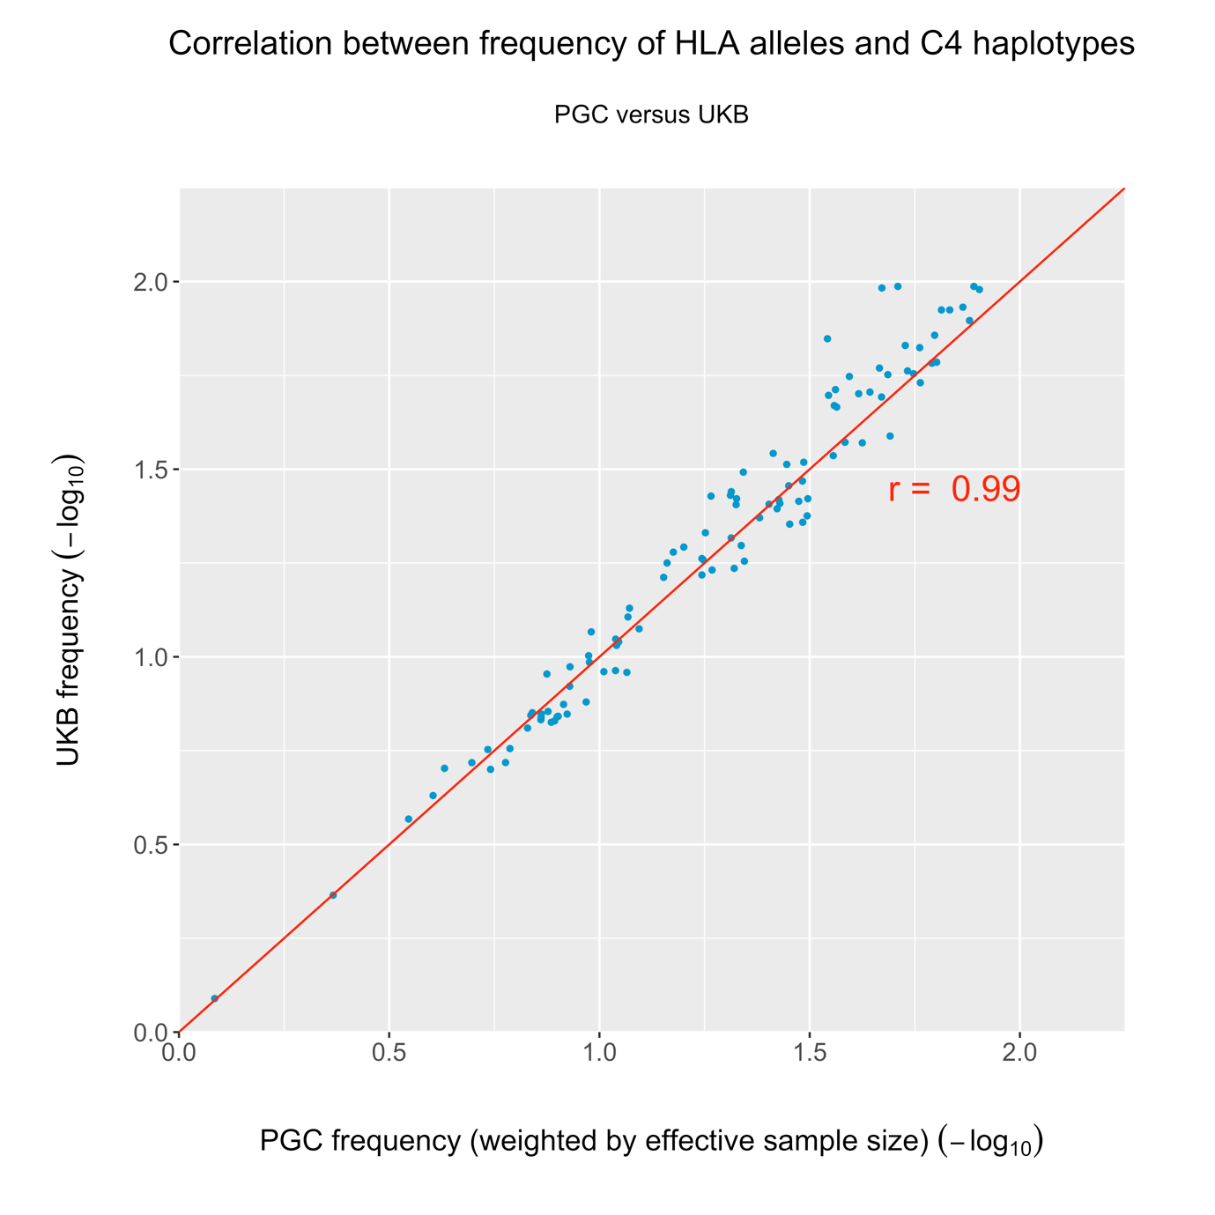
Supplementary Figure 1: Correlation between frequency (-log₁₀) of HLA alleles and C4 haplotypes common to the PGC and UKB, weighted by effective sample size in the PGC.

Supplementary figure 2: correlation between info scores in the PGC and UKB
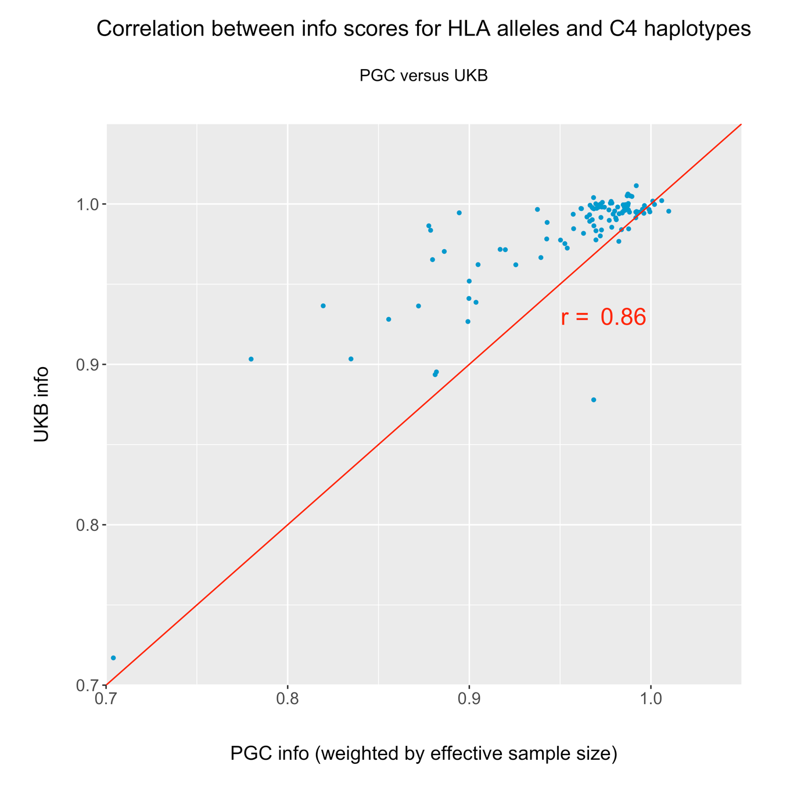
Supplementary Figure 2: Correlation between info scores for HLA alleles and C4 haplotypes common to the PGC and UKB, weighted by effective sample size in the PGC.

Acknowledgements
We thank contributors to the primary studies comprising the PGC sample in this paper. EDINBURGH: Genotyping was conducted at the Genetics Core Laboratory at the Clinical Research Facility (University of Edinburgh). GSK_MUNICH: We thank all participants in the GSK-Munich study. We thank numerous people at GSK and Max-Planck Institute, BKH Augsburg and Klinikum Ingolstadt in Germany who contributed to this project. MARS: This work was funded by the Max Planck Society, by the Max Planck Excellence Foundation, and by a grant from the German Federal Ministry for Education and Research (BMBF) in the National Genome Research Network framework (NGFN2 and NGFN-Plus, FKZ 01GS0481), and by the BMBF Program FKZ 01ES0811. We acknowledge all study participants. We thank numerous people at Max-Planck Institute, and all study sites in Germany and Switzerland who contributed to this project. Controls were from the Dortmund Health Study which was supported by the German Migraine & Headache Society, and by unrestricted grants to the University of Münster from Almirall, Astra Zeneca, Berlin Chemie, Boehringer, Boots Health Care, Glaxo-Smith-Kline, Janssen Cilag, McNeil Pharma, MSD Sharp & Dohme, and Pfizer. Blood collection was funded by the Institute of Epidemiology and Social Medicine, University of Münster. Genotyping was supported by the German Ministry of Research and Education (BMBF grant 01ER0816). NESDA: The infrastructure for the NESDA study (www.nesda.nl) is funded through the Geestkracht program of the Netherlands Organisation for Health Research and Development (ZonMw, grant number 10-000-1002) and financial contributions by participating universities and mental health care organizations (VU University Medical Center, GGZ inGeest, Leiden University Medical Center, Leiden University, GGZ Rivierduinen, University Medical Center Groningen, University of Groningen, Lentis, GGZ Friesland, GGZ Drenthe, Rob Giel Onderzoekscentrum). Genotyping was supported by the Biobanking and Biomolecular Resources Research Infrastructure (BBMRI-NL) and National Institutes of Health (Genetic Association Information Network (GAIN) of the Foundation for the National Institutes of Health, Grand Opportunity grants 1RC2 MH089951 and 1RC2 MH089995). NTR: is supported by NWO(480-15-001/674); BBMRI –NL: Biobanking and Biomolecular Resources Research Infrastructure (184.021.007 and BBMRI-NL2.0 184.033.111); Genotyping was supported BBMRI-NL, the Avera Institute, Sioux Falls (USA) and National Institutes of Health (Genetic Association Information Network (GAIN) of the Foundation for the National Institutes of Health, Grand Opportunity grants 1RC2 MH089951 and 1RC2 MH089995). PsyColaus: PsyCoLaus/CoLaus received additional support from research grants from GlaxoSmithKline and the Faculty of Biology and Medicine of Lausanne. QIMR: We thank the twins and their families for their willing participation in our studies. RADIANT: This report represents independent research funded by the National Institute for Health Research (NIHR) Biomedical Research Centre at South London and Maudsley NHS Foundation Trust, and King’s College London. The views expressed are those of the authors and not necessarily those of the NHS, the NIHR, or the Department of Health. Rotterdam Study: The Rotterdam Study is also funded by Erasmus Medical Center and Erasmus University. SHIP-LEGEND/TREND: SHIP is part of the Community Medicine Research net of the University of Greifswald which is funded by the Federal Ministry of Education and Research (grants 01ZZ9603, 01ZZ0103, and 01ZZ0403), the Ministry of Cultural Affairs, and the Social Ministry of the Federal State of Mecklenburg-West Pomerania. Genotyping in SHIP was funded by Siemens Healthineers and the Federal State of Mecklenburg-West Pomerania. Genotyping in SHIP-TREND-0 was supported by the Federal Ministry of Education and Research (grant 03ZIK012). STAR*D: The authors appreciate the efforts of the STAR*D investigator team for acquiring, compiling, and sharing the STAR*D clinical data set. TwinGene: thanks the Karolinska Institutet for infrastructural support of the Swedish Twin Registry.
Funding support for the Genome-Wide Association of Schizophrenia Study was provided by the National Institute of Mental Health (R01 MH67257, R01 MH59588, R01 MH59571, R01 MH59565, R01 MH59587, R01 MH60870, R01 MH59566, R01 MH59586, R01 MH61675, R01 MH60879, R01 MH81800, U01 MH46276, U01 MH46289 U01 MH46318, U01 MH79469, and U01 MH79470) and the genotyping of samples was provided through the Genetic Association Information Network (GAIN). The datasets used for the analyses described in this manuscript were obtained from the database of Genotypes and Phenotypes (dbGaP) found at http://www.ncbi.nlm.nih.gov/gap through dbGaP accession number phs000021.v3.p2. Samples and associated phenotype data for the Genome-Wide Association of Schizophrenia Study were provided by the Molecular Genetics of Schizophrenia Collaboration (PI: Pablo V. Gejman, Evanston Northwestern Healthcare (ENH) and Northwestern University, Evanston, IL, USA).

Funding sources
The table below lists the funding that supported the primary studies in this paper.
Study | Lead investigator | Award number | Funder | Country
PGC | PF Sullivan | U01 MH109528 | NIMH | USA
PGC | A Agrawal | U01 MH109532 | NIDA | USA
PGC | D Posthuma | 480-05-003 | Netherlands Scientific Organization | Netherlands
PGC | D Posthuma | – | Dutch Brain Foundation and the VU University Amsterdam | Netherlands
BoMa | M Rietschel | RI 908/11-1 | Deutsche Forschungsgemeinschaft | Germany
BoMa | MM Nöthen | NO246/10-1 | Deutsche Forschungsgemeinschaft | Germany
BoMa | MM Nöthen | Excellence Cluster ImmunoSensation | Deutsche Forschungsgemeinschaft | Germany
BoMa | MM Nöthen, M Rietschel, S Cichon | 01ZX1314A/01ZX1614A,  01ZX1314G/01ZX1614G | BMBF Integrament | Germany
BoMa | MM Nöthen, M Rietschel, S Cichon | 01GS08144, 01GS08147 | BMBF NGFNplus MooDS | Germany
CoFaMS - Adelaide | BT Baune | APP1060524 | NHMRC | Australia
Danish Radiant | T Werge (controls)  O Mors (cases) | 0001-2009-2 | Højteknologifonden | Denmark
Danish Radiant | T Werge (controls)  O Mors (cases) | R24-A3242 | Lundbeck Foundation | Denmark
EDINBURGH | AM McIntosh | 104036/Z/14/Z | Wellcome Trust | UK
GenPod/Newmeds | G Lewis, M O'Donovan | G0200243 | MRC | UK
GenPod/Newmeds | R Uher | LSHB-CT-2003-503428 | EU 6th framework | UK
GenPod/Newmeds | G Lewis | 15008 | EU IMI-JU | UK
Harvard i2b2 | JW Smoller | R01 MH085542 | NIMH | USA
Harvard i2b2 | RH Perlis | R01 MH086026 | NIMH | USA
NESDA | BWJH Penninx | ZonMW Geestkracht grant | N.W.O. | Netherlands
NESDA | BJWH Penninx | 1RC2 MH089951; 1RC2 MH089995 | NIH | USA
NTR | DI Boomsma | 1RC2 MH089951; 1RC2 MH089995 | NIH | Netherlands
PsyColaus | M Preisig | 3200B0–105993, 3200B0-118308, 33CSCO-122661, 33CS30-139468, 33CS30-148401 | Swiss National Science Foundation | Switzerland
QIMR | NG Martin | 941177, 971232, 3399450 and 443011 | National Health and Medical Research Council | Australia
QIMR | AC Heath | AA07535, AA07728, andAA10249 | NIAAA | USA
RADIANT | C Lewis, G Breen | G0701420 | MRC | UK
RADIANT | G Breen | G0901245 | MRC | UK
RADIANT | G Breen | U01 MH109528 | NIMH | UK
Rotterdam Study | AG Uitterlinden | 175.010.2005.011, 911-03-012 | Netherlands Organization of Scientific Research NWO Investments | Netherlands
SHIP-LEGEND/TREND | HJ Grabe | DFG: GR 1912/5-1 | German Research Foundation | Germany
STAR*D | SP Hamilton | R01 MH-072802 | NIMH | USA
TwinGene | N Pedersen | EU/QLRT-2001-01254; QLG2-CT-2002-01254 | GenomeEUtwin | EU
TwinGene | P Magnusson | 20070481 | Heart and Lung foundation | Sweden
TwinGene | U de Faire |  | SSF | Sweden
TwinGene | U de Faire | M-2005-1112 | Vetenskapsrådet | Sweden
UK Biobank | P F O'Reilly | MR/N015746/1 | Medical Research Council | UK

Full author list for the Major Depressive Disorder Working Group of the Psychiatric Genomics Consortium
Naomi R Wray* 1, 2
Stephan Ripke* 3, 4, 5
Manuel Mattheisen* 6, 7, 8, 9
Maciej Trzaskowski* 1
Enda M Byrne 1
Abdel Abdellaoui 10
Mark J Adams 11
Esben Agerbo 9, 12, 13
Tracy M Air 14
Till F M Andlauer 15, 16
Silviu-Alin Bacanu 17
Marie Bækvad-Hansen 9, 18
Aartjan T F Beekman 19
Tim B Bigdeli 17, 20
Elisabeth B Binder 15, 21
Douglas H R Blackwood 11
Julien Bryois 22
Henriette N Buttenschøn 9, 23
Jonas Bybjerg-Grauholm 9, 18
Na Cai 24, 25
Enrique Castelao 26
Jane Hvarregaard Christensen 7, 8, 9
Toni-Kim Clarke 11
Jonathan R I Coleman 27
Lucía Colodro-Conde 28
Baptiste Couvy-Duchesne 2, 29
Nick Craddock 30
Gregory E Crawford 31, 32
Gail Davies 33
Ian J Deary 33
Franziska Degenhardt 34, 35
Eske M Derks 28
Nese Direk 36, 37
Conor V Dolan 10, 118
Erin C Dunn 38, 39, 40
Thalia C Eley 27
Valentina Escott-Price 41
Farnush Farhadi Hassan Kiadeh 42
Hilary K Finucane 43, 44
Jerome C Foo 45
Andreas J Forstner 34, 35, 46, 47
Josef Frank 45
Héléna A Gaspar 27
Michael Gill 48
Fernando S Goes 49
Scott D Gordon 28
Jakob Grove 7, 8, 9, 50
Lynsey S Hall 11, 51
Christine Søholm Hansen 9, 18
Thomas F Hansen 52, 53, 54
Stefan Herms 34, 35, 47
Ian B Hickie 55
Per Hoffmann 34, 35, 47
Georg Homuth 56
Carsten Horn 57
Jouke-Jan Hottenga 10,118
David M Hougaard 9, 18
Marcus Ising 58
Rick Jansen 19
Ian Jones 59
Lisa A Jones 60
Eric Jorgenson 61
James A Knowles 62
Isaac S Kohane 63, 64, 65
Julia Kraft 4
Warren W. Kretzschmar 66
Jesper Krogh 67
Zoltán Kutalik 68, 69
Yihan Li 66
Penelope A Lind 28
Donald J MacIntyre 70, 71
Dean F MacKinnon 49
Robert M Maier 2
Wolfgang Maier 72
Jonathan Marchini 73
Hamdi Mbarek 10, 118
Patrick McGrath 74
Peter McGuffin 27
Sarah E Medland 28
Divya Mehta 2, 75
Christel M Middeldorp 10, 76, 77
Evelin Mihailov 78
Yuri Milaneschi 19
Lili Milani 78
Francis M Mondimore 49
Grant W Montgomery 1
Sara Mostafavi 79, 80
Niamh Mullins 27
Matthias Nauck 81, 82
Bernard Ng 80
Michel G Nivard 10, 118
Dale R Nyholt 83
Paul F O'Reilly 27
Hogni Oskarsson 84
Michael J Owen 59
Jodie N Painter 28
Carsten Bøcker Pedersen 9, 12, 13
Marianne Giørtz Pedersen 9, 12, 13
Roseann E. Peterson 17, 85
Erik Pettersson 22
Wouter J Peyrot 19
Giorgio Pistis 26
Danielle Posthuma 86, 87
Jorge A Quiroz 88
Per Qvist 7, 8, 9
John P Rice 89
Brien P. Riley 17
Margarita Rivera 27, 90
Saira Saeed Mirza 36
Robert Schoevers 91
Eva C Schulte 92, 93
Ling Shen 61
Jianxin Shi 94
Stanley I Shyn 95
Engilbert Sigurdsson 96
Grant C B Sinnamon 97
Johannes H Smit 19
Daniel J Smith 98
Hreinn Stefansson 99
Stacy Steinberg 99
Fabian Streit 45
Jana Strohmaier 45
Katherine E Tansey 100
Henning Teismann 101
Alexander Teumer 102
Wesley Thompson 9, 53, 103, 104
Pippa A Thomson 105
Thorgeir E Thorgeirsson 99
Matthew Traylor 106
Jens Treutlein 45
Vassily Trubetskoy 4
André G Uitterlinden 107
Daniel Umbricht 108
Sandra Van der Auwera 109
Albert M van Hemert 110
Alexander Viktorin 22
Peter M Visscher 1, 2
Yunpeng Wang 9, 53, 104
Bradley T. Webb 111
Shantel Marie Weinsheimer 9, 53
Jürgen Wellmann 101
Gonneke Willemsen 10,118
Stephanie H Witt 45
Yang Wu 1
Hualin S Xi 112
Jian Yang 2, 113
Futao Zhang 1
Volker Arolt 114
Bernhard T Baune 115
Klaus Berger 101
Dorret I Boomsma 10,118
Sven Cichon 34, 47, 116, 117
Udo Dannlowski 114
EJC de Geus 10, 118
J Raymond DePaulo 49
Enrico Domenici 119
Katharina Domschke 120
Tõnu Esko 5, 78
Hans J Grabe 109
Steven P Hamilton 121
Caroline Hayward 122
Andrew C Heath 89
Kenneth S Kendler 17
Stefan Kloiber 58, 123, 124
Glyn Lewis 125
Qingqin S Li 126
Susanne Lucae 58
Pamela AF Madden 89
Patrik K Magnusson 22
Nicholas G Martin 28
Andrew M McIntosh 11, 33
Andres Metspalu 78, 127
Ole Mors 9, 128
Preben Bo Mortensen 8, 9, 12, 13
Bertram Müller-Myhsok 15, 16, 129
Merete Nordentoft 9, 130
Markus M Nöthen 34, 35
Michael C O'Donovan 59
Sara A Paciga 131
Nancy L Pedersen 22
Brenda WJH Penninx 19
Roy H Perlis 38, 132
David J Porteous 105
James B Potash 133
Martin Preisig 26
Marcella Rietschel 45
Catherine Schaefer 61
Thomas G Schulze 45, 93, 134, 135, 136
Jordan W Smoller 38, 39, 40
Kari Stefansson 99, 137
Henning Tiemeier 36, 138, 139
Rudolf Uher 140
Henry Völzke 102
Myrna M Weissman 74, 141
Thomas Werge 9, 53, 142
Cathryn M Lewis 27, 143
Douglas F Levinson 144
Gerome Breen 27, 145
Anders D Børglum 7, 8, 9
Patrick F Sullivan 22, 146, 147,

1, Institute for Molecular Bioscience, The University of Queensland, Brisbane, QLD, AU
2, Queensland Brain Institute, The University of Queensland, Brisbane, QLD, AU
3, Analytic and Translational Genetics Unit, Massachusetts General Hospital, Boston, MA, US
4, Department of Psychiatry and Psychotherapy, Universitätsmedizin Berlin Campus Charité Mitte, Berlin, DE
5, Medical and Population Genetics, Broad Institute, Cambridge, MA, US
6, Centre for Psychiatry Research, Department of Clinical Neuroscience, Karolinska Institutet, Stockholm, SE
7, Department of Biomedicine, Aarhus University, Aarhus, DK
8, iSEQ, Centre for Integrative Sequencing, Aarhus University, Aarhus, DK
9, iPSYCH, The Lundbeck Foundation Initiative for Integrative Psychiatric Research, DK
10 Netherlands Twin Register, Dept of Biological Psychology, Vrije Universiteit Amsterdam, Amsterdam, NL
11, Division of Psychiatry, University of Edinburgh, Edinburgh, GB
12, Centre for Integrated Register-based Research, Aarhus University, Aarhus, DK
13, National Centre for Register-Based Research, Aarhus University, Aarhus, DK
14, Discipline of Psychiatry, Adelaide Medical School, University of Adelaide, Adelaide, SA, AU
15, Department of Translational Research in Psychiatry, Max Planck Institute of Psychiatry, Munich, DE
16, Munich Cluster for Systems Neurology (SyNergy), Munich, DE
17, Department of Psychiatry, Virginia Commonwealth University, Richmond, VA, US
18, Center for Neonatal Screening, Department for Congenital Disorders, Statens Serum Institut, Copenhagen, DK
19, Department of Psychiatry, Amsterdam UMC, Vrije Universiteit Amsterdam, NL
20, Virginia Institute for Psychiatric and Behavior Genetics, Richmond, VA, US
21, Department of Psychiatry and Behavioral Sciences, Emory University School of Medicine, Atlanta, GA, US
22, Department of Medical Epidemiology and Biostatistics, Karolinska Institutet, Stockholm, SE
23, NIDO | Danmark, Regional Hospital West Jutland, DK
24, Human Genetics, Wellcome Trust Sanger Institute, Cambridge, GB
25, Statistical genomics and systems genetics, European Bioinformatics Institute (EMBL-EBI), Cambridge, GB
26, Department of Psychiatry, University Hospital of Lausanne, Prilly, Vaud, CH
27, Social Genetic and Developmental Psychiatry Centre, King's College London, London, GB
28, Genetics and Computational Biology, QIMR Berghofer Medical Research Institute, Brisbane, QLD, AU
29, Centre for Advanced Imaging, The University of Queensland, Brisbane, QLD, AU
30, Psychological Medicine, Cardiff University, Cardiff, GB
31, Center for Genomic and Computational Biology, Duke University, Durham, NC, US
32, Department of Pediatrics, Division of Medical Genetics, Duke University, Durham, NC, US
33, Centre for Cognitive Ageing and Cognitive Epidemiology, University of Edinburgh, Edinburgh, GB
34, Institute of Human Genetics, University of Bonn, Bonn, DE
35, Life&Brain Center, Department of Genomics, University of Bonn, Bonn, DE
36, Epidemiology, Erasmus MC, Rotterdam, Zuid-Holland, NL
37, Psychiatry, Dokuz Eylul University School Of Medicine, Izmir, TR
38, Department of Psychiatry, Massachusetts General Hospital, Boston, MA, US
39, Psychiatric and Neurodevelopmental Genetics Unit (PNGU), Massachusetts General Hospital, Boston, MA, US
40, Stanley Center for Psychiatric Research, Broad Institute, Cambridge, MA, US
41, Neuroscience and Mental Health, Cardiff University, Cardiff, GB
42, Bioinformatics, University of British Columbia, Vancouver, BC, CA
43, Department of Epidemiology, Harvard T.H. Chan School of Public Health, Boston, MA, US
44, Department of Mathematics, Massachusetts Institute of Technology, Cambridge, MA, US
45, Department of Genetic Epidemiology in Psychiatry, Central Institute of Mental Health, Medical Faculty Mannheim, Heidelberg University, Mannheim, Baden-Württemberg, DE
46, Department of Psychiatry (UPK), University of Basel, Basel, CH
47, Human Genomics Research Group, Department of Biomedicine, University of Basel, Basel, CH
48, Department of Psychiatry, Trinity College Dublin, Dublin, IE
49, Psychiatry & Behavioral Sciences, Johns Hopkins University, Baltimore, MD, US
50, Bioinformatics Research Centre, Aarhus University, Aarhus, DK
51, Institute of Genetic Medicine, Newcastle University, Newcastle upon Tyne, GB
52, Danish Headache Centre, Department of Neurology, Rigshospitalet, Glostrup, DK
53, Institute of Biological Psychiatry, Mental Health Center Sct. Hans, Mental Health Services Capital Region of Denmark, Copenhagen, DK
54, iPSYCH, The Lundbeck Foundation Initiative for Psychiatric Research, Copenhagen, DK
55, Brain and Mind Centre, University of Sydney, Sydney, NSW, AU
56, Interfaculty Institute for Genetics and Functional Genomics, Department of Functional Genomics, University Medicine and Ernst Moritz Arndt University Greifswald, Greifswald, Mecklenburg-Vorpommern, DE
57, Roche Pharmaceutical Research and Early Development, Pharmaceutical Sciences, Roche Innovation Center Basel, F. Hoffmann-La Roche Ltd, Basel, CH
58, Max Planck Institute of Psychiatry, Munich, DE
59, MRC Centre for Neuropsychiatric Genetics and Genomics, Cardiff University, Cardiff, GB
60, Department of Psychological Medicine, University of Worcester, Worcester, GB
61, Division of Research, Kaiser Permanente Northern California, Oakland, CA, US
62, Psychiatry & The Behavioral Sciences, University of Southern California, Los Angeles, CA, US
63, Department of Biomedical Informatics, Harvard Medical School, Boston, MA, US
64, Department of Medicine, Brigham and Women's Hospital, Boston, MA, US
65, Informatics Program, Boston Children's Hospital, Boston, MA, US
66, Wellcome Trust Centre for Human Genetics, University of Oxford, Oxford, GB
67, Department of Endocrinology at Herlev University Hospital, University of Copenhagen, Copenhagen, DK
68, Institute of Social and Preventive Medicine (IUMSP), University Hospital of Lausanne, Lausanne, VD, CH
69, Swiss Institute of Bioinformatics, Lausanne, VD, CH
70, Division of Psychiatry, Centre for Clinical Brain Sciences, University of Edinburgh, Edinburgh, GB
71, Mental Health, NHS 24, Glasgow, GB
72, Department of Psychiatry and Psychotherapy, University of Bonn, Bonn, DE
73, Statistics, University of Oxford, Oxford, GB
74, Psychiatry, Columbia University College of Physicians and Surgeons, New York, NY, US
75, School of Psychology and Counseling, Queensland University of Technology, Brisbane, QLD, AU
76, Child and Youth Mental Health Service, Children's Health Queensland Hospital and Health Service, South Brisbane, QLD, AU
77, Child Health Research Centre, University of Queensland, Brisbane, QLD, AU
78, Estonian Genome Center, University of Tartu, Tartu, EE
79, Medical Genetics, University of British Columbia, Vancouver, BC, CA
80, Statistics, University of British Columbia, Vancouver, BC, CA
81, DZHK (German Centre for Cardiovascular Research), Partner Site Greifswald, University Medicine, University Medicine Greifswald, Greifswald, Mecklenburg-Vorpommern, DE
82, Institute of Clinical Chemistry and Laboratory Medicine, University Medicine Greifswald, Greifswald, Mecklenburg-Vorpommern, DE
83, Institute of Health and Biomedical Innovation, Queensland University of Technology, Brisbane, QLD, AU
84, Humus, Reykjavik, IS
85, Virginia Institute for Psychiatric & Behavioral Genetics, Virginia Commonwealth University, Richmond, VA, US
86, Clinical Genetics, Vrije Universiteit Medical Center, Amsterdam, NL
87, Complex Trait Genetics, Vrije Universiteit Amsterdam, Amsterdam, NL
88, Solid Biosciences, Boston, MA, US
89, Department of Psychiatry, Washington University in Saint Louis School of Medicine, Saint Louis, MO, US
90, Department of Biochemistry and Molecular Biology II, Institute of Neurosciences, Center for Biomedical Research, University of Granada, Granada, ES
91, Department of Psychiatry, University of Groningen, University Medical Center Groningen, Groningen, NL
92, Department of Psychiatry and Psychotherapy, Medical Center of the University of Munich, Campus Innenstadt, Munich, DE
93, Institute of Psychiatric Phenomics and Genomics (IPPG), Medical Center of the University of Munich, Campus Innenstadt, Munich, DE
94, Division of Cancer Epidemiology and Genetics, National Cancer Institute, Bethesda, MD, US
95, Behavioral Health Services, Kaiser Permanente Washington, Seattle, WA, US
96, Faculty of Medicine, Department of Psychiatry, University of Iceland, Reykjavik, IS
97, School of Medicine and Dentistry, James Cook University, Townsville, QLD, AU
98, Institute of Health and Wellbeing, University of Glasgow, Glasgow, GB
99, deCODE Genetics / Amgen, Reykjavik, IS
100, College of Biomedical and Life Sciences, Cardiff University, Cardiff, GB
101, Institute of Epidemiology and Social Medicine, University of Münster, Münster, Nordrhein-Westfalen, DE
102, Institute for Community Medicine, University Medicine Greifswald, Greifswald, Mecklenburg-Vorpommern, DE
103, Department of Psychiatry, University of California, San Diego, San Diego, CA, US
104, KG Jebsen Centre for Psychosis Research, Norway Division of Mental Health and Addiction, Oslo University Hospital, Oslo, NO
105, Medical Genetics Section, CGEM, IGMM, University of Edinburgh, Edinburgh, GB
106, Clinical Neurosciences, University of Cambridge, Cambridge, GB
107, Internal Medicine, Erasmus MC, Rotterdam, Zuid-Holland, NL
108, Roche Pharmaceutical Research and Early Development, Neuroscience, Ophthalmology and Rare Diseases Discovery & Translational Medicine Area, Roche Innovation Center Basel, F. Hoffmann-La Roche Ltd, Basel, CH
109, Department of Psychiatry and Psychotherapy, University Medicine Greifswald, Greifswald, Mecklenburg-Vorpommern, DE
110, Department of Psychiatry, Leiden University Medical Center, Leiden, NL
111, Virginia Institute for Psychiatric & Behavioral Genetics, Virginia Commonwealth University, Richmond, VA, US
112, Computational Sciences Center of Emphasis, Pfizer Global Research and Development, Cambridge, MA, US
113, Institute for Molecular Bioscience; Queensland Brain Institute, The University of Queensland, Brisbane, QLD, AU
114, Department of Psychiatry, University of Münster, Münster, Nordrhein-Westfalen, DE
115, Department of Psychiatry, Melbourne Medical School, University of Melbourne, Melbourne, AU
116, Institute of Medical Genetics and Pathology, University Hospital Basel, University of Basel, Basel, CH
117, Institute of Neuroscience and Medicine (INM-1), Research Center Juelich, Juelich, DE
118 Amsterdam Public Health Institute (APH), Vrije Universiteit Medical Center, Amsterdam, NL
119, Centre for Integrative Biology, Università degli Studi di Trento, Trento, Trentino-Alto Adige, IT
120, Department of Psychiatry and Psychotherapy, Medical Center, University of Freiburg, Faculty of Medicine, University of Freiburg, Freiburg, DE
121, Psychiatry, Kaiser Permanente Northern California, San Francisco, CA, US
122, Medical Research Council Human Genetics Unit, Institute of Genetics and Molecular Medicine, University of Edinburgh, Edinburgh, GB
123, Department of Psychiatry, University of Toronto, Toronto, ON, CA
124, Centre for Addiction and Mental Health, Toronto, ON, CA
125, Division of Psychiatry, University College London, London, GB
126, Neuroscience Therapeutic Area, Janssen Research and Development, LLC, Titusville, NJ, US
127, Institute of Molecular and Cell Biology, University of Tartu, Tartu, EE
128, Psychosis Research Unit, Aarhus University Hospital, Risskov, Aarhus, DK
129, University of Liverpool, Liverpool, GB
130, Mental Health Center Copenhagen, Copenhagen Universtity Hospital, Copenhagen, DK
131, Human Genetics and Computational Biomedicine, Pfizer Global Research and Development, Groton, CT, US
132, Psychiatry, Harvard Medical School, Boston, MA, US
133, Psychiatry, University of Iowa, Iowa City, IA, US
134, Department of Psychiatry and Behavioral Sciences, Johns Hopkins University, Baltimore, MD, US
135, Department of Psychiatry and Psychotherapy, University Medical Center Göttingen, Goettingen, Niedersachsen, DE
136, Human Genetics Branch, NIMH Division of Intramural Research Programs, Bethesda, MD, US
137, Faculty of Medicine, University of Iceland, Reykjavik, IS
138, Child and Adolescent Psychiatry, Erasmus MC, Rotterdam, Zuid-Holland, NL
139, Psychiatry, Erasmus MC, Rotterdam, Zuid-Holland, NL
140, Psychiatry, Dalhousie University, Halifax, NS, CA
141, Division of Epidemiology, New York State Psychiatric Institute, New York, NY, US
142, Department of Clinical Medicine, University of Copenhagen, Copenhagen, DK
143, Department of Medical & Molecular Genetics, King's College London, London, GB
144, Psychiatry & Behavioral Sciences, Stanford University, Stanford, CA, US
145, NIHR Maudsley Biomedical Research Centre, King's College London, London, GB
146, Genetics, University of North Carolina at Chapel Hill, Chapel Hill, NC, US
147, Psychiatry, University of North Carolina at Chapel Hill, Chapel Hill, NC, US

