Supplementary figures and tables

Periplasmic protein EipA determines envelope stress resistance and virulence in Brucella abortus

Julien Herrou, Jonathan W. Willett, Aretha Fiebig, Lydia M. Varieso, Daniel M. Czyż, Jason X. Cheng, Eveline Ultee, Ariane Briegel, Lance Bigelow, Gyorgy Babnigg, Youngchang Kim, and Sean Crosson

Running Title: Functional characterization of DUF1134 in Alphaproteobacteria

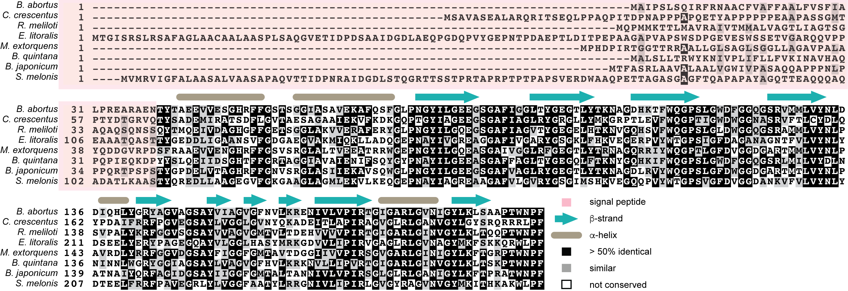

Figure S1: Amino acid sequence alignment of EipA (DUF1134) proteins of diverse Alphaproteobacteria: B. abortus (Bab1_1612), C. crescentus (CC_1035 / CCNA_1087), R. meliloti (Smc00651), Erythrobacter litoralis (Eli_00125), Methylobacterium extorquens (MexAM1_META1p1722), Bartonella quintana (BQ09480), Bradyrhizobium japonicum (RN69_37190), and Sphingomonas melonis (BJP26_12640). Sequences corresponding to the peptide signal are delimited by a light-red rectangle. B. abortus EipA secondary structure is reported above the sequence alignment. β-strands are in turquoise and α-helices are in light brown.

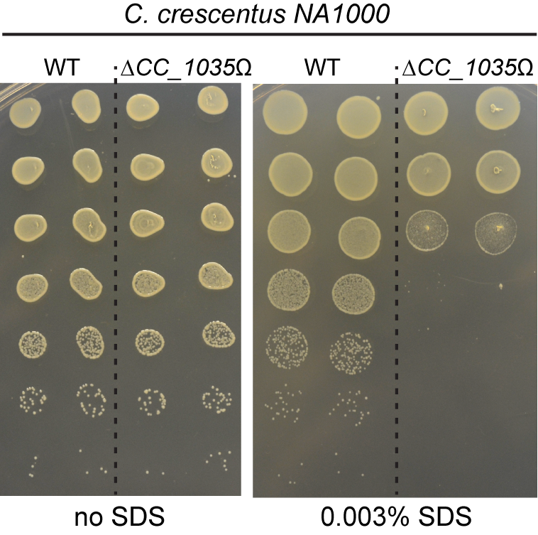

Figure S2: C. crescentus stress survival plates show that deleting gene locus CC_1035 / CCNA_01087 – a homolog of eipA – results in sensitivity to sodium dodecyl sulfate (SDS) at high dilutions. Ten-fold serial dilutions (undiluted to 10⁻⁶, top to bottom) of log phase cultures of C. crescentus NA1000 strains (wild-type or ∆CC_1035Ω) were spotted on plain PYE agar plates or PYE plates containing 0.003% SDS and incubated for 3 days at 30°C.

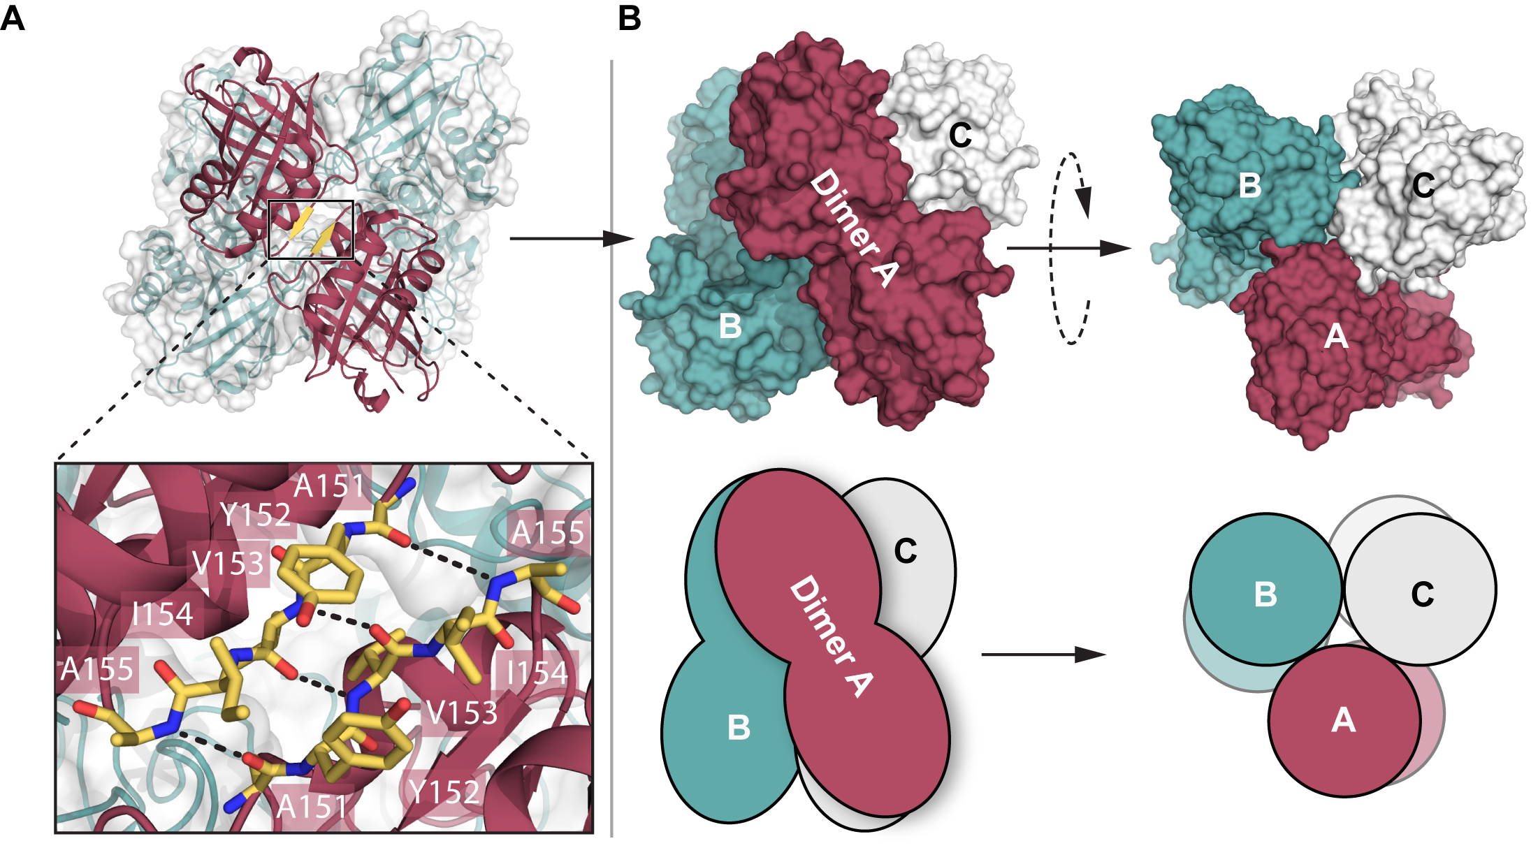

Figure S3: EipA interactions in the protein crystal. A) Two EipA molecules are present in the asymmetric unit of the crystal. These two proteins interact through hydrogen bonds between the β-strand 6 (in yellow) of each monomer (in maroon). Residues involved in this interaction are annotated in the inset. B) Two other dimers (in white and turquoise), present in the adjacent asymmetric units, could associate with the EipA dimer (in maroon) to form a hexameric complex of three dimers. Surface (top) and cartoon (bottom) representations of the crystal hexamer are presented. We note that at high concentrations in solution, EipA appears to be a monomer, based on size exclusion chromatography (see Figure 9).

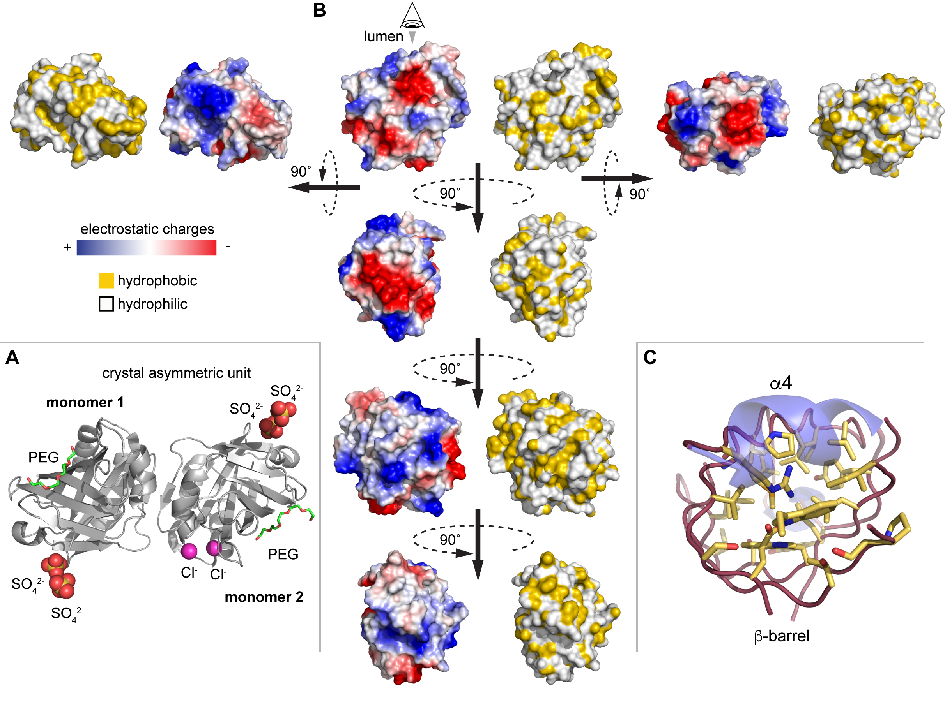
Figure S4: Electrostatic and hydrophobic characteristics of EipA surface. A) In the crystal asymmetric unit, two EipA molecules are present (in grey); in addition, we modeled 4 sulfate ions (in red and yellow), 2 chloride ions (in magenta), and 2 PEG molecules (in green). B) Surface representation of EipA. Electrostatic potentials are mapped in blue for positive charges and in red for negative charges. Hydrophobicity is represented in yellow. C) Inside view of EipA β-barrel. Yellow sticks represent side chains of residues present inside the β-barrel, which are mostly hydrophobic. α-helices α3 and α4 are in transparent blue.

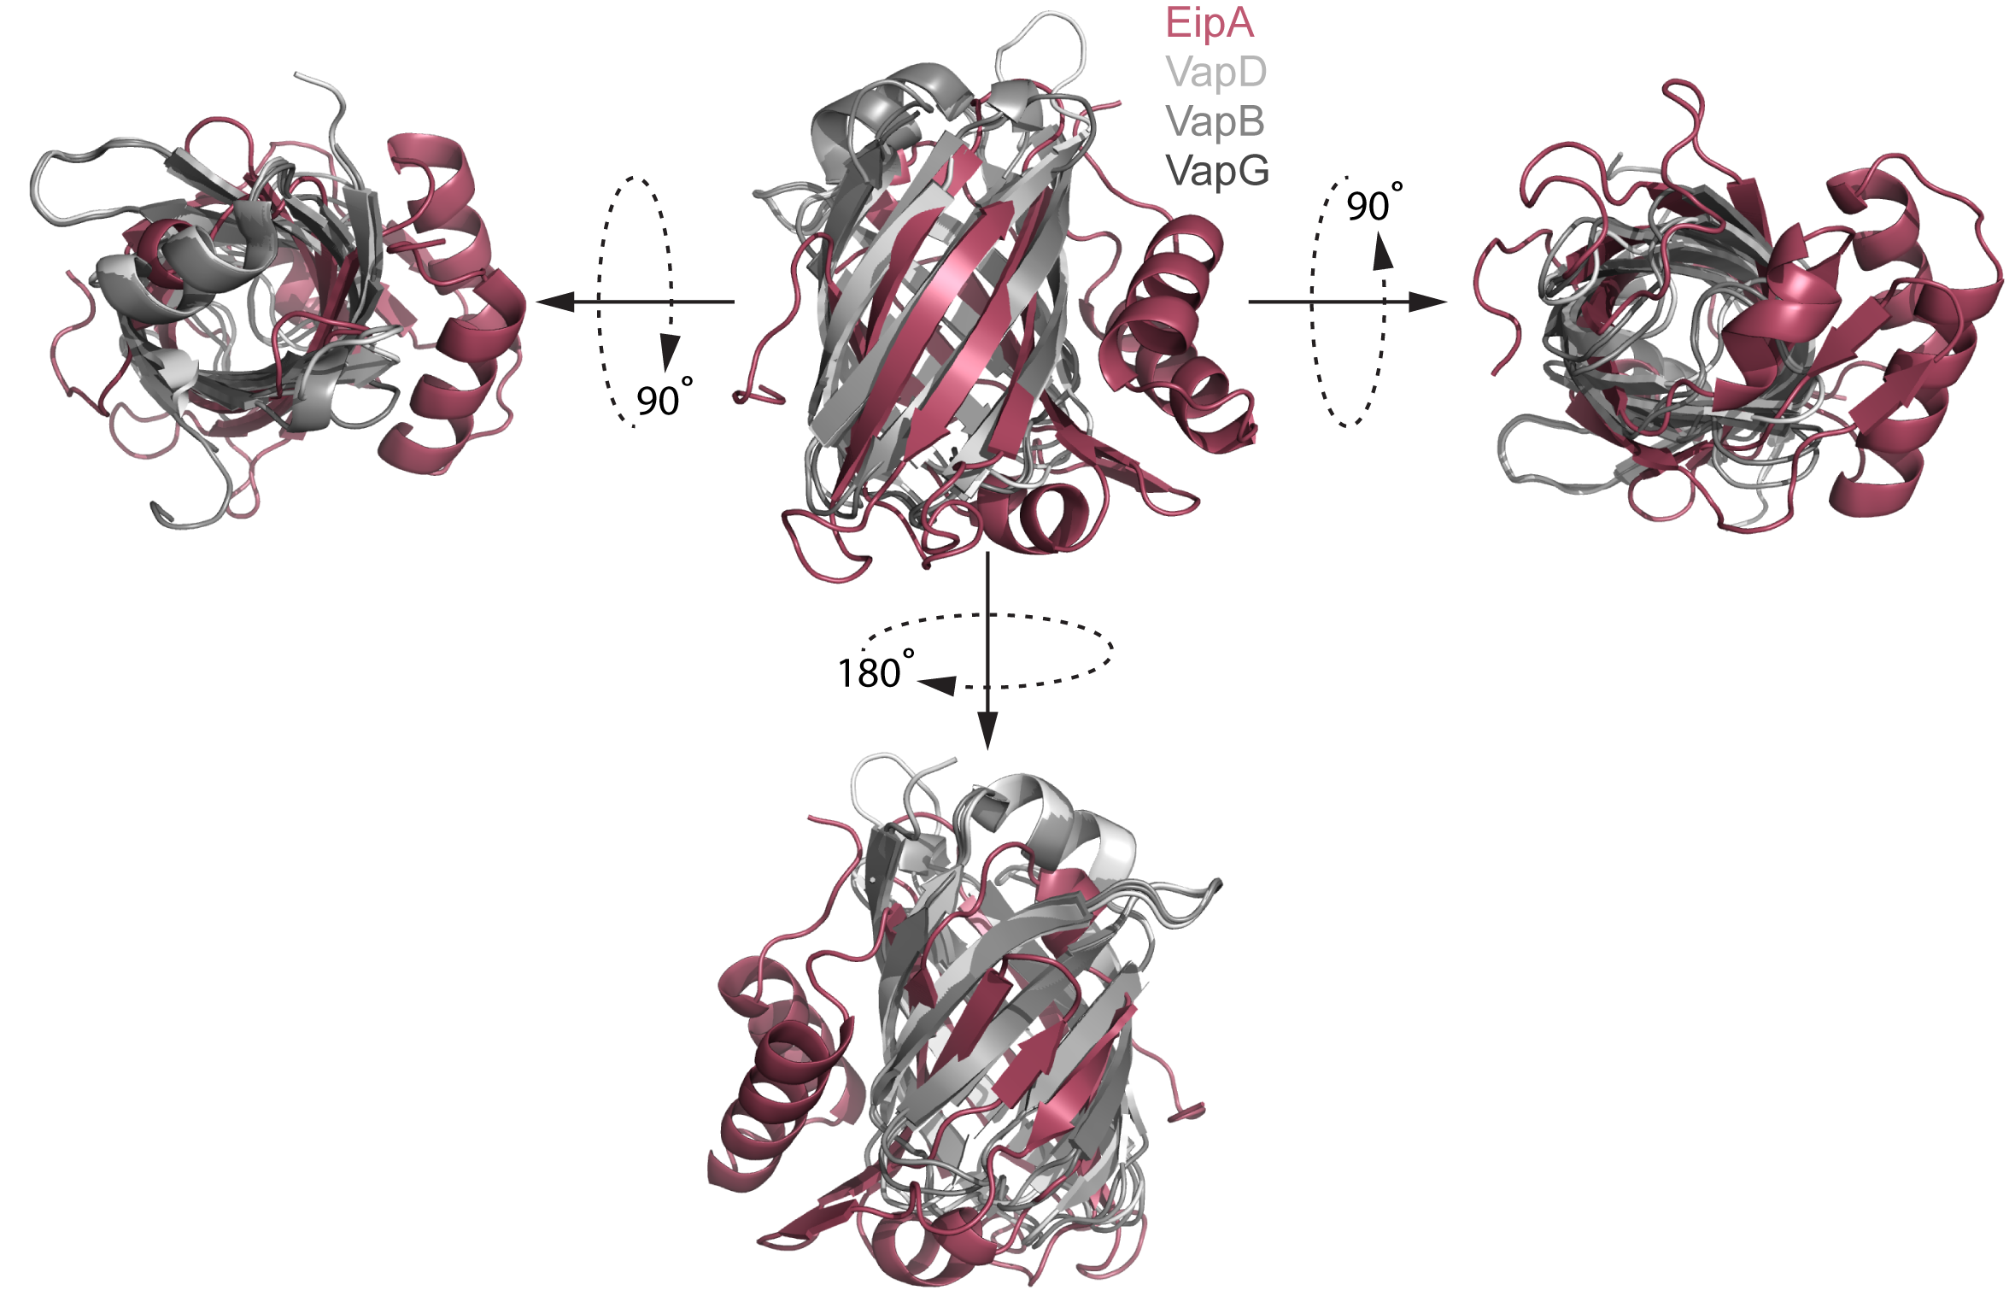
Figure S5: Structural alignment between EipA (PDB: 5UC0, in maroon), and R. equi VapD (PDB: 4CSB, light grey), VapB (PDB: 4CV7, grey) and VapG (PDB: 5AEO, dark grey).

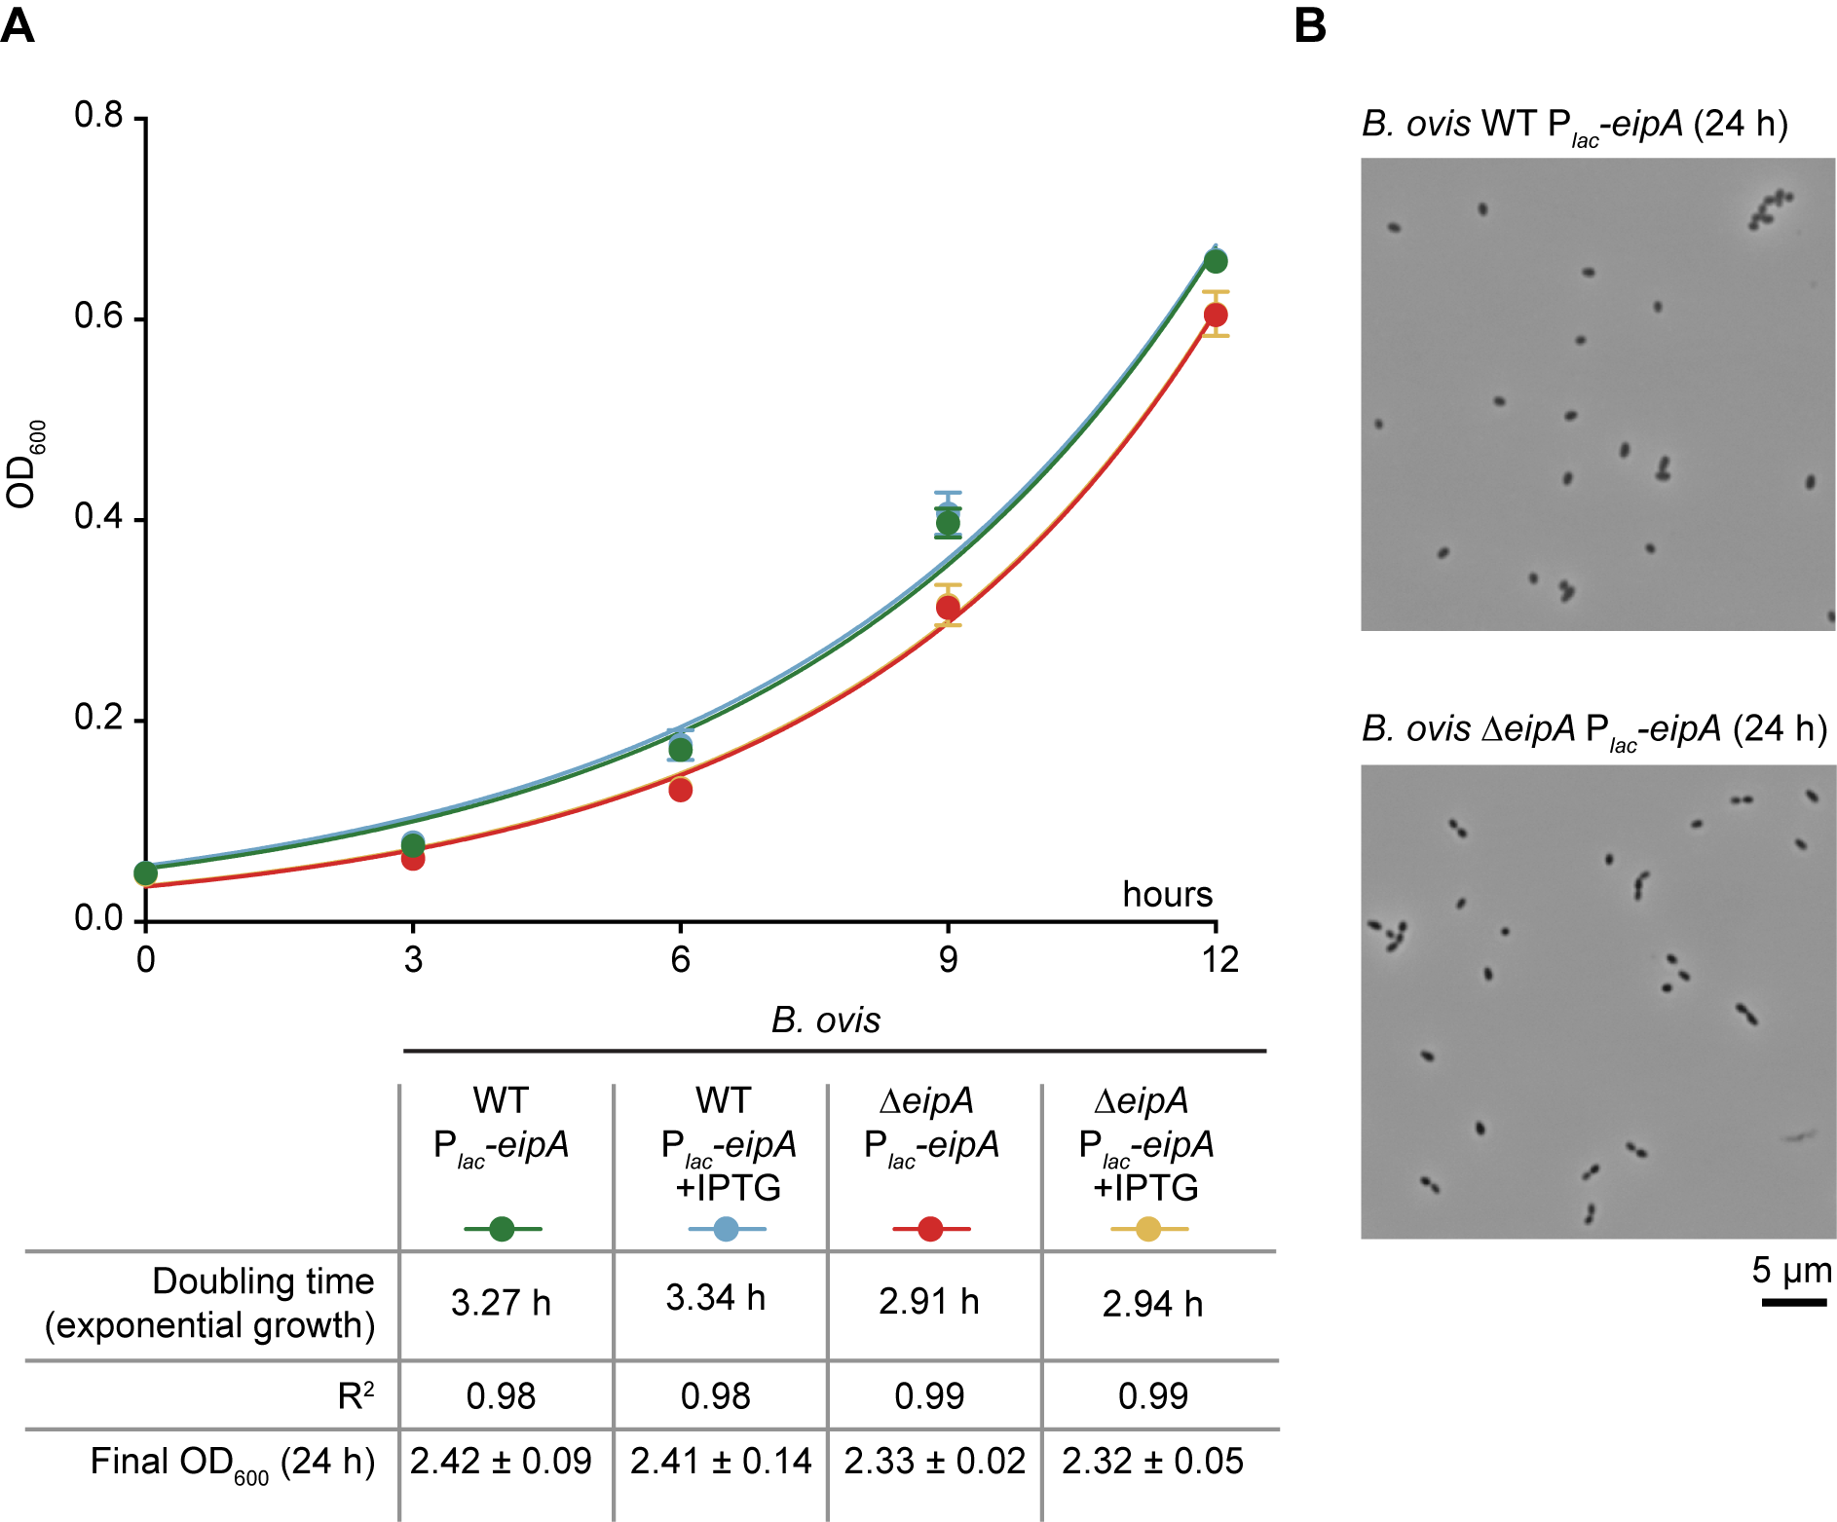

Figure S6: Growth and morphology of the B. ovis eipA depletion strain in liquid medium. A) 12-hour liquid growth profiles of B. ovis wild-type and ∆eipA strains. Wild-type B. ovis carrying pSRK-eipA (P_{lac}-eipA; IPTG-inducible) was grown in Brucella broth supplemented with (blue) or without (green) 1 mM IPTG. Similar conditions were tested with B. ovis ∆eipA carrying P_{lac}-eipA (no IPTG: red, with IPTG: orange). The corresponding doubling times, R² (coefficient of determination), and final ODs after 24 hours of cultivation are reported in the table below. B) Light micrographs of the corresponding strains after 24 hours of liquid growth without IPTG. The growth and morphology defects of the B. ovis eipA depletion strain cultivated on solid medium is reported in Figure 10.

Table S1: Summary of histopathology scoring of spleens from B. abortus-infected mice. Scores range from 0 to 3, and are based on masked evaluation of sectioned and stained spleen tissue. The presence of Brucella in tissue was confirmed by immunohistochemistry. 0 = normal (no) pathology (all naïve spleens scored 0 in all categories); 1 = mild pathology, 2 = moderate pathology, 3 = severe pathology relative to uninfected (naïve) control.
 | Naive | Wild-type | ∆eipA | Complementation
White pulp to red pulp ratio | Normal (1:1) | Marked decrease, (2-3) | No change, (0) | Marked decrease, (3)
Average lymphoid follicles per field | 12 | Decrease, (2) | No change, (0) | Decrease, (3)
Size of follicles | Normal | Decrease, (2) | Minimal change, (0-1) | Decrease, (2)
Marginal zone depletion | Normal (intact) | Increase, (2) | Minimal to mild increase, (0-1) | Increase, (3)
Extramedullary hematopoiesis | Minimal | Moderate to marked increase, (2-3) | Moderate increase, (2) | Marked increase, (3)
Histiocytic proliferation | Absent | Moderate to marked increase, (2-3) | Mild increase, (1) | Marked increase, (3)
Granulomas | Absent | Frequent, (3) | Rare, (1) | Frequent, (3)
Brucella immunoreactivities | Absent | Frequent, (2-3) | Very rare, (0-1) | Frequent, (3)

Table S2 (see Excel file Table S2): List of the 1,920 growth conditions tested and the corresponding absorbance change (∆Abs₆₃₀) between time=0 and 118 hours. This experiment was conducted once; concentrations of the different compounds present in this commercial screen are not available from the manufacturer. This Biolog dataset provided preliminary evidence for an envelope stress defect in the B. abortus ∆eipA strain, which was directly validated in experiments presented in Figure 5.

Table S3: Transposon library statistics based on analysis of Tn-sequencing data analysis using MapTnSeq.pl and DesignRandomPool.pl available at https://bitbucket.org/berkeleylab/feba. 150 bp single end read data that include the barcode and Tn-chromosome insertion junction are available through the NCBI sequence read archive at accessions SRR7943723, SRR7943724, and SRR7943771 (https://www.ncbi.nlm.nih.gov/sra).

Library | Estimated number of Tn strains ª | Unique Tn strain included ^{b} | Unique insertion sites^{c} | Total TA sites^{d} | Median Tn per gene | Median reads per gene
B. abortus 2308 | 3.8 x 10⁶ | 535,231 | 99,761 | 156,924 (78,462) | 86 | 1436
B. abortus 2308 ∆eipA | 15.5 x 10⁶ | 716,817 | 108,106 | 156,924 (78,462) | 119 | 5460
B. ovis | 2.6 x 10⁶ | 367,537 | 95,026 | 156,996 (78,498) | 61 | 1080

ª Chao2 estimate of number of barcodes present in the library
^{b} Number of unique barcodes passing mapping criteria (sequenced 5 or more times, mapped to unique site, perfect match)
^{c} Counts hits on opposite strands as unique
^{d} TA sites on forward and reverse complement (TA on forward only)

Table S4: Crystallographic data collection and refinement statistics. Statistics for the highest resolution shell are shown in parentheses.

 | EipA
Wavelength (Å) | 0.97929
Resolution range (Å) | 32.64 - 1.73 (1.76 - 1.73)
Space group | P6₃
Unit cell | a=b=113.08 Å, c=64.31 Å, α=β=90°, γ=120°
# molecules in ASU | 2
Unique reflections | 49076 (2420)
Multiplicity | 7.4 (7.3)
Completeness (%) | 99.7 (99.1)
Mean I/sigma(I) | 24.9 (2.2)
Wilson B-factor (Å²) | 23.12
R-merge | 0.089 (0.761)
cc1/2 (highest resolution shell) | 0.799
Reflections used for R-free | 2539
R-work | 0.176
R-free | 0.208
RMS(bonds) | 0.0100
RMS(angles) | 0.876
Ramachandran favored (%) | 97.8
Ramachandran outliers (%) | 0.0
Clashscore | 8.97
Average B-factor (Å²) | 25.5
Table S5: A list of the top 50 most structurally similar proteins to EipA based on a Dali protein structure comparison (http://ekhidna2.biocenter.helsinki.fi/dali/). Proteins with a high Z-score, low rmsd, and high percentage of identity were considered to be structurally-related to the query protein structure. As expected, comparison of EipA to itself (Uncharacterized protein COG5400, PDB ID: 5UC0) is the top hit.

 | PDB + Chain | Z-score | rmsd | Length of alignment | # residues | % identity | Description
1 | 5uc0-A | 36.5 | 0 | 161 | 161 | 100 | UNCHARACTERIZED PROTEIN COG5400 | EipA
2 | 5uc0-B | 33.5 | 0.3 | 159 | 159 | 100 | UNCHARACTERIZED PROTEIN COG5400 | EipA
3 | 4csb-A | 7 | 3.1 | 95 | 113 | 11 | VIRULENCE ASSOCIATED PROTEIN VAPD
4 | 5aeo-B | 6.7 | 2.9 | 93 | 110 | 13 | R. EQUI VAPG PROTEIN
5 | 5aeo-A | 6.7 | 2.9 | 92 | 110 | 11 | R. EQUI VAPG PROTEIN
6 | 4cv7-A | 6.4 | 2.9 | 91 | 111 | 10 | VIRULENCE ASSOCIATED PROTEIN VAPB
7 | 3ke6-A | 4.1 | 3 | 77 | 354 | 12 | PROTEIN RV1364C/MT1410
8 | 2ovs-A | 3.9 | 3 | 69 | 118 | 13 | L0044
9 | 5l33-A | 3.6 | 2.9 | 52 | 106 | 8 | DENOVO NTF2
10 | 5tgn-A | 3.5 | 3.2 | 54 | 109 | 13 | UNCHARACTERIZED PROTEIN
11 | 2b4w-A | 3.5 | 2.8 | 65 | 292 | 11 | HYPOTHETICAL PROTEIN, CONSERVED
12 | 6f0x-P | 3.5 | 3.3 | 82 | 194 | 13 | PACHYTENE CHECKPOINT PROTEIN 2 HOMOLOG
13 | 3ke6-B | 3.5 | 2.9 | 75 | 348 | 12 | PROTEIN RV1364C/MT1410
14 | 4odd-A | 3.3 | 4 | 74 | 149 | 3 | LIPOCALIN ALLERGEN
15 | 4z6j-A | 3.3 | 3.6 | 75 | 133 | 7 | AVIDIN FAMILY
16 | 3cnx-C | 3.2 | 3.2 | 58 | 148 | 3 | UNCHARACTERIZED PROTEIN
17 | 6dbn-A | 3.2 | 2.8 | 51 | 281 | 8 | TYROSINE-PROTEIN KINASE JAK1
18 | 3d2u-E | 3.2 | 5.5 | 60 | 279 | 2 | UL18 PROTEIN
19 | 6f92-A | 3 | 4.2 | 77 | 760 | 6 | PUTATIVE ALPHA-1,2-MANNOSIDASE
20 | 5oqj-H | 3 | 2.9 | 68 | 136 | 4 | DNA-DIRECTED RNA POLYMERASE II SUBUNIT RPB1
21 | 4rul-A | 3 | 3 | 70 | 821 | 16 | DNA TOPOISOMERASE 1
22 | 4cgy-A | 3 | 3.2 | 70 | 619 | 6 | DNA TOPOISOMERASE 3-ALPHA
23 | 2waq-G | 3 | 3.5 | 68 | 113 | 7 | DNA-DIRECTED RNA POLYMERASE RPO1N SUBUNIT
24 | 4rki-A | 3 | 4.2 | 59 | 374 | 7 | DNA POLYMERASE III SUBUNIT BETA
25 | 2jso-A | 2.9 | 3 | 63 | 88 | 10 | POLYMYXIN RESISTANCE PROTEIN PMRD
26 | 5hnv-A | 2.9 | 2.7 | 51 | 283 | 8 | PPKA N TERMINAL
27 | 5wce-A | 2.9 | 3.7 | 58 | 370 | 9 | DNA POLYMERASE III SUBUNIT BETA
28 | 4ge1-A | 2.9 | 3.6 | 79 | 195 | 4 | BIOGENIC AMINE-BINDING PROTEIN
29 | 4rlc-A | 2.9 | 4 | 76 | 135 | 8 | OUTER MEMBRANE PORIN F
30 | 5iuq-A | 2.9 | 4.7 | 49 | 138 | 8 | GALECTIN-3
31 | 6d47-A | 2.8 | 3.8 | 59 | 388 | 5 | BETA SLIDING CLAMP
32 | 2y32-C | 2.8 | 3 | 67 | 138 | 6 | BLR5658 PROTEIN
33 | 1yem-B | 2.8 | 3.9 | 67 | 166 | 3 | CONSERVED HYPOTHETICAL PROTEIN PFU-838710-001
34 | 5i8u-C | 2.8 | 3.8 | 46 | 203 | 9 | ADP-RIBOSE PYROPHOSPHATASE
35 | 6deg-B | 2.8 | 3.8 | 56 | 351 | 2 | BETA SLIDING CLAMP
36 | 1wzn-A | 2.8 | 5.1 | 55 | 245 | 5 | SAM-DEPENDENT METHYLTRANSFERASE
37 | 3en8-A | 2.8 | 3.2 | 53 | 128 | 9 | UNCHARACTERIZED NTF-2 LIKE PROTEIN
38 | 4ysm-A | 2.7 | 2.6 | 48 | 475 | 10 | CALMODULIN-LIKE DOMAIN PROTEIN KINASE
39 | 2dsb-A | 2.7 | 3.1 | 46 | 206 | 13 | ADP-SUGAR PYROPHOSPHATASE
40 | 5izl-A | 2.7 | 4.6 | 58 | 514 | 10 | SELENOCYSTEINE-SPECIFIC ELONGATION FACTOR
41 | 4dk0-A | 2.7 | 3.2 | 55 | 324 | 5 | PUTATIVE MACA
42 | 6fu5-B | 2.7 | 3.6 | 49 | 286 | 8 | RECEPTOR-INTERACTING SER/THR-PROTEIN KIN
43 | 4xrw-A | 2.7 | 3.2 | 56 | 305 | 9 | BEXL
44 | 1z47-A | 2.7 | 4.6 | 51 | 345 | 4 | PUTATIVE ABC-TRANSPORTER ATP-BINDING PROTEIN
45 | 4ci8-A | 2.7 | 3.6 | 58 | 640 | 7 | ECHINODERM MICROTUBULE-ASSOCIATED PROTEIN-LIKE
46 | 3f40-A | 2.7 | 2.6 | 51 | 112 | 6 | UNCHARACTERIZED NTF2-LIKE PROTEIN
47 | 1mm4-A | 2.7 | 3.1 | 70 | 170 | 11 | CRCA PROTEIN
48 | 6es1-A | 2.7 | 6.9 | 64 | 420 | 5 | BOTULINUM NEUROTOXIN TYPE A
49 | 5czo-A | 2.7 | 3.2 | 50 | 374 | 10 | CASEIN KINASE I HOMOLOG HRR25
50 | 3cm1-A | 2.7 | 3.5 | 75 | 137 | 4 | SSGA-LIKE SPORULATION-SPECIFIC CELL DIVISION PROT

Table S6 (see Excel file Table S6): Primers used in this study.

Table S7 (see Excel file Table S7): Strains used in this study.

