Supplementary Information

Jahanshad et al.,
Do Candidate Genes Affect the Brain's White Matter Microstructure?
Large-Scale Evaluation of 6,165 Pooled Diffusion MRI Scans

SI TEXT:
Statistical Methods

We used SOLAR (http://www.nitrc.org/projects/se_linux) to create kinship matrices for each individual cohort of related individuals after specifying familial relationships. Regressions were run between each SNP in an additive fashion and each ROI independently in R using the ‘lm’ function for unrelated cohorts and the ‘lmekin’ function from the ‘kinship’ package for groups with related individuals as well as the mega-analysis. The ‘lme’ function from the ‘nlme’ package was used to remove the effect of all non-genetic covariates for the related samples before normalization of the phenotypic residuals.
Several covariates were used in this study. Covariates including age, sex, age×sex, age² and age²×sex, were included for all cohorts as fixed effects. The first four components of the MDS analyses were also used as covariates for all groups. Two sites, NeuroIMAGE and BIG had additional covariates – NeuroIMAGE had two added: one covariate to model potential fixed differences patients and controls, and both NeuroIMAGE and BIG had an added covariate to model the two scanners at which the images were collected.

The statistical models used included:
Site Level:
- Raw: additive values for SNPs and covariates were incorporated into a single regression model, and Beta effect sizes and standard errors for the SNP were extracted. The minor allele count for each SNP was also permuted 5000 times, and the permuted statistics for each of the permutations, for each site, were saved for subsequent use.
- Normalized residuals: In order to standardize the sites for mega-analysis, we ensured the normality in the distribution of FA at each site and remove the effects of covariates. Following this an inverse Gaussian normalization was conducted to normalize FA values within a site such that variability due to imaging parameters did not influence the FA values. First fixed covariates including age and sex combinations and any unique site regressors were removed using the ‘lm’ or ‘lme’ functions for unrelated or related cohorts, respectively. For the ‘lme’ model, a random-effects grouping variable was entered into the model to group by family. The residuals from the first regression were normalized and used as the output variable for the second step, which regressed only the additive effect of the SNP and the MDS components on the residuals; a kinship matrix was included into a mixed-effects model using ‘lmekin’ for cohorts with related individuals. Beta and standard errors for the SNP at each site were then carried forward for meta-analysis.
Group Level:
- Meta-analysis on the raw (unnormalized) and normalized residuals: Beta and standard errors for the SNP at each site from the observed results of analyses 1 and 2 were then carried forward for meta-analysis. An inverse-variance weighted meta-analysis was used to pool the effects of a SNP on a single ROI at each site. Betas and standard errors were used, computed from each site’s individual regression model.
- Mega-analysis on the normalized residuals: For the mega-analysis, site-specific regressions were performed as in the first step of (2) above to obtain normalized residuals. An overall kinship matrix was formed by merging the individual cohort kinship matrices together (the identity matrix was used for unrelated cohorts). The relationship between individuals in different cohorts was set to 0. The additive effect of the SNP of interest was then regressed on the pooled array of normalized residuals with MDS components as added covariates. A grouping variable for site was also added to the model to account for additional site effects. Resulting Beta, standard errors, and p-values represent the joint effects.
Region-of-interest (ROI) Level Pooling
- Regions of interest are highlighted in Supplementary Figure 1. As white matter tracts and fiber bundles are often intertwined and are all connected, it may be that the genetic influence over the different regions as defined by the skeletonization and region of interest analysis is limited; this would imply that combining different portions of tracts, rather than analyzing their anterior, posterior, or superior regions separately is going to give us stronger signal. In the same sense, it would be important to acknowledge if combining all tracts to assess only the global FA variance is sufficient, or whether defining regions based on their smallest lateralized components would reveal greater unique genetic signal.
  - The following groups of ROIs were compared at the meta-analytical level. (regions pooled and tested are displayed in Supplementary Figure 2):
    - Group 1: Average FA across the full white matter skeleton
    - Group 2 (full names for the abbreviated tracts can be found in SI Table 1): ACR, ALIC, BCC, CGC, CGH, EC, FXST, GCC, IFO, PCR, PLIC, PTR, RLIC, SCC, SCR, SFO, SLF, SS, UNC
    - Group 3 (“_L” and “_R” represent left and right hemisphere averages, respectively): ACR_L, ACR_R, ALIC_L, ALIC_R, BCC, CGC_L, CGC_R, CGH_L, CGH_R, EC_L, EC_R, FXST_L, FXST_R, GCC, IFO_L, IFO_R, PCR_L, PCR_R, PLIC_L, PLIC_R, PTR_L, PTR_R, RLIC_L, RLIC_R, SCC, SCR_L, SCR_R, SFO_L, SFO_R, SLF_L, SLF_R, SS_L, SS_R, UNC_L, UNC_R
  - Meta-analysis was performed combining the ROIs using Stouffer’s Z-score method across the n regions of interest; both standard error weighted and sample-size weighted meta analyses were done to combine statistics across the k-studies, where the overall effect (as a Z-score). Here we formulate the sample-size (N)-weighted meta-analysis across sites:
$Z=\frac{\sum_{i=1}^{k}{N_{i}Z_{i}}}{\sqrt{\sum_{i=1}^{k}{N_{i}}}};$ where $Z_{i}=\frac{\sum_{j=1}^{n}{Z_{j}}}{\sqrt{n}}$ is the Stouffer’s Z-weighted meta analysis across the ROIs and N_{i} is the sample size for study i.
  - Despite maintaining the null finding, results for evaluating regional specificity by incorporating ROI-level statistics as opposed to just the average FA, showed moderately higher effect sizes and lower standard errors with statistics combining the tests on bilateral regions. However, statistical inference estimates were no longer improved when combining statistics on all lateralized regions, suggesting averaging the FA across the hemispheres for the tracts maintains regional genetic specificity without an unnecessary amount of regional tests assumed by the lateralized investigation. Nevertheless, most SNPs were found to have similar directions of effect across many regions of interest as seen in the main text Figure 1, highlighting a strong correlation in FA values among certain regions.
  - When comparing various groupings of the regions, we used family-wise error (FWE) corrected p-values, obtained for each SNP per ROI using permutation inference¹. Permutation methods can be used to construct the combined statistical null sample distribution. FWE corrected P-values, corrected for the number of ROIs and the number of SNPs, were computed. When grouping ROIs through meta-analysis, we are then able to reduce the number of regions needed to statistically correct for to 1; as all regions are included in a single Z-score. We hypothesize that this will allow us to reduce the comparisons, and therefore the correction needed, while avoiding the need to smooth the data by taking the FA over the entire map and maintaining possible regional effects.
    - For the cohorts with unrelated individuals, the data are freely permuted and for those with related individuals there is an additional permuted covariance matrix fitted for each permutation step to preserve exchangeability of relationships, following one-step heritability estimator as described in our previous work².

Supplementary Results
Results for these pooled estimates for three different groupings of ROIs within the CEU populations are shown in Supplementary Figure 3. G1 is the group consisting of only the average FA, while G2 combines all bilaterally averaged ROIs using Stouffer’s meta analysis and G3 combines all ROIs, with the left and right being considered separately. We note that in all cases, the effect is still null when correcting for the number of SNPs. Combining the ROIs in general did not have a great affect on the results. For consistency with the main text, we show uncorrected P-values.
We find that regardless of the number of regions in the groups, the results are not significant; the lowest corrected P-value was G1: 0.286; G2: 0. 0.585; G3: 0.665 all for rs6675281, remaining consistently null. In the mega-analysis, no group or SNP resulted in a FWE-corrected P-value less than 0.5.

Supplementary References

- Nichols TE, Holmes AP. Nonparametric permutation tests for functional neuroimaging: a primer with examples. Hum Brain Mapp 2002; 15(1): 1-25.
- Ganjgahi H, Winkler AM, Glahn DC, Blangero J, Kochunov P, Nichols TE. Fast and powerful heritability inference for family-based neuroimaging studies. Neuroimage 2015; 115: 256-268.

Supplementary Tables:

SI Table 1 Abbreviations of white matter tract names are defined below.
Abbreviation | Full Tract Name
Average FA | Full skeleton average FA
ACR | Anterior corona radiata
ALIC | Anterior limb of internal capsule
BCC | Body of corpus callosum
CC | Corpus callosum
CGC | Cingulum (cingulate gyrus)
CGH | Cingulum (hippocampal portion)
CR | Corona radiata
CST | Corticospinal tract
EC | External capsule
FX | Fornix
FXST | Fornix (cres) / Stria terminalis
GCC | Genu of the corpus callosum
IC | Internal capsule
IFO | Inferior fronto-occipital fasciculus
PCR | Posterior corona radiata
PLIC | Posterior limb of internal capsule
PTR | Posterior thalamic radiation
RLIC | Retrolenticular part of internal capsule
SCC | Splenium of corpus callosum
SCR | Superior corona radiata
SFO | Superior fronto-occipital fasciculus
SLF | Superior longitudinal fasciculus
SS | Sagittal stratum
UNC | Uncinate fasciculus

SI Table 2 SNP distribution per cohort. The distributions of SNP frequencies with respect to the minor allele are shown below for both the CEU subpopulation and the full sample. Cohorts marked with * indicate some individuals were not genotyped for certain alleles. Frequencies for the alleles in the ALL group were obtained from the 1000 Genomes Project frequency information available on dbSNP (http://www.ncbi.nlm.nih.gov/projects/SNP/index.html), while those of the CEU population were obtained from HapMap Phase Release 28 (http://hapmap.ncbi.nlm.nih.gov/cgi-perl/gbrowse/hapmap28_B36/); for the SNPs marked with (*) HapMap did not provide CEU only frequencies and the European population from 1000 Genomes was used.
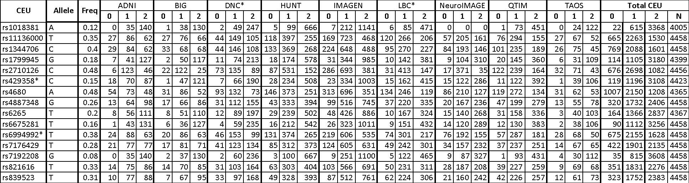

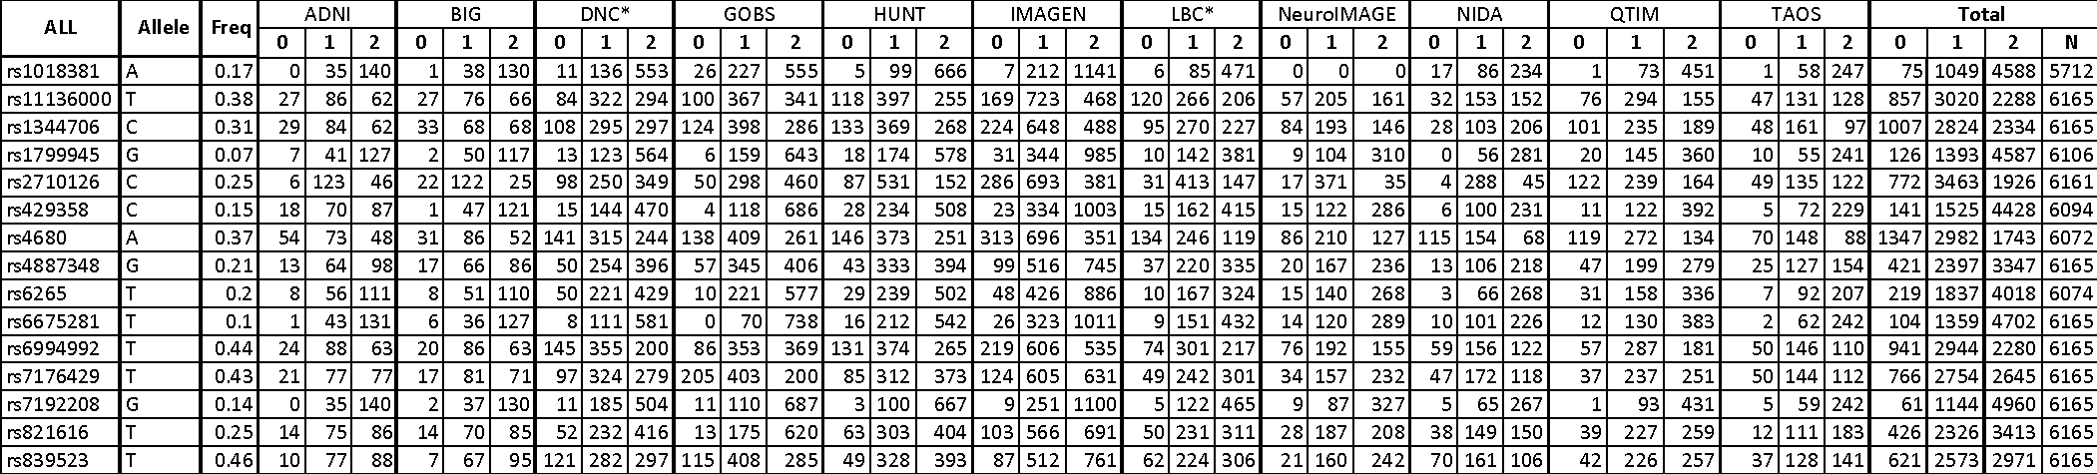

Supplementary Figures

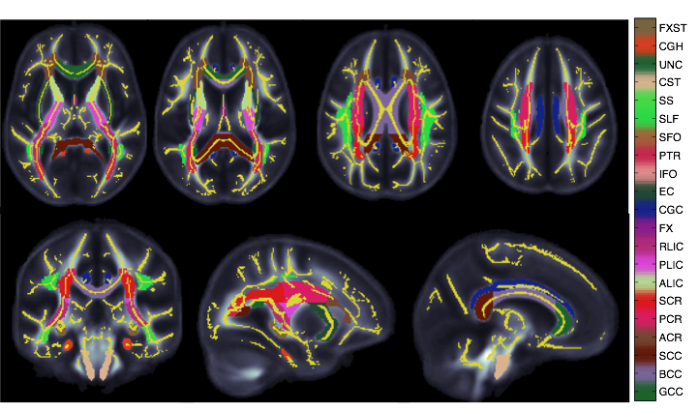
Supplementary Figure 1 Color-coded FA regions of interest from the white matter skeleton displayed on the ENIGMA-DTI template brain.
Supplementary Figure 2 Tree diagram of the breakdown of the DTI region of interest groupings statistically compared at the meta-analysis level. The lowest level in the tree corresponds to all regions contained in Group 3, the smallest ROIs were used per site and meta analysis of these regions were conducted; Group 2 consists of pooling together the statistics computed on the bilaterally averaged measures (the second level up); Group 1 is the highest level, or average FA across the full skeleton, where meta-analysis was conducted only on the statistics performed on average FA.

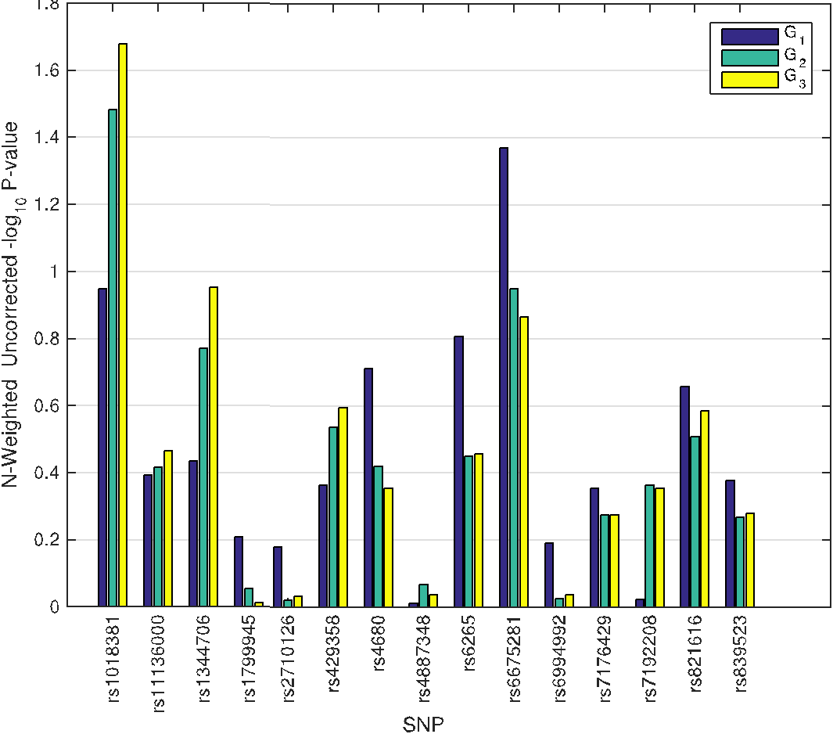
Supplementary Figure 3- Uncorrected P-values are shown per SNP for each ROI-grouping attempted. G1 is the group consisting of only the average FA, while G2 combines all bilaterally averaged ROIs using Stouffer’s meta analysis and G3 combines all ROIs, with the left and right being considered separately.

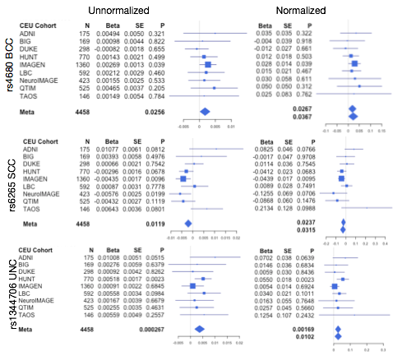
Supplementary Figure 4 None of the tested SNP reached statistical significance after correction for multiple comparisons across all SNPs in the full brain average FA, nor was any SNP suggestively significant (p < 0.05). Although no significant effects were found after correcting for multiple comparisons across regions or SNPs, some SNPs reached nominal significance (p < 0.05) when evaluating the FA skeleton in a regional manner. The by-site breakdown of SNPs reaching nominal significance in all the meta and mega-analytical approaches within the CEU sample are shown in forest plots. The SNP and white matter region are labeled on the left. The plots in the left-most column represent the analysis performed with the unnormalized meta-analysis, while those on the right represent the normalized meta analysis and mega analysis of the normalized measures.

