New Phytologist Supporting Information
A microbially derived tyrosine sulfated peptide mimics a plant peptide hormone
Rory N. Pruitt^{1,2‡†}, Anna Joe^{1,2†}, Weiguo Zhang^{1¶†}, Wei Feng³, Valley Stewart⁴, Benjamin Schwessinger^{1,2§}, José R. Dinneny³, Pamela C. Ronald^{1,2*}

¹ Department of Plant Pathology and the Genome Center, University of California, Davis, CA 95616, USA. ² Feedstocks Division, Joint BioEnergy Institute and Physical Biosciences Division, Lawrence Berkeley National Laboratory, Berkeley, CA 94720, USA. ³ Department of Plant Biology, Carnegie Institution for Science, Stanford, CA 94305, USA. ⁴ Department of Microbiology and Molecular Genetics, University of California, Davis, CA 95616, USA.

Author for correspondence:
Pamela C. Ronald
Tel: +1 530 752 1654
E-mail: pcronald@ucdavis.edu
†These authors contributed equally to this work.
‡ Present Address: Centre of Plant Molecular Biology, Department of Plant Biochemistry, University of Tübingen, D-72076 Tübingen, Germany
¶ Present Address: Institute for Microbiology, ETH Zurich, 8093 Zürich Switzerland.
§ Present Address: Division of Plant Science, Research School of Biology, The Australian National University, Canberra ACT 0200 Australia.

The following Supporting Information is available for this article:

Table S1. RaxX13 sequences from diverse Xanthomonas sources.

The RaxX sequences were grouped into three categories X. oryzae (blue), X. translucens (green) and other Xanthomonas strains (orange). The full length sequences of the strains are shown in Fig. S2. A short-hand letter/number code was given to each RaxX13 sequence. RaxX proteins that are identical over the 13 amino acid PSY-like region have the same letter. Proteins that are identical over the entire RaxX sequence have the same letter and number.

Table S2. Synthetic peptides used in this study.
Peptide | Sequence | Sequence Source | Synthetic Peptide Source
RaxX21-Y | HVGGGDYPPPGANPKHDPPPR | Xoo PXO99 | Pacific Immunology
RaxX21-sY | HVGGGDY^{S}PPPGANPKHDPPPR* | Xoo PXO99 | Pacific Immunology
RaxX16-sY | DY^{S}PPPGANPKHDPPPR | Xoo PXO99 | Peptide 2.0
RaxX13-sY | DY^{S}PPPGANPKHDP | Xoo PXO99 | Pacific Immunology
AtPSY1 | DY^{S}GDPSANPKHDPGVPPS | A. thaliana Col-0 | Pacific Immunology
OsPSY1a | DY^{S}PAPGANPRHNPKRPPG | O. sativa Nipponbare | Pacific Immunology
PSK | Y^{S}IY^{S}TQ | A. thaliana Col-0 | Pacific Immunology
RaxX24-Xoc-sY | LWKHVGGGDY^{S}PPSGPNTKHDPPPP | X. oryzae pv. oryzicola BSL256 | Pacific Immunology
RaxX24-Xe-sY | LWKHVGGGDY^{S}PPPGANTKHDPPPK | X. euvesicatoria 85-10 | Pacific Immunology
RaxX24-Xcm-sY | LWKHVGGGDY^{S}APPGSNDRHDPPKP | X. campestris pv. musacearum NCPPB4394 | Pacific Immunology
*Y^{S} indicates sulfated tyrosine.

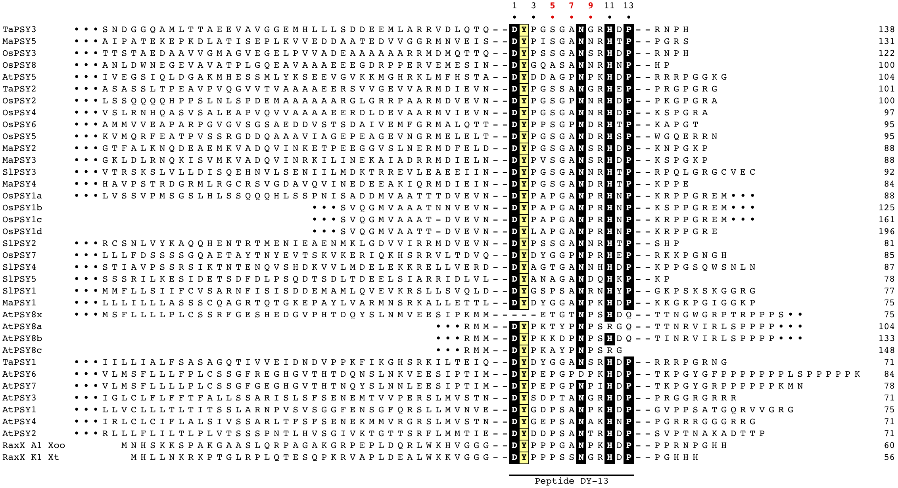
Figure S1. Putative PSY-like proteins from Arabidopsis (At), rice (Os), banana (Ma), tomato (Sl), and wheat (Ta). PSY-like proteins were identified as described in the Material and Methods. The sequences are aligned based on the highly conserved 13-amino acid region. The conserved tyrosine, which is sulfated in AtPSY1, is highlighted in yellow. OsPSY1 and AtPSY8 have multiple repeats of the PSY-like motif within the full-length protein labeled with an appended letter. AtPSY8 has one pseudo-repeat lacking the tyrosine (AtPSY8x). The individual repeats are noted with an appended lowercase letter. For comparison, the RaxX sequences from X. oryzae pv. oryzae strain PXO99 and X. translucens strain 4699 are also included in the alignment. The residues of the conserved 13-amino acid region are numbered at the top of the figure, with positions 5, 7, and 9 in red. These three residues are important for recognition of RaxX by XA21.

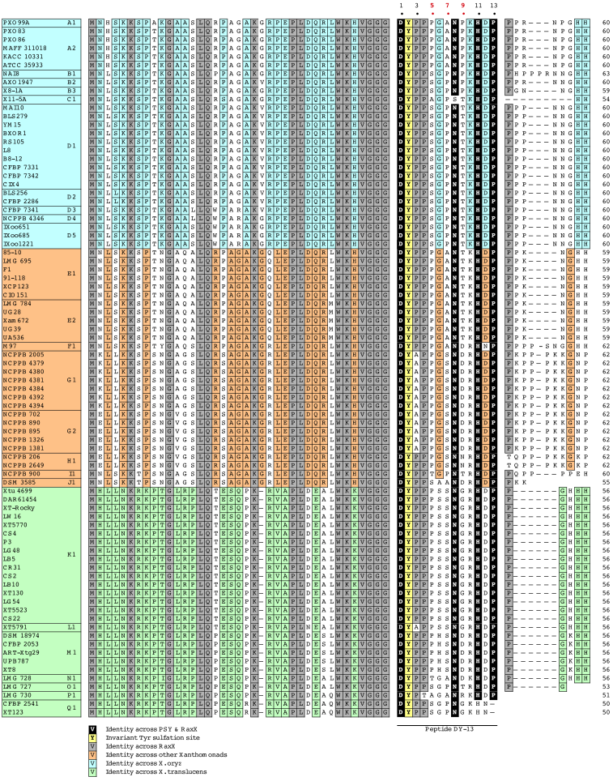
Figure S2. Comparison of the RaxX sequences from diverse bacterial strains. RaxX sequences from X. oryzae (blue), X. translucens (green) and other Xanthomonas strains (orange). Amino acids are colored according to conservation among Xanthomonas strains and among all PSY-like proteins. The invariant tyrosine is highlighted in yellow. The residues of the conserved 13-amino acid PSY-like motif are numbered at the top of the figure, with amino acids in positions 5, 7, and 9 in red. These three residues are important for recognition of RaxX by XA21.
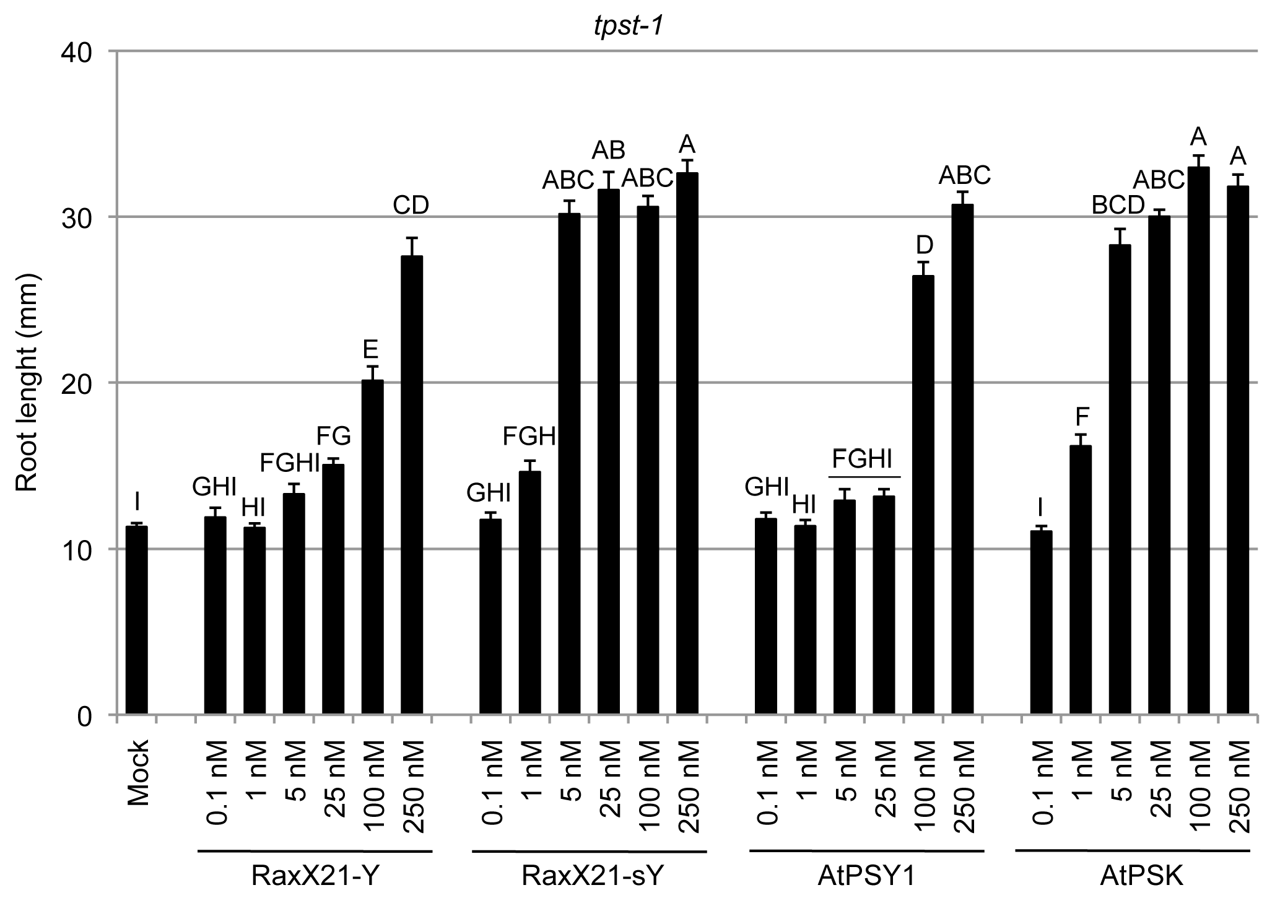

Figure S3. Dose dependent activity of RaxX21-Y, RaxX21-sY, AtPSY1, and PSK on root growth of Arabidopsis tpst-1 seedlings. Arabidopsis tpst-1 seeds were grown on 0.5× MS plates with or without the indicated peptides as described in the materials and methods. Root lengths were measured 8 days after plating seeds. Error bars indicate standard error (n ≥ 16). Statistical analysis was performed using the Tukey-Kramer honestly significant difference test for mean comparison using the JMP software. Different letters represent significant differences within each plant genotype (p ≤ 0.05).

Figure S4. Sulfated RaxX21 promotes root growth in Kitaake rice. a) Root lengths of 4-day old rice seedlings (Kitaake cultivar) grown on 0.5× MS with or without 100 nM of the indicated peptides (n ≥35). b) Rice seedling grown as in a) were photographed. Bars indicate the average seedling root length measured after 8 days. Error bars indicate standard error. Statistical analysis was performed using the Tukey-Kramer honestly significant difference test for mean comparison using the JMP software. Different letters represent significant differences within each plant genotype (p ≤ 0.05). Experiments were performed at least two times with similar results.

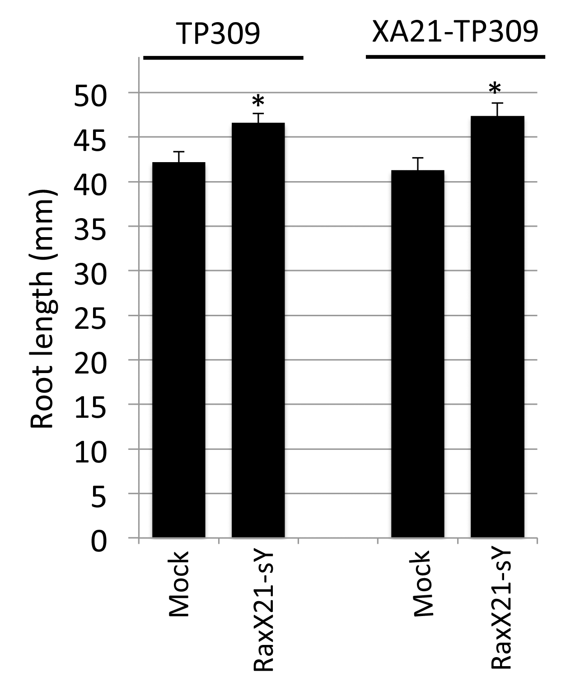
Figure S5. Sulfated RaxX21 promotes root growth in XA21 rice. Bars indicate the average root lengths of 4-day old rice seedlings (TP309 and XA21-TP309) grown on 0.5× MS with or without 100 nM of the indicated peptides (n ≥35). Error bars indicate standard error. The ‘*’ indicates statistically significant difference from PXO99 using Dunnett’s test (α=0.01). Experiments were performed at least two times with similar results.

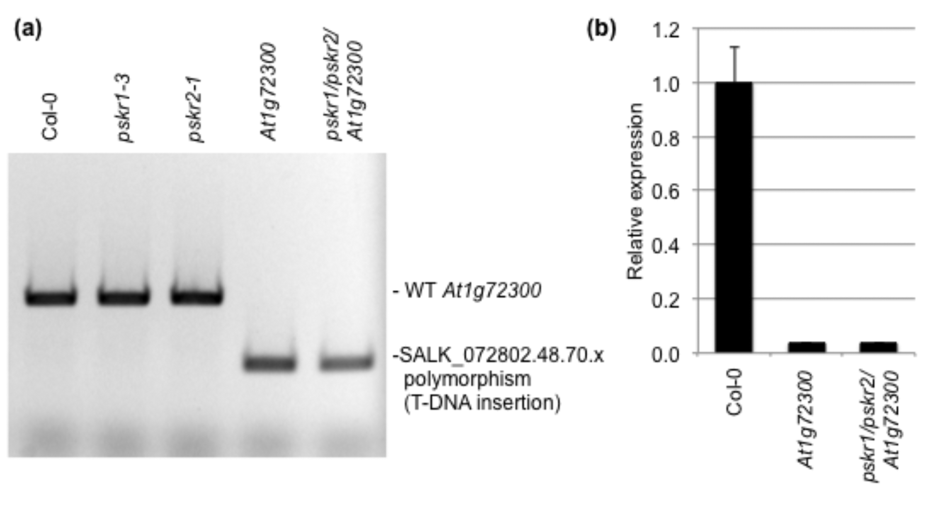

Figure S6. Validation of the At1g72300 mutants. a) The At1g72300 mutants were confirmed by PCR using the SIGnAL T-DNA Primer Design protocol (http://signal.salk.edu/ tdnaprimers.2.html). Wild type At1g72300 or the SALK_072802.48.70.x polymorphism (T-DNA insertion in At1g72300) were detected by PCR with the following primers: LBb1.3, 5’- ATTTTGCCGATTTCGGAAC-3’; LP, 5’- GAGAACCTTTAGCTGCCCAAC-3’; RP, 5’- ACAATGATTTCAGCGGTGATC-3.’b) At1g72300 transcript levels were assessed by RT-qPCR. 8-day old Col-0 or At1g72300 (SALK_072802C). RNA was treated with DNAseI, and cDNA was synthesized using MultiScribe (Applied Biosystems). qPCR reactions were performed with iTaq (BioRad) with annealing and amplification at 55 °C for 5 s and denaturation at 95 °C for 10 s run for 40 cycles. The following primers were used for qPCR: At1g72300: 5’-GAGAACCTTTAGCTGCCCAAC-3’, 5’-GCAATACAATCAGCTTTCCAGCC-3’, Actin: 5’-GGTAACATTGTGCTCAGTGGTGG-3’, 5’-GGTGCAACGACCTTAATCTTCAT-3’)
Transcript levels are normalized to actin, and relative to wild-type.

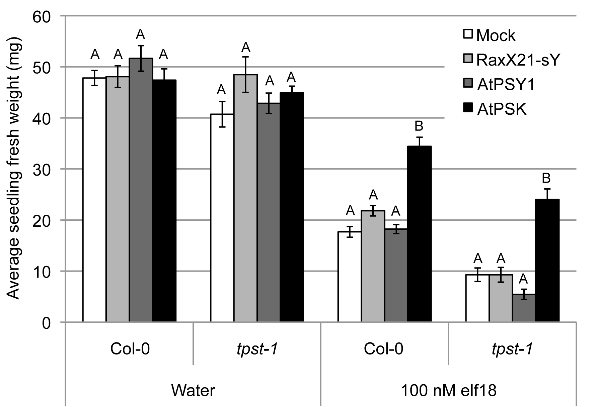
Figure S7. Addition of PSK partially blocks elf18-triggered growth inhibition in Arabidopsis seedlings, whereas RaxX21-sY and AtPSY1 do not. Seedling growth inhibition assays were performed using Col-0 or tpst-1 seeds as described in (Igarashi et al., 2012). Seeds were grown on vertical plates with 0.5× MS with 1% sucrose, solidified with 0.8% agar. After 5 d Arabidopsis seedlings were transferred to a 24 well-plate with 800 µL 0.5× MS MS, 1% sucrose with 100 nM elf18 and/or 1 µM sulfated peptides. The seedlings were grown under continuous light, and the fresh weight was recorded after 8 days. Bars represent the average for 8 seedlings. Error bars indicate standard error. Statistical analysis was performed using the Tukey-Kramer honestly significant difference test for mean comparison using the JMP software. Different letters represent significant differences within each plant genotype (p ≤ 0.05). Experiments were performed at least two times with similar results.

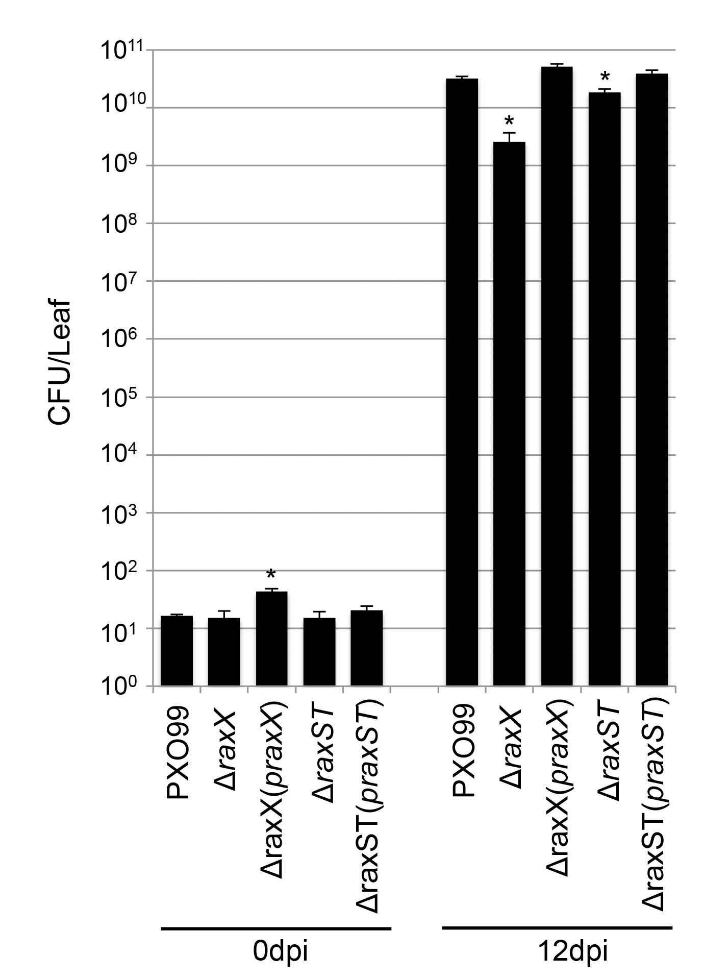

Figure S8. PXO99 strain lacking RaxX is impaired in virulence. Growth of indicated strains in rice leaves was measured at 0 day and 12 day after post-inoculation (dpi). Bars indicate the number of colony forming units (CFU) extracted per inoculated leaf. For the final data point, ‘*’ indicates statistically significant difference from PXO99 using Dunnett’s test (α=0.01, n = 4). The experiment was repeated twice with similar results.

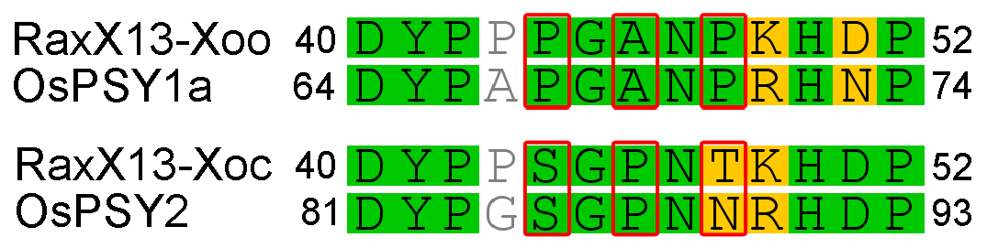

Figure S9. Sequence similarity of RaxX from Xoo and Xoc with selected rice PSYs. 13 amino acid RaxX sequences from Xoo (strain PXO99) and Xoc (strain BSL256) were aligned with the corresponding 13 amino acid fragments of OsPSY1a and OsPSY2, respectively. RaxX residues 44, 46, and 48 (marked in red boxes) are important for activation of XA21-mediated immunity. Sequence alignments were generated with Geneious software using default parameters (Kearse et al., 2012).

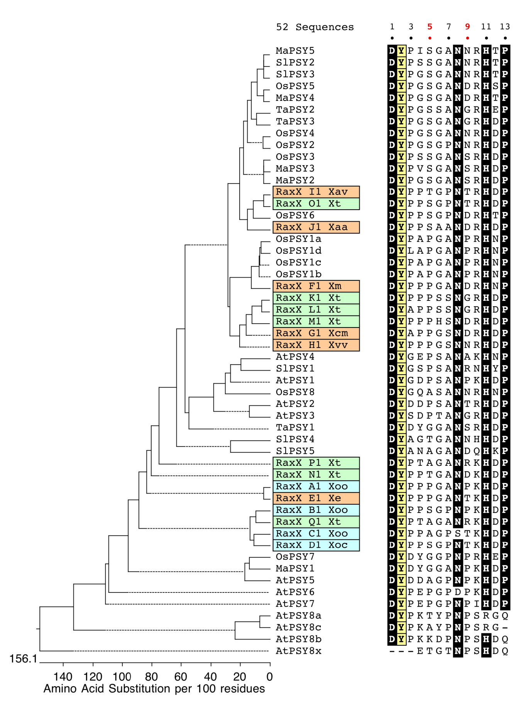
Figure S10. Comparison of RaxX and PSY peptides from various species. The highly conserved 13 amino acids from a collection of RaxX sequences (Table S1) and PSY sequences (Fig. S1) were used to build a tree to compare similarity. The invariant tyrosine residues are highlighted yellow and the other highly conserved residues are highlighted black. The RaxX sequences are colored as in Table S1 and Fig. S2.

