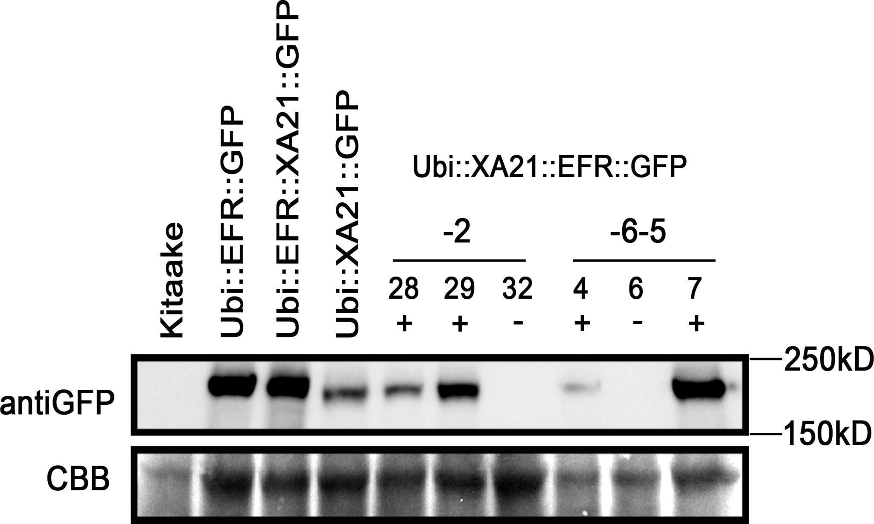
Figure S3: Xa21:EFR:GFP rice containing the transgene express GFP-tagged chimeric protein
Western blot showing protein level of EFR:GFP, EFR:XA21:GFP, XA21:GFP, and XA21:EFR:GFP using an anti-GFP antibody to detect the C-terminal GFP tag. The lower panel shows the coomassie brilliant blue staining of the membrane as a loading control. + and - indicates the presence of the transgene determined by PCR. XA21:EFR:GFP samples were from T1 individuals XA21:EFR:GFP-2-28, -2-29, and -2-32 and T2 individuals XA21:EFR:GFP-6-5-4, -6-5-6, and -6-5-7.

