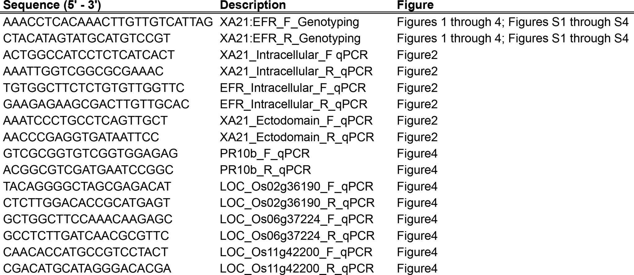
Table S1. List of primers used in this study
Table indicates each primer used in this study. The first column shows the 5’ to 3’ primer sequence. The second column indicates the associated MSU locus ID, primer direction, and purpose of primer. The last column indicates figures associated with each primer set.

