Appendix S5 Model Evaluation
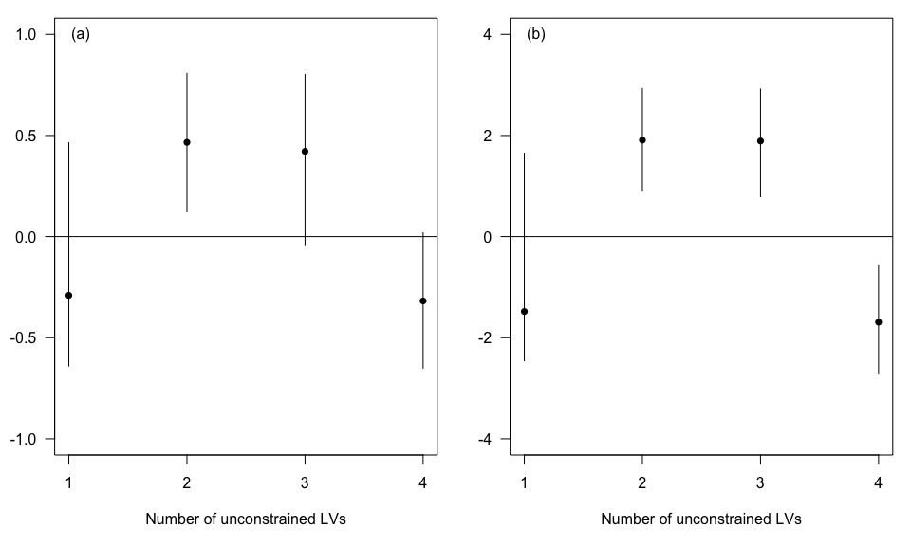
Figure S1 Estimates for the effect of distance to log ponds (a) and high flow (b) on the constrained latent variable as a function of the number of unconstrained latent variables included in the model. Points show median estimate and bars show the 95% credibility interval.
Table S2 Fit of the two latent variable model to each habitat type. r² values are calculated on observed versus expected abundances. Slope values of 1 indicate now bias, <1 under-predictions and >1 over-prediction.
Habitat | Mean abundance | r² | Slope of expected on observed
Others | 0.84 | 0.19 | 0.11
Other habitats | 1.86 | 0.44 | 0.32
Rare corals | 2.65 | 0.20 | 0.18
Acropora Tabular | 4.69 | 0.81 | 0.57
Turf Algae | 4.90 | 0.37 | 0.25
Macroalgae | 8.10 | 0.72 | 0.47
Halimeda Algae | 11.31 | 0.96 | 0.47
Algal assemblage | 12.61 | 0.96 | 0.57
Submassive coral | 13.96 | 0.48 | 0.41
Dead Coral | 17.39 | 0.80 | 0.74
Other corals | 19.43 | 0.48 | 0.57
Dead branching coral | 25.76 | 0.69 | 0.70
Rock | 39.04 | 0.79 | 0.68
Acropora Branching | 42.80 | 0.97 | 0.91
Coral Massive | 51.12 | 0.82 | 0.85
Coral Branching | 56.88 | 0.89 | 0.78
Soft sediment | 61.67 | 0.94 | 0.81

