Supplementary Information
Table S1. Species relative abundances in four community-types estimated by LDA model
Figure S1. Histogram of “best” number of community-types as estimated using 200 random seeds
Figure S2. Comparison of community composition of the “best” LDA model to “worst” model
Figure S3. Results of LDA model fit with three community-types
Figure S4. Results of LDA model fit with four community-types
Figure S5. Results of LDA model fit with five community-types
Figure S6. Comparison of change-point models fit with 2, 3, 4, or 5 change-points. The model containing 4 change-points was best supported.

Table S1: species relative abundances in the four community-types estimated by the LDA model. Species codes: NA = Neotoma albigula, DS = Dipodomys spectabilis, SH = Sigmodon hispidus, SF = Sigmodon fulviventer, SO = Sigmodon ochrognathus, DO = Dipodomys ordii, DM = Dipodomys merriami, PB = Chaetodipus baileyi, PH = Chaetodipus hispidus, OL = Onychomys leucogaster, OT = Onychomys torridus, PL = Peromyscus leucopus, PM = Peromyscus maniculatus, PE = Peromyscus eremicus, PP = Chaetodipus penicillatus, PI = Chaetodipus intermedius, RF = Reithrodontomys fulvescens, RM = Reithrodontomys megalotis, RO = Reithrodontomys montanus, BA = Baiomys taylori, PF = Perognathus flavus.
 | NA | DS | SH | SF | SO | DO | DM | PB | PH | OL | OT | PL | PM | PE | PP | PI | RF | RM | RO | BA | PF
1 | 0.088 | 0.340 | 0.001 | 0.000 | 0.000 | 0.076 | 0.341 | 0.000 | 0.000 | 0.061 | 0.051 | 0.000 | 0.000 | 0.011 | 0.000 | 0.000 | 0.000 | 0.000 | 0.000 | 0.000 | 0.030
2 | 0.025 | 0.000 | 0.004 | 0.003 | 0.001 | 0.128 | 0.606 | 0.000 | 0.001 | 0.030 | 0.064 | 0.000 | 0.012 | 0.041 | 0.000 | 0.000 | 0.001 | 0.049 | 0.001 | 0.001 | 0.032
3 | 0.024 | 0.000 | 0.020 | 0.014 | 0.000 | 0.211 | 0.078 | 0.450 | 0.000 | 0.003 | 0.130 | 0.004 | 0.006 | 0.016 | 0.022 | 0.006 | 0.000 | 0.000 | 0.000 | 0.009 | 0.007
4 | 0.001 | 0.000 | 0.000 | 0.000 | 0.000 | 0.018 | 0.216 | 0.025 | 0.000 | 0.001 | 0.006 | 0.000 | 0.000 | 0.002 | 0.722 | 0.002 | 0.000 | 0.000 | 0.000 | 0.002 | 0.006

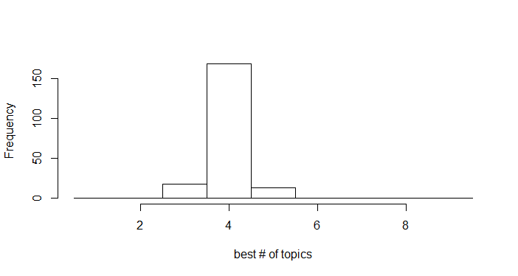
Figure S1. We estimated model fit using an approximate AIC procedure for LDA models using 2 to 9 community-types. Since LDA depends on a random seed, we repeated the LDA model fit and AIC model selection using 200 different seeds to obtain a distribution of “best number of community-types.” This procedure always selected between 3 and 5 community-types, with 4 selected by the majority of runs.

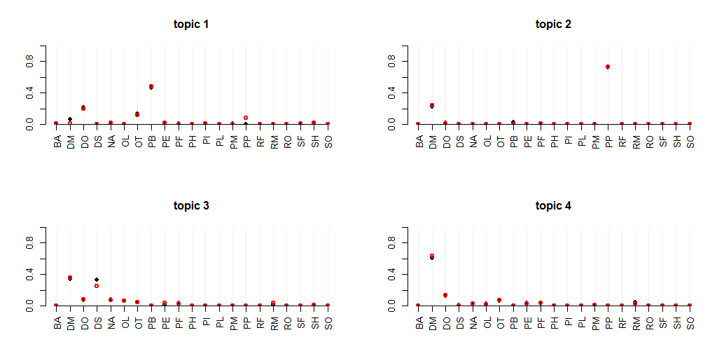
Figure S2. We fit the four community-type LDA model 200 times with different random initializations, using the model with the highest likelihood (black points) for all subsequent analyses. Among the top 100 model fits, the average Hellinger distance from this local optimum was 0.085, and maximum distance was 0.133, on a scale from 0 to 1. The red points indicate estimates from the farthest model.

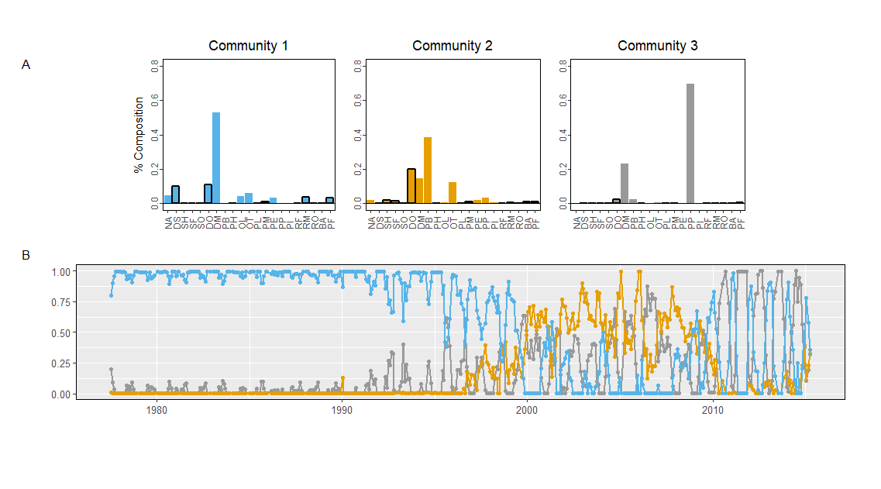
Figure S3. Results of LDA model fit with three community-types

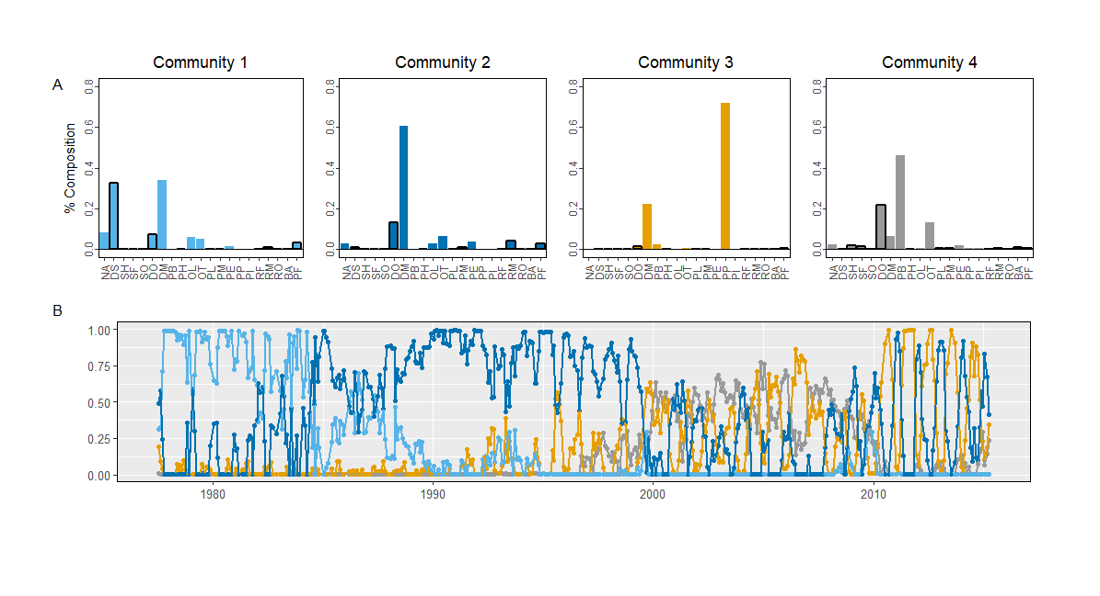
Figure S4. Results of LDA model fit with four community-types

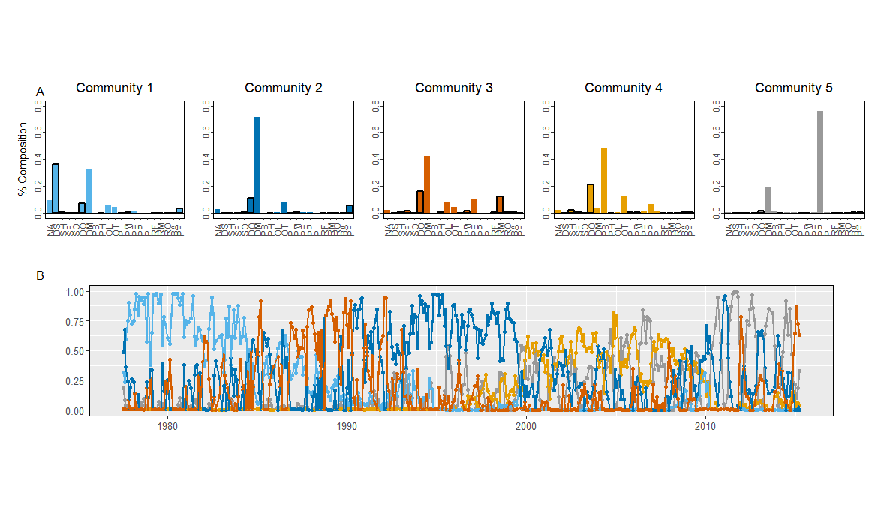
Figure S5. Results of LDA model fit with five community-types
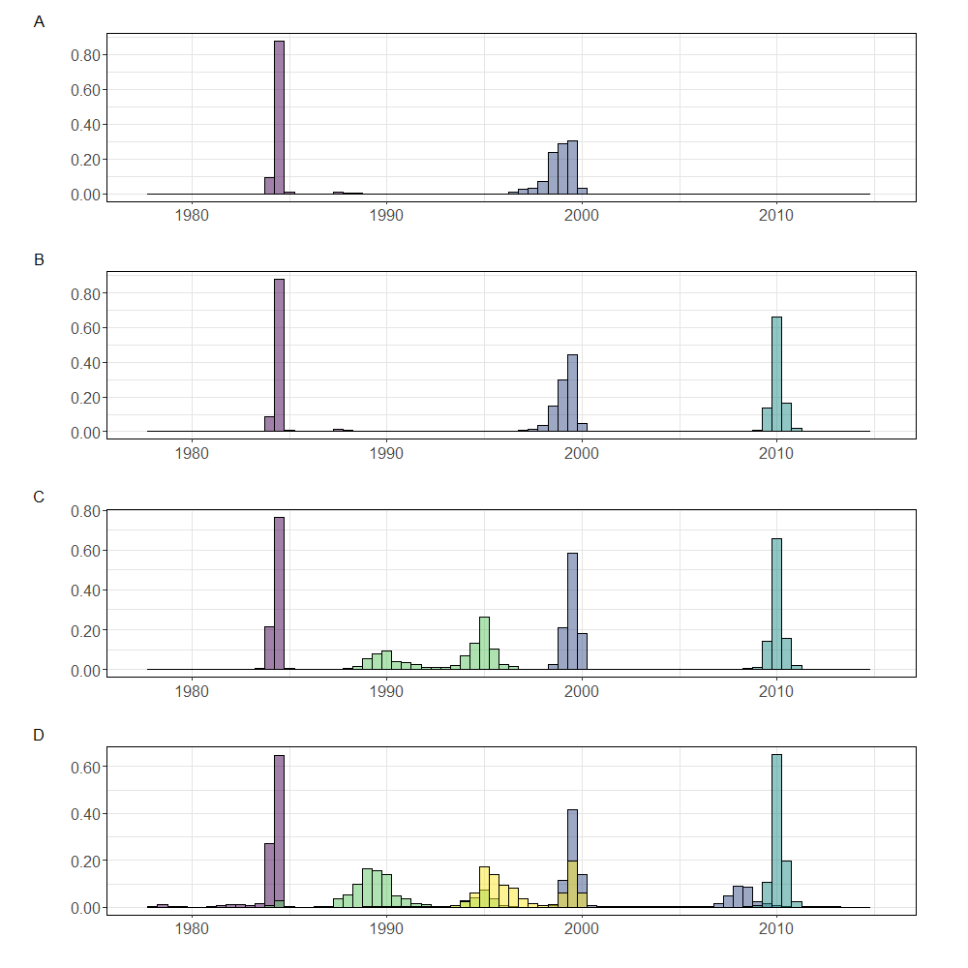
Figure S6. Comparison of change-point models fit with 2, 3, 4, or 5 change-points. The model containing 4 change-points was best supported.

