Section 3.7: Supplementary Material

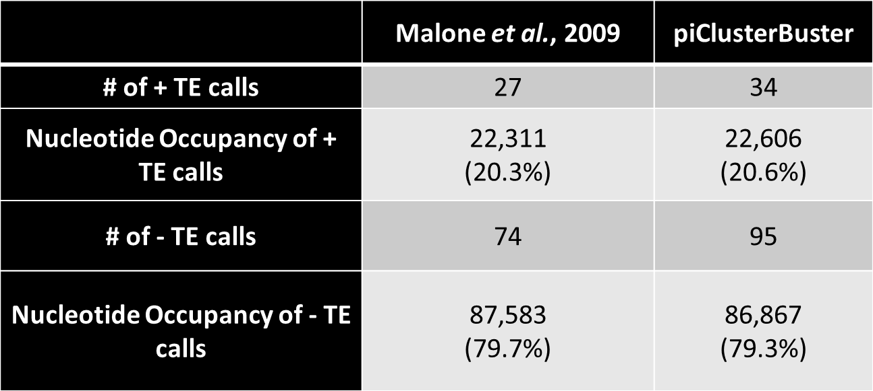

Table 3.1S: Improved Annotation with piClusterBusteR

Species | Datasets
Dr. melanogaster | ♀ - SRR618933, SRR797070, SRR797071, SRR797172, SRR797179, SRR797182, SRR797187, SRR797193, SRR797195, SRR797196, SRR797197, SRR797198, SRR797199, SRR797200, SRR797203  ♂ - GSM280085
Ae. aegypti | RNAlib17
An. gambiae | SRR1927173
H. sapiens | ♀ - SRR1755247,SRR1755248, SRR1755251, SRR1755252, SRR1755255, SRR1755256  ♂ - ERR328151, SRR835324, SRR835325, SRR950451
Ma. mulatta | ♂ - SRR116839, SRR553581, SRR606728
Ma. fascicularis | ♀ - SRR1755241, SRR1755242  ♂ - SRR1755243, SRR1755244
C. jacchus | ♂ - SRR606715, SRR1041905, SRR1041906, SRR1041907
Mu. musculus | ♀ - SRR014234  ♂ - SRR014231, SRR014232, SRR014233, SRR014235, SRR772028, SRR772029, SRR772030, SRR772031, SRR772032, SRR772033, SRR772050, SRR772051, SRR772052, SRR772053, SRR772054, SRR772055
R. norvegicus | ♂ - SRR035663
B. taurus | ♀ - SRR1755229, SRR1755230  ♂ - SRR1755231, SRR1755232
S. scrofa | ♀ - SRR066809, SRR1274763  ♂ - SRR066810, SRR1274764, SRR1654828
G. gallus | ♂ - SRR772069
Da. rerio | ♀ - SRR578904, SRR578905, SRR578906, SRR578913, SRR578914, SRR578915  ♂ - SRR578922, SRR578923

Table 3.2S: Description of Datasets

Species | Number of piRNA Clusters | Genome Size (Mb) | Total Read Count
Dr. melanogaster | 10 | 148 | 205,554,806
Ae. aegypti | 210 | 1064 | 10,655,147
An. gambiae | 30 | 236 | 22,370,627
H. sapiens | 303 | 2996 | 29,968,314
Ma. fascicularis | 213 | 2946 | 10,117,534
Mu. musculus | 336 | 2689 | 269,297
B. taurus | 42 | 2697 | 4,528,165
S. scrofa | 48 | 2508 | 17,661,429
Da. rerio | 166 | 1391 | 35,936,571

Table 3.3S: Ovary Genome Size and Read Count

Species | Number of piRNA Clusters | Genome Size (Mb) | Total Read Count
H. sapiens | 355 | 2996 | 50,251,433
Ma. mulatta | 316 | 3097 | 41,304,681
Ma. fascicularis | 467 | 2946 | 42,234,678
C. jacchus | 441 | 2621 | 158,431,380
Mu. musculus | 879 | 2689 | 454,610,320
R. norvegicus | 231 | 2870 | 8,407,181
B. taurus | 618 | 2697 | 55,482,891
G. gallus | 166 | 1230 | 116,234,474
D. rerio | 166 | 1391 | 47,798,654
S. scrofa | 527 | 2508 | 37,221,910
Table 3.4S: Testis Genome Size and Read Count

Pearson Correlation Test Relative to piRNA Cluster Calls | Tissue | T value | Pearson Correlation Value | P value
Genome Size | Ovary | 1.8787 | 0.5789624 | 0.1024
 | Testis | -1.3173 | -0.4457003 | 0.2292
Number of Reads | Ovary | 1.7516 | 0.5520267 | 0.1233
 | Testis | 2.936 | 0.7428724 | 0.02184

Table 3.5S: Correlations of piRNA Cluster Definition

Species | Number of piRNA Clusters Called | Average piRNA Cluster Size (kb) | Total Nucleotides Occupied by piRNA Clusters | Genome Occupancy | % TE | % Gene | % Other | % Unannotated
Dr. melanogaster | 10 | 11.4 | 113,593 | 0.07% | 78 | 4 | 0 | 18
Ae. aegypti | 210 | 10 | 2,109,482 | 0.15% | 45 | 4 | 0 | 51
An. gambiae | 30 | 8.9 | 268,084 | 0.10% | 35 | 3 | 9 | 53
H. sapiens | 303 | 10 | 3,023,129 | 0.09% | 27 | 6 | 4 | 63
Ma. fascicularis | 213 | 21.8 | 4,635,040 | 0.15% | 26 | 1 | 3 | 70
Mu. musculus | 336 | 7.67 | 2,576,831 | 0.09% | 45 | 3 | 4 | 48
B. taurus | 42 | 15.5 | 652,933 | 0.02% | 22 | 3 | 8 | 67
S. scrofa | 48 | 17.8 | 856,408 | 0.03% | 20 | 4 | 7 | 69
Da. rerio | 166 | 10.6 | 1,761,421 | 0.13% | 61 | 1 | 2 | 36

Table 3.6S: piRNA Cluster Contents - Ovary

Species | Number of piRNA Clusters Called | Average piRNA Cluster Size (kb) | Total Nucleotides Occupied by piRNA Clusters | Genome Occupancy | % TE | % Gene | % Other | % Unannotated
H. sapiens | 355 | 12.9 | 4578738 | 0.14 | 28 | 3 | 6 | 63
Ma. mulatta | 300 | 11.2 | 3360121 | 0.12 | 32 | 3 | 4 | 61
Ma. fascicularis | 213 | 12 | 5602830 | 0.15 | 29 | 2 | 4 | 65
C. jacchus | 441 | 13.5 | 5959699 | 0.22 | 27 | 2 | 5 | 66
Mu. musculus | 167 | 21.8 | 3642073 | 0.13 | 31 | 3 | 3 | 63
R. norvegicus | 231 | 18 | 4146688 | 0.14 | 25 | 4 | 3 | 68
B. taurus | 618 | 12 | 7434999 | 0.28 | 29 | 2 | 4 | 65
G. gallus | 166 | 10.7 | 1772287 | 0.18 | 23 | 11 | 3 | 63
D. rerio | 157 | 10.8 | 1691347 | 0.12 | 62 | 0 | 3 | 35
S. scrofa | 527 | 43.2 | 6147214 | 0.24 | 30 | 5 | 0 | 65

Table 3.7S: piRNA Cluster Contents - Testis

Species | Nucleotide Occupancy of Top 30 piRNA clusters | Nucleotide Occupancy of All piRNA Cluster Calls | Percent Composition of Top 30 piRNA Clusters
Dr. melanogaster | 113,593 | 113,593 | 100%
Ae. aegypti | 585,679 | 2,109,482 | 27.8%
An. gambiae | 268,084 | 268,084 | 100%
H. sapiens | 741,925 | 3,023,129 | 24.5%
Ma. fascicularis | 2,326,841 | 4,635,040 | 50.2%
Mu. musculus | 496,848 | 2,576,831 | 19.3%
B. taurus | 569,934 | 652,933 | 87.3%
S. scrofa | 722,238 | 856,408 | 84.3%
Da. rerio | 575,932 | 1,761,421 | 32.7%

Table 3.8S: Nucleotide Occupancy of the Top 30 piRNA Clusters - Ovary

Species | Nucleotide Occupancy of Top 30 piRNA clusters | Nucleotide Occupancy of All piRNA Cluster Calls | Percent Composition of Top 30 piRNA Clusters
H. sapiens | 1,054,062 | 4,578,738 | 23.0%
Ma. mulatta | 979,655 | 3,360,121 | 29.2%
Ma. fascicularis | 1,472,922 | 5,602,830 | 26.3%
C. jacchus | 1,609,193 | 5,959,699 | 27.0%
Mu. musculus | 1,570,168 | 3,642,073 | 43.1%
R. norvegicus | 1,719,232 | 4,146,688 | 41.5%
B. taurus | 1,496,074 | 7,434,999 | 20.1%
G. gallus | 505,336 | 1,772,287 | 28.5%
D. rerio | 622,435 | 1,691,347 | 36.8%
S. scrofa | 1,297,435 | 6,147,214 | 21.1%

Table 3.9S: Nucleotide Occupancy of the Top 30 piRNA Clusters - Testis

Species | piRNA Generation of Top 30 piRNA clusters | piRNA Generation of All piRNA Cluster Calls | Percent piRNA Generation of Top 30 piRNA Clusters
Dr. melanogaster | 27,422 | 27,422 | 100%
Ae. aegypti | 80,000 | 161,016 | 49.7%
An. gambiae | 124,402 | 124,402 | 100%
H. sapiens | 97,707 | 121,570 | 80.4%
Ma. fascicularis | 3,280 | 25,222 | 13.0%
Mu. musculus | 95,879 | 164,121 | 58.4%
B. taurus | 3,630 | 3,854 | 94.2%
S. scrofa | 792 | 1,176 | 67.3%
Da. rerio | 8,5872 | 175,856 | 48.8%

Table 3.10S: piRNA Generation of the Top 30 piRNA Clusters - Ovary

Species | piRNA Generation of Top 30 piRNA clusters | piRNA Generation of All piRNA Cluster Calls | Percent piRNA Generation of Top 30 piRNA Clusters
H. sapiens | 308061 | 383126 | 80.4%
Ma. mulatta | 414155 | 477018 | 86.8%
Ma. fascicularis | 411479 | 488199 | 84.3%
C. jacchus | 559813 | 631692 | 88.6%
Mu. musculus | 363370 | 476957 | 76.2%
R. norvegicus | 751565 | 876417 | 85.8%
B. taurus | 820381 | 903538 | 90.8%
G. gallus | 195819 | 362278 | 54.1%
D. rerio | 95038 | 178252 | 53.3%
S. scrofa | 578459 | 621844 | 93.0%

Table 3.11S: piRNA Generation of the Top 30 piRNA Clusters - Testis

Wilcoxon Rank Sum Test with Continuity Correction

Testis vs Ovary

W = 25, p-value = 0.08225

Testis vs Between Tissue

W = 1, p-value = 0.002165

Ovary vs Between Tissue

W = 7, p-value = 0.08874
Table 3.12S: Degree of Agreement of piRNA Cluster Definition

