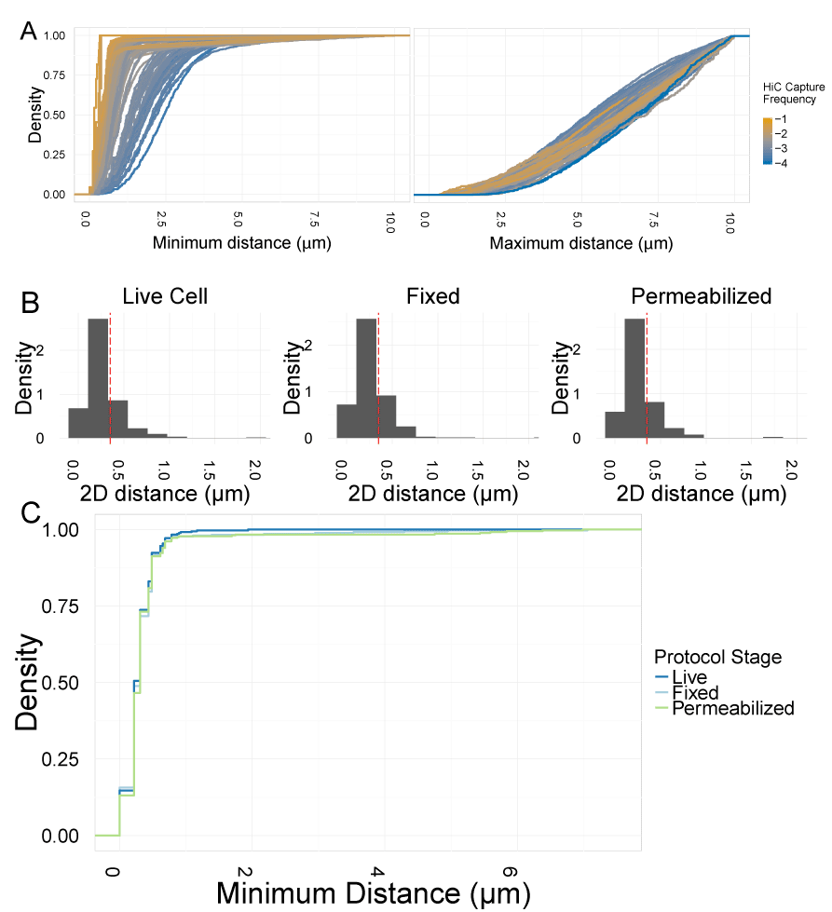
Fig. S1: Robustness of protocol and spot detection. (A) Cumulative distance distributions for minimum distance on a per-bait-spot basis (left panel) or maximum distance on a per-spot basis (right panel). Color coded by Hi-C score. (B) Histograms showing distance distributions for distances between tightly linked LacO and TetO cassettes in live cells, the same cells after fixation, and the same cells after permeabilization. (C) Cumulative distance distribution for distances between tightly linked LacO and TetO cassettes in live cells, the same cells after fixation, and the same cells after permeabilization.
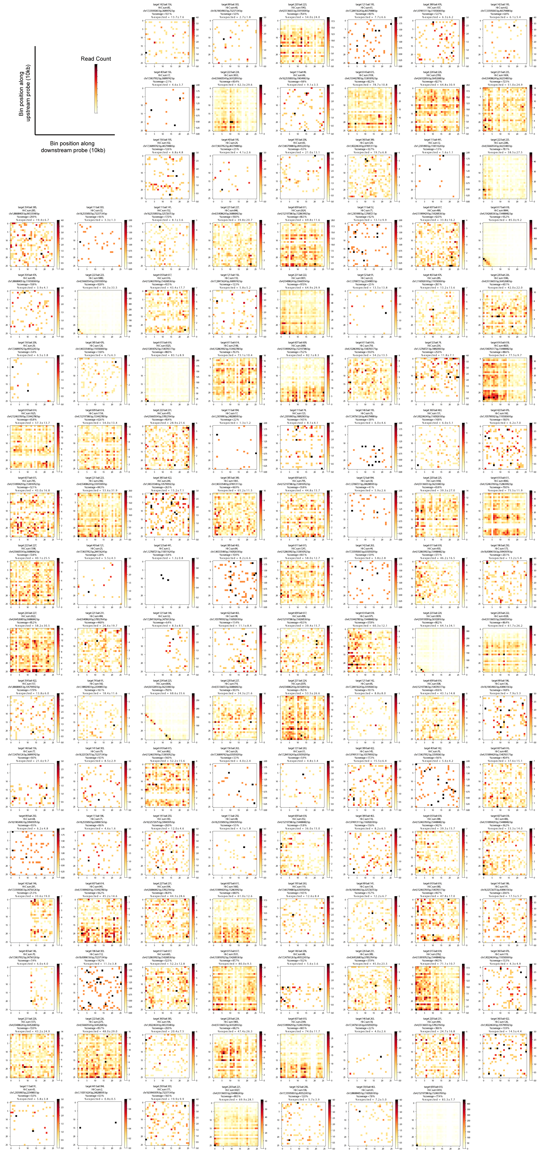

Fig. S2: Hi-C Coverage plots for all pairs. 10kb binned Hi-C coverage plots showing coverage across 250kb bins centered on the BAC probes used. All probe pairs tested are included.
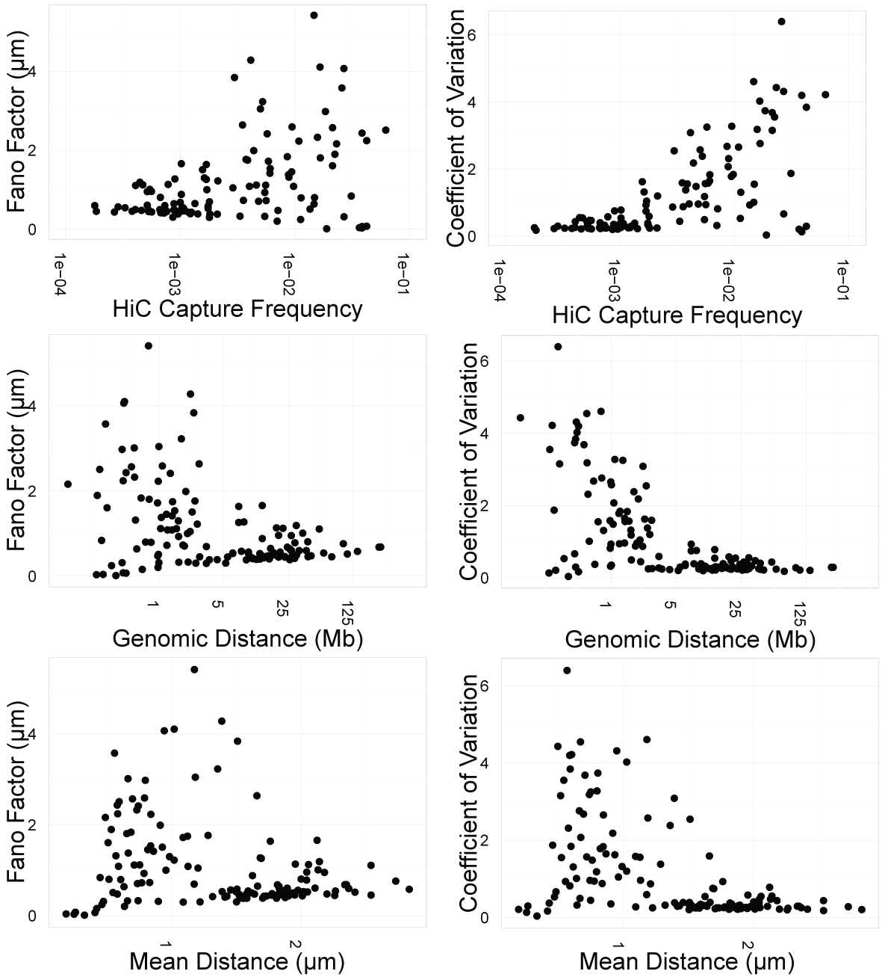
Fig. S3: Analysis of noise. Scatterplots showing noise analysis. Quantification of noise, by both Fano factor (variance/mean) and coefficient of variation (standard deviation/mean), on the y-axis. Hi-C capture frequency, genomic distance, and mean spatial distance on the x-axis.

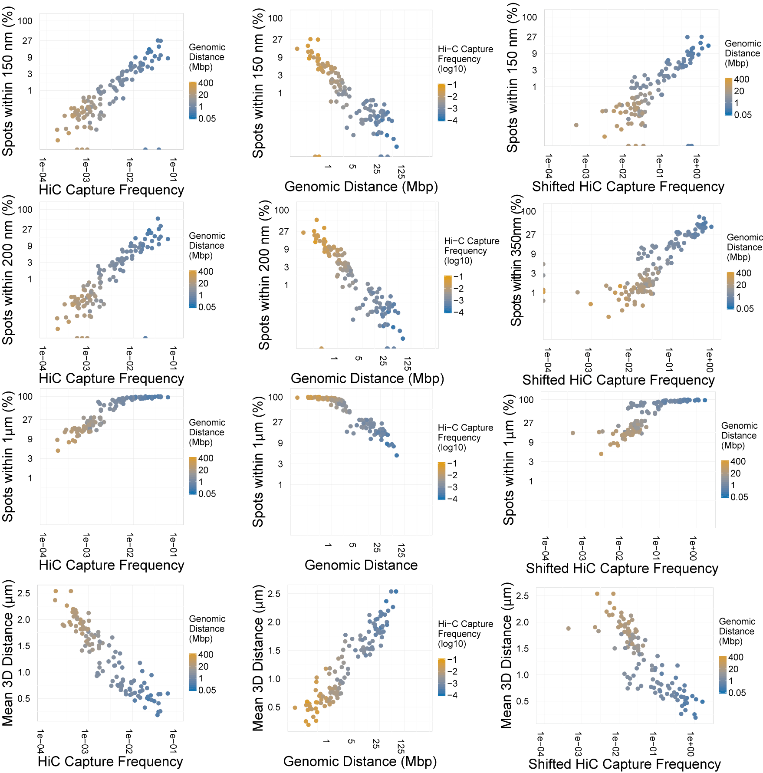
Fig. S4: Correlations between FISH and Hi-C, genomic distance, and shifted Hi-C at various thresholds. Y-axis is FISH data; either mean distance (µm) or percent spots associating at three different distance thresholds (150 nm, 200 nm, and 1 µm). X-axis is Hi-C capture frequency (color-coded by genomic distance), shifted Hi-C capture frequency (Hi-C capture frequency for a bin shifted by 500kb form the tested bin; color-coded by genomic distance), or genomic distance (color-coded by Hi-C capture frequency).
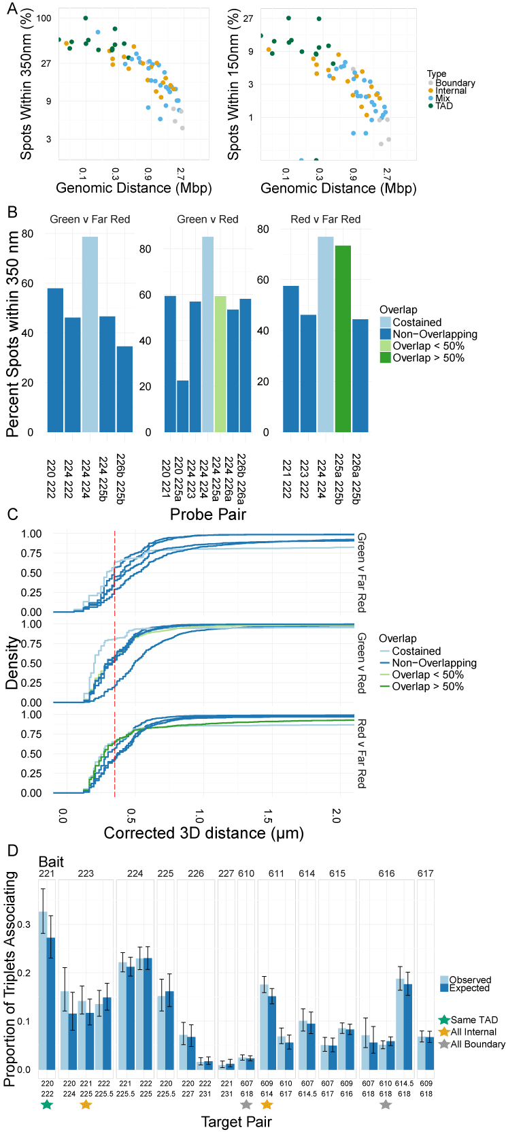
Fig. S5: Discrimination of adjacent probes from costained probes. (A) Barchart showing the percent of spots associating within 350 nm for co-stained probes (light blue), overlapping probes (green), or adjacent probes (dark blue). (B) Cumulative distance distributions comparing co-stained probes (light blue), overlapping probes (green), or adjacent probes (dark blue). Red dashed line is 350 nm. (C) Cluster formation for regions in the same TAD or adjacent TADs. Light blue: proportion of alleles found in clusters of three. Dark blue: proportion of alleles expected to be found in clusters of three, given pairwise colocalization frequencies and assuming statistical independence between interactions. One triplet of pairs all in the same TAD marked with a green star, two triplets of all regions internal to TADs marked with yellow stars, two triplets of all TAD boundaries marked with gray stars.
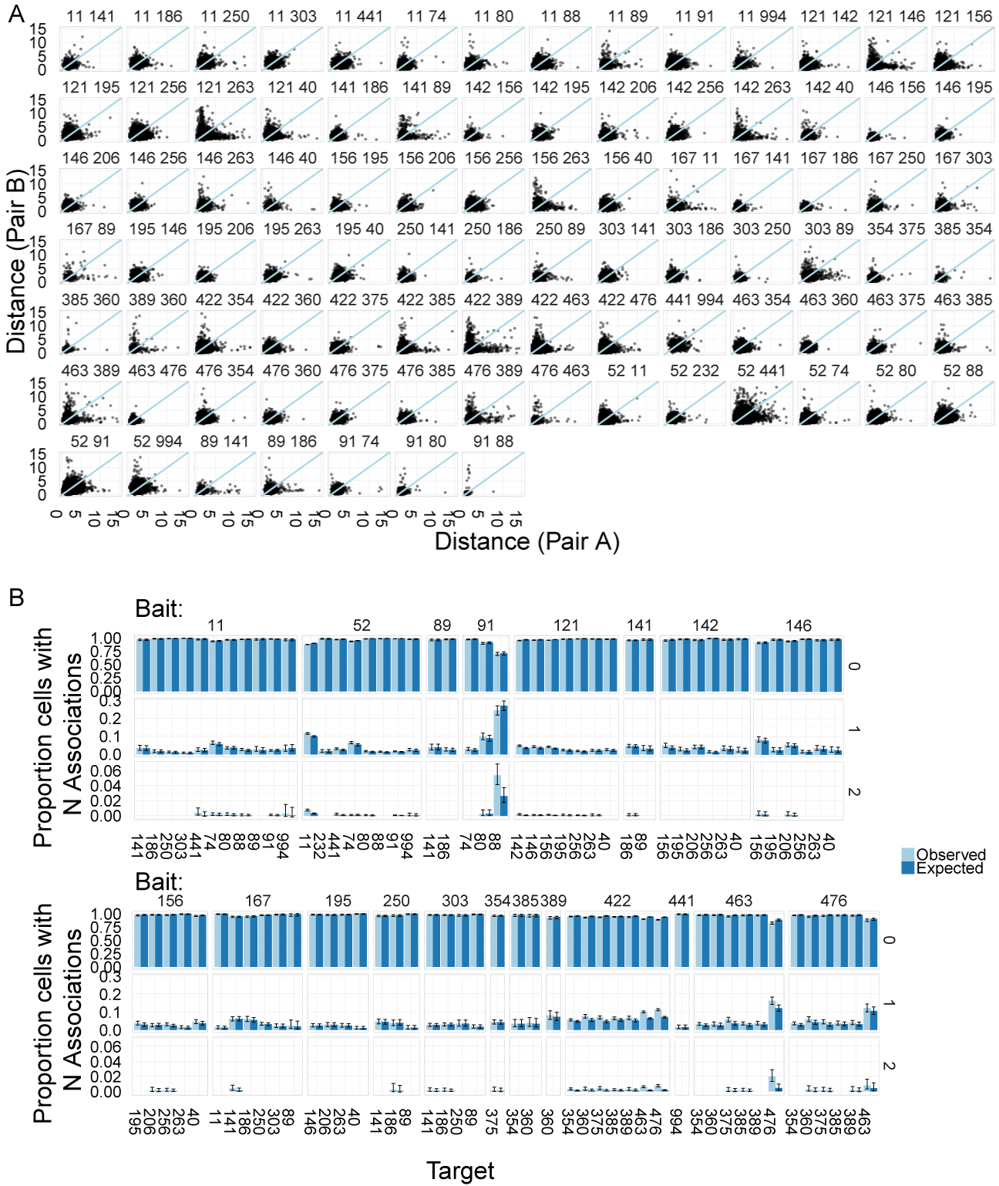
Fig. S6: Allelic independence at all tested pairs. (A) Scatterplots showing spatial distance at one allele in a cell vs. spatial distance at the second allele in the same cell. (B) Bar charts showing proportion of cells with zero, one, or two pairing events. Light blue: observe proportions. Dark blue: proportions expected based on pairwise interaction frequencies, and assuming statistical independence between the two alleles in the cell.
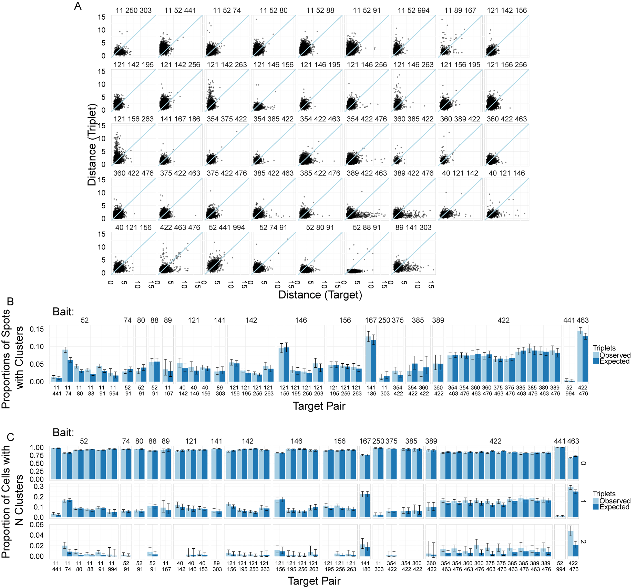
Fig. S7: Independence of two associations on the same chromosome. (A) Scatterplots showing, on a per-bait basis, the distance to an upstream target vs. the distance to a downstream target. (B) Bar charts showing number of clusters. Light blue: observed number of clusters (bait is within 1 µm of both upstream and downstream targets). Dark blue: expected values based on pairwise interaction frequencies and the assumption of independence between interactions on the same chromosome. (C) As in panel B, but separated out by number of cluster events per cell, (0, 1, or 2).

ID | My ID | Probe number | chr | start | end
RP11-1012C20 | LR.1.11 | 11 | 1 | 2,301,890 | 2,502,158
RP11-380A17 | LR.1.52 | 52 | 1 | 12,768,721 | 12,925,598
RP11-702L8 | LR.1.91 | 91 | 1 | 22,549,855 | 22,721,150
RP11-978H24 | LR.1.249 | 249 | 1 | 62,026,615 | 62,212,578
RP11-577F1 | LR.1.255 | 255 | 1 | 63,525,431 | 63,690,613
RP11-662G21 | LR.1.433 | 433 | 1 | 108,025,327 | 108,188,093
RP11-15H5 | LR.1.441 | 441 | 1 | 110,011,624 | 110,205,112
RP11-248A15 | LR.1.994 | 994 | 1 | 248,288,595 | 248,426,855
RP11-164D21 | LR.1.74 | 74 | 1 | 18,892,903 | 19,093,374
RP11-451I3 | LR.1.80 | 80 | 1 | 20,338,862 | 20,504,125
RP11-655O19 | LR.1.89 | 89 | 1 | 22,326,992 | 22,496,176
RP11-107I3 | LR.1.232 | 232 | 1 | 58,498,154 | 58,657,130
RP11-605M13 | LR.1.254 | 254 | 1 | 63,999,588 | 64,183,763
RP11-75M16 | LR.1.422 | 422 | 1 | 105,799,592 | 105,969,902
RP11-489I11 | LR.1.385 | 385 | 1 | 96,533,548 | 96,692,322
RP11-647L1 | LR.1.354 | 354 | 1 | 88,688,405 | 88,884,154
RP11-465E12 | LR.1.360 | 360 | 1 | 90,224,634 | 90,379,045
RP11-357E20 | LR.1.389 | 389 | 1 | 97,491,311 | 97,673,416
RP11-657I7 | LR.1.376 | 376 | 1 | 93,994,334 | 94,153,486
RP11-1089F2 | LR.1.482 | 482 | 1 | 144,551,754 | 144,679,189
RP11-675C19 | LR.1.463 | 463 | 1 | 116,092,618 | 116,272,182
RP11-419G7 | LR.1.476 | 476 | 1 | 119,358,369 | 119,532,471
RP11-354P11 | LR.17.121 | 121 | 17 | 28,415,624 | 28,590,586
RP11-93E5 | LR.17.263 | 263 | 17 | 63,505,929 | 63,674,318
RP11-357H14 | LR.17.195 | 195 | 17 | 46,579,488 | 46,766,859
RP11-171A12 | LR.17.142 | 142 | 17 | 33,595,065 | 33,768,624
RP11-793K16 | LR.17.146 | 146 | 17 | 34,756,126 | 34,930,376
RP11-630H24 | LR.17.256 | 256 | 17 | 61,844,654 | 62,005,150
RP11-111E14 | LR.17.40 | 40 | 17 | 9,637,952 | 9,804,303
RP11-425G1 | LR.17.156 | 156 | 17 | 36,899,742 | 37,095,782
RP11-625L2 | LR.17.278 | 278 | 17 | 67,257,758 | 67,421,760
RP11-661H23 | LR.17.206 | 206 | 17 | 49,352,243 | 49,545,132
RP11-728E14 | LR.17.86 | 86 | 17 | 21,178,535 | 21,381,518
RP11-610D22 | LR.17.123 | 123 | 17 | 28,868,967 | 29,066,365
RP11-98K21 | LR.17.133 | 133 | 17 | 31,347,965 | 31,513,345
RP11-7E6 | LR.18.163 | 163 | 18 | 38,176,590 | 38,341,709
RP11-373G4 | LR.18.303 | 303 | 18 | 73,237,134 | 73,407,204
RP11-640A1 | LR.18.250 | 250 | 18 | 59,943,976 | 60,124,080
RP11-63N12 | LR.18.141 | 141 | 18 | 32,572,675 | 32,731,928
RP11-153O13 | LR.18.296 | 296 | 18 | 71,445,285 | 71,612,312
RP11-18K7 | LR.18.89 | 89 | 18 | 19,654,963 | 19,819,473
RP11-879H24 | LR.18.193 | 193 | 18 | 45,542,965 | 45,715,477
RP11-265P7 | LR.18.11 | 11 | 18 | 2,535,850 | 2,706,099
RP11-19L3 | LR.18.186 | 186 | 18 | 43,896,156 | 44,066,723
RP11-1070E4 | LR.18.157 | 157 | 18 | 36,596,681 | 36,786,703
RP11-698A7 | LR.18.167 | 167 | 18 | 39,117,802 | 39,307,768
RP11-657O23 | SR.4.607 | 607 | 4 | 151,899,429 | 152,046,120
RP11-151D8 | SR.4.609 | 609 | 4 | 152,197,386 | 152,365,527
RP11-32J2 | SR.4.610 | 610 | 4 | 152,463,769 | 152,600,375
RP11-458F16 | SR.4.611 | 611 | 4 | 152,863,992 | 153,023,379
RP11-669K4 | SR.4.613 | 613 | 4 | 153,241,008 | 153,420,432
RP11-102C9 | SR.4.614a | 614 | 4 | 153,442,780 | 153,598,548
RP11-767A6 | SR.4.614b | 614.5 | 4 | 153,633,936 | 153,820,258
RP11-805L16 | SR.4.615 | 615 | 4 | 153,818,762 | 154,025,154
RP11-71G1 | SR.4.616 | 616 | 4 | 154,076,517 | 154,249,705
RP11-1152M14 | SR.4.617 | 617 | 4 | 154,268,536 | 154,427,104
RP11-153M7 | SR.4.618 | 618 | 4 | 154,488,482 | 154,640,606
RP11-1150L6 | SR.4.220 | 220 | 4 | 55,136,655 | 55,301,183
RP11-1137P22 | SR.4.221 | 221 | 4 | 55,408,624 | 55,561,196
RP11-1030A19 | SR.4.222 | 222 | 4 | 55,660,554 | 55,861,689
RP11-1125E19 | SR.4.223 | 223 | 4 | 55,919,309 | 56,062,859
RP11-504F11 | SR.4.224 | 224 | 4 | 56,102,816 | 56,304,040
RP11-177J6 | SR.4.225a | 225 | 4 | 56,233,483 | 56,382,406
RP11-157O5 | SR.4.225b | 225.5 | 4 | 56,305,662 | 56,452,678
RP11-991O21 | SR.4.226a | 226 | 4 | 56,452,680 | 56,641,895
RP11-521J23 | SR.4.226b | 226.5 | 4 | 56,637,429 | 56,814,477
RP11-436G15 | SR.4.227 | 227 | 4 | 56,886,842 | 57,044,748
RP11-186L22 | SR.4.228 | 228 | 4 | 57,164,897 | 57,351,649
RP11-1132E12 | SR.4.229 | 229 | 4 | 57,310,195 | 57,446,118
RP11-1005B7 | SR.4.230 | 230 | 4 | 57,665,518 | 57,852,759
RP11-589G9 | SR.4.231 | 231 | 4 | 57,852,764 | 58,011,852

Table S1: Locations of all probes used. ID: BAC ID of the format RP11-XXXXX, searchable on UCSC. My ID: Unique identifier including long range/short range (LR vs SR), chromosome number, and probe number. Probe number: Probe ID corresponding to the 250kb bin in which the center of the BAC falls; unique within a chromosome. Chr: Chromosome number. Start: BAC probe genomic start location. End: Bac probe genomic end location.

Bait | Target | chr | HiC | Bias Quantile | Genomic Distance | Bait Comp. | Target Comp. | nspots | 150nm% | 200nm% | 350nm% | 1um% | Pooled Mean
52 | 11 | 1 | 1.69E-03 | 0.98 | 10,250,000 | B | B | 42530 | 0.60 | 1.36 | 5.03 | 33.40 | 1.32
74 | 11 | 1 | 1.96E-03 | 0.74 | 15,750,000 | B | B | 2939 | 0.27 | 0.27 | 1.70 | 23.78 | 1.64
11 | 74 | 1 | 1.96E-03 | 0.74 | 15,750,000 | B | B | 5643 | 0.50 | 1.01 | 2.78 | 24.51 | 1.52
11 | 89 | 18 | 5.57E-04 | 0.88 | 19,500,000 | A | A | 1396 | 0.14 | 0.14 | 1.07 | 16.26 | 2.04
91 | 11 | 1 | 8.18E-04 | 0.86 | 20,000,000 | A | B | 1900 | 0.05 | 0.05 | 0.68 | 11.58 | 2.05
11 | 91 | 1 | 8.18E-04 | 0.86 | 20,000,000 | B | A | 7547 | 0.12 | 0.27 | 0.87 | 12.07 | 1.94
11 | 141 | 18 | 7.29E-04 | 0.02 | 32,500,000 | A | B | 1422 | 0.49 | 0.49 | 1.55 | 16.74 | 1.83
11 | 186 | 18 | 4.56E-04 | 0.48 | 43,750,000 | A | A | 2511 | 0.20 | 0.20 | 0.68 | 7.89 | 2.20
11 | 250 | 18 | 3.27E-04 | 0.18 | 59,750,000 | A | B | 3385 | 0.06 | 0.06 | 0.50 | 7.50 | 2.26
11 | 303 | 18 | 1.84E-04 | 0.46 | 73,000,000 | A | B | 2724 | 0.04 | 0.04 | 0.26 | 4.66 | 2.54
11 | 441 | 1 | 1.94E-04 | 0.83 | 107,500,000 | B | A | 2692 | 0.07 | 0.07 | 1.00 | 5.87 | 2.41
11 | 994 | 1 | 3.66E-04 | 0.97 | 245,750,000 | B | B | 962 | 0.21 | 0.21 | 1.46 | 8.52 | 2.35
121 | 40 | 17 | 2.84E-04 | 0.73 | 20,250,000 | A | B | 6355 | 0.08 | 0.08 | 1.02 | 15.17 | 1.88
142 | 40 | 17 | 8.76E-04 | 0.80 | 25,500,000 | B | B | 1269 | 0.00 | 0.00 | 0.95 | 18.36 | 1.83
146 | 40 | 17 | 1.03E-03 | 1.00 | 26,500,000 | A | B | 2620 | 0.08 | 0.08 | 1.07 | 15.11 | 1.89
156 | 40 | 17 | 4.02E-04 | 0.93 | 29,000,000 | A | B | 5097 | 0.20 | 0.20 | 1.49 | 16.03 | 1.90
195 | 40 | 17 | 1.78E-04 | 0.42 | 38,750,000 | A | B | 1354 | 0.07 | 0.07 | 0.37 | 8.57 | 2.37
52 | 74 | 1 | 4.46E-03 | 0.74 | 5,500,000 | B | B | 13434 | 0.37 | 0.52 | 2.66 | 25.06 | 1.52
52 | 91 | 1 | 3.53E-04 | 0.86 | 9,750,000 | B | A | 27624 | 0.10 | 0.15 | 0.64 | 6.90 | 2.26
52 | 441 | 1 | 6.30E-05 | 0.83 | 97,250,000 | B | A | 12434 | 0.36 | 0.36 | 1.18 | 4.83 | 2.73
52 | 994 | 1 | 7.61E-04 | 0.97 | 235,500,000 | B | B | 4324 | 0.25 | 0.25 | 1.04 | 6.59 | 2.34
91 | 74 | 1 | 1.42E-03 | 0.86 | 4,250,000 | A | B | 5363 | 0.07 | 0.24 | 0.95 | 14.79 | 1.70
141 | 89 | 18 | 1.02E-03 | 0.02 | 13,000,000 | B | A | 1248 | 0.24 | 0.24 | 1.44 | 20.35 | 2.12
89 | 141 | 18 | 1.02E-03 | 0.02 | 13,000,000 | A | B | 1167 | 0.34 | 0.34 | 1.71 | 26.31 | 1.62
89 | 186 | 18 | 9.95E-04 | 0.48 | 24,250,000 | A | A | 2298 | 0.09 | 0.09 | 1.13 | 18.06 | 1.82
250 | 89 | 18 | 6.67E-04 | 0.18 | 40,250,000 | B | A | 1032 | 0.00 | 0.00 | 0.48 | 13.66 | 2.00
303 | 89 | 18 | 4.05E-04 | 0.46 | 53,500,000 | B | A | 1674 | 0.18 | 0.18 | 0.72 | 8.36 | 2.54
121 | 142 | 17 | 8.57E-04 | 0.80 | 5,250,000 | A | B | 22555 | 0.29 | 0.29 | 1.70 | 22.68 | 1.50
121 | 146 | 17 | 1.03E-03 | 1.00 | 6,250,000 | A | A | 14281 | 0.21 | 0.21 | 1.67 | 21.39 | 1.59
121 | 156 | 17 | 2.10E-03 | 0.93 | 8,750,000 | A | A | 29679 | 0.19 | 0.19 | 1.56 | 23.41 | 1.55
121 | 195 | 17 | 7.21E-04 | 0.42 | 18,500,000 | A | A | 8566 | 0.16 | 0.16 | 1.03 | 14.53 | 1.92
121 | 263 | 17 | 5.39E-04 | 0.50 | 35,500,000 | A | A | 6377 | 0.27 | 0.27 | 0.94 | 14.52 | 2.13
141 | 186 | 18 | 1.22E-03 | 0.48 | 11,250,000 | B | A | 4561 | 0.37 | 0.37 | 2.17 | 24.01 | 1.53
250 | 141 | 18 | 9.05E-04 | 0.18 | 27,250,000 | B | B | 1800 | 0.33 | 0.33 | 2.11 | 24.89 | 1.58
303 | 141 | 18 | 3.77E-04 | 0.46 | 40,500,000 | B | B | 2969 | 0.30 | 0.30 | 1.28 | 13.81 | 1.95
146 | 142 | 17 | 7.55E-03 | 1.00 | 1,000,000 | A | B | 783 | 1.28 | 1.28 | 11.37 | 67.69 | 0.90
142 | 156 | 17 | 1.81E-03 | 0.93 | 3,500,000 | B | A | 3883 | 0.23 | 0.23 | 1.47 | 21.50 | 1.58
142 | 195 | 17 | 5.60E-04 | 0.42 | 13,250,000 | B | A | 2620 | 0.19 | 0.19 | 1.03 | 11.07 | 2.01
142 | 206 | 17 | 1.34E-03 | 0.68 | 16,000,000 | B | B | 3142 | 0.32 | 0.32 | 1.88 | 23.11 | 1.66
142 | 263 | 17 | 4.41E-04 | 0.50 | 30,250,000 | B | A | 1629 | 0.31 | 0.31 | 1.35 | 16.88 | 2.14
146 | 156 | 17 | 3.31E-03 | 0.93 | 2,500,000 | A | A | 4607 | 0.72 | 0.72 | 3.30 | 38.40 | 1.22
195 | 146 | 17 | 7.17E-04 | 0.42 | 12,250,000 | A | A | 2290 | 0.09 | 0.09 | 1.05 | 13.36 | 2.02
146 | 195 | 17 | 7.17E-04 | 0.42 | 12,250,000 | A | A | 1360 | 0.22 | 0.22 | 1.18 | 12.72 | 1.88
146 | 206 | 17 | 2.44E-03 | 0.68 | 15,000,000 | A | B | 3367 | 0.33 | 0.33 | 2.73 | 25.81 | 1.58
146 | 263 | 17 | 3.00E-04 | 0.50 | 29,250,000 | A | A | 2773 | 0.22 | 0.22 | 1.05 | 14.35 | 2.04
156 | 195 | 17 | 1.18E-03 | 0.42 | 9,750,000 | A | A | 2605 | 0.19 | 0.19 | 1.46 | 19.50 | 1.71
156 | 206 | 17 | 8.73E-04 | 0.68 | 12,500,000 | A | B | 2469 | 0.20 | 0.20 | 1.26 | 16.57 | 1.83
263 | 156 | 17 | 5.12E-04 | 0.50 | 26,750,000 | A | A | 1156 | 0.09 | 0.09 | 0.52 | 10.55 | 2.11
156 | 263 | 17 | 5.12E-04 | 0.50 | 26,750,000 | A | A | 3001 | 0.00 | 0.00 | 0.60 | 13.00 | 2.18
250 | 186 | 18 | 1.07E-03 | 0.18 | 16,000,000 | B | A | 1229 | 0.08 | 0.08 | 1.87 | 25.06 | 1.52
303 | 186 | 18 | 7.32E-04 | 0.46 | 29,250,000 | B | A | 3228 | 0.25 | 0.25 | 1.39 | 18.56 | 1.73
195 | 206 | 17 | 1.01E-03 | 0.68 | 2,750,000 | A | B | 1701 | 0.12 | 0.12 | 1.29 | 16.17 | 1.77
195 | 263 | 17 | 1.03E-03 | 0.50 | 17,000,000 | A | A | 2003 | 0.25 | 0.25 | 1.05 | 13.83 | 1.97
220 | 221 | 4 | 2.58E-02 | 0.60 | 265,991 | A | A | 544 | 13.05 | 21.14 | 52.94 | 96.88 | 0.56
220 | 222 | 4 | 1.47E-02 | 0.12 | 542,203 | A | A | 1550 | 10.84 | 19.35 | 47.81 | 93.16 | 0.66
220 | 223 | 4 | 1.47E-02 | 0.12 | 772,165 | A | A | 335 | 6.27 | 10.45 | 27.76 | 87.16 | 1.18
220 | 224 | 4 | 1.08E-02 | 0.43 | 984,509 | A | A | 1541 | 5.00 | 8.63 | 27.84 | 88.97 | 0.84
220 | 225 | 4 | 9.44E-03 | 0.76 | 1,089,026 | A | A | 737 | 2.04 | 4.61 | 26.19 | 93.49 | 0.79
220 | 226 | 4 | 5.72E-03 | 0.47 | 1,328,369 | A | A | 872 | 3.44 | 6.19 | 25.69 | 90.60 | 0.74
220 | 227 | 4 | 5.22E-03 | 0.26 | 1,746,876 | A | A | 1188 | 1.52 | 3.11 | 12.79 | 71.55 | 1.35
220 | 231 | 4 | 3.49E-03 | 0.44 | 2,713,389 | A | A | 1670 | 0.48 | 1.14 | 4.13 | 46.53 | 1.66
221 | 222 | 4 | 2.13E-02 | 0.12 | 276,212 | A | A | 595 | 12.10 | 19.83 | 47.73 | 95.63 | 0.51
221 | 223 | 4 | 2.13E-02 | 0.12 | 506,174 | A | A | 724 | 4.83 | 8.29 | 32.60 | 92.82 | 0.70
221 | 224 | 4 | 1.48E-02 | 0.43 | 718,518 | A | A | 2652 | 5.35 | 9.73 | 35.60 | 97.40 | 0.52
221 | 225 | 4 | 1.13E-02 | 0.76 | 823,035 | A | A | 2139 | 3.32 | 6.50 | 26.93 | 94.02 | 0.61
221 | 226 | 4 | 8.79E-03 | 0.47 | 1,062,378 | A | A | 1114 | 3.95 | 6.28 | 24.33 | 92.01 | 0.66
221 | 227 | 4 | 6.08E-03 | 0.26 | 1,480,885 | A | A | 1233 | 2.03 | 3.57 | 15.41 | 81.43 | 0.84
221 | 231 | 4 | 3.74E-03 | 0.44 | 2,447,398 | A | A | 2188 | 1.19 | 1.97 | 6.95 | 51.05 | 1.28
222 | 223 | 4 | 6.23E-02 | 0.12 | 229,963 | A | A | 942 | 8.39 | 14.01 | 41.61 | 95.33 | 0.59
222 | 224 | 4 | 3.86E-02 | 0.43 | 442,307 | A | A | 1915 | 8.15 | 14.31 | 41.31 | 96.08 | 0.58
222 | 225 | 4 | 1.58E-02 | 0.76 | 546,823 | A | A | 1913 | 3.97 | 6.95 | 26.45 | 91.58 | 0.73
222 | 226 | 4 | 1.67E-02 | 0.47 | 786166 | A | A | 1668 | 5.52 | 9.95 | 31.35 | 93.05 | 0.65
222 | 227 | 4 | 9.37E-03 | 0.26 | 1204673.5 | A | A | 1772 | 2.03 | 3.84 | 16.14 | 82.05 | 0.82
222 | 231 | 4 | 2.87E-03 | 0.44 | 2171186.5 | A | A | 2184 | 0.41 | 0.96 | 5.04 | 49.31 | 1.20
224 | 225 | 4 | 2.31E-02 | 0.76 | 104516.5 | A | A | 1707 | 15.17 | 24.90 | 53.66 | 96.78 | 0.49
226 | 227 | 4 | 2.68E-02 | 0.26 | 418507.5 | A | A | 910 | 4.29 | 7.69 | 26.04 | 88.79 | 0.94
226 | 231 | 4 | 4.01E-03 | 0.44 | 1385020.5 | A | A | 1358 | 0.59 | 0.88 | 5.38 | 58.03 | 1.13
227 | 231 | 4 | 5.87E-03 | 0.44 | 966513 | A | A | 1188 | 0.59 | 1.68 | 7.49 | 65.66 | 1.09
303 | 250 | 18 | 1.09E-03 | 0.46 | 13250000 | B | B | 877 | 0.46 | 0.46 | 1.60 | 24.63 | 1.52
385 | 354 | 1 | 1.74E-03 | 0.29 | 7750000 | B | B | 660 | 0.15 | 0.76 | 1.52 | 20.15 | 1.50
422 | 354 | 1 | 1.14E-03 | 0.68 | 1.70E+07 | B | B | 13681 | 0.33 | 0.52 | 2.40 | 21.39 | 1.62
463 | 354 | 1 | 2.64E-04 | 0.58 | 27250000 | A | B | 4819 | 0.19 | 0.19 | 1.16 | 13.30 | 1.90
476 | 354 | 1 | 6.59E-04 | 0.31 | 30500000 | B | B | 4967 | 0.32 | 0.32 | 1.35 | 14.25 | 1.93
385 | 360 | 1 | 1.06E-03 | 0.29 | 6250000 | B | B | 2129 | 0.33 | 0.42 | 2.16 | 30.11 | 1.39
389 | 360 | 1 | 1.68E-03 | 0.07 | 7250000 | B | B | 1038 | 0.19 | 1.06 | 3.66 | 20.62 | 1.69
360 | 389 | 1 | 1.68E-03 | 0.07 | 7250000 | B | B | 627 | 0.16 | 0.16 | 1.59 | 29.98 | 1.76
422 | 360 | 1 | 9.57E-04 | 0.68 | 15500000 | B | B | 6853 | 0.64 | 0.79 | 3.09 | 21.17 | 1.55
463 | 360 | 1 | 9.51E-04 | 0.58 | 25750000 | A | B | 1951 | 0.31 | 0.31 | 1.18 | 13.53 | 1.81
476 | 360 | 1 | 6.71E-04 | 0.31 | 2.90E+07 | B | B | 3029 | 0.23 | 0.23 | 2.11 | 14.59 | 1.82
385 | 389 | 1 | 5.00E-03 | 0.07 | 1.00E+06 | B | B | 652 | 1.84 | 1.84 | 13.80 | 83.44 | 1.18
422 | 385 | 1 | 1.74E-03 | 0.68 | 9250000 | B | B | 9052 | 0.40 | 0.80 | 2.93 | 27.97 | 1.45
385 | 422 | 1 | 1.74E-03 | 0.68 | 9250000 | B | B | 1058 | 0.57 | 0.57 | 1.89 | 30.06 | 1.50
463 | 385 | 1 | 5.26E-04 | 0.58 | 19500000 | A | B | 3815 | 0.16 | 0.16 | 1.42 | 15.96 | 1.77
385 | 463 | 1 | 5.26E-04 | 0.58 | 19500000 | B | A | 1399 | 0.21 | 0.21 | 1.07 | 15.37 | 1.87
476 | 385 | 1 | 7.56E-04 | 0.31 | 22750000 | B | B | 2345 | 0.17 | 0.17 | 1.54 | 15.91 | 1.82
385 | 476 | 1 | 7.56E-04 | 0.31 | 22750000 | B | B | 1125 | 0.09 | 0.09 | 1.07 | 16.00 | 1.86
422 | 389 | 1 | 8.93E-04 | 0.68 | 8250000 | B | B | 6100 | 0.51 | 0.67 | 3.03 | 24.98 | 1.68
463 | 389 | 1 | 7.79E-04 | 0.58 | 18500000 | A | B | 2942 | 0.48 | 0.48 | 1.43 | 16.79 | 1.95
476 | 389 | 1 | 4.68E-04 | 0.31 | 21750000 | B | B | 2511 | 0.24 | 0.24 | 1.63 | 15.53 | 2.06
422 | 463 | 1 | 7.17E-04 | 0.58 | 10250000 | B | A | 36494 | 0.61 | 0.61 | 3.64 | 29.88 | 1.41
422 | 476 | 1 | 1.25E-03 | 0.31 | 13500000 | B | B | 35088 | 0.64 | 0.64 | 3.96 | 30.50 | 1.43
441 | 994 | 1 | 2.03E-05 | 0.97 | 138250000 | A | B | 1327 | 0.08 | 0.08 | 0.53 | 3.24 | 2.83
476 | 463 | 1 | 1.79E-03 | 0.31 | 3250000 | B | A | 2113 | 0.80 | 0.80 | 5.25 | 47.37 | 1.17
463 | 476 | 1 | 1.79E-03 | 0.31 | 3250000 | A | B | 4879 | 1.29 | 1.29 | 6.21 | 44.78 | 1.09
607 | 609 | 4 | 1.12E-02 | 0.50 | 308682 | A | A | 2208 | 8.92 | 14.86 | 39.86 | 97.55 | 0.46
607 | 610 | 4 | 8.87E-03 | 0.63 | 559297.5 | A | A | 13447 | 5.98 | 10.51 | 31.77 | 95.37 | 0.57
607 | 611 | 4 | 7.11E-03 | 0.19 | 970911 | A | A | 3117 | 3.59 | 6.13 | 23.36 | 94.06 | 0.58
607 | 614 | 4 | 5.55E-03 | 0.71 | 1547889.5 | A | A | 1036 | 3.28 | 6.95 | 20.75 | 87.26 | 0.71
607 | 615 | 4 | 4.37E-03 | 0.09 | 1949183.5 | A | A | 1897 | 2.21 | 3.69 | 13.65 | 79.28 | 0.91
607 | 616 | 4 | 4.11E-03 | 0.59 | 2190336.5 | A | A | 508 | 0.98 | 2.76 | 12.80 | 71.65 | 1.39
607 | 617 | 4 | 2.96E-03 | 0.11 | 2375045.5 | A | A | 1273 | 1.41 | 2.44 | 9.19 | 63.71 | 1.51
607 | 618 | 4 | 2.12E-03 | 0.15 | 2591769.5 | A | A | 13923 | 0.93 | 1.79 | 6.71 | 60.76 | 1.02
609 | 611 | 4 | 2.31E-02 | 0.19 | 662229 | A | A | 3340 | 8.08 | 14.58 | 43.86 | 98.89 | 0.42
609 | 614 | 4 | 9.74E-03 | 0.71 | 1239207.5 | A | A | 2196 | 4.60 | 8.88 | 27.23 | 94.58 | 0.59
609 | 615 | 4 | 5.45E-03 | 0.09 | 1640501.5 | A | A | 3247 | 2.77 | 3.94 | 17.59 | 88.60 | 0.66
609 | 616 | 4 | 4.81E-03 | 0.59 | 1881654.5 | A | A | 2825 | 2.12 | 3.40 | 14.23 | 85.56 | 0.74
609 | 617 | 4 | 3.31E-03 | 0.11 | 2066363.5 | A | A | 2809 | 1.89 | 3.03 | 12.82 | 82.13 | 0.74
609 | 618 | 4 | 1.56E-03 | 0.15 | 2283087.5 | A | A | 2215 | 1.08 | 2.35 | 9.16 | 73.91 | 0.93
610 | 611 | 4 | 4.24E-02 | 0.19 | 411613.5 | A | A | 2816 | 10.23 | 16.48 | 46.31 | 95.31 | 0.58
610 | 614 | 4 | 1.36E-02 | 0.71 | 988592 | A | A | 3387 | 4.43 | 8.03 | 28.64 | 95.98 | 0.55
610 | 615 | 4 | 6.04E-03 | 0.09 | 1389886 | A | A | 2424 | 1.98 | 3.67 | 14.23 | 83.99 | 0.86
610 | 616 | 4 | 5.46E-03 | 0.59 | 1631039 | A | A | 3374 | 1.66 | 2.87 | 13.54 | 83.61 | 0.79
610 | 617 | 4 | 3.55E-03 | 0.11 | 1815748 | A | A | 1708 | 1.23 | 2.40 | 11.77 | 78.57 | 0.83
610 | 618 | 4 | 1.70E-03 | 0.15 | 2032472 | A | A | 13813 | 0.91 | 1.85 | 7.22 | 65.06 | 0.96
611 | 614 | 4 | 1.47E-02 | 0.71 | 576978.5 | A | A | 3924 | 3.67 | 5.94 | 23.11 | 89.32 | 0.63
611 | 615 | 4 | 7.00E-03 | 0.09 | 978272.5 | A | A | 3911 | 2.10 | 3.99 | 16.62 | 90.36 | 0.64
611 | 616 | 4 | 5.60E-03 | 0.59 | 1219425.5 | A | A | 16144 | 1.42 | 2.70 | 11.94 | 82.48 | 0.77
611 | 617 | 4 | 3.86E-03 | 0.11 | 1404134.5 | A | A | 1298 | 1.08 | 2.47 | 10.09 | 72.11 | 1.12
611 | 618 | 4 | 1.62E-03 | 0.15 | 1620858.5 | A | A | 2839 | 0.92 | 1.48 | 7.93 | 70.13 | 0.98
614 | 615 | 4 | 2.69E-02 | 0.09 | 401294 | A | A | 4311 | 7.03 | 12.36 | 38.60 | 97.01 | 0.47
614 | 618 | 4 | 4.60E-03 | 0.15 | 1043880 | A | A | 2902 | 2.31 | 3.65 | 16.40 | 85.49 | 0.75
615 | 616 | 4 | 3.11E-02 | 0.59 | 241153 | A | A | 2872 | 9.58 | 16.92 | 48.19 | 98.15 | 0.45
615 | 617 | 4 | 1.66E-02 | 0.11 | 425862 | A | A | 1523 | 5.78 | 9.06 | 30.73 | 88.51 | 1.02
615 | 618 | 4 | 8.58E-03 | 0.15 | 642586 | A | A | 2603 | 5.03 | 8.76 | 30.54 | 92.70 | 0.69
616 | 618 | 4 | 1.85E-02 | 0.15 | 401433 | A | A | 5587 | 8.32 | 14.07 | 39.56 | 90.23 | 0.80
617 | 618 | 4 | 2.24E-02 | 0.15 | 216724 | A | A | 2110 | 12.61 | 21.23 | 50.28 | 96.02 | 0.53

Table S2: Summary data for all tested probe pairs. Bait: Unique within a chromosome bait ID. Target: Unique within a chromosome target ID. Chr: Chromosome number. HiC: Normalized Hi-C capture frequency. Bias Quantile: Bias quantile after normalization. Genomic Distance: Genomic distance between center of bait and center of target. Bait.Compartment: Compartment of bait probe. Target.Compartment: Compartment of target probe. Nspots: Total number of spot pairs used. Perc.150nm.3D: Percent of spot pairs within 150 nm (3D distance). Perc.200nm.3D: Percent of spot pairs within 200 nm (3D distance). Perc.350nm.3D: Percent of spot pairs within 350 nm (3D distance). Perc.1um.3D: Percent of spot pairs within 1 µm (3D distance). Mean.pool: Mean spatial distance (3D, pooled between experiments).

