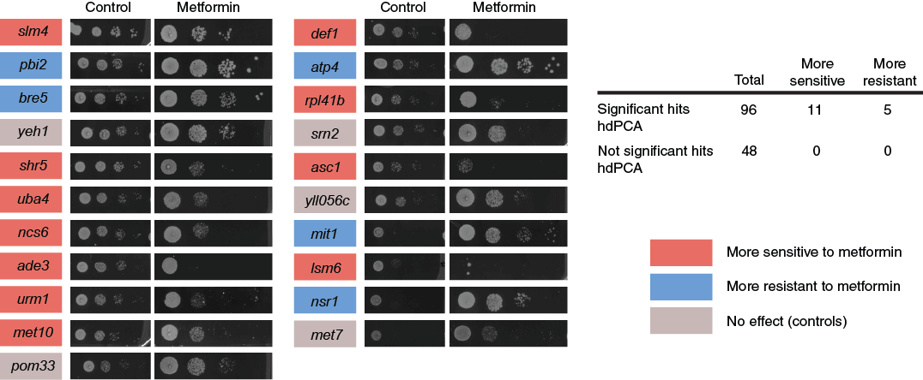
Figure S1. A deletion miniscreen confirms contribution of significant hits from the metformin hdPCA in metformin resistance. Significant hits from the metformin hdPCA screen were tested for their involvement in metformin sensitivity by testing their growth in the presence of the drug. 96 deletion strains from significant hits were tested together with 48 negative control strains. No strains from the negative control set were affecting metformin sensitivity. Pictures for the control condition were taken after 2 days, for metformin after 5 days.
Figure S2. Metformin hdPCA data on proteins involved in TOR signaling (A) and proteins involved in DNA repair (B).
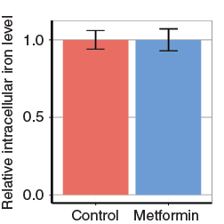
Figure S3. Intracellular iron content of yeast cultures in exponential growth phase (O.D.₆₀₀ = 1) after treatment with metformin, relative to the control condition.

