Supplement

Fig. S1. Engagement of the executive control network is associated with two distinct routes of shifts in large-scale neurodynamics.
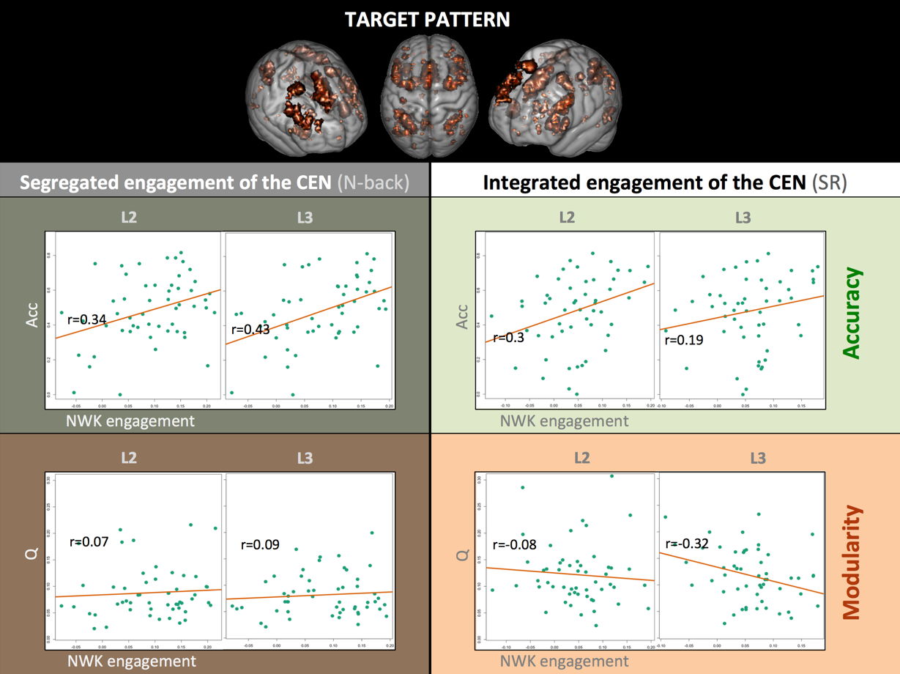
L2,3 = difficulty loads: 2-back and 3-back / reasoning-B and reasoning-C.

Fig. S2. Distinct directions of load-dependent modularity shifts in n-back and reasoning tasks in a representative (high performing) subject.
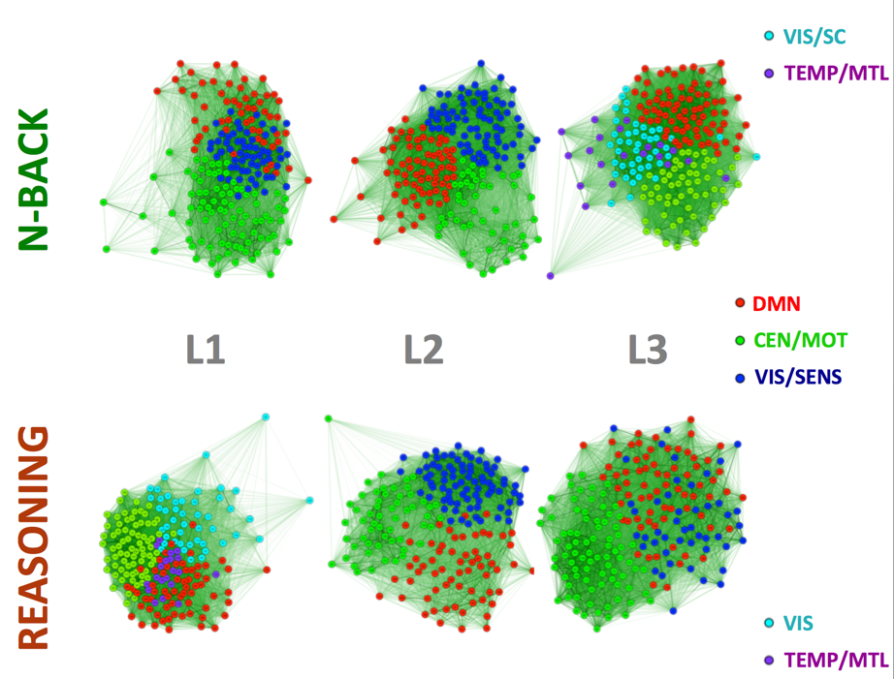
Large-scale brain dynamics exhibit two distinct paths of shifts as a function of load: 1) segregation of the CEN (n-back) and 2) expansion of the CEN and enhanced cross-talk between the DMN and visual community (reasoning). DMN = default mode network; CEN =central executive; MOT =motor; VIS = visual; AUD = auditory; SENS = sensory; SC = subcortical.

