Supplementary Information:

# Circulating small non-coding RNAs associated with age, sex, smoking, body mass and physical activity

Figure S1: Heatmaps of the hierarchical clustering of -log10 p-values after adjusting for age. The p-values were adjusted for multiple testing from the associations between sncRNAs from the classes miRNAs, isomiRs, tRNAs, tRNA fragments, piRNAs, lncRNAs, miscRNAs, snRNAs and mRNA fragments and the attributes blood donor group (BDg), sex, body mass, smoking (current vs never smokers) and physical activity (low vs high activity). sncRNAs are visualized if any of the associations produced p-values <0.01. Colors are yellow to orange for -log10 p-value 0 to 5 and red for -log10 p-values > 6.

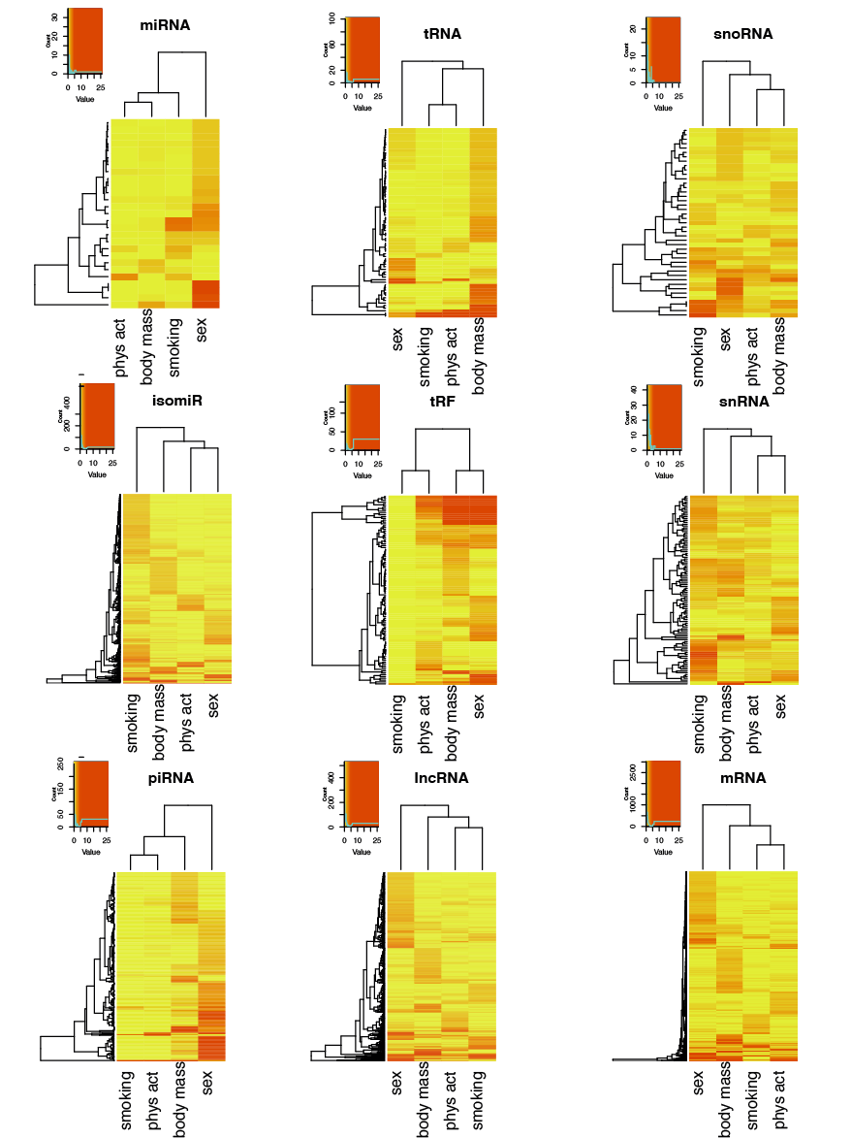

Figure S2: Volcano plots showing differential expression in log2fold change on the x-axis and adjusted p-values from the associations in -log10 on the y-axis. The analyses were adjusted for age. Associations with miRNAs, isomiRs, tRNAs, tRNA fragments, piRNAs, lncRNAs, miscRNAs, snRNAs and fragments mapping mRNA and the traits; blood donor group (BDg), sex, body mass smoking (current vs never smokers) and physical activity (low vs high activity) are shown.

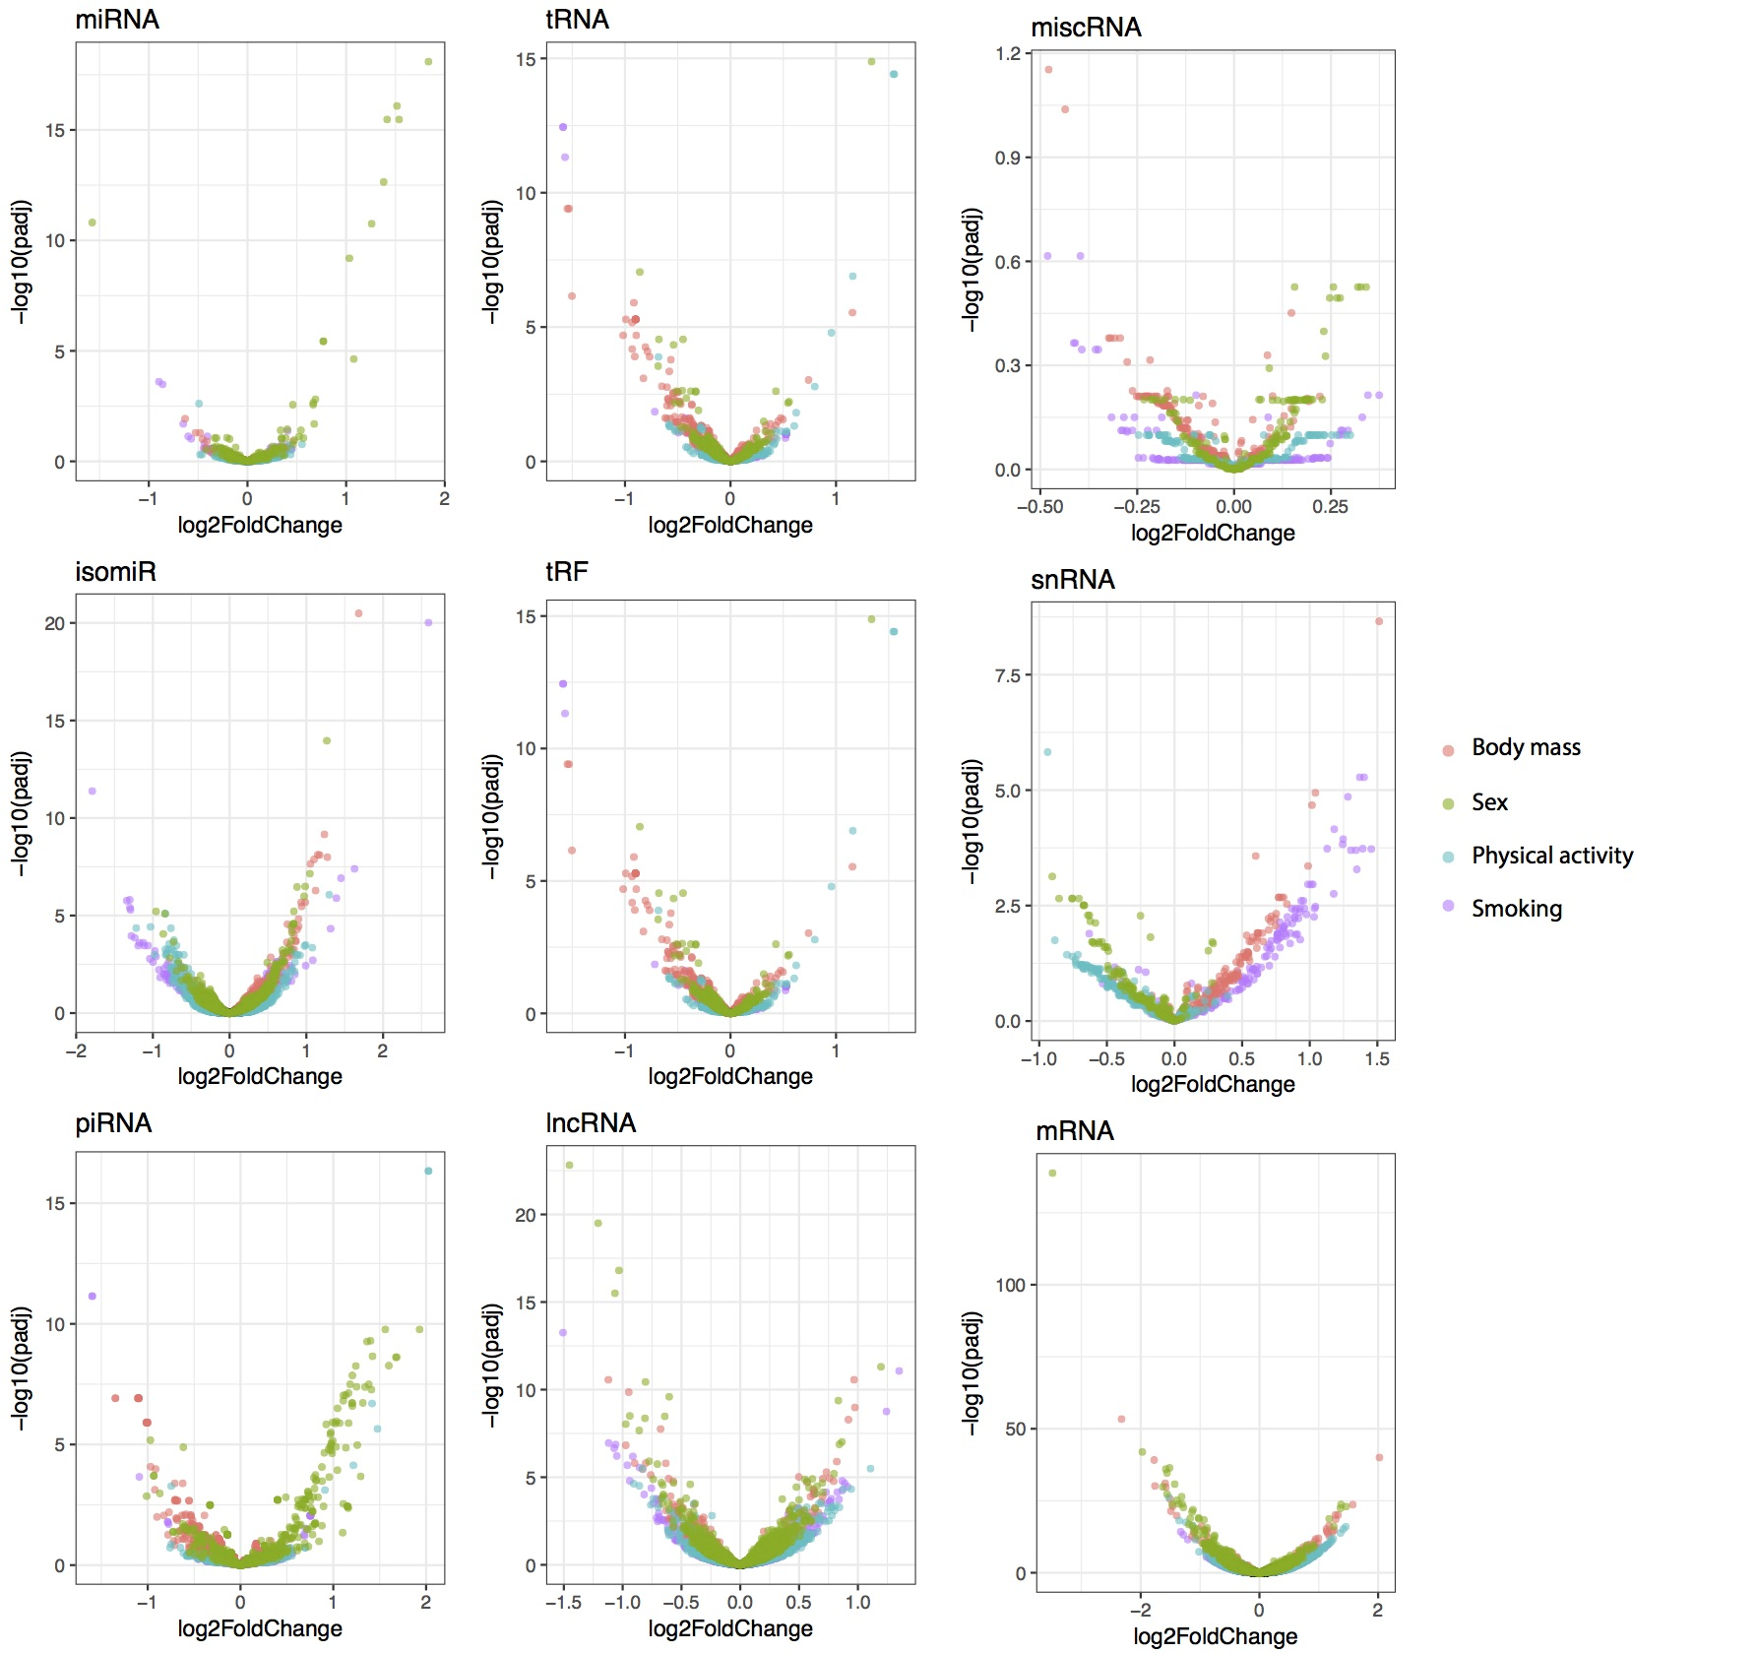

Figure S3: Weighted correlation network analysis (WGCNA) to determine co-expression modules among serum RNAs.

/Users/trro/Documents/prosjekter/sncRNA_Janus/doc/manus/sncRNA_environ/Nat_Com/Supplementary/FigS3_module_analyses_plot_new_version.pdf