Supplementary figures
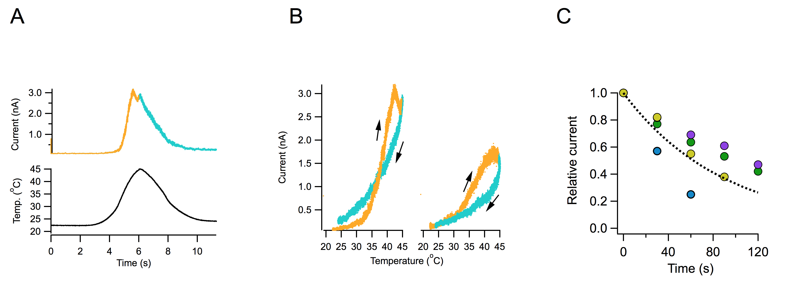
Figure Supplement 1. Hysteresis is present and identical in longer temperature ramps. (A) Temperature ramps lasting 8 seconds elicit currents that show asymmetric up and down components (upper panel). (B) The temperature-dependence of the activation and deactivation of TRPV1 in longer ramps is identical to that observed in shorter ramps and the loss of current is present with subsequent application of activation ramps. (C) The decay of current with each activation ramp from 4 inside-out patches is fitted to an exponential function with a time constant of 90 s.
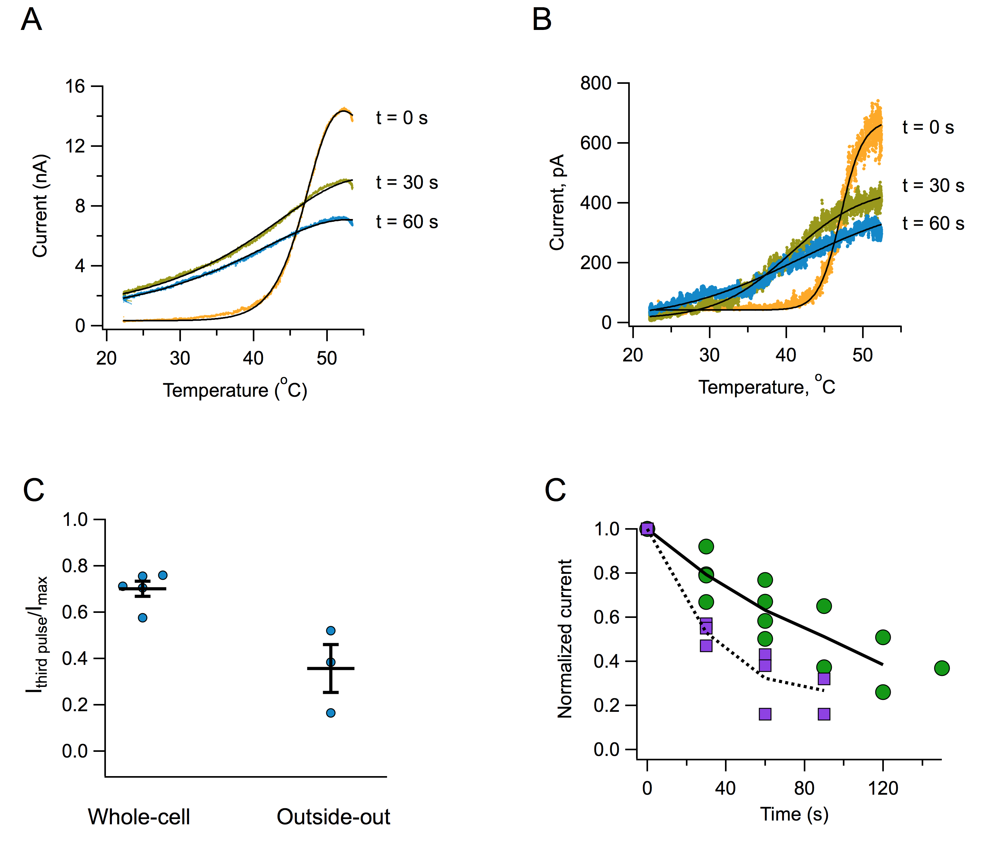
Figure Supplement 2. Current loss with repetitive stimulation is observed in whole-cell and outside-our recordings. (A) Whole-cell recoding form a HEK293 cell. Inactivation of the current is obvious as is the reduced steepness of the response to a second and third temperature ramp. Interval between ramps is 30 s. (B) Temperature-activated TRPV1 currents recorded in the outside-out configuration. As is the case in whole-cell and inside-out recordings, current loss remains with consecutive activations. Interval between ramps is 30 s. (C) Fractional reduction of current between the first and third activation ramp, for whole-cell and outside-out recordings. (D) Time course of current decay for cells in whole–cell recording mode (green circles, n=4) and outside-out mode (purple squares, n=3). The continuous and dotted black curves are the mean for whole-cell and outside-out, respectively.
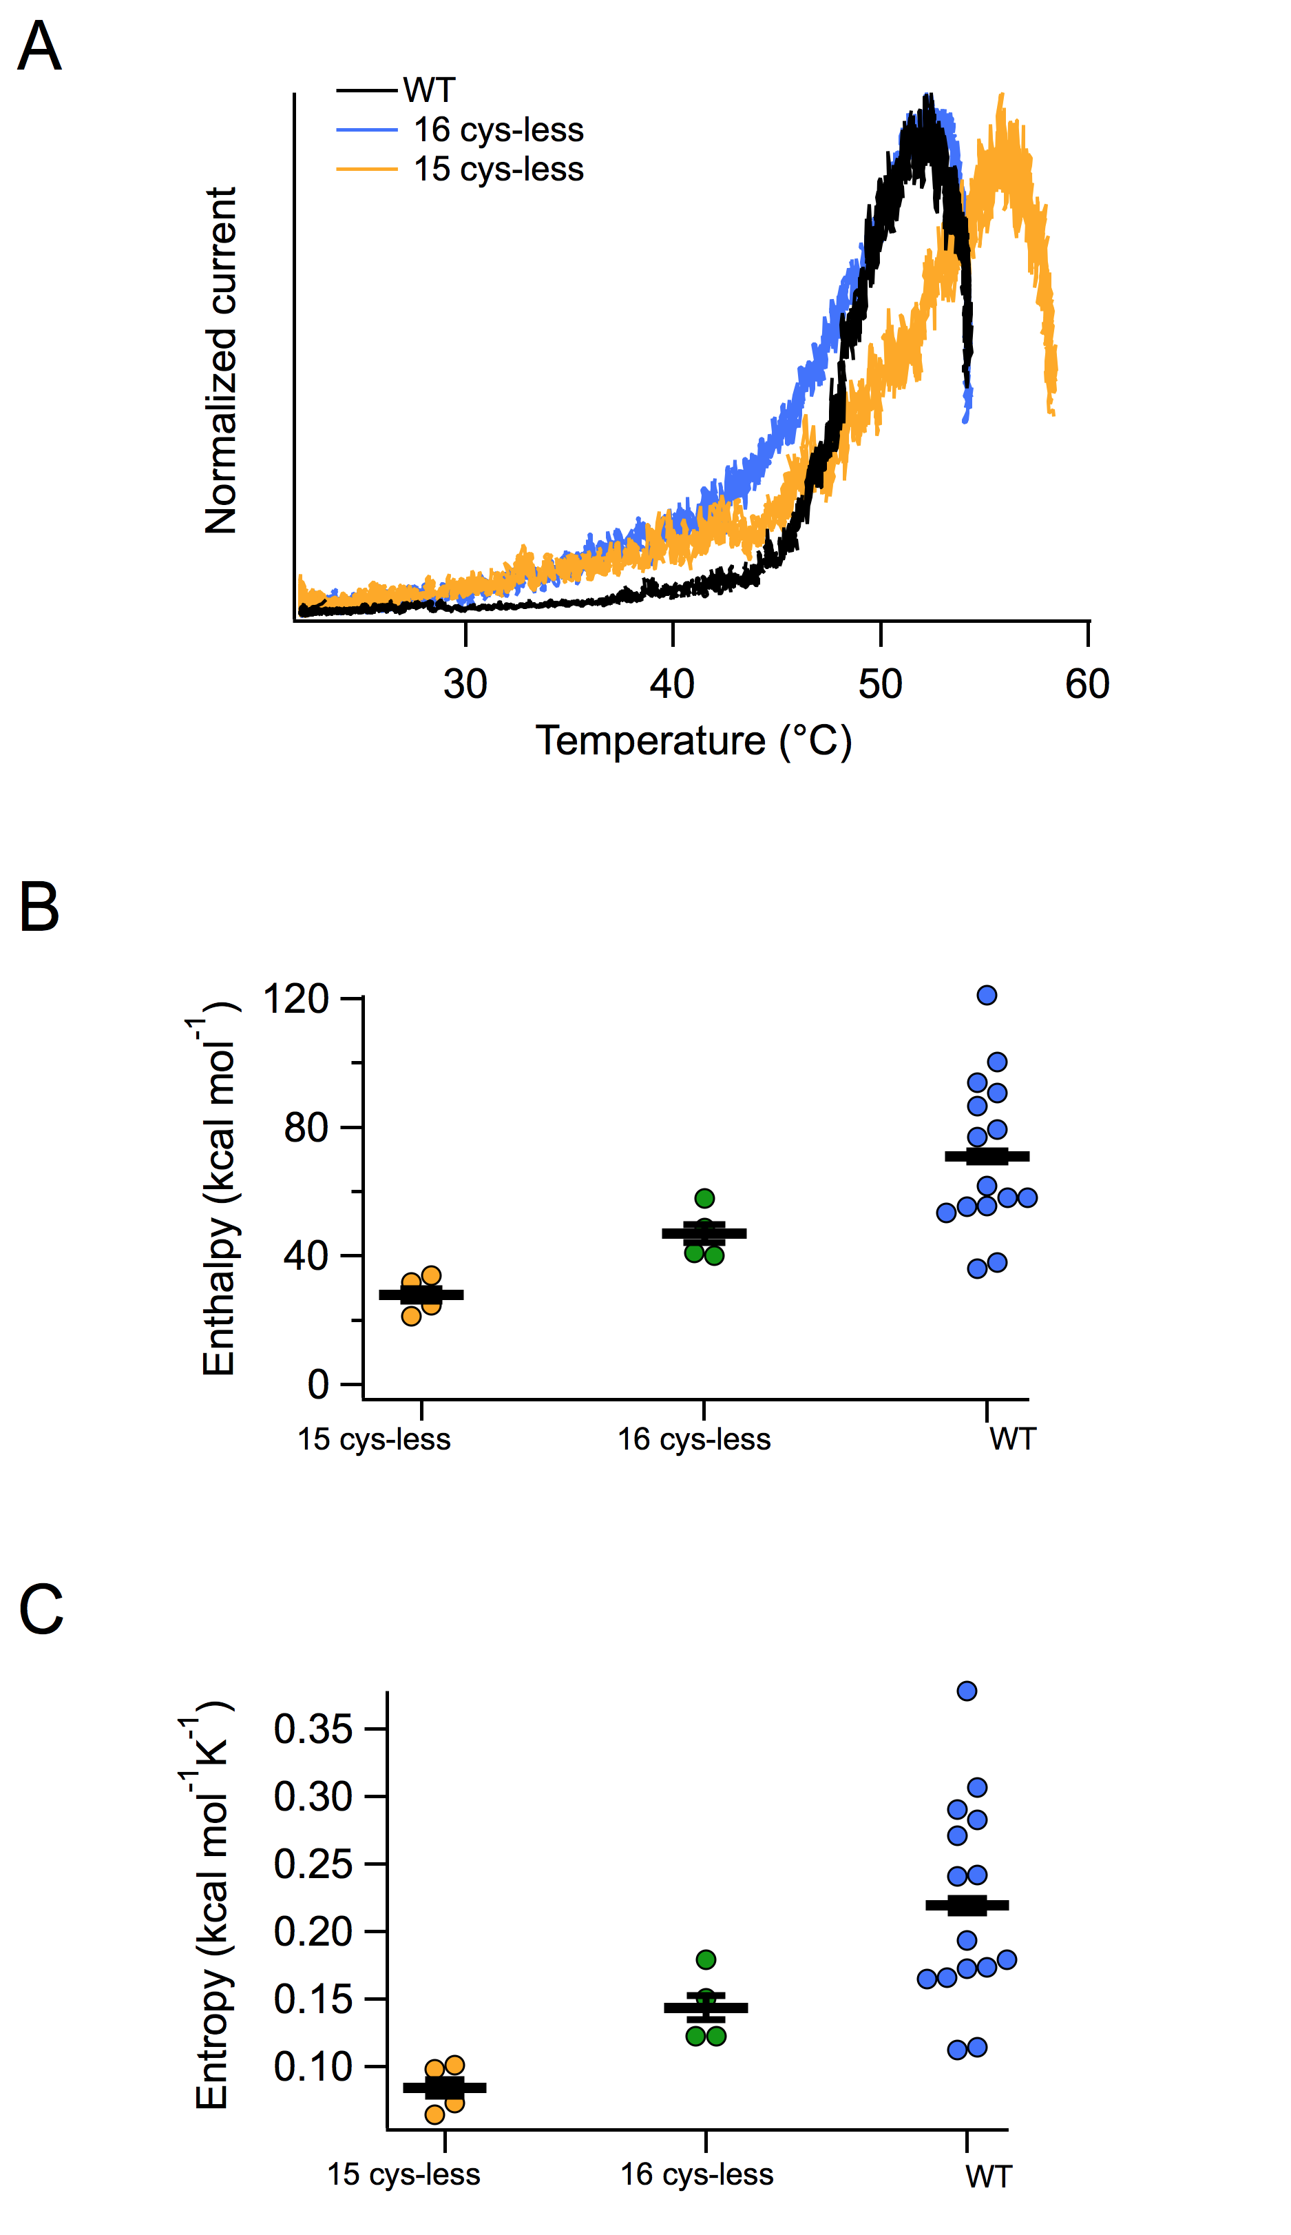
Figure Supplement 6. Cysteines are not necessary for heat activation, but modulate the threshold and steepness of activation. (A) Representative normalized currents in response to temperature ramps for the WT TRPV1, 15cys-less TRPV1 and 16cys-less TRPV1 channels. (B) Enthalpy of activation calculated from fits to the allosteric model (Figure 4a) for the three channels. (C) Entropy of activation calculated from fits to the allosteric model.

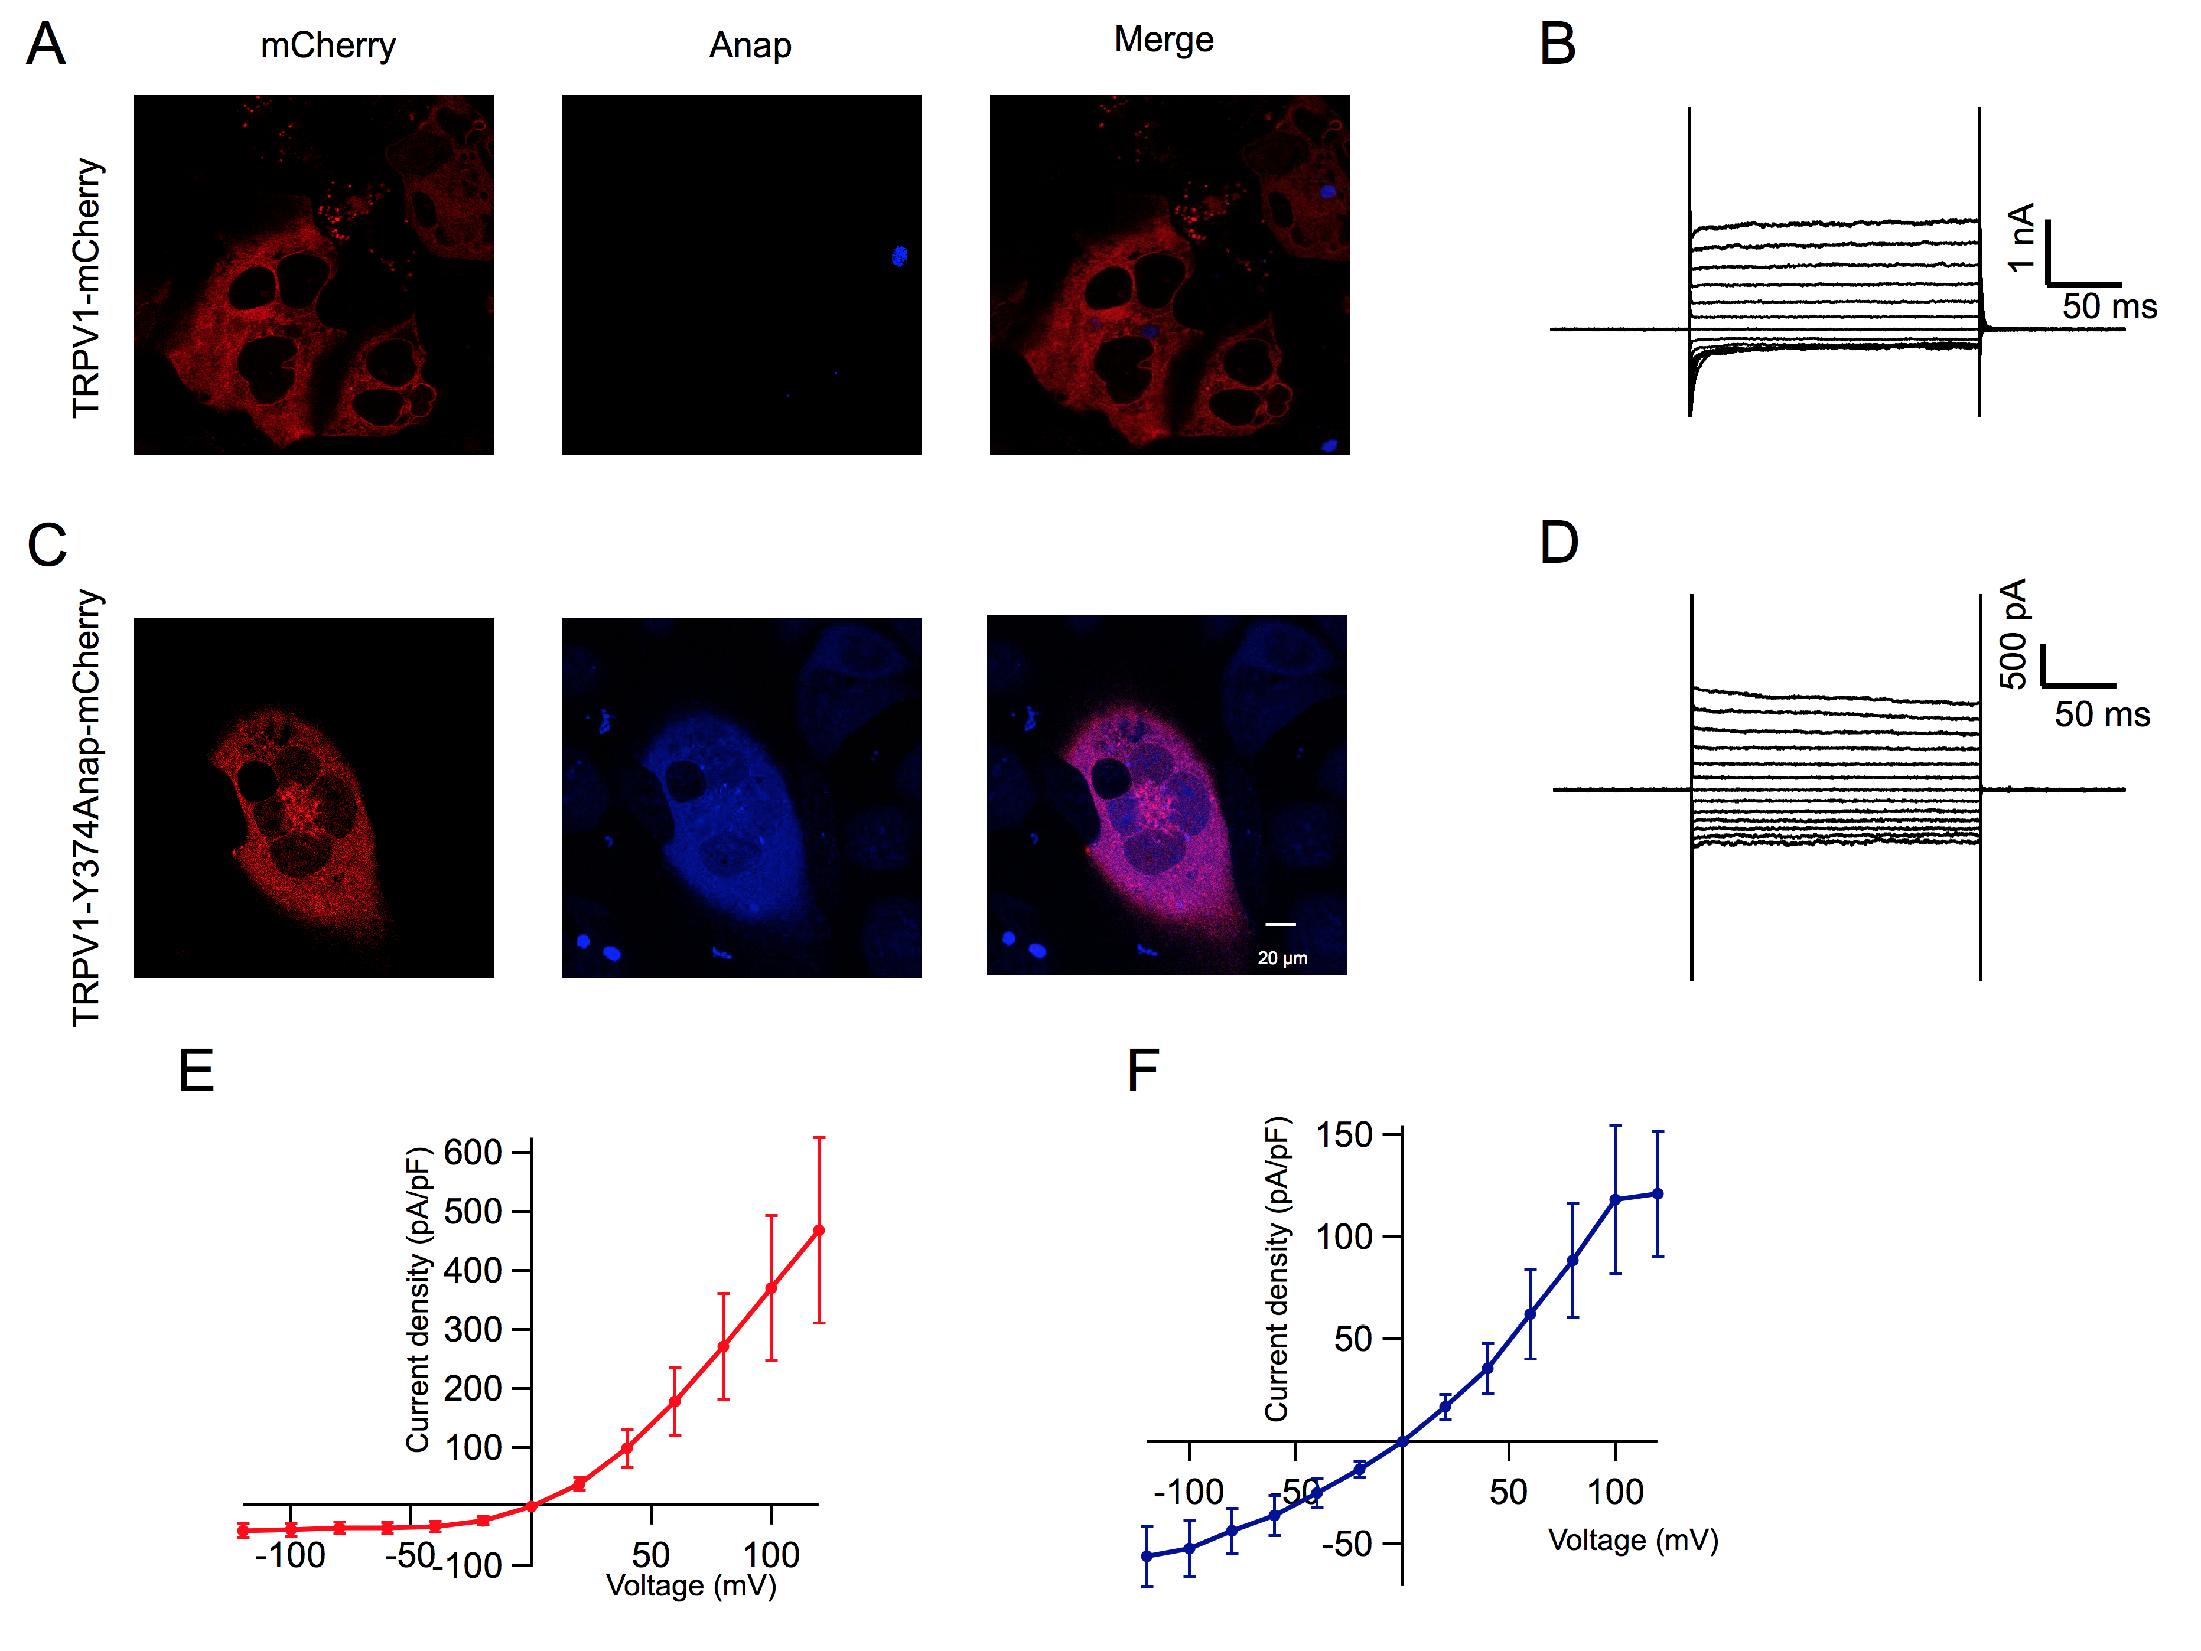
Figure Supplement 7. Incorporation of ANAP into TRPV1 374TAG-mCherry results in capsaicin-sensitive channels. (A) Confocal imaging of HEK293 cells expressing rTRPV1-mCherry in the presence of L-ANAP. No colocalized ANAP/ mCherry fluorescence is detectable. (B) Confocal imaging of HEK293 cells expressing rTRPV1-374ANAP-mCherry channels in the presence of L-ANAP. Note that the ANAP and mCherry signals do colocalize. (C) Whole-cell recording of currents evoked by 4 M capsaicin application to a cell expressing rTRPV1-mCherry (D) Whole-cell recording of currents evoked by 4 M capsaicin application to a cell expressing rTRPV1-374ANAP-mCherry. (E) Mean capsacicin-activated current density vs. voltage curve from 8 cells expressing rTRPV1-mCherry channels recorded in whole-cell mode. (F) Mean capsacicin-activated current density vs. voltage curve from 8 cells expressing rTRPV1-374ANAP-mCherry channels recorded in whole-cell mode. The leak currents before application of 4 M capsaicin have been subtracted in all records. Error bars are s.e.m.

