Appendix S1: additional information methodologies

Methodologies

Aerial dispersal assay

To evaluate the effect of metapopulation context on the rearing dispersal behaviour, mated females were transferred to test arenas for trials of aerial dispersal after one whole generation on bean to minimise maternal effects. The same setup as used by (Li & Margolies 1993; Li & Margolies 1994) was applied. The test arenas consisted of 1cm² black painted plastic discs located on soaked cotton dishes in order to avoid escape of the mites. Mites of the three treatments were placed on one cm² disc and test arenas were provided with an upward (30°) wind current of 1.5 m/s (produced by a fan) and a strong light source (990 lumen) at the source of the air current. As mites perform rearing behaviour before entering the air column, we were able to count and select the number of mites performing this behaviour (for at least 5 seconds) in the subsequent 3 hours. Mites that showed this behaviour were immediately removed in order to avoid double records. We simultaneously tested mites originating from metapopulations with the three treatments.

Physiological trait assays

Due to the extremely low mass of a single mite, 50 one-day-old females were pooled together for each sample, and all samples were snap-frozen at -80°C immediately after mite collection. Fresh mass of the pools was measured using a microbalance accurate to 0.01mg. The concentrations of triglycerids (TGs), glucose and trehalose were measured following the protocol of Laparie et al. (2012). Samples were homogenised in 300 µl of methanol-chloroform solution (2:1, v:v for sugars; 1:2, v:v for TGs) with a bead-beating apparatus (Retsch MM301, Retsch GmbH, Germany) for 60 s at 30/s frequency. For sugars, 200 µL of ultrapure water was added to each sample, further vortexed and centrifuged at 8000g for 10 min at 4°C. 300 µL of the upper aqueous phase containing the sugars were transferred to microtubes, and dissolved in 200 µL of ultrapure water before analysis. For TGs, samples were stored at -20°C for 12 h after the homogenization with the bead-beating. Then, 60 µL of KCl (2g/L) were added, and the samples were incubated for 5 min at 40 °C. One hundred and 50 µL of the lower phase (containing lipids in chloroform) were transferred to microtubes and dried at 30°C under a nitrogen stream. Eventually the residual lipids were dissolved in 100 µL of Triton X 100 solution (0.2%) and delipidated BSA (3%). Finally samples were vortexed and incubated for 10 min at 60°C before metabolic assays. Spectrophotometric assay kits (K-TREH, Megazyme International Ireland Ltd. and Triglyceride assay kit, Cayman Chemical Company, Ann Arbor, MI, USA) were used to measure glucose, trehalose, and triglycerides. Manufacturer's protocol was followed.

Micro-array set-up,differential gene-expression, Blast2GO and Gene Set analysis

Mites of all three treatments underwent two whole generations under identical conditions (common garden) before sampling for transcriptome analysis. Of every independent biological replication, a sample was collected. RNA samples were extracted from 50 pooled one-to-two day old female mites using the RNeasy mini kit (Qiagen). The quality and quantity of the RNA were assessed by a NanoDrop ND-1000 spectrophotometer (NanoDrop Technologies) and by running an aliquot on a 1% agarose gel. RNA was labelled as previously described (Dermauw et al. 2013). RNA samples of SPA and TEM were labelled with cy5, while the three HOM samples with cy3. Hybridization of cRNA samples was performed as previously described (Dermauw et al. 2013). On every array, a cy3-labelled HOM sample was mixed with either a cy5-labelled SPA or TEM sample. Slides were scanned with an Agilent Microarray High-Resolution Scanner and extracted with Agilent Feature Extraction software using the GE2_107_Sep09 protocol. The microarray data have been deposited in the Gene Expression Omnibus (GEO) (accession number: GSE55623). Data was then processed and analysed in limma (Smyth 2005). Background intensities were corrected by the “normexp”-method using an offset of 50 (Ritchie et al. 2007). A within- and between-array normalisation (“loess”- and “Aquantile”-method, respectively) was subsequently performed. In the linear modelling of the data, intra-spot correlations were incorporated (Smyth & Altman, 2013). Significant differentially expressed genes were identified by an empirical Bayes approach with cut-offs of the Benjamin-Hochberg corrected p-values and log₂-converted FC at 0.05 and 0.585, respectively. For the hierarchical clustering analysis, data of Bryon et al. (2013) and Zhurov et al. (2014) were incorporated. Here, the non-connected design on which the linear model was fitted compared our data and the same LS-VL strain in cold conditions (17°C, 60%RH) to a common reference T. urticae strain (London) on bean at standard laboratory conditions (25°C, 60% RH). The obtained data was subsequently hierarchically clustered (Euclidean, ward) using the pvclust package (Suzuki & Shimodaira 2006).

Assignment of GO-terms to the differentially expressed genes and the full genome of T. urticae was executed using Blast2GO software v.2.6.6 (Conesa et al. 2005). An E-value cut off of 1e⁻¹⁵ was used for BLAST analysis. Annotation was performed with a cut off of 1e⁻¹⁵ and updated using InterPro. Gene Set Analysis was executed using the Bioconductor package piano (Parametric Analysis of Gene set Enrichment) to identify significant up- and down-regulation of Biological Process GO-terms in the transcriptomic comparisons (SPA vs HOM and TEM vs HOM) (Varemo et al., 2013). The input statistics were obtained from the linear model used to detect significant differential gene-expression.

References
Bryon A, Wybouw N, Dermauw W, Tirry L & Van Leeuwen T (2013) Genome wide gene-expression analysis of facultative reproductive diapause in the two-spotted spider mite Tetranychus urticae. BMC genomics, 14, 815.
Dermauw W, Wybouw N, Rombauts S, Menten B, Vontas J, Grbic M et al. (2013) A link between host plant adaptation and pesticide resistance in the polyphagous spider mite Tetranychus urticae. Proceedings of the National Academy of Sciences of the United States of America, 110, E113-E122.
Laparie M, Larvor V, Frenot Y & Renault D (2012) Starvation resistance and effects of diet on energy reserves in a predatory ground beetle (Merizodus soledadinus; Carabidae) invading the Kerguelen Islands. Comparative Biochemistry and Physiology A, 161, 122-129.
Li J & Margolies DC (1993) Quantitative genetics of aerial dispersal behavior and life-history traits in Tetranychus urticae. Heredity, 70, 544-552.
Li JB & Margolies DC (1994) Responses to direct and indirect selection on aerial dispersal behavior in Tetranychus urticae. Heredity, 72, 10-22.
Ritchie ME, Silver J, Oshlack A, Holmes M, Diyagama D, Holloway A & Smyth GK (2007) A comparison of background correction methods for two-colour microarrays. Bioinformatics, 23, 2700-2707.
Smyth GK (2005) limma: Linear models for microarray data. Bioinformatics and computational biology solutions using R and Bioconductor Statistics for biology and health, Springer New York, pp 397-420.
Smyth GK & Altman NS (2013) Separate-channel analysis of two-channel microarrays: recovering inter-spot information. BMC bioinformatics, 14, 165.
Suzuki R & Shimodaira H (2006) Pvclust: an R package for assessing the uncertainty in hierarchical clustering. Bioinformatics, 22, 1540-1542.
Väremo L., Nielsen J. & Nookaew, I. 2013. Enriching the gene set analysis of genome-wide data by incorporating directionality of gene expression and combining statistical hypotheses and methods. Nucleic acids research 41 (8): 4378-4391.
Zhurov V, Navarro M, Bruinsma KA, Arbona V, Santamaria ME, Cazaux M et al. (2014) Reciprocal responses in the interaction between Arabidopsis and the cell-content-feeding chelicerate herbivore spider mite. Plant Physiology, 164, 384-399.

Appendix S2: Trait variation at the start of the experiment
Mite from the base population lay on average 6.9368 ± 0.3132SE eggs per day. After 7 days their total fecundity was 36.2640 ± 3.3226SE eggs. A clutch contained on average 0.3225 ± 0.0806SE % males. 85.4629 ± 2.7823SE % of juveniles survived until adulthood. Mites developed in 8.6753 ± 0.0358SE days and had longevity of 10.1 ± 0.1599SE days.
Table S1
Corresponding GO category labels of the GO-IDs presented in Fig. 5.
GO-ID | GO-label
GO:0003333 | amino acid transmembrane transport
GO:0005975 | carbohydrate metabolic process
GO:0006094 | gluconeogenesis
GO:0006108 | malate metabolic process
GO:0006629 | lipid metabolic process
GO:0006665 | sphingolipid metabolic process
GO:0006754 | ATP biosynthetic process
GO:0007040 | lysosome organization
GO:0008152 | metabolic process
GO:0009086 | methionine biosynthetic process
GO:0009987 | cellular process
GO:0015810 | aspartate transport
GO:0015813 | L-glutamate transport
GO:0019369 | arachidonic acid metabolic process
GO:0030259 | lipid glycosylation
GO:0043490 | malate-aspartate shuttle
GO:0044262 | cellular carbohydrate metabolic process
GO:0046331 | lateral inhibition
GO:0051592 | response to calcium ion
GO:0060271 | cilium morphogenesis

Figure S1. Expression heatmap depicting the expression levels of the three biological lines within the TEM and SPA selection treatments, relative to the HOM reference. Fold changes were log₂ transformed. Genes were clustering using Euclidean distance (ward-method).
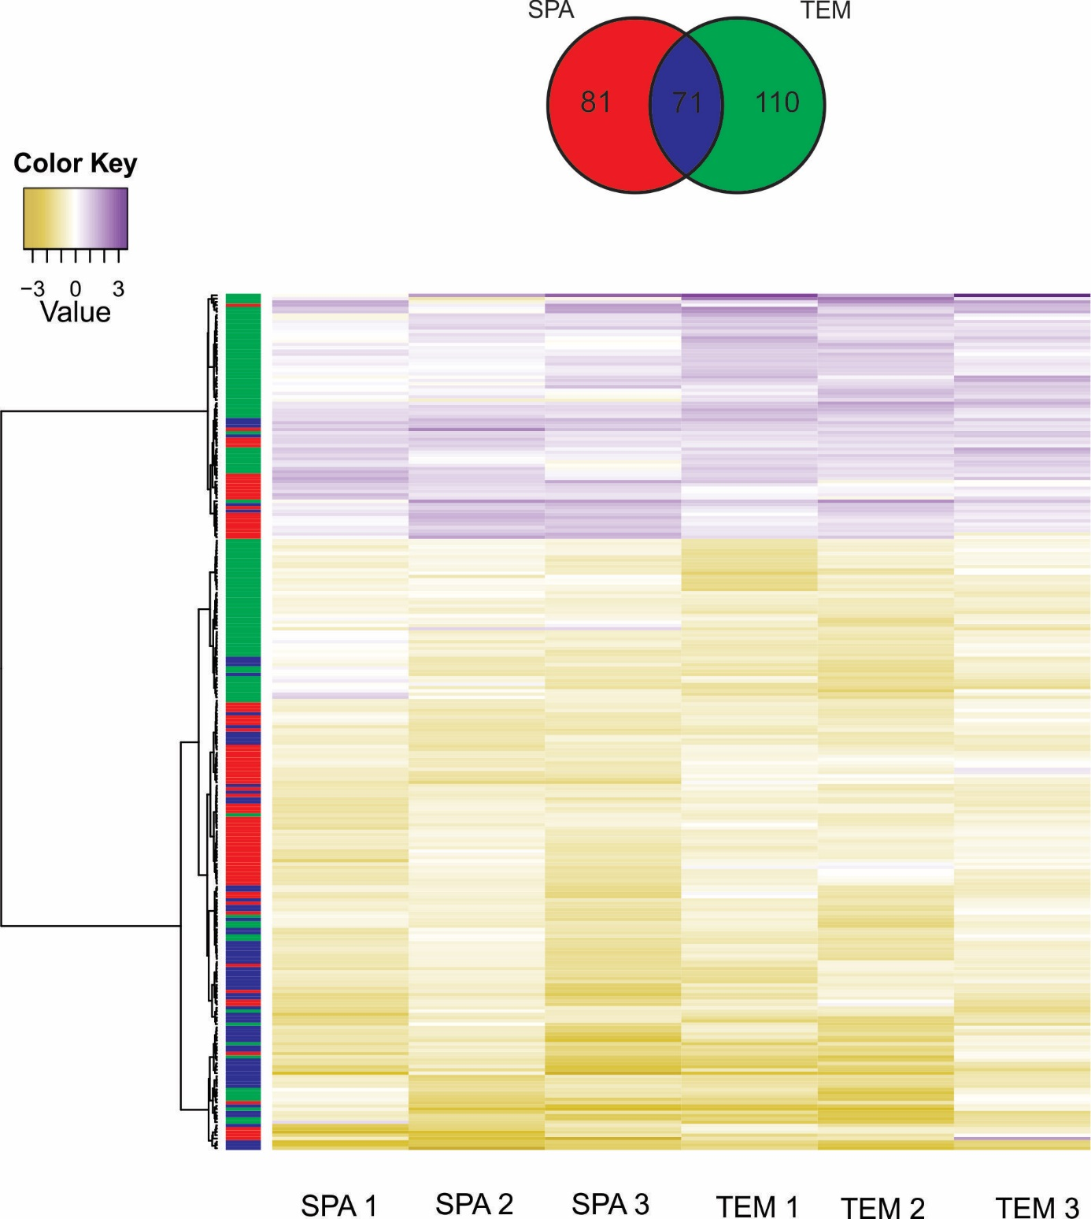

Figure S2. Overview of the differentially expressed genes in the TEM (red) and SPA (orange) lines, relative to HOM, encoding proteins of the citric acid cycle, glycolysis and gluconeogenesis. The reaction catalysed by the phosphoglucose isomerise enzyme is indicated by PGI. Mitochondrial localization is depicted by a grey background. The citric acid pathway is indicated by a dotted black line.
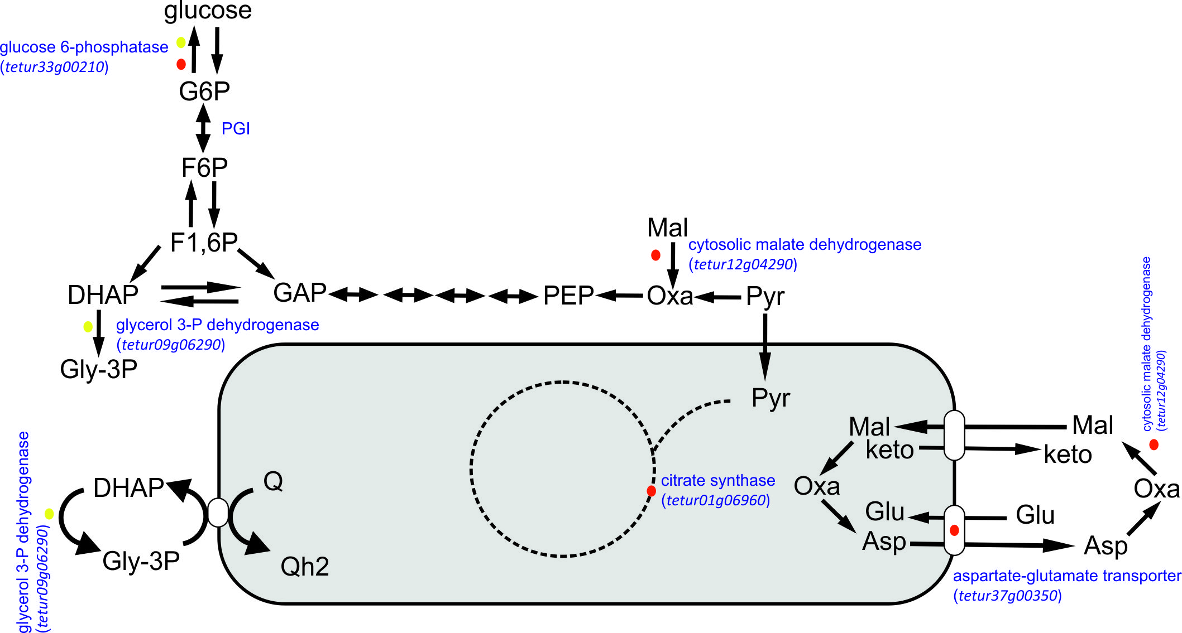

Figure S3. Overview of the differentially expressed genes encoding for proteins of the methionine synthesis pathway through one carbon metabolism in the TEM (red) and SPA (orange) lines, relative to HOM. Tetur16g00990 is a laterally acquired bacterial gene in the spider mite genome.
