Appendix

Appendix A: TWAS and the LDA-MR

If $σ_{G,j}^{*}=v$ for all SNPs, the TWAS and LDA-MR will be proportional to each other by a constant. Recall that:
$$Z_{TWAS}=\frac{{\hat{β}}_{E}^{*T}Σ^{-1}Z_{G}^{*}}{\sqrt{{\hat{β}}_{E}^{*T}Σ^{-1}{\hat{β}}_{E}^{*}}}.$$
If $σ_{G,j}^{*}=v$, then $Z_{G}^{*}={\hat{β}}_{G}^{*}/v$. Also, recall ${\hat{β}}_{E}=Σ^{-1}{\hat{β}}_{E}^{*}$ and ${\hat{β}}_{G}=Σ^{-1}{\hat{β}}_{G}^{*}$, we then have:
$$\frac{{\hat{β}}_{E}^{*T}Σ^{-1}Z_{G}^{*}}{\sqrt{{\hat{β}}_{E}^{*T}Σ^{-1}{\hat{β}}_{E}^{*}}}=\frac{{\hat{β}}_{E}^{*T}Σ^{-1}{\hat{β}}_{G}^{*}v^{-1}}{\sqrt{{\hat{β}}_{E}^{*T}Σ^{-1}{\hat{β}}_{E}^{*}}}*\frac{v^{-1}}{v^{-1}}=\frac{{\hat{β}}_{E}^{*T}Σ^{-1}v^{-2}{\hat{β}}_{G}^{*}}{\sqrt{{\hat{β}}_{E}^{*T}Σ^{-1}v^{-2}{\hat{β}}_{E}^{*}}}$$
Recall that $Σ^{-1}v^{2}=Σ_{G}$ when all the marginal variances are the same and therefore $Σ_{G}^{-1}=Σv^{-2}$.
$$=\frac{{\hat{β}}_{E}^{T}v^{-2}{\hat{β}}_{G}^{*}}{\sqrt{{\hat{β}}_{E}^{T}v^{-2}{\hat{β}}_{E}^{*}}}=\frac{{\hat{β}}_{E}^{T}v^{-2}ΣΣ^{-1}{\hat{β}}_{G}^{*}}{\sqrt{{\hat{β}}_{E}^{T}v^{-2}ΣΣ^{-1}{\hat{β}}_{E}^{*}}}=\frac{{\hat{β}}_{E}^{T}Σ_{G}^{-1}{\hat{β}}_{G}}{\sqrt{{\hat{β}}_{E}^{T}Σ_{G}^{-1}{\hat{β}}_{E}}}=Z_{LDMR}*{\hat{σ}}_{LDMR}$$

The desired result.
Appendix B: Convergence of the LDA MR-Egger Parameters.

Recall from the document that the parameters converge to ($W=Σ_{G}^{-1}$).

$$\left[\begin{matrix}\hat{α} \\ {\hat{γ}}^{*}\end{matrix}\right]={\left(\left[\begin{matrix}1_{J}^{T}W1_{J} & 1_{J}^{T}W{\hat{β}}_{E} \\ {\hat{β}}_{E}^{T}W1_{J} & {\hat{β}}_{E}^{T}W{\hat{β}}_{E}\end{matrix}\right] \right)}^{-1}\left[\begin{matrix}1_{J}^{T}W \\ {\hat{β}}_{E}^{T}W\end{matrix}\right]{\hat{β}}_{G},$$
$${\hat{γ}}^{*}=\frac{\left(\left(1_{J}^{T}W1_{J}\right){\hat{β}}_{E}^{T}W-\left(1_{J}^{T}W{\hat{β}}_{E}\right)1_{J}^{T}W\right){\hat{β}}_{G}}{\left(1_{J}^{T}W1_{J}\right)\left({\hat{β}}_{E}^{T}W{\hat{β}}_{E}\right)-{\left(1_{J}^{T}W{\hat{β}}_{E}\right)}^{2}}$$
Recall that:
$$E\left({\hat{β}}_{G}|{\hat{β}}_{E}\right)=θ+β_{E}γ$$

The expected value of our γ estimate is:

$$E\left({\hat{γ}}^{*} | {\hat{β}}_{E}\right)=γ\frac{\left(1_{J}^{T}W1_{J}\right){\hat{β}}_{E}^{T}Wβ_{E}-\left(1_{J}^{T}W{\hat{β}}_{E}\right)1_{J}^{T}Wβ_{E} }{\left(1_{J}^{T}W1_{J}\right)\left({\hat{β}}_{E}^{T}W{\hat{β}}_{E}\right)-{\left(1_{J}^{T}W{\hat{β}}_{E}\right)}^{2}}+\frac{\left(1_{J}^{T}W1_{J}\right){\hat{β}}_{E}^{T}Wθ-\left(1_{J}^{T}W{\hat{β}}_{E}\right)1_{J}^{T}Wθ }{\left(1_{J}^{T}W1_{J}\right)\left({\hat{β}}_{E}^{T}W{\hat{β}}_{E}\right)-{\left(1_{J}^{T}W{\hat{β}}_{E}\right)}^{2}}$$

The first term will go to $γ$ as N_{E} (the sample size used to estimate ${\hat{β}}_{E}$) increases. Therefore, as N_{E} →∞, ${\hat{β}}_{E}$→β_{E}. Assume that N_{E} is sufficiently large to reach this convergence boundary. We then have:
$$E\left({\hat{γ}}^{*} | {\hat{β}}_{E}\right)≈γ+\frac{\left(1_{J}^{T}W1_{J}\right){\hat{β}}_{E}^{T}Wθ-\left(1_{J}^{T}W{\hat{β}}_{E}\right)1_{J}^{T}Wθ }{\left(1_{J}^{T}W1_{J}\right)\left({\hat{β}}_{E}^{T}W{\hat{β}}_{E}\right)-{\left(1_{J}^{T}W{\hat{β}}_{E}\right)}^{2}}$$
Focusing on the second term, it can be rewritten as
$$\frac{\left(1_{J}^{T}W1_{J}\right){\hat{β}}_{E}^{T}Wθ-\left(1_{J}^{T}W{\hat{β}}_{E}\right)1_{J}^{T}Wθ }{\left(1_{J}^{T}W1_{J}\right)\left({\hat{β}}_{E}^{T}W{\hat{β}}_{E}\right)-{\left(1_{J}^{T}W{\hat{β}}_{E}\right)}^{2}}=\frac{\left(1_{J}^{T}W1_{J}\right){\hat{β}}_{E}^{T}Wθ-\left({\hat{β}}_{E}^{T}W1_{J}\right)1_{J}^{T}Wθ }{\left(1_{J}^{T}W1_{J}\right)\left({\hat{β}}_{E}^{T}W{\hat{β}}_{E}\right)-{\left(1_{J}^{T}W{\hat{β}}_{E}\right)}^{2}}$$
The numerator is the sample univariate covariance between $θ$ and ${\hat{β}}_{E}$ weighted by W, times ${\left(1_{J}^{T}W1_{J}\right)}^{2}.$ We’ll treat that as a constant. The denominator is the sample univariate variance of ${\hat{β}}_{E}$ weighted by W times ${\left(1_{J}^{T}W1_{J}\right)}^{2}$. If $θ$ is independent of ${\hat{β}}_{E}$ and the mean of $θ$ is a constant - the term will go to 0 as J_{EFF}→∞. J_{EFF} denotes the effective number of SNPs at the loci. We will take the expectation of the numerator conditional on ${\hat{β}}_{E}$:

$$E_{θ}\left(\left(1_{J}^{T}W1_{J}\right){\hat{β}}_{E}^{T}Wθ-\left({\hat{β}}_{E}^{T}W1_{J}\right)1_{J}^{T}Wθ | {\hat{β}}_{E}\right)$$
$$=\left(1_{J}^{T}W1_{J}\right){\hat{β}}_{E}^{T}WE_{θ}\left(θ | {\hat{β}}_{E}\right)-\left({\hat{β}}_{E}^{T}W1_{J}\right)1_{J}^{T}WE_{θ}\left(θ | β_{E}\right)$$
If $θ$ is independent of ${\hat{β}}_{E},$ then $E_{θ}\left(θ | {\hat{β}}_{E}\right)=E_{θ}\left(θ\right)=μ_{θ}$ and if $μ_{θ}=c1_{J}$, the above reduces to:
$$\left(1_{J}^{T}W1_{J}\right)\left\{{\hat{β}}_{E}^{T}Wc1_{J}\right\}-\left({\hat{β}}_{E}^{T}W1_{J}\right)1_{J}^{T}Wc1_{J}$$
$$=c\left(1_{J}^{T}W1_{J}\right)\left({\hat{β}}_{E}^{T}W1_{J}-{\hat{β}}_{E}^{T}W1_{J}\right)=0$$

The above results taken together gives us:
$$E\left({\hat{γ}}^{*}\right)→γ as N_{E}→∞ and J→∞$$
Our estimate of the intercept from the LDA-MR Egger regressions is:
$$\hat{α}=\frac{\left(\left({\hat{β}}_{E}^{T}W{\hat{β}}_{E}\right)1_{J}^{T}W-\left(1_{J}^{T}W{\hat{β}}_{E}\right){\hat{β}}_{E}^{T}W\right){\hat{β}}_{G}}{\left(1_{J}^{T}W1_{J}\right)\left({\hat{β}}_{E}^{T}W{\hat{β}}_{E}\right)-{\left(1_{J}^{T}W{\hat{β}}_{E}\right)}^{2}}$$
With expectation:
$$E\left(\hat{α} | {\hat{β}}_{E}\right)=γ\frac{\left({\hat{β}}_{E}^{T}W{\hat{β}}_{E}\right)1_{J}^{T}Wβ_{E}-\left(1_{J}^{T}W{\hat{β}}_{E}\right){\hat{β}}_{E}^{T}Wβ_{E}}{\left(1_{J}^{T}W1_{J}\right)\left({\hat{β}}_{E}^{T}W{\hat{β}}_{E}\right)-{\left(1_{J}^{T}W{\hat{β}}_{E}\right)}^{2}}+\frac{\left({\hat{β}}_{E}^{T}W{\hat{β}}_{E}\right)1_{J}^{T}Wθ-\left(1_{J}^{T}W{\hat{β}}_{E}\right){\hat{β}}_{E}^{T}Wθ}{\left(1_{J}^{T}W1_{J}\right)\left({\hat{β}}_{E}^{T}W{\hat{β}}_{E}\right)-{\left(1_{J}^{T}W{\hat{β}}_{E}\right)}^{2}}$$
As N_{E} goes to infinity, the first term will go to 0 as ${\hat{β}}_{E}→β_{E}$

$$E\left(\hat{α} | {\hat{β}}_{E}\right)≈\frac{\left({\hat{β}}_{E}^{T}W{\hat{β}}_{E}\right)1_{J}^{T}Wθ-\left(1_{J}^{T}W{\hat{β}}_{E}\right){\hat{β}}_{E}^{T}Wθ}{\left(1_{J}^{T}W1_{J}\right)\left({\hat{β}}_{E}^{T}W{\hat{β}}_{E}\right)-{\left(1_{J}^{T}W{\hat{β}}_{E}\right)}^{2}}$$
Rewriting this, if we have that $θ$ is independent of ${\hat{β}}_{E}$ and $μ_{θ}=1_{J}c$.
$$E_{θ}\left(E\left(\hat{α} | {\hat{β}}_{E}\right)|{\hat{β}}_{E}\right)≈\frac{\left({\hat{β}}_{E}^{T}W{\hat{β}}_{E}\right)1_{J}^{T}W1_{J}c-\left(1_{J}^{T}W{\hat{β}}_{E}\right){\hat{β}}_{E}^{T}W1_{J}c}{\left(1_{J}^{T}W1_{J}\right)\left({\hat{β}}_{E}^{T}W{\hat{β}}_{E}\right)-{\left(1_{J}^{T}W{\hat{β}}_{E}\right)}^{2}}=$$
$$c\frac{\left({\hat{β}}_{E}^{T}W{\hat{β}}_{E}\right)1_{J}^{T}W1_{J}-\left(1_{J}^{T}W{\hat{β}}_{E}\right){\hat{β}}_{E}^{T}W1_{j}}{\left(1_{J}^{T}W1_{J}\right)\left({\hat{β}}_{E}^{T}W{\hat{β}}_{E}\right)-{\left(1_{J}^{T}W{\hat{β}}_{E}\right)}^{2}}=c$$
This is if the INSIDE condition holds, and the mean is a constant. Therefore
$$E\left(\hat{α} | {\hat{β}}_{E}\right)→c as N_{E},J_{EFF}→∞$$

Supplementary Figures

Supplementary Figure 1: Type I error when J=300. Each bar represents results over 5x10⁴ simulations. Evaluated at $α$ = 0:05. First panel represent when low LD (plots with A). Second panel represents when strong LD (plots with B). From left to right correspond to: no direct effect, variable direct effects with mean 0 across SNPs, and direct effects with mean >0 across SNPs and small variability (directional pleiotropy). When there is a direct effect, the SNPs explain 1% of the variation in the outcome ($h_{G→Y}^{2}=.1$).

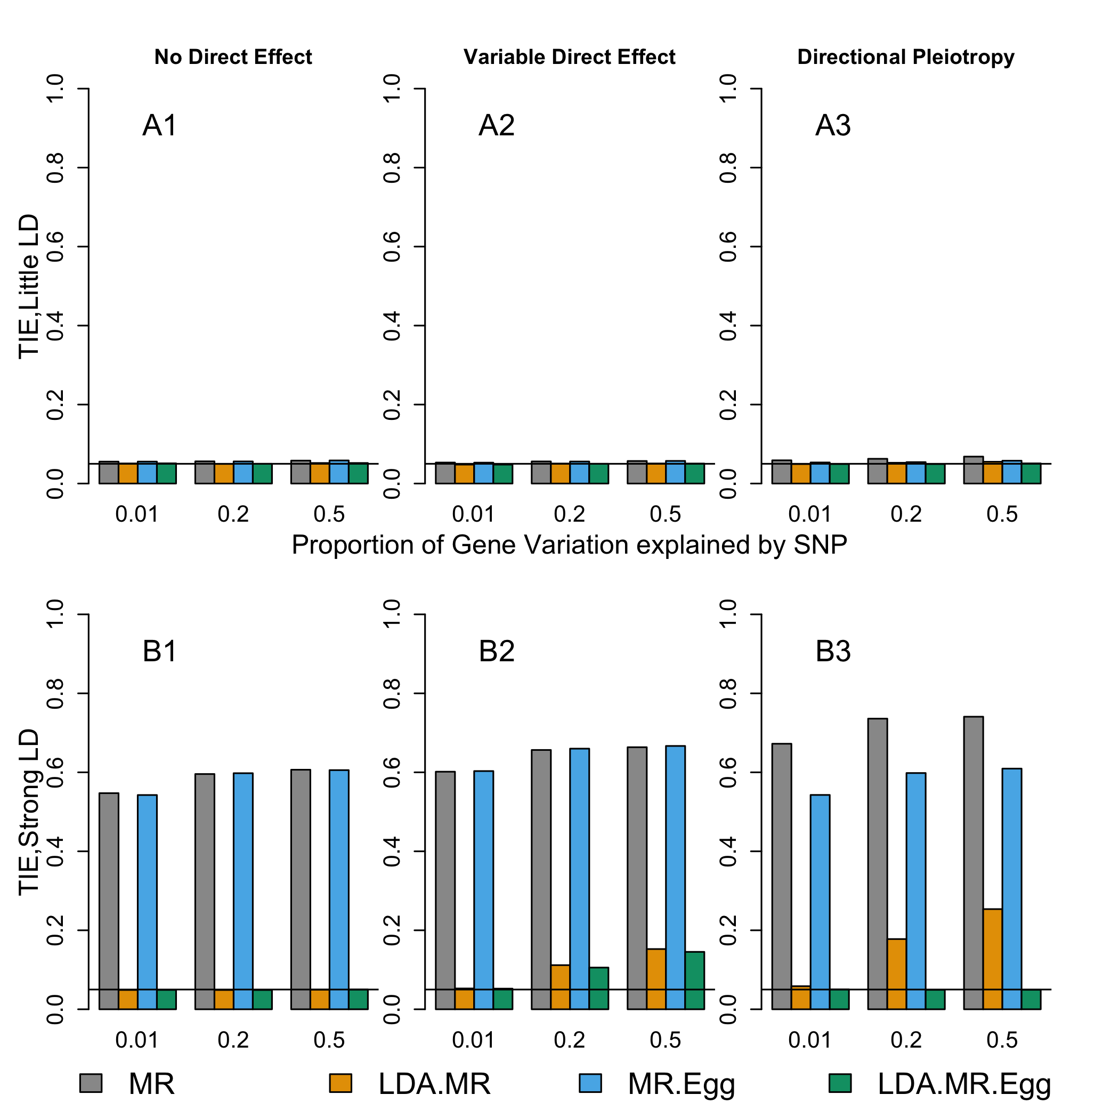

Supplementary Figure 2: Type I error when J=50, little LD, and co-localization. Each bar represents results over 5x10⁴ simulations. Evaluated at $α$ = 0:05. First panel represent when 10% eQTL and 10% disease SNPs (plots with A). Second panel represents when 50% eQTL and 50% disease SNPs (plots with B). From left to right correspond to: no direct effect, variable direct effects with mean 0 across SNPs, and directional pleiotropy. When there is a direct effect, the SNPs explain 1% of the variation in the outcome ($h_{G→Y}^{2}=.01$).

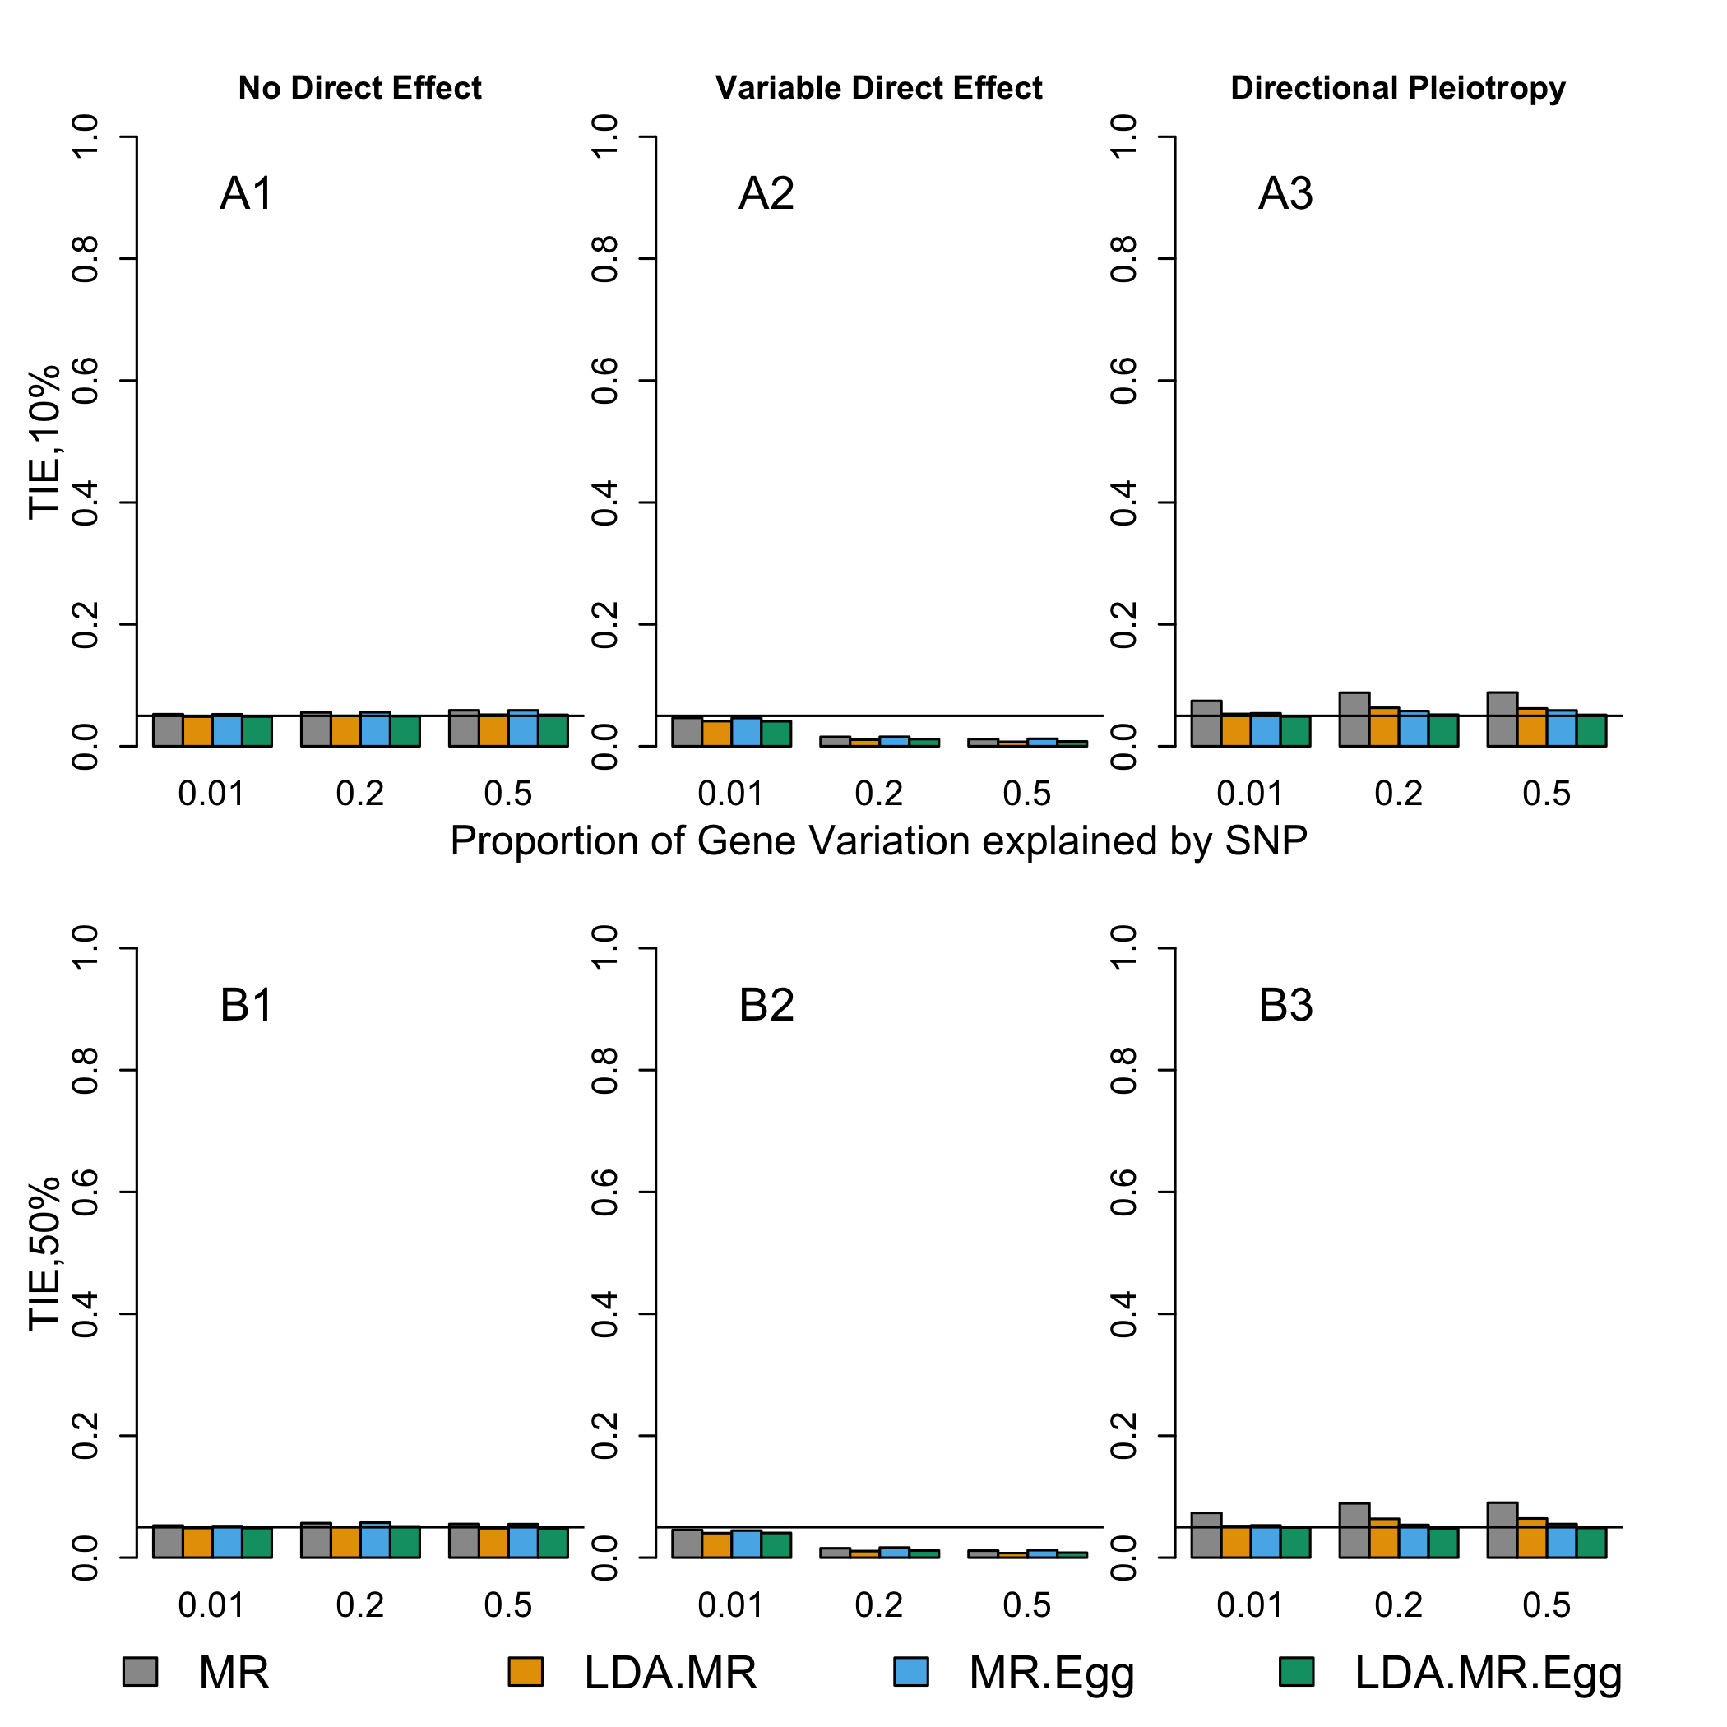

Supplementary Figure 3: Type I error when J=300, little LD, and co-localization. Each bar represents results over 5x10⁴ simulations. Evaluated at $α$ = 0:05. First panel represent when 10% eQTL and 10% disease SNPs (plots with A). Second panel represents when 50% eQTL and 50% disease SNPs (plots with B). From left to right correspond to: no direct effect, variable direct effects with mean 0 across SNPs, and directional pleiotropy. When there is a direct effect, the SNPs explain 1% of the variation in the outcome ($h_{G→Y}^{2}=.01$).

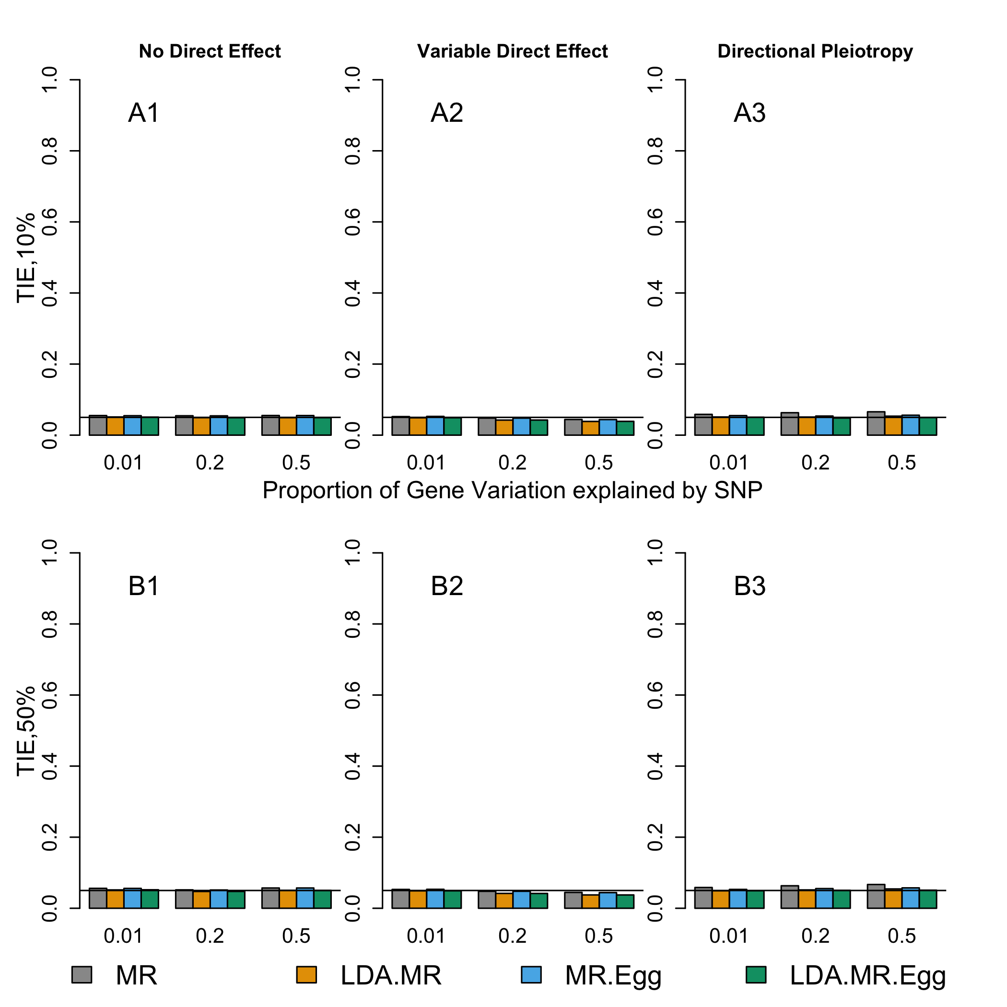

Supplementary Figure 4: Type I error when J=50, strong LD, and co-localization. Each bar represents results over 5x10⁴ simulations. Evaluated at $α$ = 0:05. First panel represent when 10% eQTL and 10% disease SNPs (plots with A). Second panel represents when 50% eQTL and 50% disease SNPs (plots with B). From left to right correspond to: no direct effect, variable direct effects with mean 0 across SNPs, and directional pleiotropy. When there is a direct effect, the SNPs explain 1% of the variation in the outcome ($h_{G→Y}^{2}=.01$).

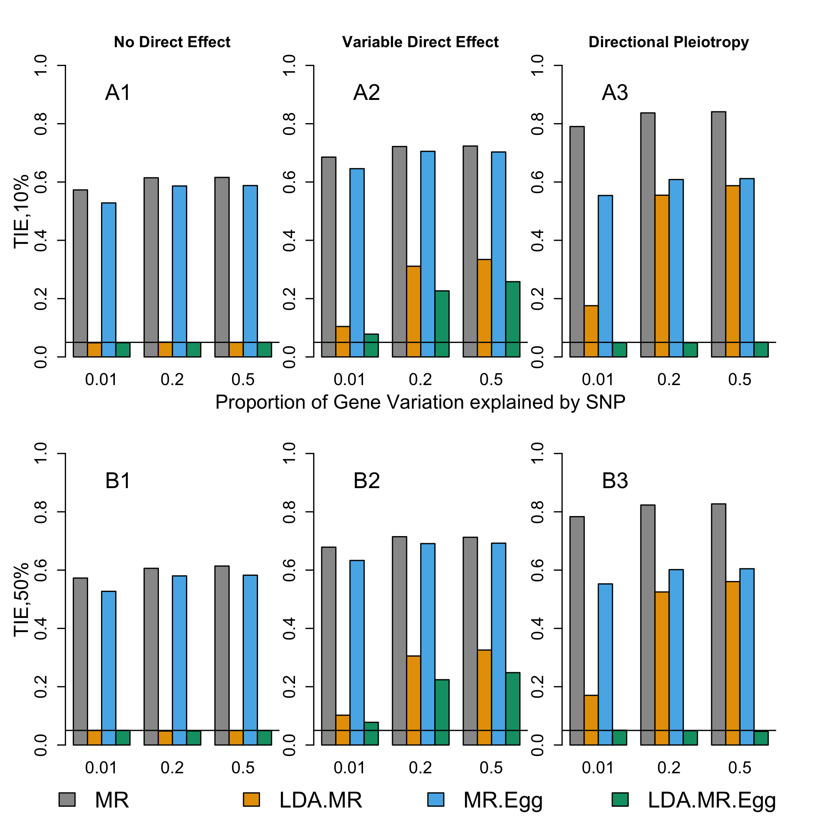

Supplementary Figure 5: Type I error when J=300, strong LD, and co-localization. Each bar represents results over 5x10⁴ simulations. Evaluated at $α$ = 0:05. First panel represent when 10% eQTL and 10% disease SNPs (plots with A). Second panel represents when 50% eQTL and 50% disease SNPs (plots with B). From left to right correspond to: no direct effect, variable direct effects with mean 0 across SNPs, and directional pleiotropy. When there is a direct effect, the SNPs explain 1% of the variation in the outcome ($h_{G→Y}^{2}=.01$).

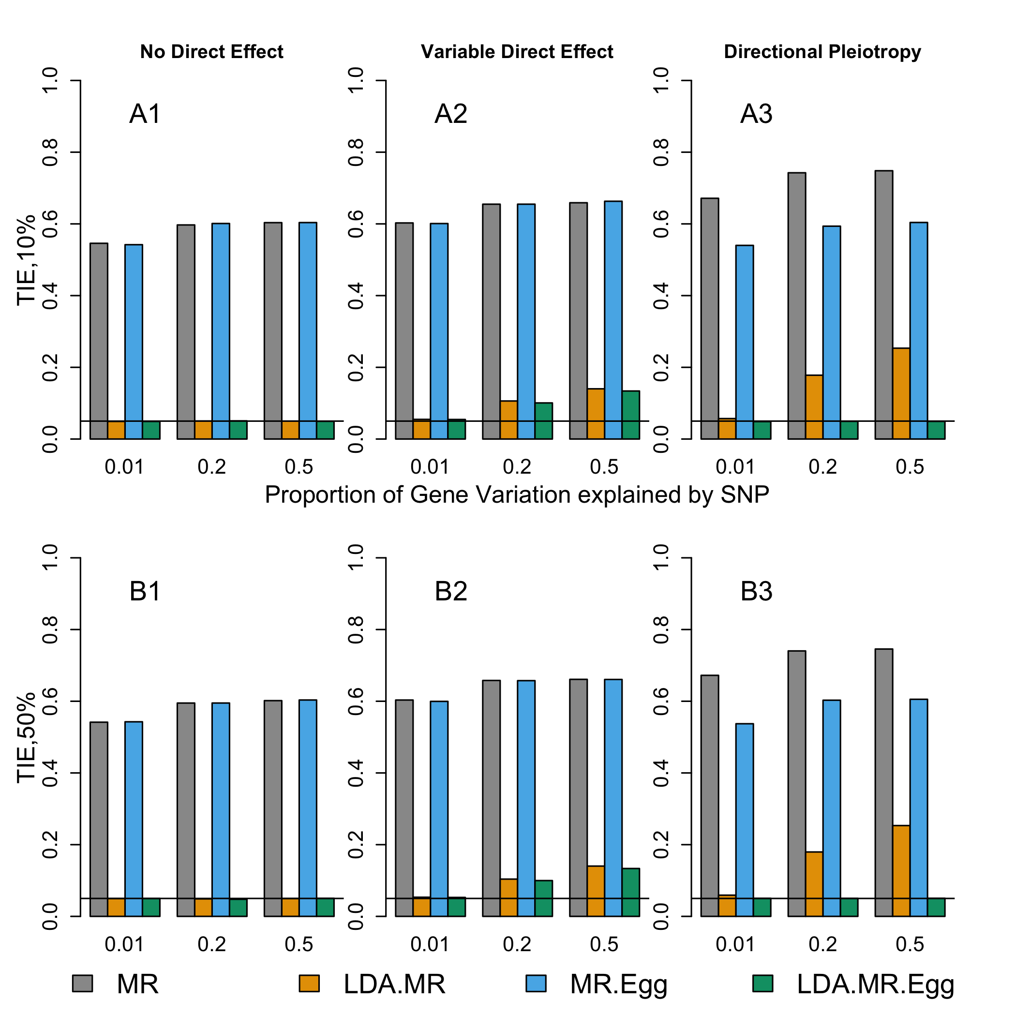

Supplementary Figure 6: Type I error when J=50, InSIDE condition violated, and variable direct effects with mean 0 across SNPs. Each bar represents results over 5x10⁴ simulations. Evaluated at α = 0:05. First panel represent when low LD (plots with A). Second panel represents when strong LD (plots with B). From left to right correspond to: correlation between $θ_{j}$ and $β_{E,j}$ is 0.125, 0.5, or 0.9.

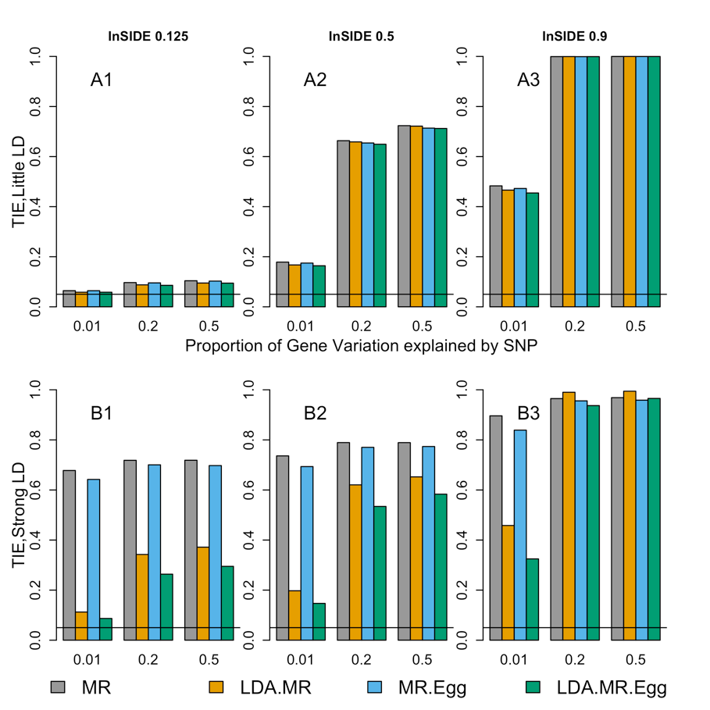

Supplementary Figure 7: Type I error when J=300, InSIDE condition violated, and directional pleiotropy. Each bar represents results over 5x10⁴ simulations. Evaluated at α = 0:05. First panel represent when low LD (plots with A). Second panel represents when strong LD (plots with B). From left to right correspond to: correlation between $θ_{j}$ and $β_{E,j}$ is 0.125, 0.5, or 0.9.

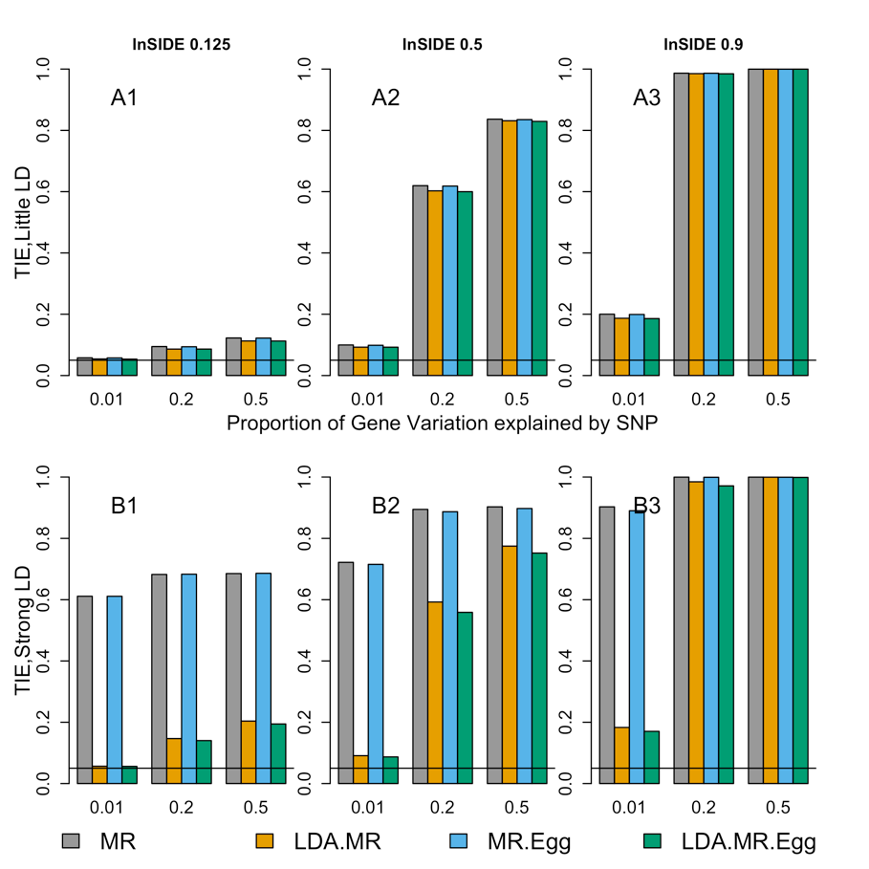

Supplementary Figure 8: Type I error when J=300, InSIDE condition violated, and variable direct effects with mean 0 across SNPs. Each bar represents results over 5x10⁴ simulations. Evaluated at α = 0:05. First panel represent when low LD (plots with A). Second panel represents when strong LD (plots with B). From left to right correspond to: correlation between $θ_{j}$ and $β_{E,j}$ is 0.125, 0.5, or 0.9.

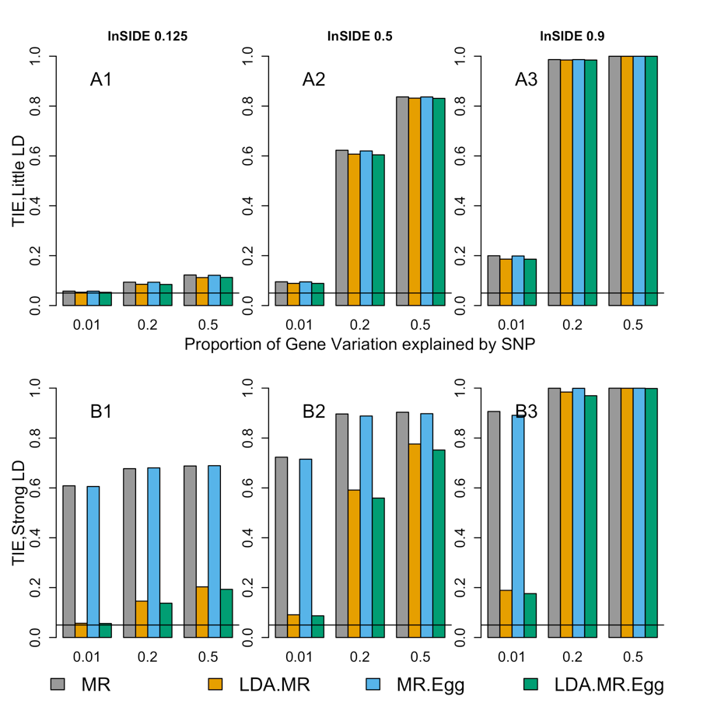

Supplementary Figure 9: Bias when low LD for J=50, 300. Bias plots for when there is low LD in the SNP set. First row corresponds to J=50, γ²= 0 (plots with A). Second panel (plots with B) when J = 50 and γ² = 0.01. Third panel (plots with C) when J = 300 and γ = 0. Final panel (plots with D) J = 300 and γ² = 0.01. From left to right: no direct effect, variable direct effects with mean 0 across SNPs, and directional pleiotropy. When there is a direct effect, the SNPs explain 1% of the variation in the outcome ($h_{G→Y}^{2}=.01$).

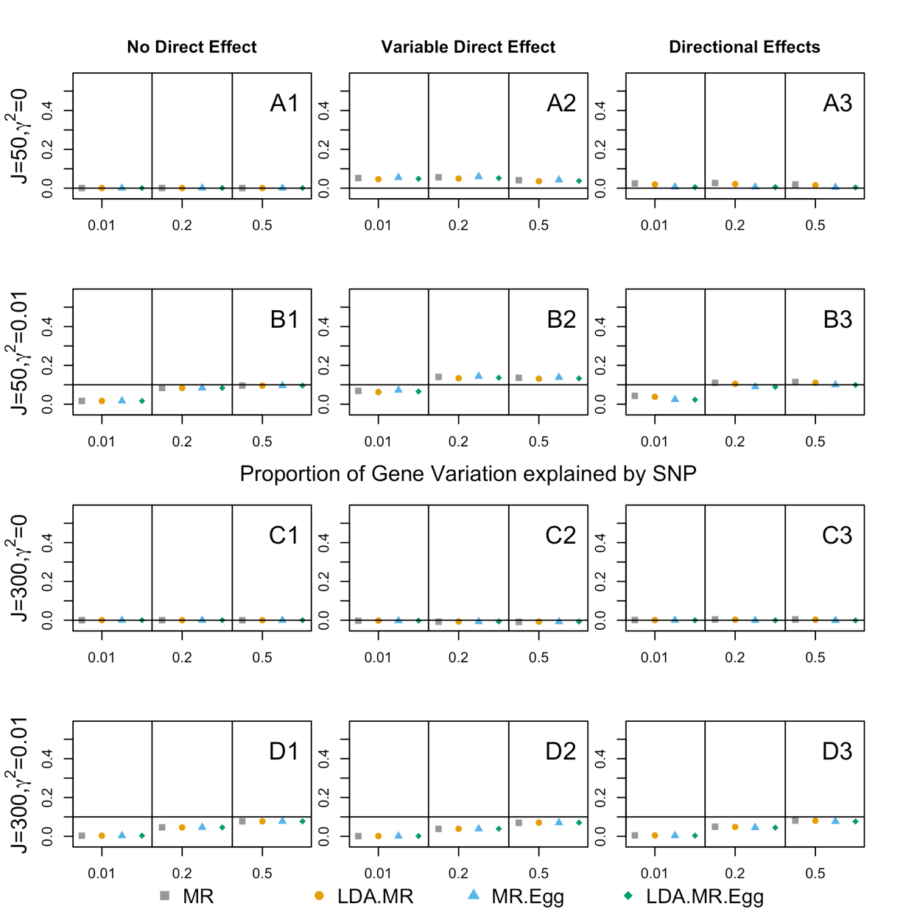

Supplementary Figure 10: Bias when low LD for J=50, 300 Comparing LDA method when add 0.1 to diagonal of LD matrix. Bias plots for when there is low LD in the SNP set. The adjusted LD methods are denoted as .2 in the legend. First row corresponds to J=50, γ²= 0 (plots with A). Second panel (plots with B) when J = 50 and γ² = 0.01. Third panel (plots with C) when J = 300 and γ = 0. Final panel (plots with D) J = 300 and γ² = 0.01. From left to right: no direct effect, variable direct effects with mean 0 across SNPs, and directional pleiotropy. When there is a direct effect, the SNPs explain 1% of the variation in the outcome ($h_{G→Y}^{2}=.01$).

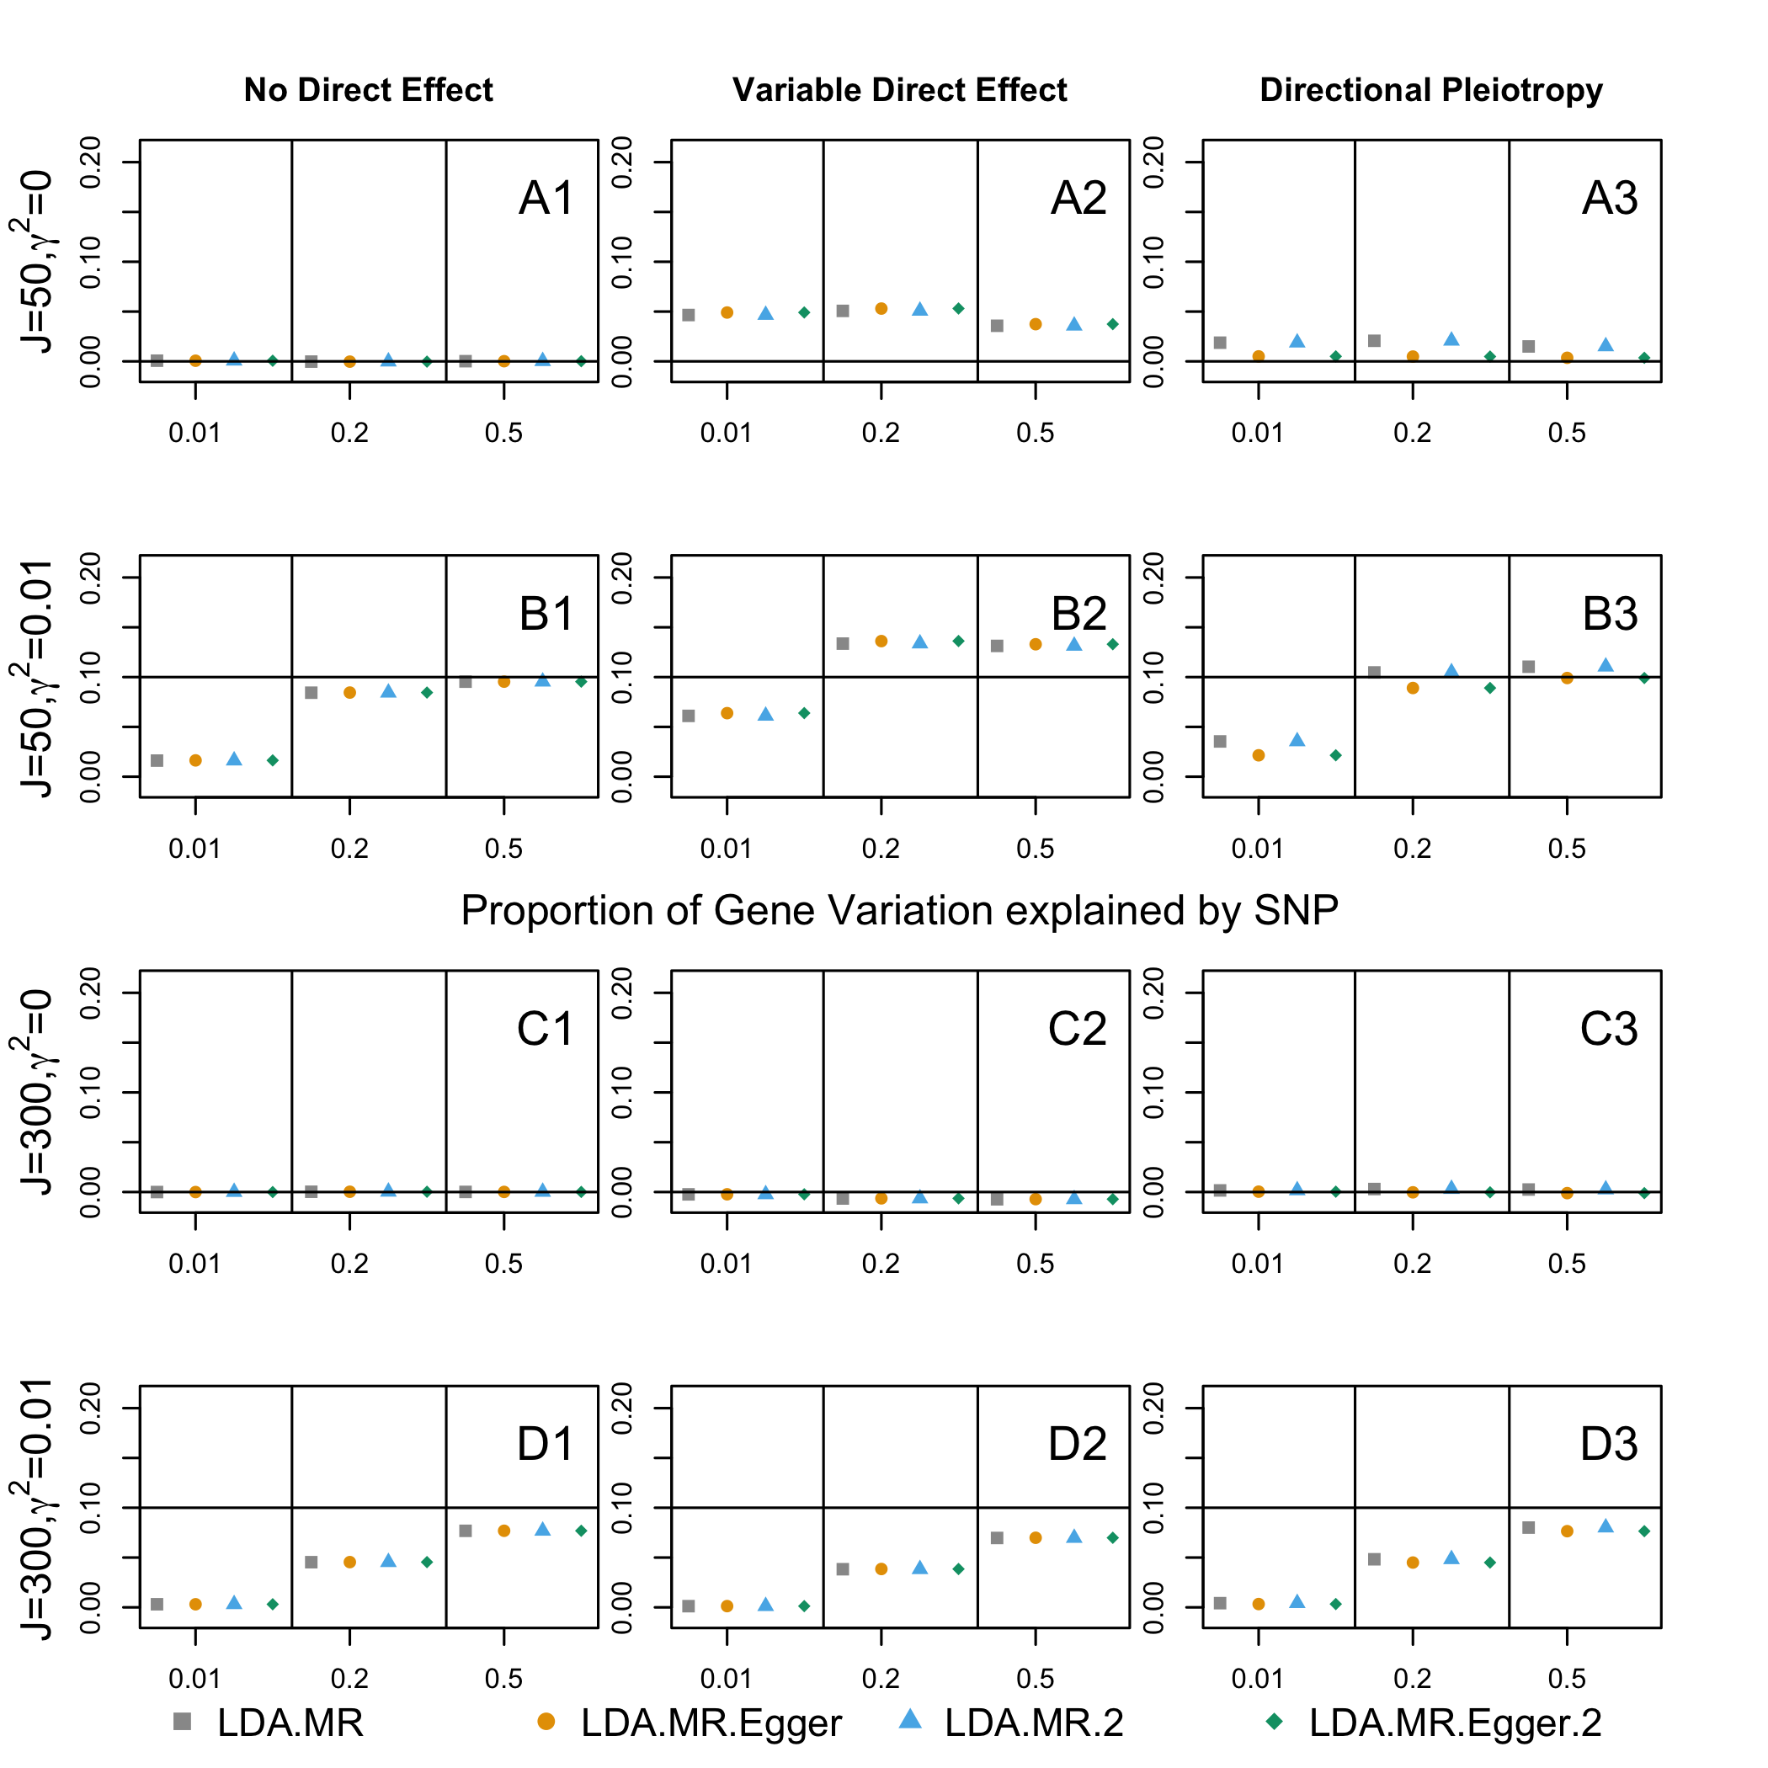

Supplementary Figure 11: Bias when high LD for J=50, 300 Comparing LDA method when add 0.1 to diagonal of LD matrix. Bias plots for when there is low LD in the SNP set. The adjusted LD methods are denoted as .2 in the legend. First row corresponds to J=50, γ²= 0 (plots with A). Second panel (plots with B) when J = 50 and γ² = 0.01. Third panel (plots with C) when J = 300 and γ = 0. Final panel (plots with D) J = 300 and γ² = 0.01. From left to right: no direct effect, variable direct effects with mean 0 across SNPs, and directional pleiotropy. When there is a direct effect, the SNPs explain 1% of the variation in the outcome ($h_{G→Y}^{2}=.01$).

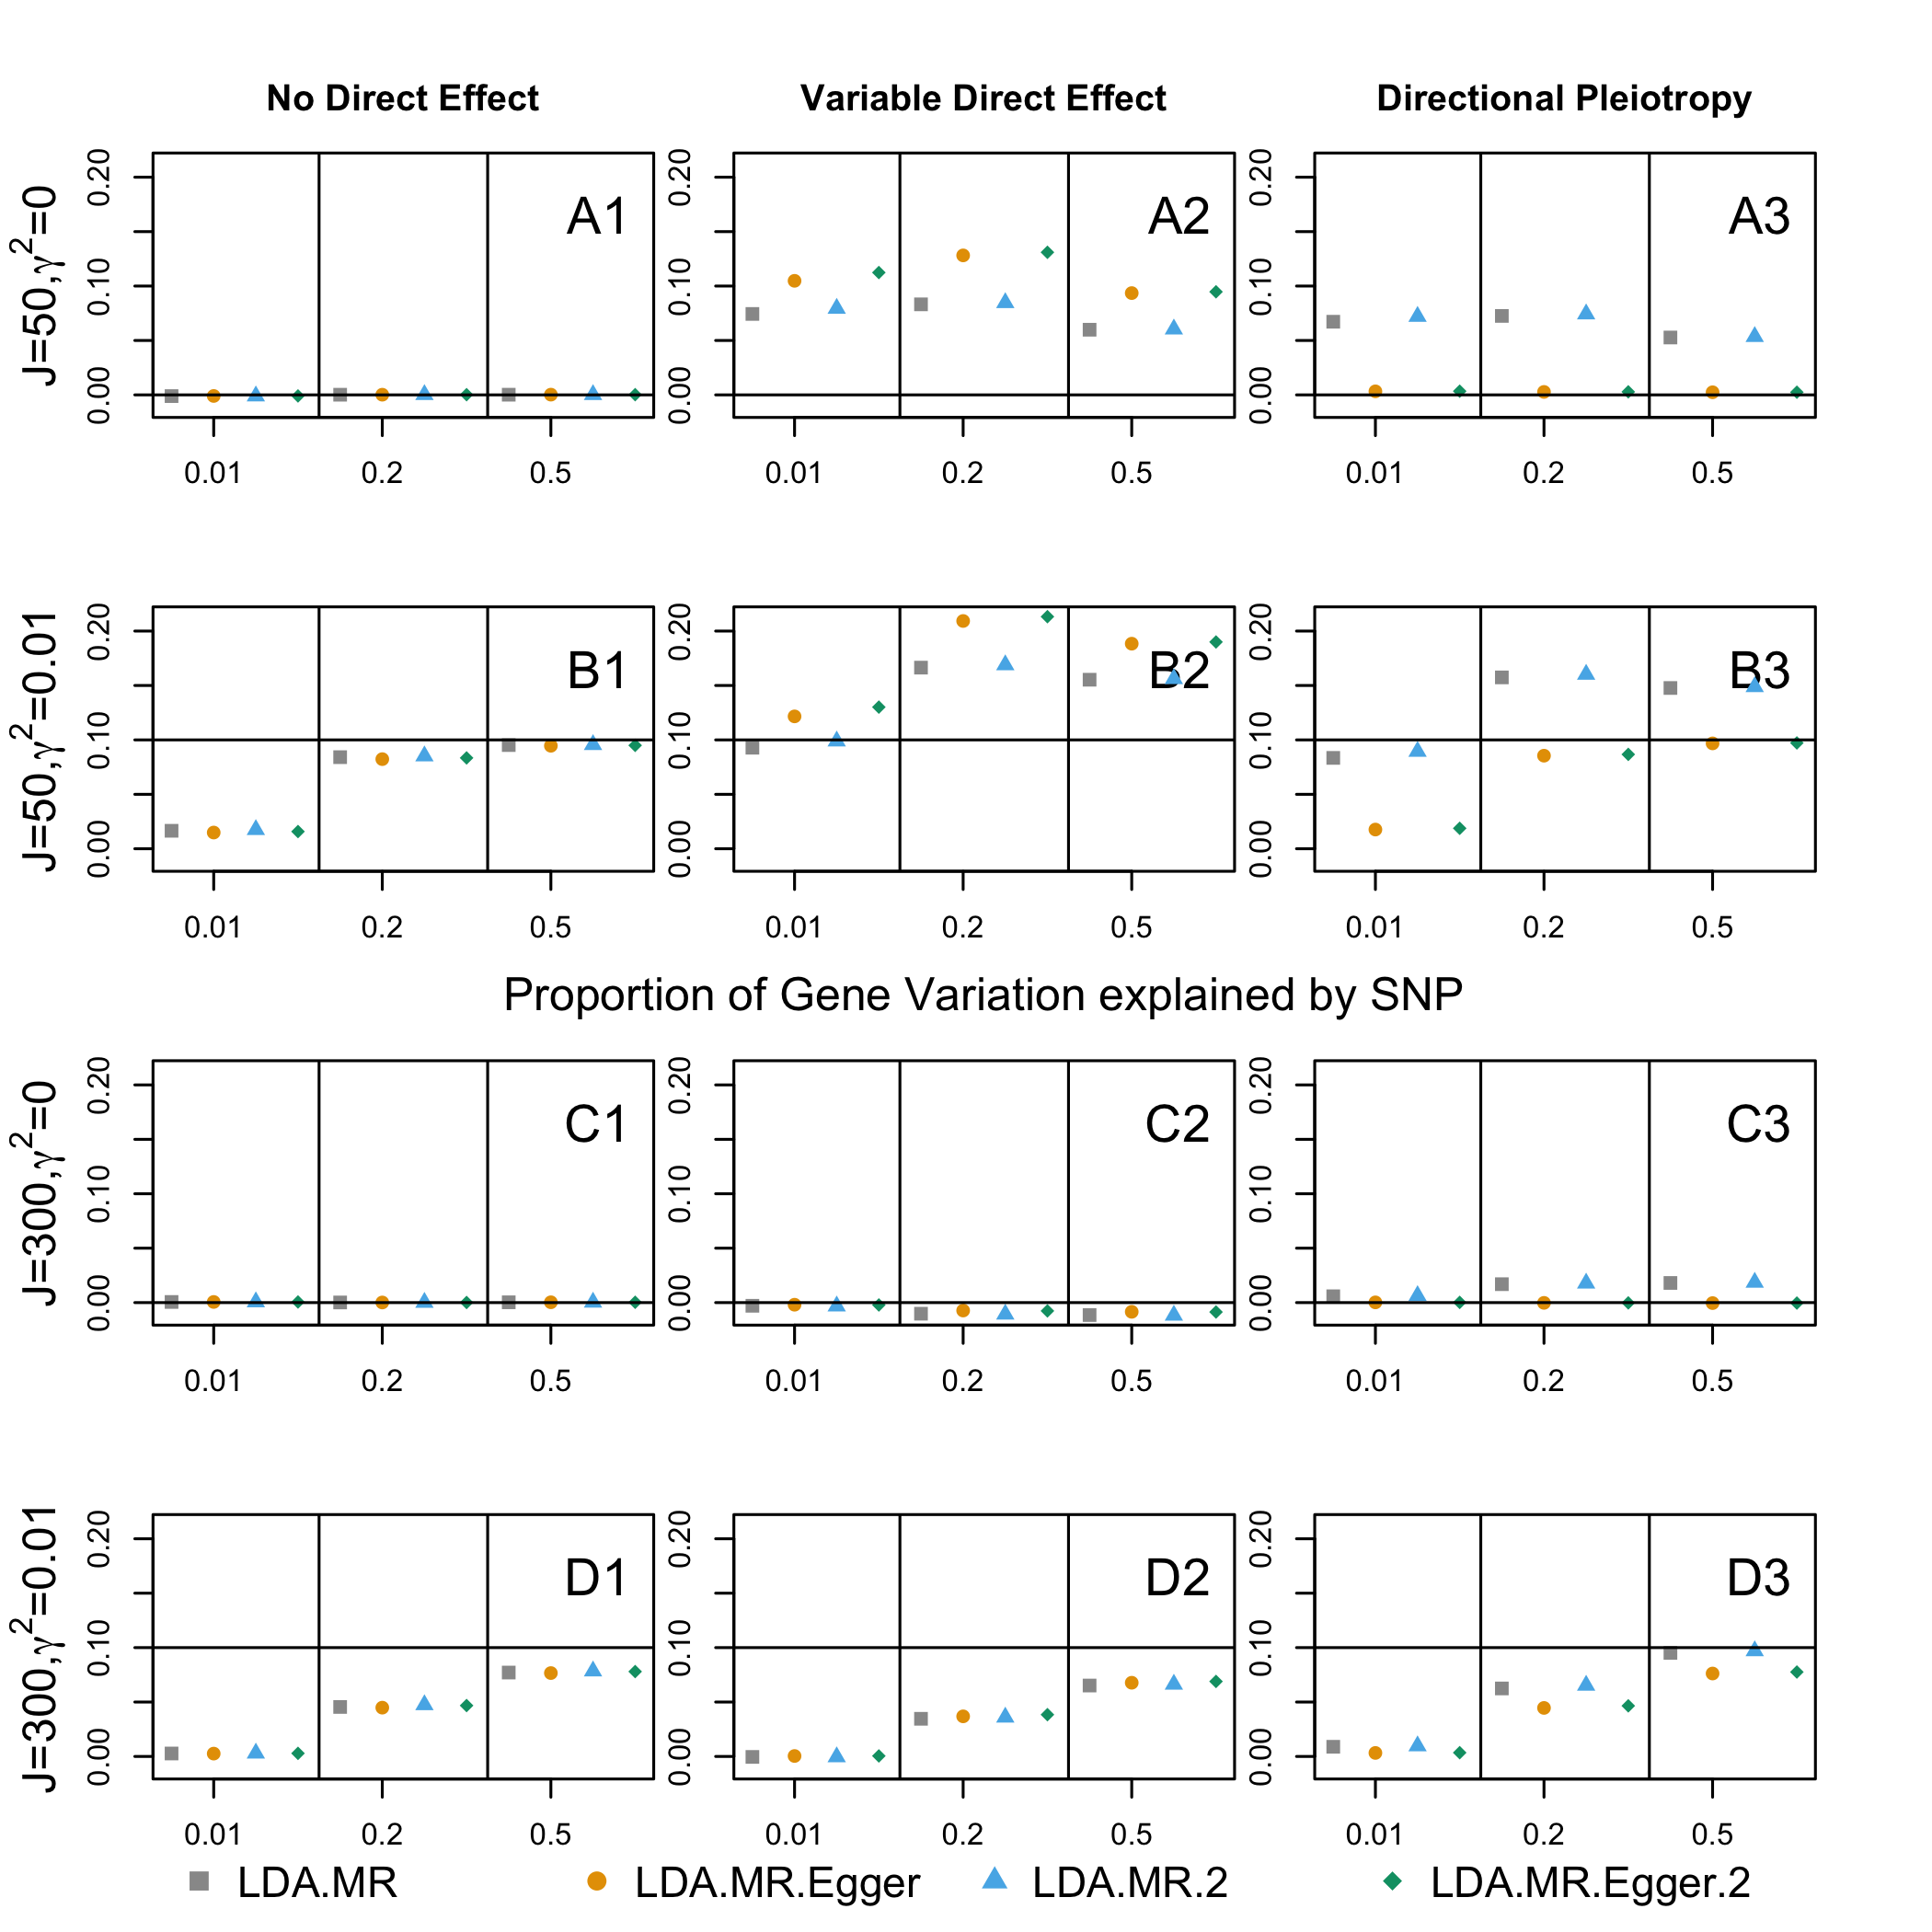

Supplementary Figure 12: Comparing TWAS vs LDA MR. Comparing test statistics between TWAS (x-axis) and LDA-MR (y-axis) across 683 genes.

