**Supplementary Materials**

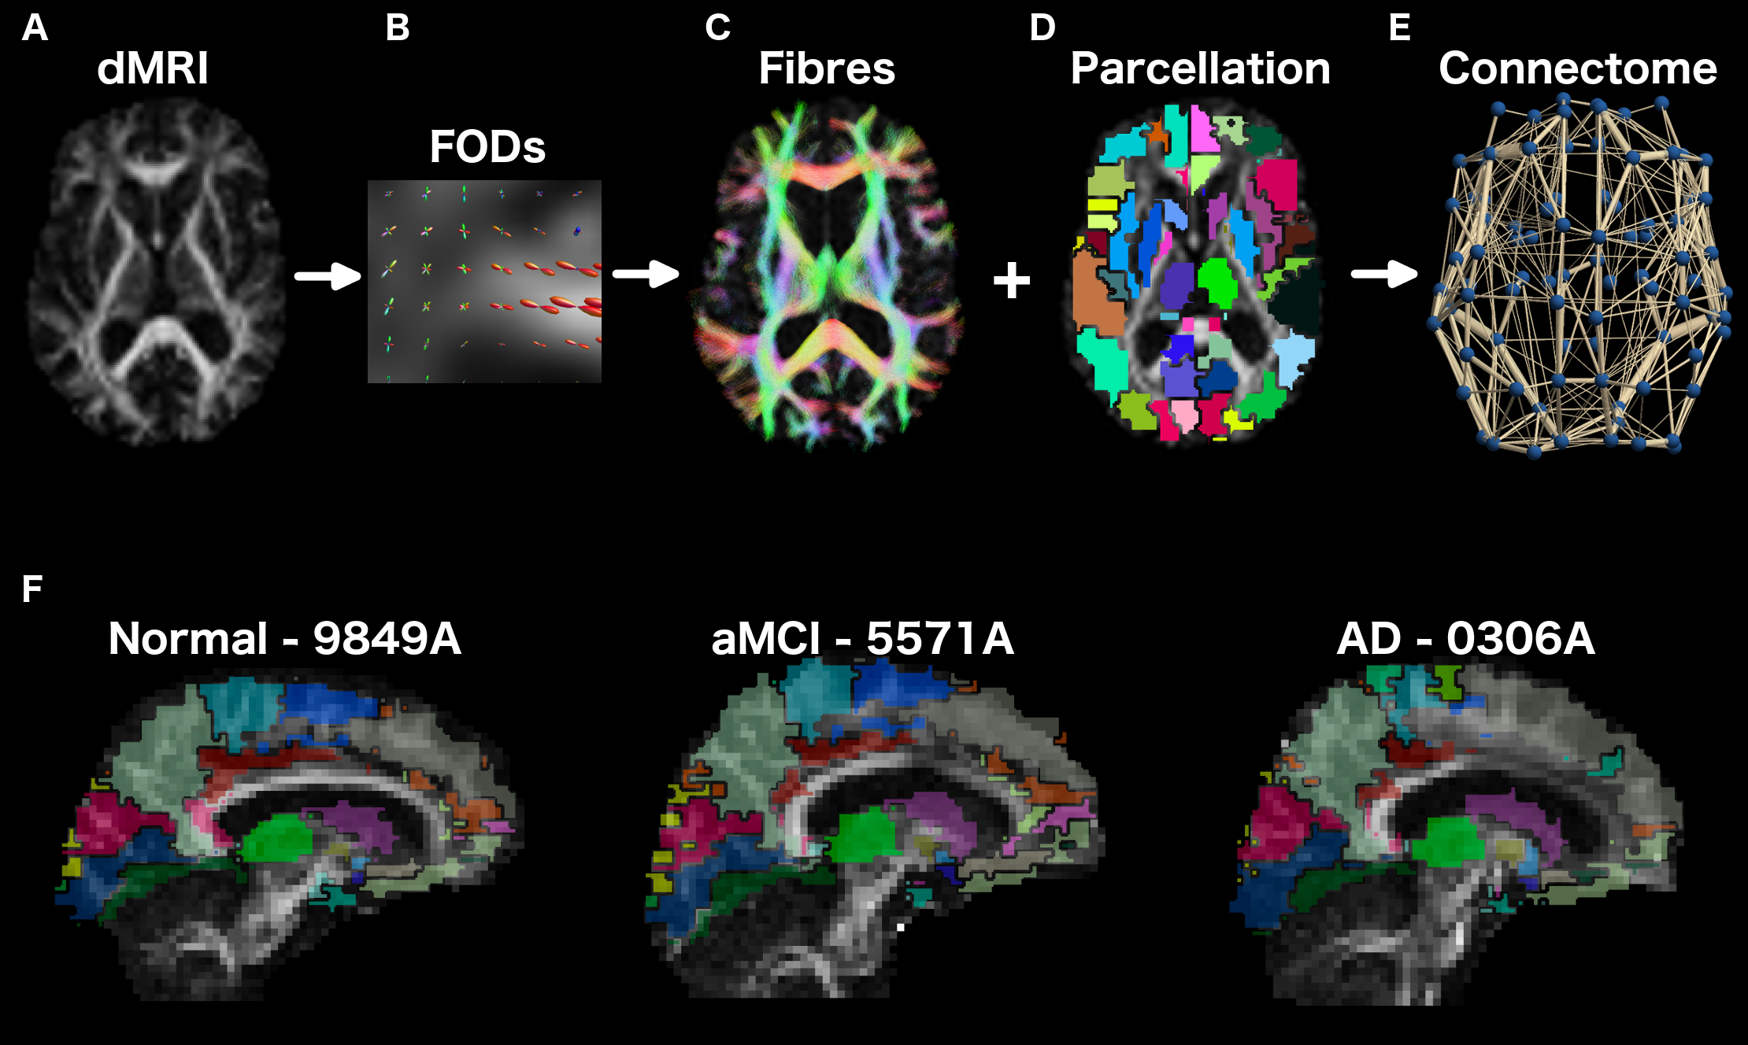

Figure S1. Schematic of the steps involved in structural network construction. As represented for a healthy subject, (A) Diffusion MRI images are used to calculate (B) local-estimates of fibre-orientation distributions (FODs) within each voxel. (C) Fibre orientations are sampled with probabilistic tractography (iFOD2) to generate five-million whole-brain fibre tracks. D) Streamline maps are combined with the anatomical boundaries of individual-specific parcellations to generate the (E) structural connectome. A connectome edge (gold lines) was identified if a streamline started/terminated between two node regions (blue circles). F) Alignment of the parcellation template on a subjects FA image, shown for a representative subject from the healthy (left panel), aMCI (middle) and AD (right) population-groups.

SuppSCDists.tif

Figure S2. Distribution of SC weights

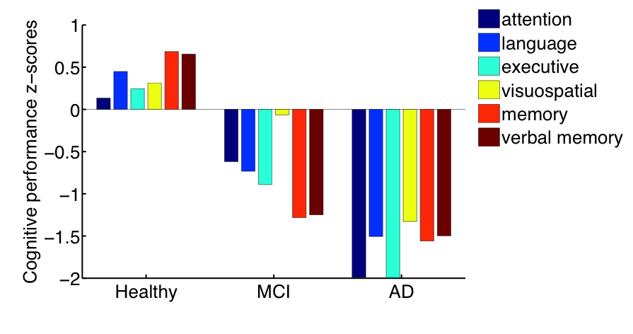

Figure S3: Cognitive domain scores by clinical group show a systematic decrease in all 6 cognitive domains from healthy to MCI to AD

G1.tifG2.tif

EE1.tifEE2.tif

EI1.tifEI2.tif

IE1.tifIE2.tif

Figure S4. Parameter space for two sample subjects (columns) for Whole Network, (top to bottom): global coupling (G), excitation-excitation (E-E), excitation-inhibition (E-I) and inhibition-excitation (I-E).

**Reductions in empirical SC and FC weights across disease severity**

As our models are tightly linked to the empirical connectomes (SC as input to our models, FC as model fitting criterion) (See Figure S3), we were interested in disease-related changes in these weights. We observed a reduction in mean empirical SC weights across groups (healthy > MCI > AD) (*F*(2,123) = 3.05, *p* = 0.045), as well as FC correlations (healthy > MCI > AD) (*F*(2,123) = 2.99, *p* = 0.05) within the Limbic SubNet network. When taking the mean of all Whole Network connections, we observed also a decrease in (absolute) mean FC across groups (*F*(2,123) = 4.39, *p* = 0.01), but not SC between groups (*F*(2,123) = 0.40, *p* = 0.67), suggesting that disease-related structural changes are region-specific.

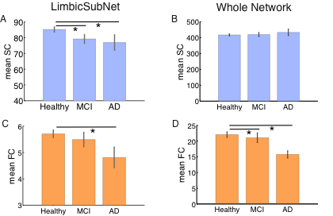

Figure S5. Mean (A) SC within Limbic SubNet (B) SC within Whole Network (C) FC within Limbic SubNet (D) FC within Whole Network, changes by clinical group. Mean SC is the mean of region-wise sums of weights. Mean FC is the mean of region-wise sums of absolute values of FC correlations.

**Graph measure comparison of SC across groups**

We also used graph metrics, computed using the Brain Connectivity Toolbox, to compare SC across groups. We compared strengths (ANOVA: F(2,121) = 0.40, p = 0.67), density (ANOVA: F(2,121) = 0.41, p = 0.66), mean local efficiency (ANOVA: F(2,121) = 1.32, p = 0.27), global efficiency (ANOVA: F(2,121) = 0.72, p = 0.49), and mean page centrality (ANOVA: F(2,121) = 0.76, p = 0.47). No significant differences were found between groups.

Table S1. Cognitive Domains and Tests Used for the Calculation of Domain Scores

|  |  |
| --- | --- |
| **Cognitive Domain** | **Test** |
| Attention/Processing speed | Digit Symbol-Coding (Wechsler, 1997a)  Trail Making Test (TMT) A (Strauss, Sherman, & Spreen, 2006) |
| Memory | Logical Memory Story A delayed recall (Wechsler, 1997b)  Rey Auditory Verbal Learning Test (RAVLT)(Strauss et al., 2006)  RAVLT total learning; sum of trials 1-5  RAVLT short-term delayed recall; trial 6  RAVLT long-term delayed recall; trial 7  Benton Visual Retention Test recognition (Benton, Sivan, & Spreen, 1996) |
| Verbal Memory | As above, but not including the Benton Visual Retention Test. |
| Language | Boston Naming Test – 30 items (Kaplan, 2001)  Semantic Fluency (Animals) (Strauss et al., 2006) |
| Visuo-spatial | Block Design (Wechsler, 1981) |
| Executive function | Controlled Oral Word Association Test (FAS) (Strauss et al., 2006)  Trail Making Test (TMT) B (Strauss et al., 2006) |

Table S2. Parameter values

|  |  |
| --- | --- |
| Parameter | Value |
| Excitatory gating variables |  |
| *aE* | 310 (nC-1) |
| *bE* | 125 (Hz) |
| *dE* | 0.16 (s) |
| *τE = τNMDA* | 100 (ms) |
| *WE* | 1 |
| Inhibitory gating variables |  |
| *aI* | 615 (nC-1) |
| *bI* | 177 (Hz) |
| *dI* | 0.087 (s) |
| *τI = τGABA* | 10 (ms) |
| *WI* | 0.7 |

Table S3. Demographic, IQ, and MMSE data by clinical group (healthy, MCI, AD)

|  |  |  |  |  |  |
| --- | --- | --- | --- | --- | --- |
|  | **Healthy** | **MCI** | **AD** | **Difference statistic** | **p-value** |
| Age, mean, (*SD*) | 82.88 (4.33) | 84.26  (4.49) | 84.69  (4.70) | *F* = 1.82 | 0.17 |
| Sex  Females, n, (%)  Males, n, (%) | 31 (42.47)  42 (57.53) | 22 (62.86)  13 (37.14) | 11 (68.75)  5 (31.25) | *X*2 = 5.1 | 0.05 |
| Education, mean number of years, (*SD*) | 12.55 (3.39) | 11.17 (3.79) | 11.5 (4.63) | *F* = 1.84 | 0.16 |
| MMSE, mean score, (*SD*) | 29.44 (0.96) | 28.57  (1.52) | 24.44  (4.38) | *F* = 45.92 | < 0.001 |
| NART IQ, mean score (*SD*) | 110.23 (9.20) | 106.04 (11.07) | 107 (12.73) | *F =* 1.81 | 0.17 |
| Framewise displacement, mean (*SD*) | 0.35 (0.16) | 0.32 (0.11) | 0.35 (0.19) | *F = 0.38* | 0.68 |

Table S4. Limbic SubNet subnetwork regions

|  |  |
| --- | --- |
| Region ID | Region Label |
| 1  2  3  4  5  6  7  8  9  10  11  12  13  14  15  16 | Cingulum_Ant_L  Cingulum_Ant_R  Cingulum_Mid_L  Cingulum_Mid_R  Cingulum_Post_L  Cingulum_Post_R  Hippocampus_L  Hippocampus_R  ParaHippocampal_L  ParaHippocampal_R  Amygdala_L  Amygdala_R  Temporal_Pole_Sup_L  Temporal_Pole_Sup_R  Temporal_Mid_L  Temporal_Mid_R |

Table S5. Internal consistency of cognitive domain scores (reproduced from (A. Perry et al., 2017)

|  |  |
| --- | --- |
| **Domain** | **Spearman-Brown Coefficient** |
| **Attention/Processing Speed** | 0.72 |
| **Memory** | 0.87 |
| **Verbal Memory** | 0.92 |
| **Language** | 0.65 |
| **Visuo-spatial ability** | N/A* |
| **Executive function** | 0.55 |

Table S6. Model fit (EmpFC-SimFC fit) correlated with model parameters across subjects, MC corrected. Significant relationships are delineated with a *

|  |  |  |
| --- | --- | --- |
|  | LBC | Whole Network |
| G | r = -0.23, p < 0.01 * | r = 0.23, p < 0.05 * |
| I-E | r = 0.25, p < 0.01 * | r = -0.30, p < 0.001 * |
| E-I | r = -0.24, p < 0.01 * | r = 0.40, p < 0.001 * |
| E-E | r = -0.22, p < 0.05 **\*** | r = 0.43, p < 0.001 * |