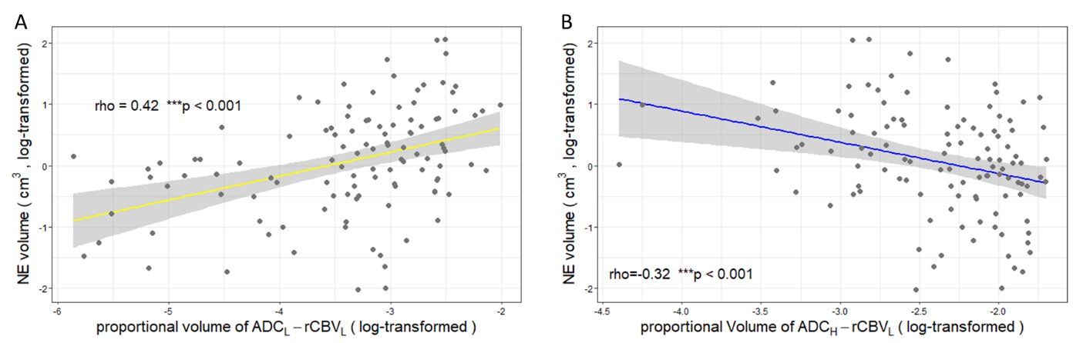
Supplementary Figure S2. Correlations between two compartments with contrast enhanced tumor and tumor infiltration. Non-enhancing (NE) tumor (measured by the volume of FLAIR beyond contrast enhancement) showed a moderate positive correlation with the proportional volume (log-transformed) of the ADC_{L}-rCBV_{L} compartment (A) and negative correlation with the proportional volume (log-transformed) of the ADC_{H}-rCBV_{L} compartment (B). ***: p < 0.001.

